# Scales plots report (NoOutliers)

Source file: 20251214-ScalesData-Combined_ver0.7-Cleaned-IncomeNormalized-NoOutliers.csv

Rows kept: 79; columns: 75

## Name

Top categories: <<MISSING>>: 1 (1.3%) | muskan: 1 (1.3%) | Chaya Gehlot: 1 (1.3%) | Usha Awasthi: 1 (1.3%) | Aaradhana Gautam: 1 (1.3%) | Veena Gupta: 1 (1.3%) | Madhu Mathur: 1 (1.3%) | Pakhi Agarwal: 1 (1.3%) | Santosh Rani Gupta : 1 (1.3%) | Pratibha Rani : 1 (1.3%) | Archana Gupta: 1 (1.3%) | Anita Pharswan: 1 (1.3%) | Puja Verma : 1 (1.3%) | Shivani: 1 (1.3%) | Sneha Kumari: 1 (1.3%) | Rekha Goel: 1 (1.3%) | Prakash: 1 (1.3%) | Dr Abhilasha Bajpai: 1 (1.3%) | Dr Nemika: 1 (1.3%) | Gazala: 1 (1.3%) | Ganga Tikka Verma: 1 (1.3%) | Kajal: 1 (1.3%) | RItu Dixit: 1 (1.3%) | Preety Singh: 1 (1.3%) | Sarita Chauhan: 1 (1.3%) | Kalpana Singh: 1 (1.3%) | Vimla Taneja : 1 (1.3%) | Rashmi Singh : 1 (1.3%) | Poonam Sharma : 1 (1.3%) | Rinku Kumar: 1 (1.3%) | Saraswati: 1 (1.3%) | Sharda Dixit: 1 (1.3%) | Divya Singh: 1 (1.3%) | Ananya Poothia : 1 (1.3%) | Khusi Gupta : 1 (1.3%) | Mansi Rastogi: 1 (1.3%) | Suhani : 1 (1.3%) | Shruti Randhawa: 1 (1.3%) | Sangeeta Devi : 1 (1.3%) | Mahima Vishnoi : 1 (1.3%) | Manya Malhotra : 1 (1.3%) | Amrita Raj: 1 (1.3%) | Samreen Khalid : 1 (1.3%) | Sana: 1 (1.3%) | Urooj Fatima : 1 (1.3%) | Palak : 1 (1.3%) | Varsha Rani: 1 (1.3%) | Deepti Sharma : 1 (1.3%) | Shivani : 1 (1.3%) | Antra : 1 (1.3%). Note: Healthy spread across categories.

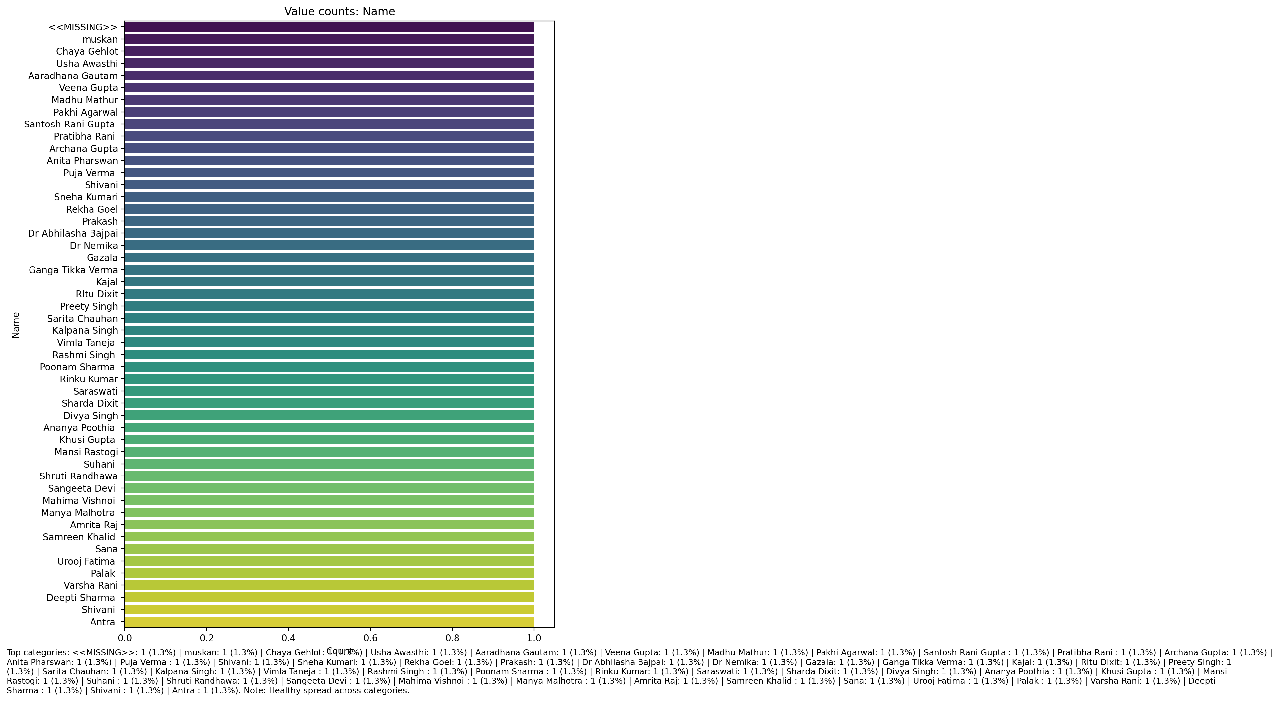

## Age (IN YEARS)

Count=76; mean=30.07; median=24.00; std=12.92; min=17.00; max=74.00; outliers=1 (1.3%). Skewness=1.21.

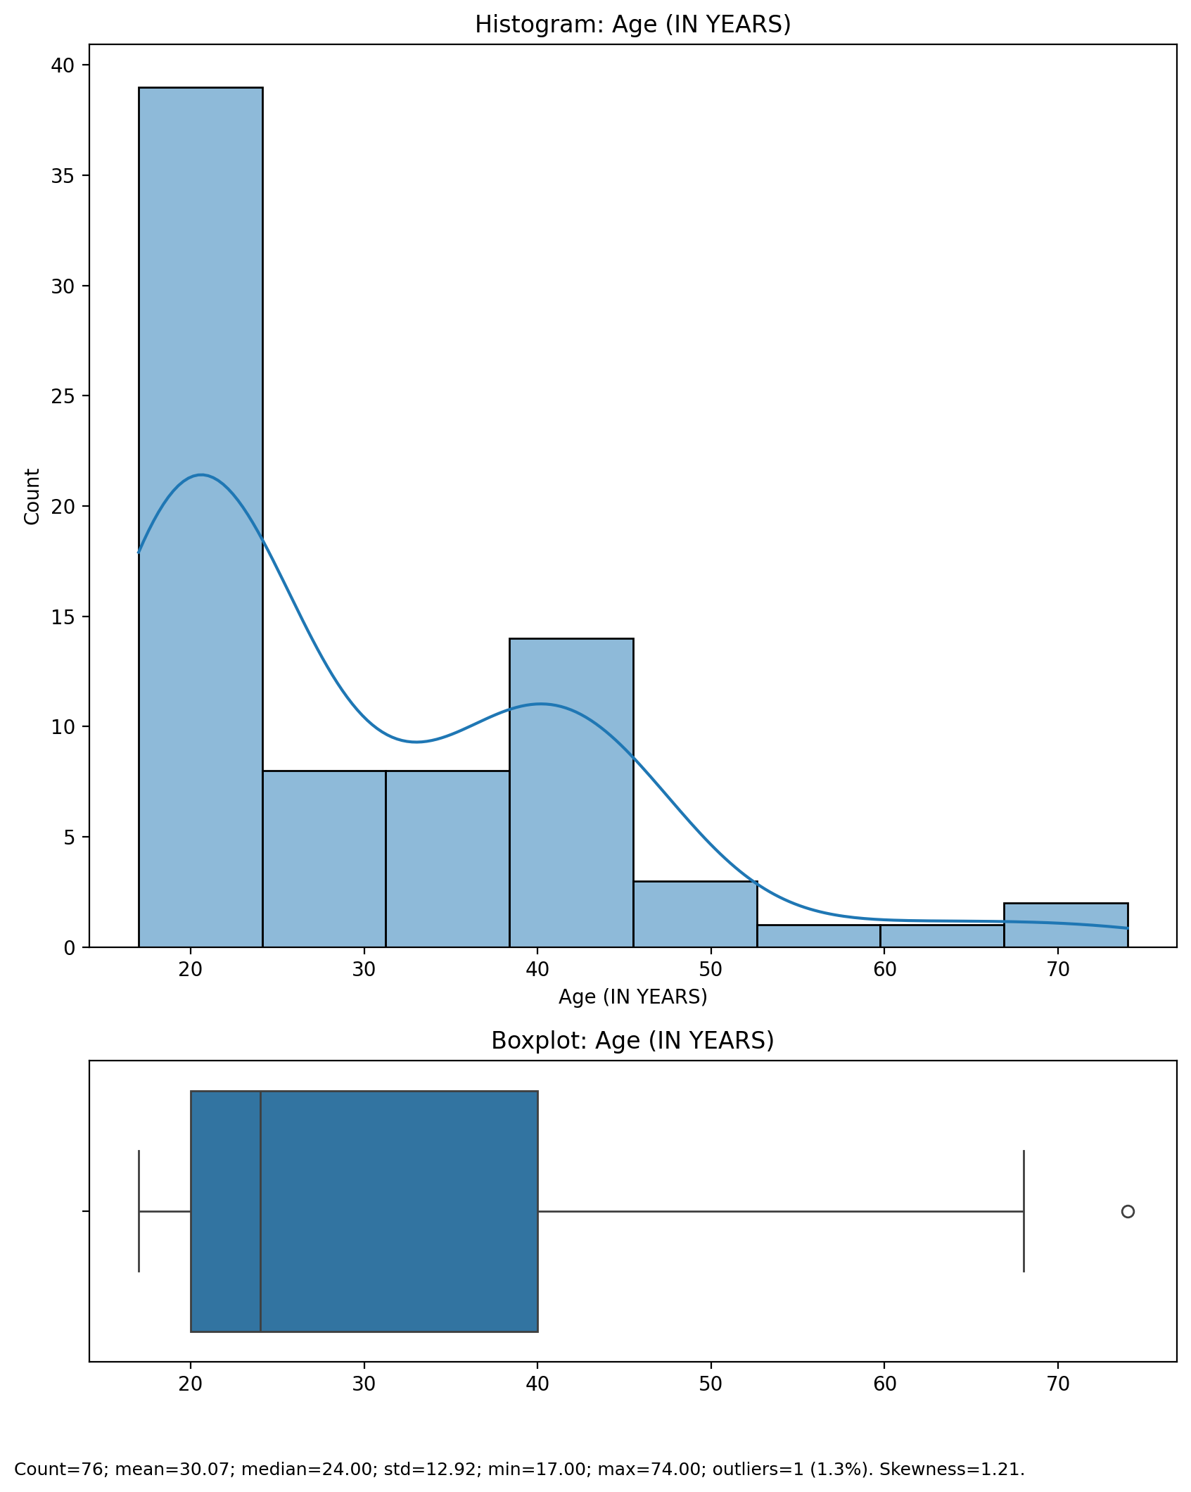

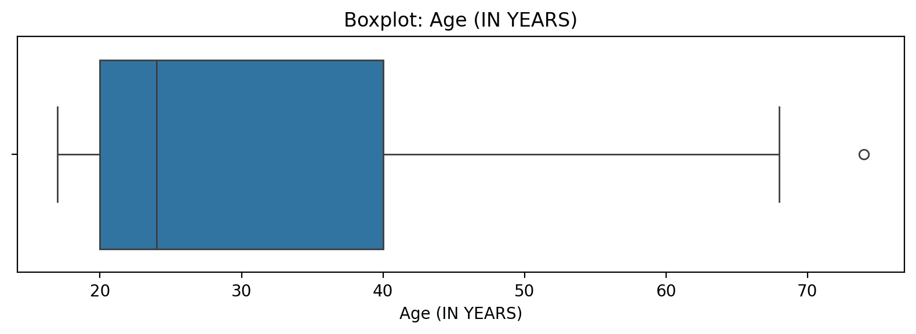

## Age (IN YEARS)

Top categories: <<MISSING>>: 1 (1.3%) | muskan: 1 (1.3%) | Chaya Gehlot: 1 (1.3%) | Usha Awasthi: 1 (1.3%) | Aaradhana Gautam: 1 (1.3%) | Veena Gupta: 1 (1.3%) | Madhu Mathur: 1 (1.3%) | Pakhi Agarwal: 1 (1.3%) | Santosh Rani Gupta : 1 (1.3%) | Pratibha Rani : 1 (1.3%) | Archana Gupta: 1 (1.3%) | Anita Pharswan: 1 (1.3%) | Puja Verma : 1 (1.3%) | Shivani: 1 (1.3%) | Sneha Kumari: 1 (1.3%) | Rekha Goel: 1 (1.3%) | Prakash: 1 (1.3%) | Dr Abhilasha Bajpai: 1 (1.3%) | Dr Nemika: 1 (1.3%) | Gazala: 1 (1.3%) | Ganga Tikka Verma: 1 (1.3%) | Kajal: 1 (1.3%) | RItu Dixit: 1 (1.3%) | Preety Singh: 1 (1.3%) | Sarita Chauhan: 1 (1.3%) | Kalpana Singh: 1 (1.3%) | Vimla Taneja : 1 (1.3%) | Rashmi Singh : 1 (1.3%) | Poonam Sharma : 1 (1.3%) | Rinku Kumar: 1 (1.3%) | Saraswati: 1 (1.3%) | Sharda Dixit: 1 (1.3%) | Divya Singh: 1 (1.3%) | Ananya Poothia : 1 (1.3%) | Khusi Gupta : 1 (1.3%) | Mansi Rastogi: 1 (1.3%) | Suhani : 1 (1.3%) | Shruti Randhawa: 1 (1.3%) | Sangeeta Devi : 1 (1.3%) | Mahima Vishnoi : 1 (1.3%) | Manya Malhotra : 1 (1.3%) | Amrita Raj: 1 (1.3%) | Samreen Khalid : 1 (1.3%) | Sana: 1 (1.3%) | Urooj Fatima : 1 (1.3%) | Palak : 1 (1.3%) | Varsha Rani: 1 (1.3%) | Deepti Sharma : 1 (1.3%) | Shivani : 1 (1.3%) | Antra : 1 (1.3%). Note: Healthy spread across categories.



## Marital Status

Top categories: Single: 44 (55.7%) | Married: 34 (43.0%) | <<MISSING>>: 1 (1.3%). Note: Top category is sizeable — consider grouping smaller categories.

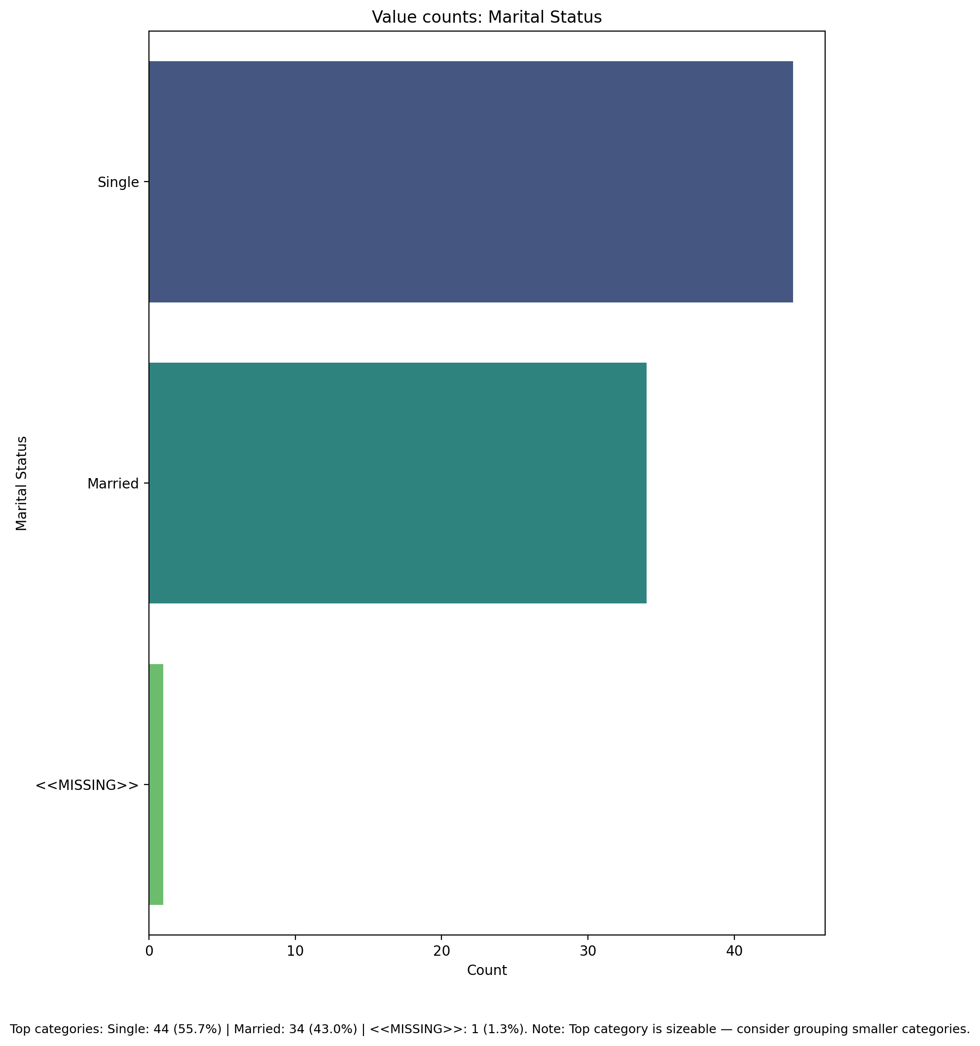

## Highest level of education completed

Top categories: Bachelor's degree: 29 (36.7%) | Postgraduate degree: 25 (31.6%) | Secondary school: 11 (13.9%) | Other (please specify): 7 (8.9%) | Diploma: 4 (5.1%) | <<MISSING>>: 2 (2.5%) | Primary school: 1 (1.3%). Note: Healthy spread across categories.

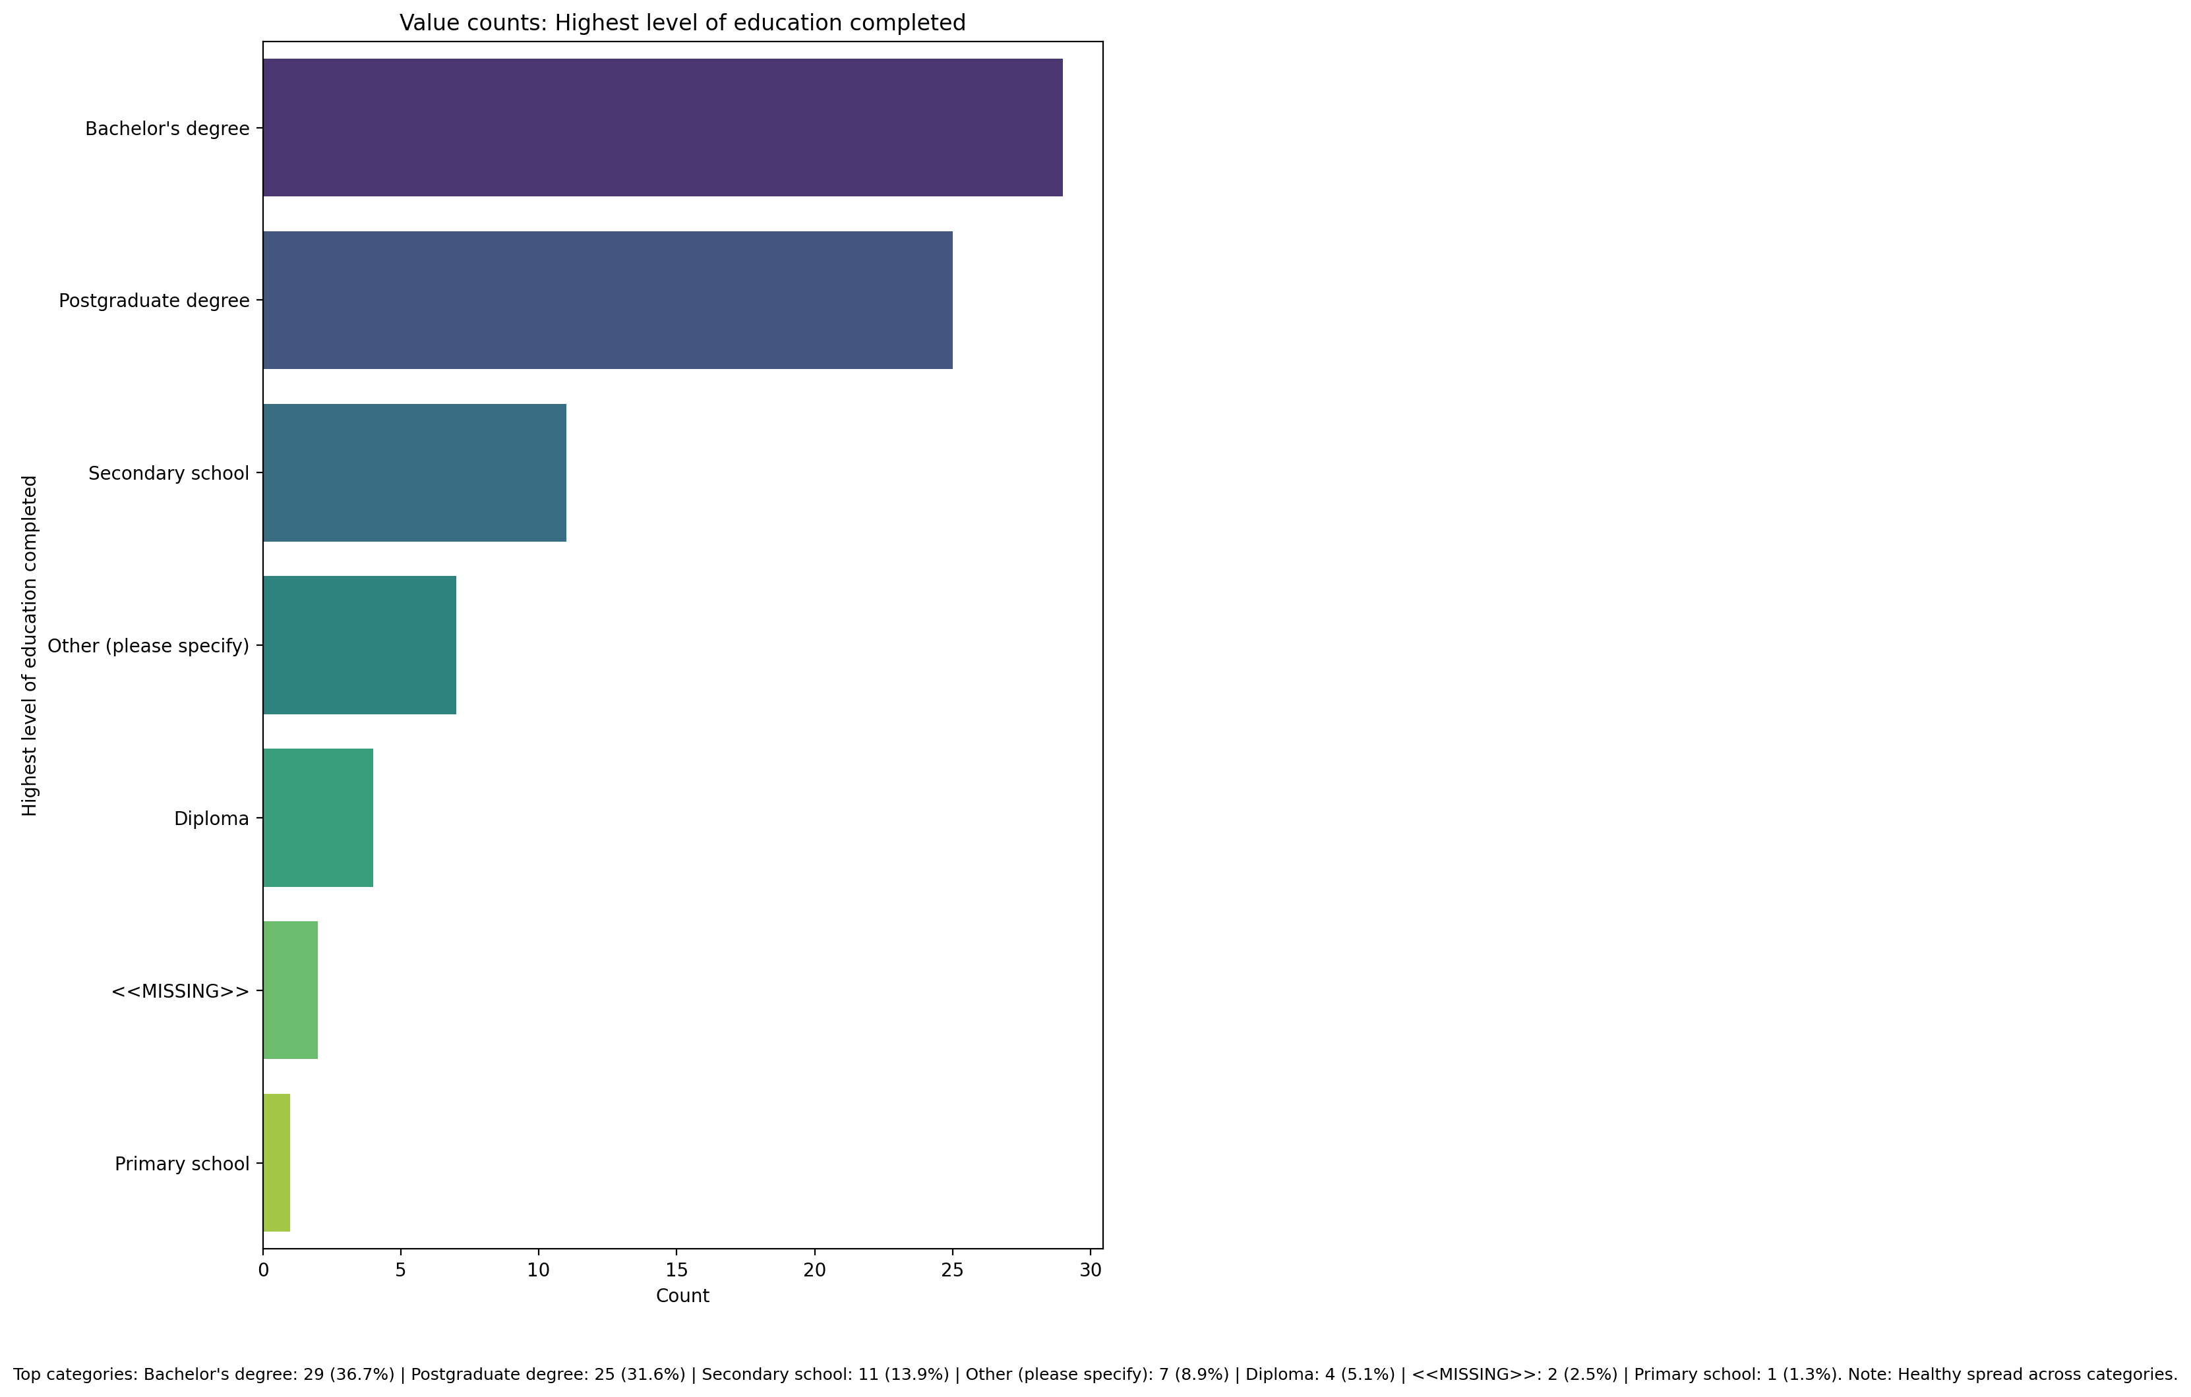

## Current Employment Status

Top categories: Student: 31 (39.2%) | Employed full-time: 18 (22.8%) | Self-employed: 7 (8.9%) | Employed part-time: 7 (8.9%) | Unemployed: 7 (8.9%) | Homemaker: 6 (7.6%) | <<MISSING>>: 2 (2.5%) | Retired: 1 (1.3%). Note: Healthy spread across categories.

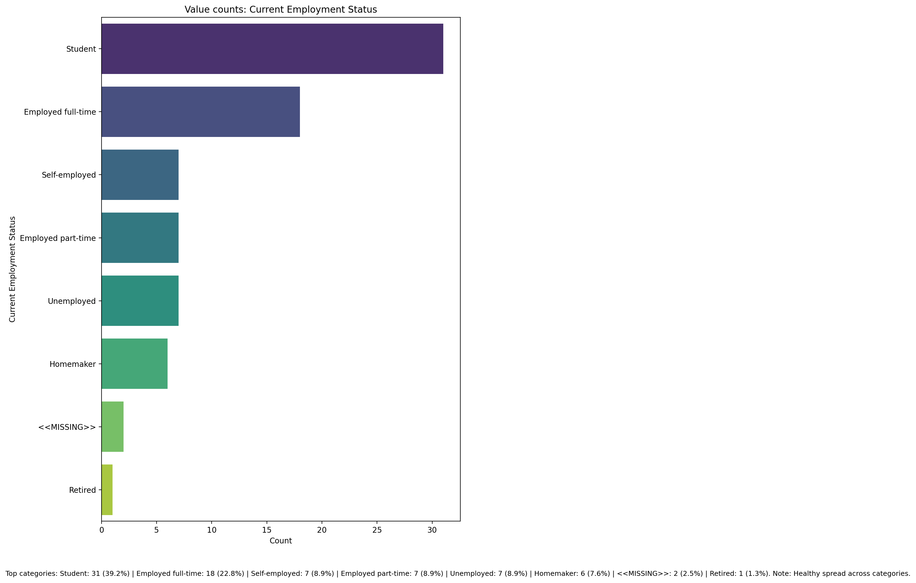

## Number of children

Top categories: <<MISSING>>: 45 (57.0%) | 2: 21 (26.6%) | 1: 7 (8.9%) | 3: 5 (6.3%) | 4 or more: 1 (1.3%). Note: Top category is sizeable — consider grouping smaller categories.

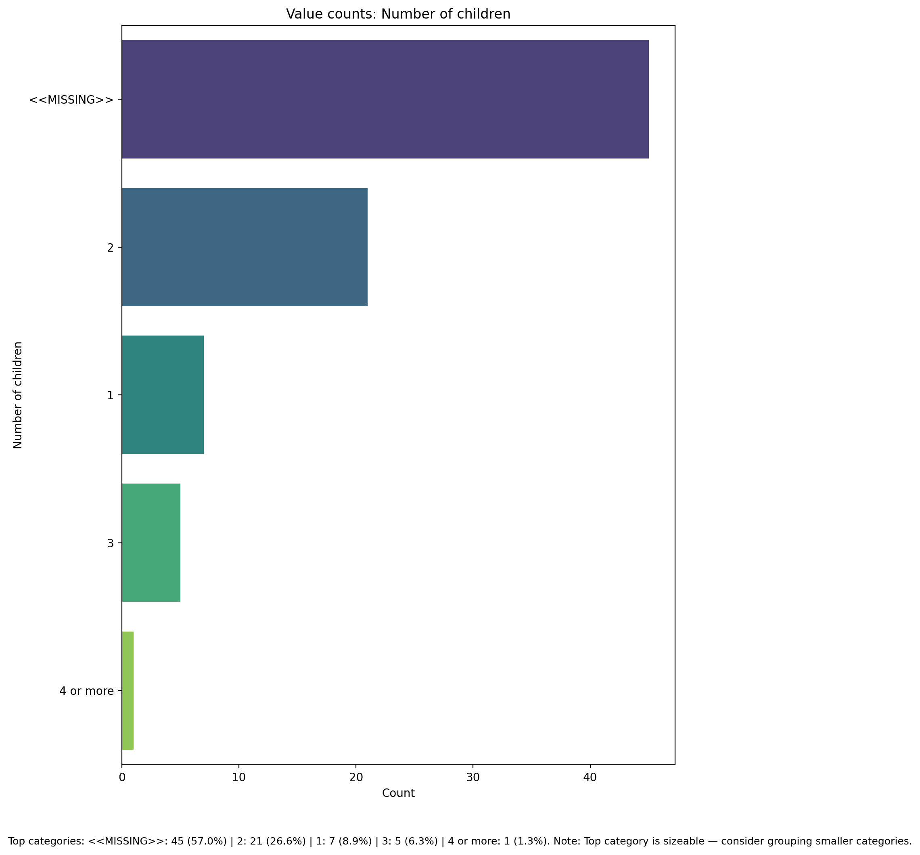

## Type of family structure

Top categories: Nuclear: 45 (57.0%) | Joint: 33 (41.8%) | <<MISSING>>: 1 (1.3%). Note: Top category is sizeable — consider grouping smaller categories.

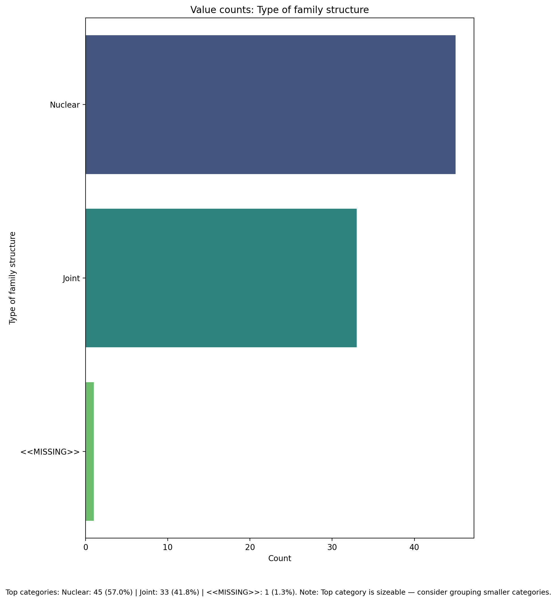

## Monthly household income

Top categories: 50,000 - 100,000 INR per month: 21 (26.6%) | Below 10,000 INR per month : 18 (22.8%) | 10,000 - 30,000 INR per month: 16 (20.3%) | Above 100,000 INR per month: 12 (15.2%) | 30,000 - 50,000 INR per month: 7 (8.9%) | <<MISSING>>: 5 (6.3%). Note: Healthy spread across categories.

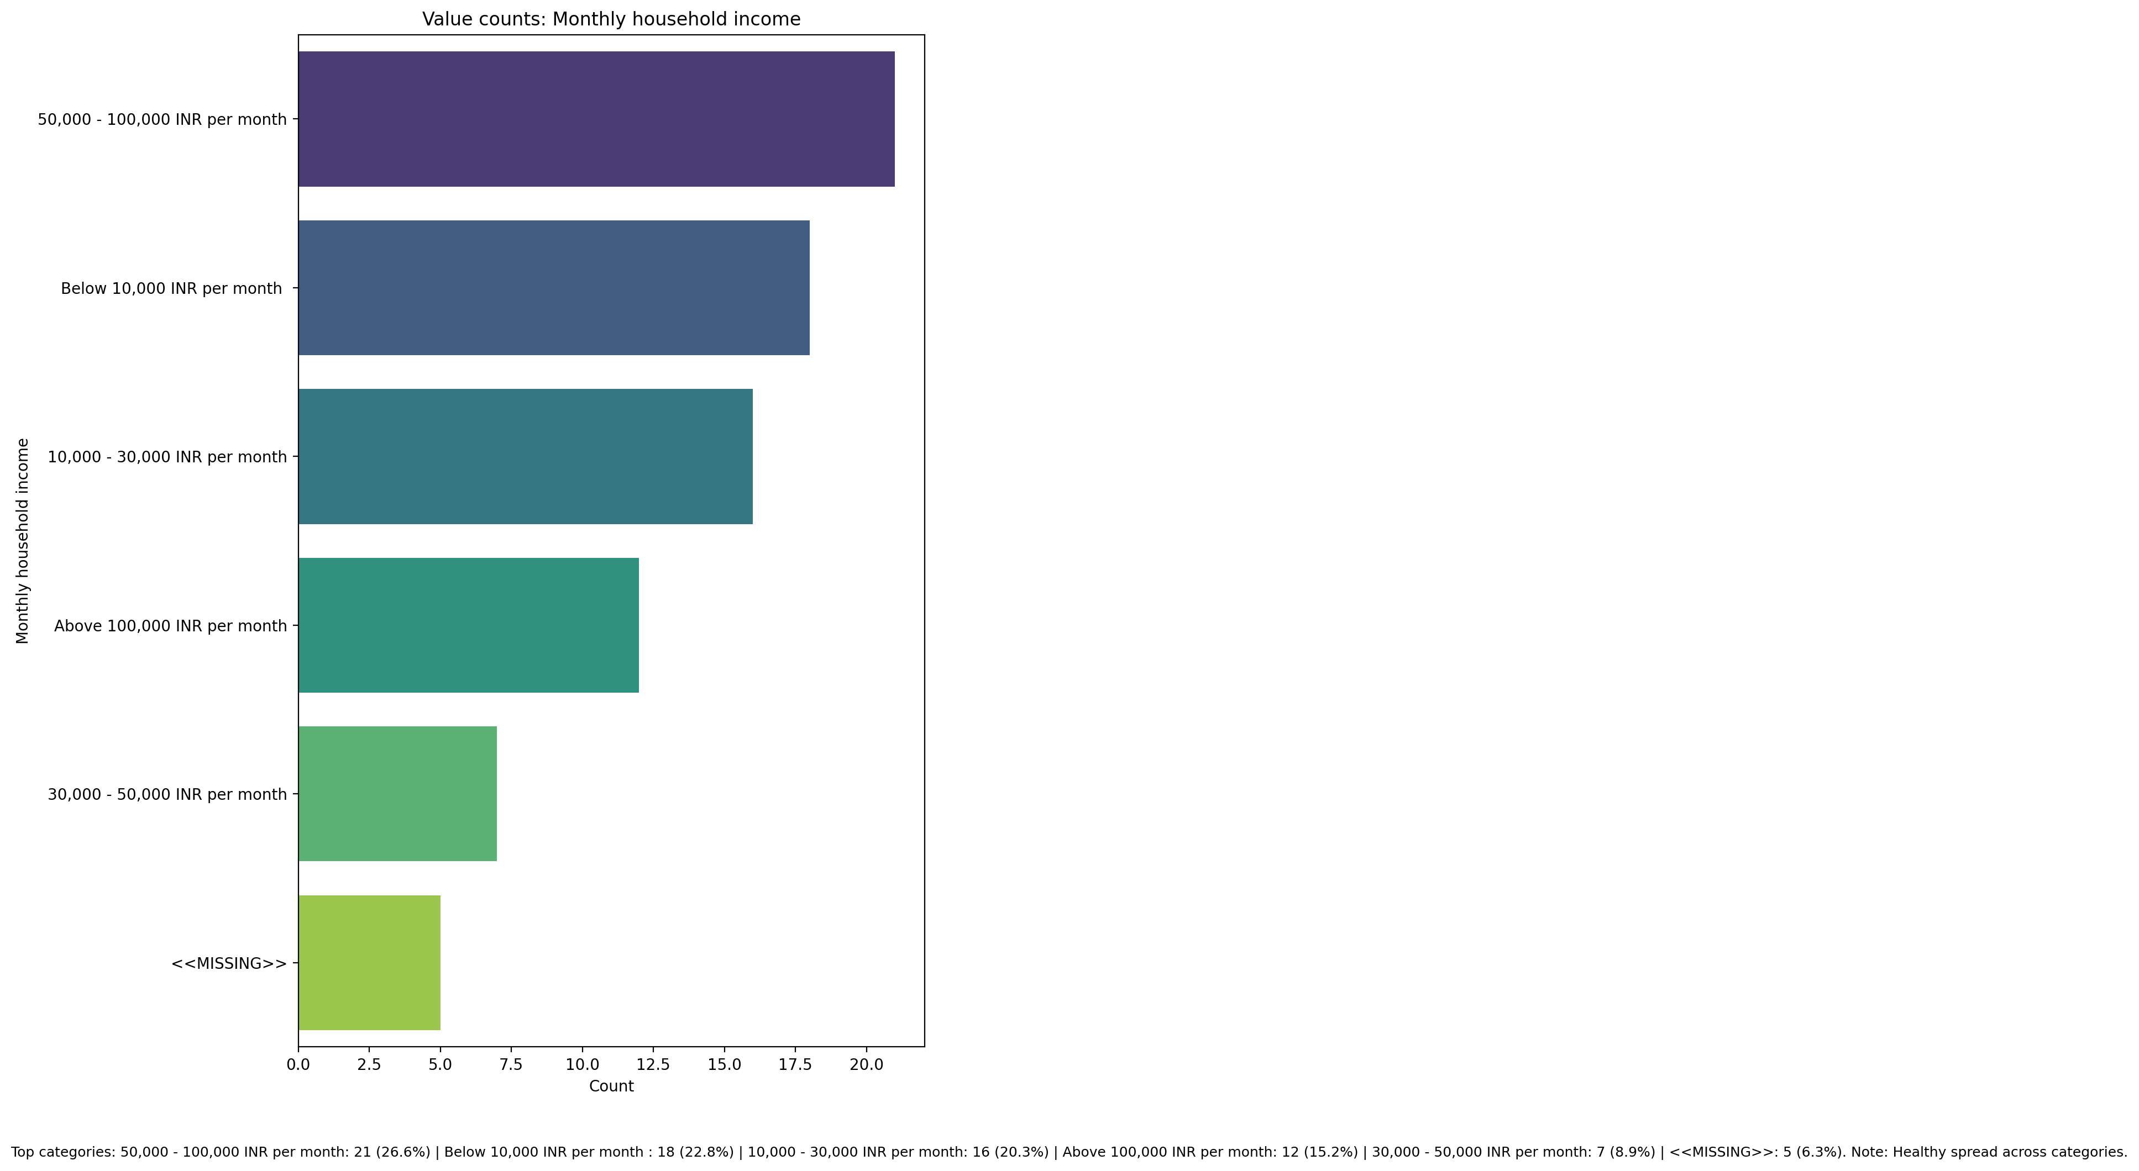

## Access to healthcare services

Top categories: Easily accessible: 59 (74.7%) | Somewhat accessible: 13 (16.5%) | <<MISSING>>: 7 (8.9%). Note: Top category is sizeable — consider grouping smaller categories.

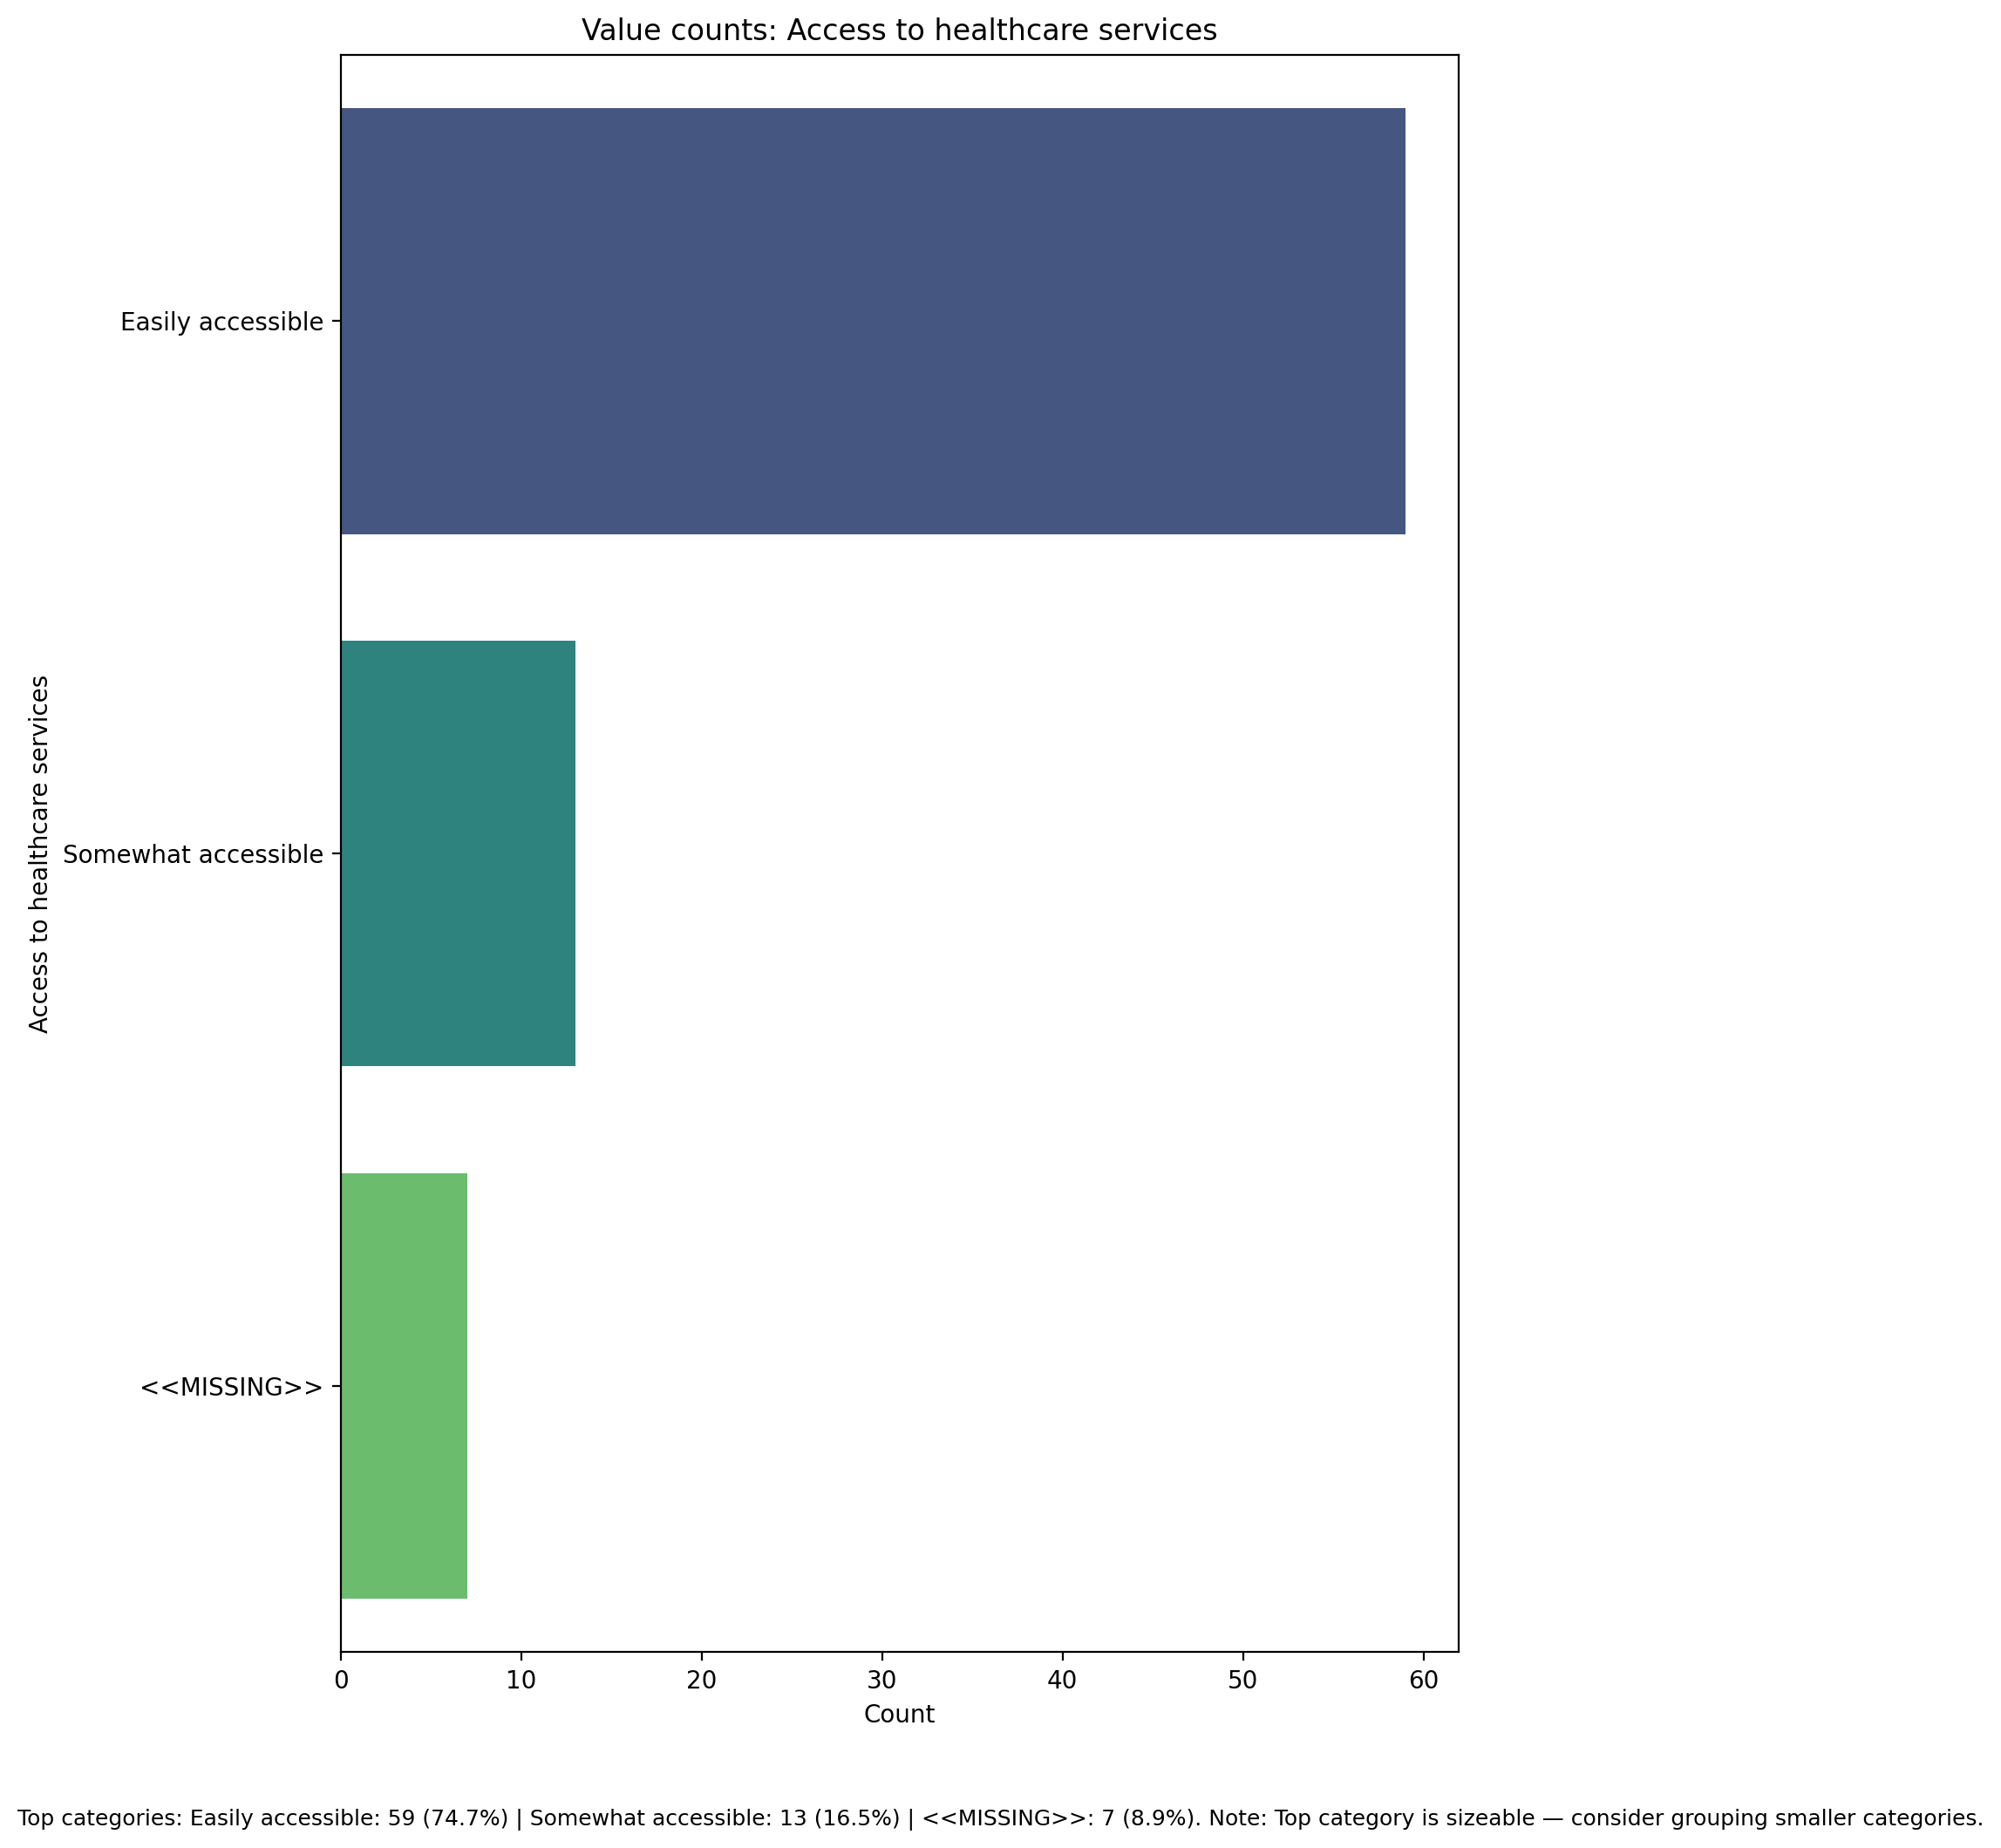

## Overall health status

Top categories: Good: 51 (64.6%) | Excellent: 15 (19.0%) | Fair: 11 (13.9%) | <<MISSING>>: 1 (1.3%) | Poor: 1 (1.3%). Note: Top category is sizeable — consider grouping smaller categories.

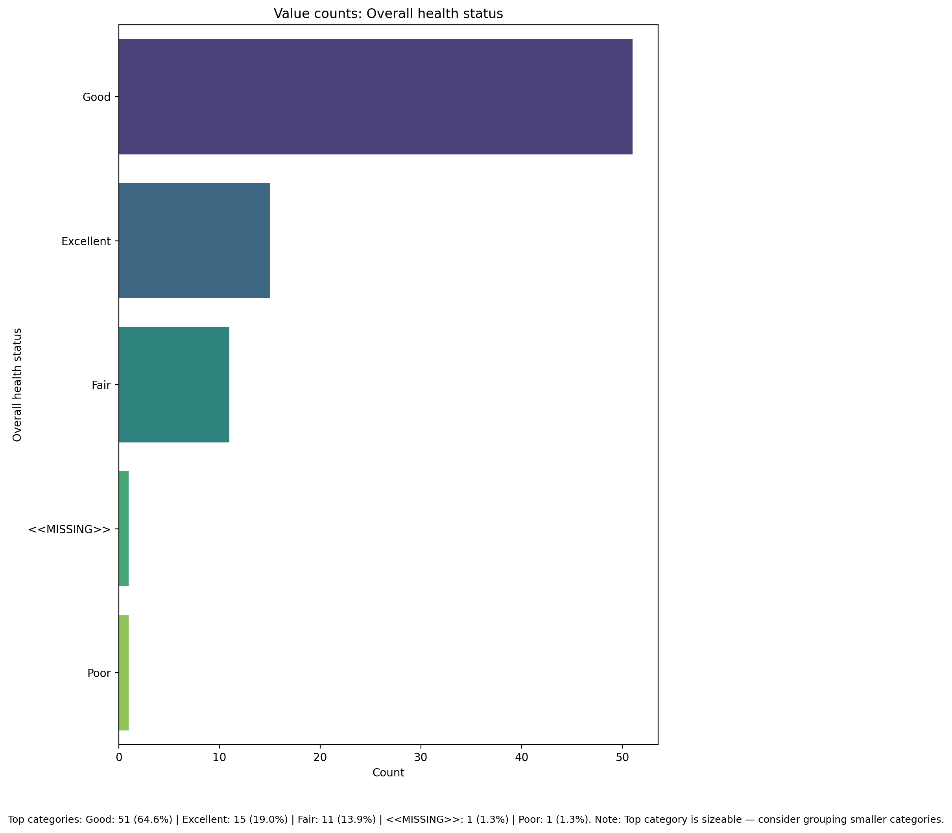

## Are you covered by health insurance?

Top categories: No: 41 (51.9%) | Yes: 34 (43.0%) | <<MISSING>>: 2 (2.5%) | Not sure: 2 (2.5%). Note: Top category is sizeable — consider grouping smaller categories.

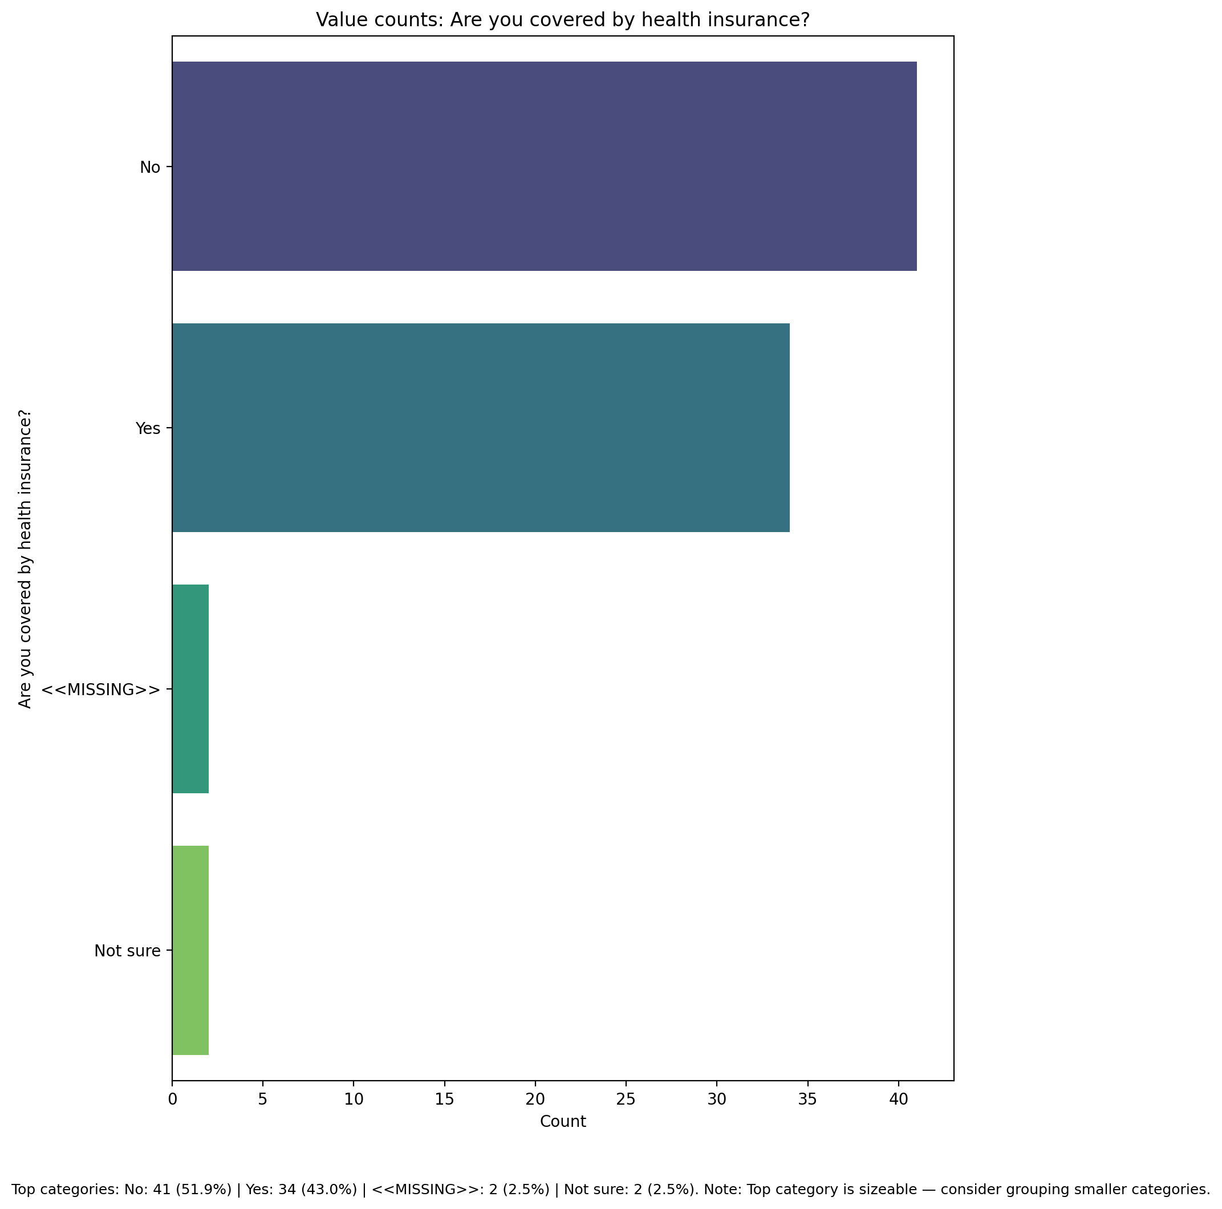

## Participation in community or social activities

Top categories: Occasionally involved: 41 (51.9%) | Actively involved: 20 (25.3%) | Not involved: 16 (20.3%) | <<MISSING>>: 2 (2.5%). Note: Top category is sizeable — consider grouping smaller categories.

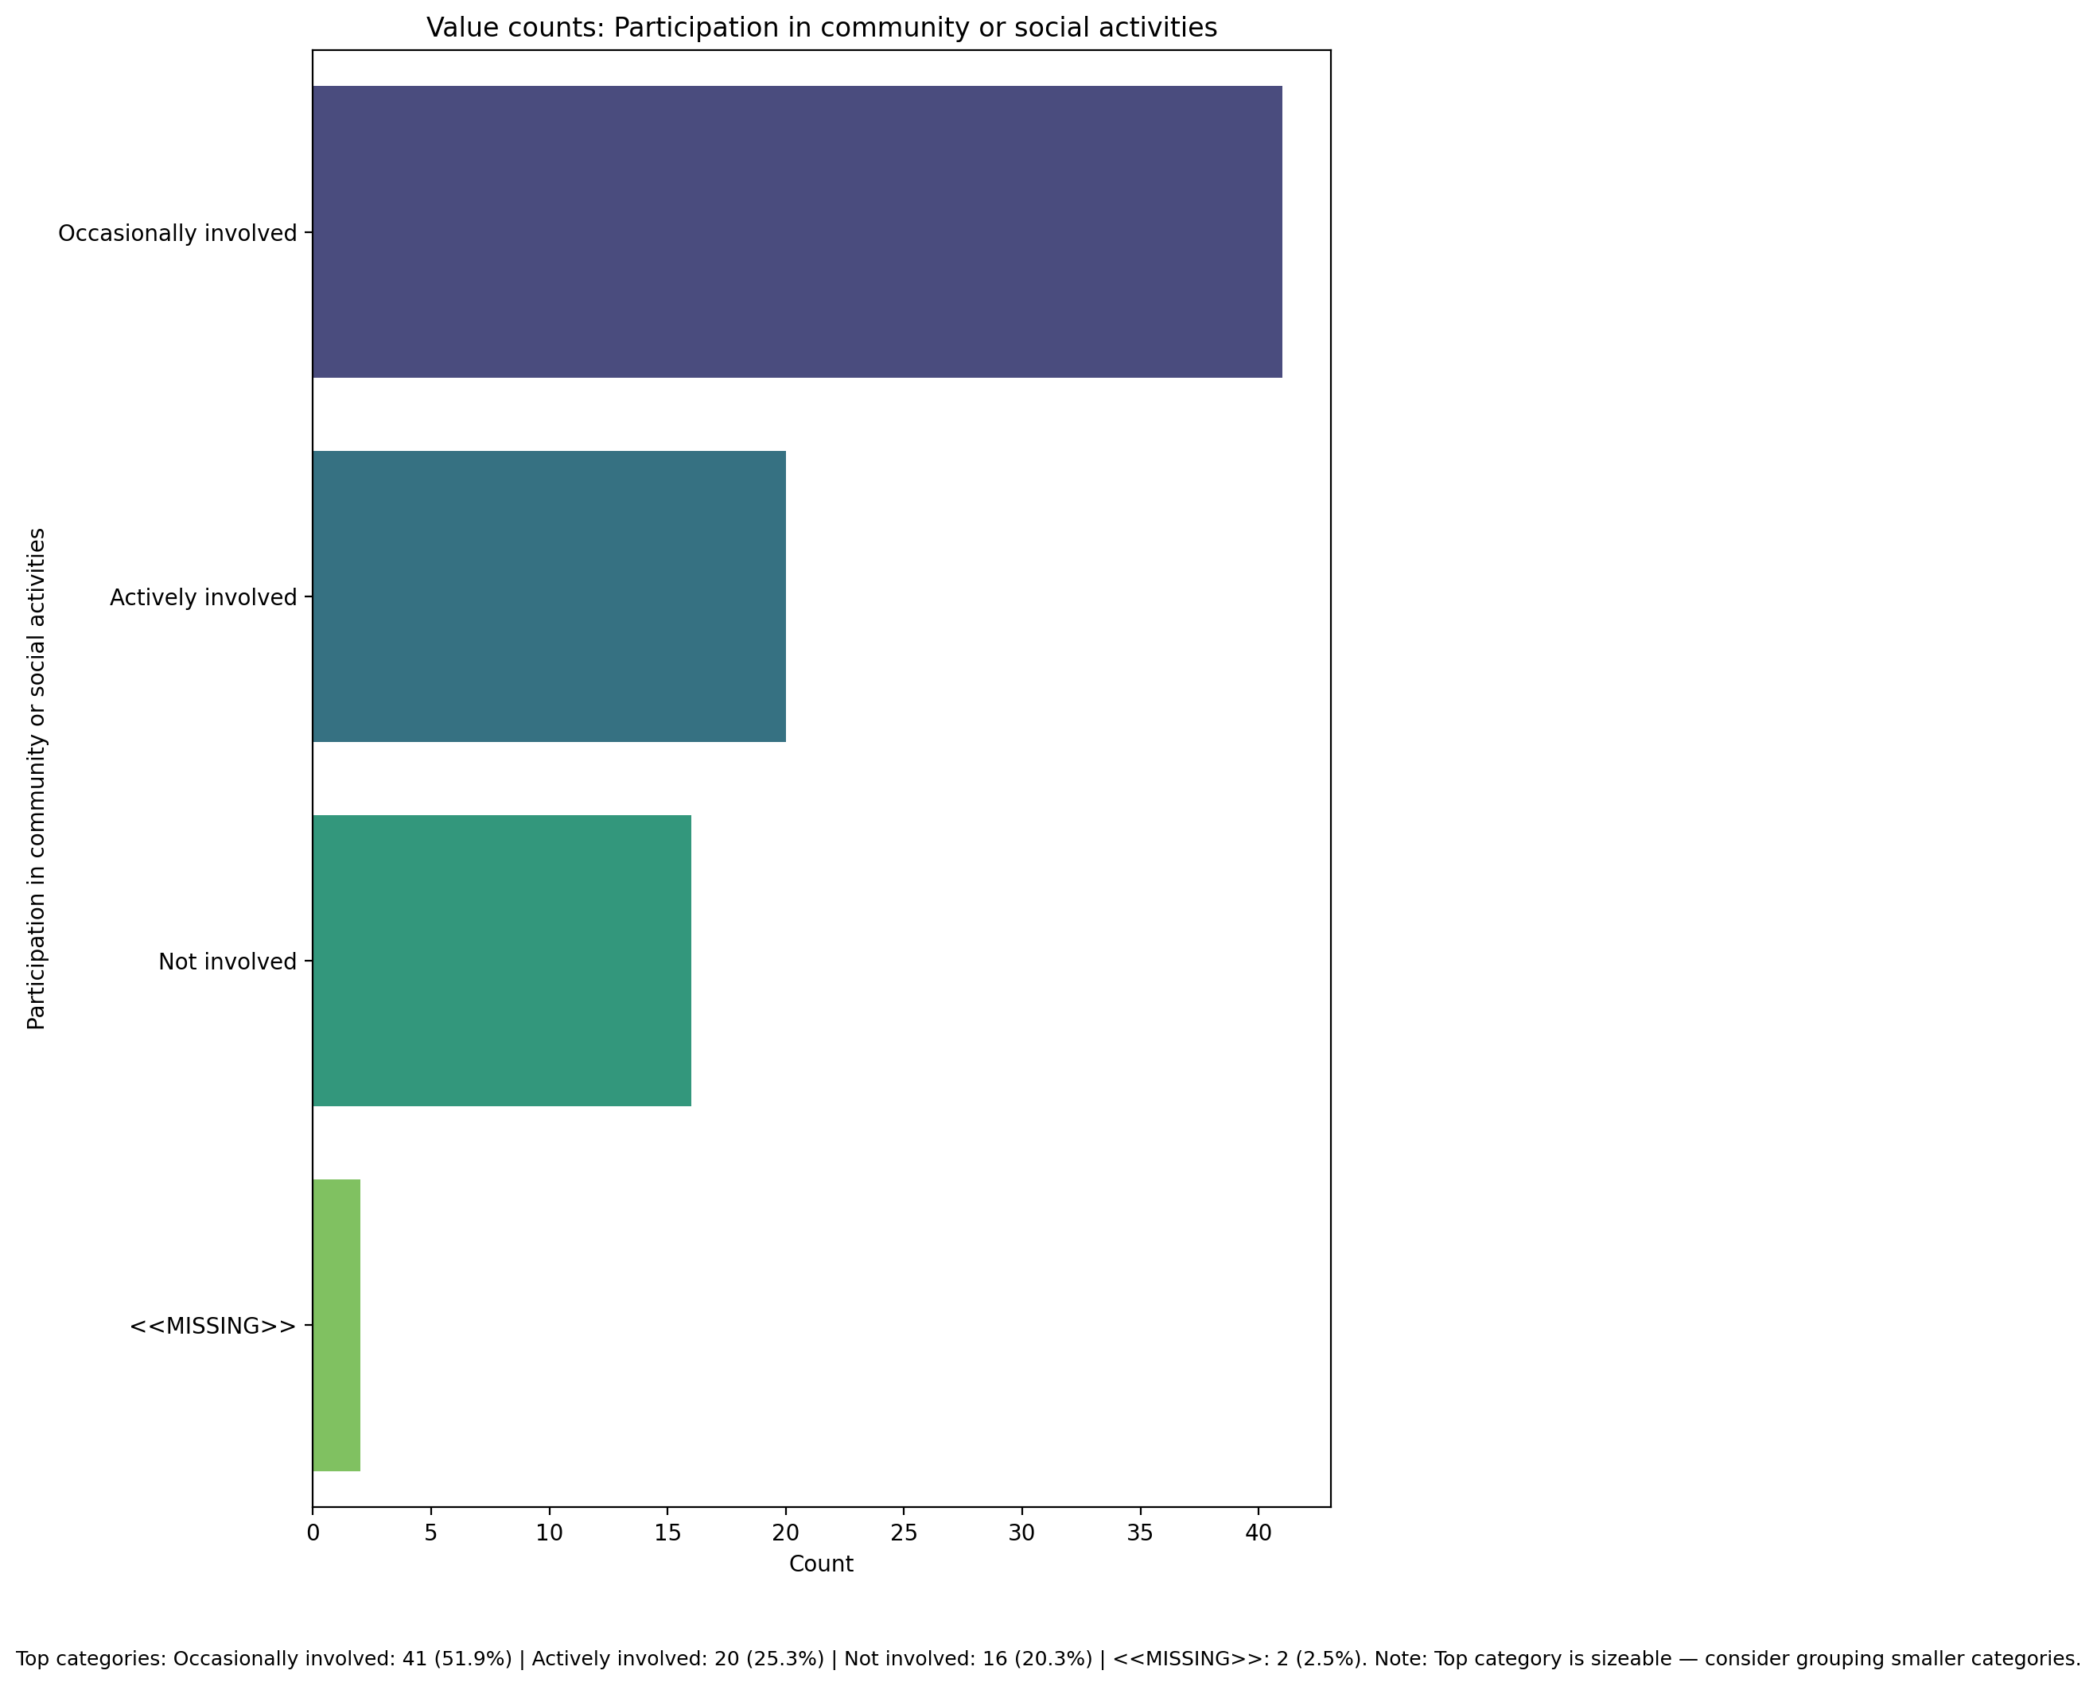

## Functional Impairment - Raw Score

Count=78; mean=12.86; median=11.50; std=5.58; min=7.00; max=30.00; outliers=0 (0.0%). Skewness=0.83.

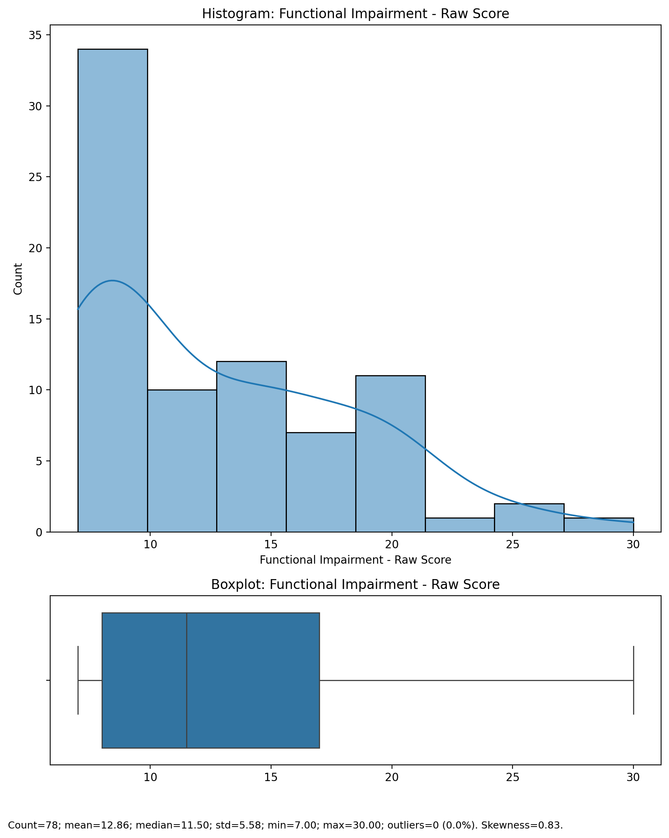

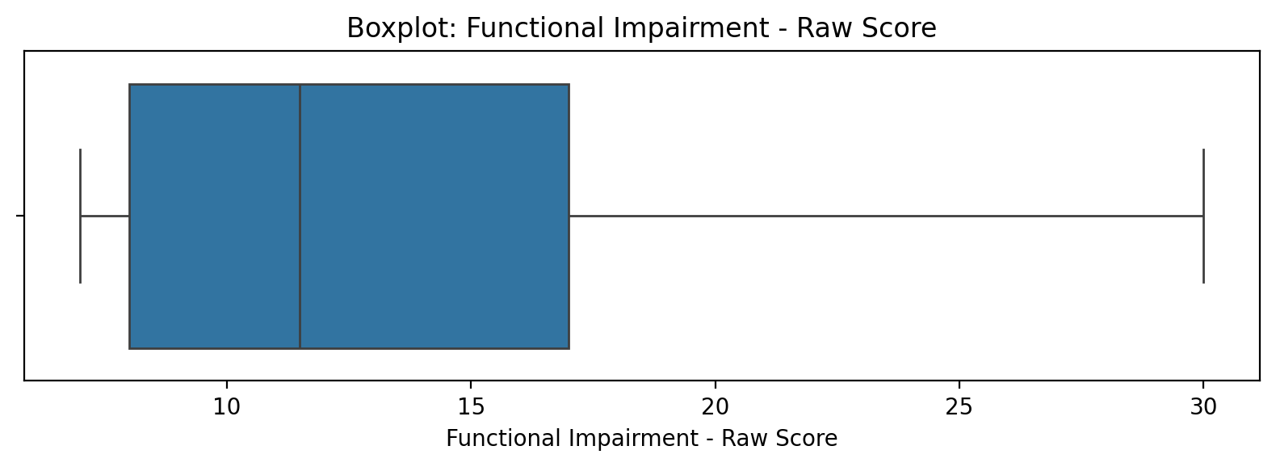

## Functional Impairment - Raw Score

Top categories: Occasionally involved: 41 (51.9%) | Actively involved: 20 (25.3%) | Not involved: 16 (20.3%) | <<MISSING>>: 2 (2.5%). Note: Top category is sizeable — consider grouping smaller categories.



## Withdrawl - Raw Score

Count=78; mean=23.86; median=22.00; std=9.70; min=7.00; max=53.00; outliers=1 (1.3%). Skewness=0.96.

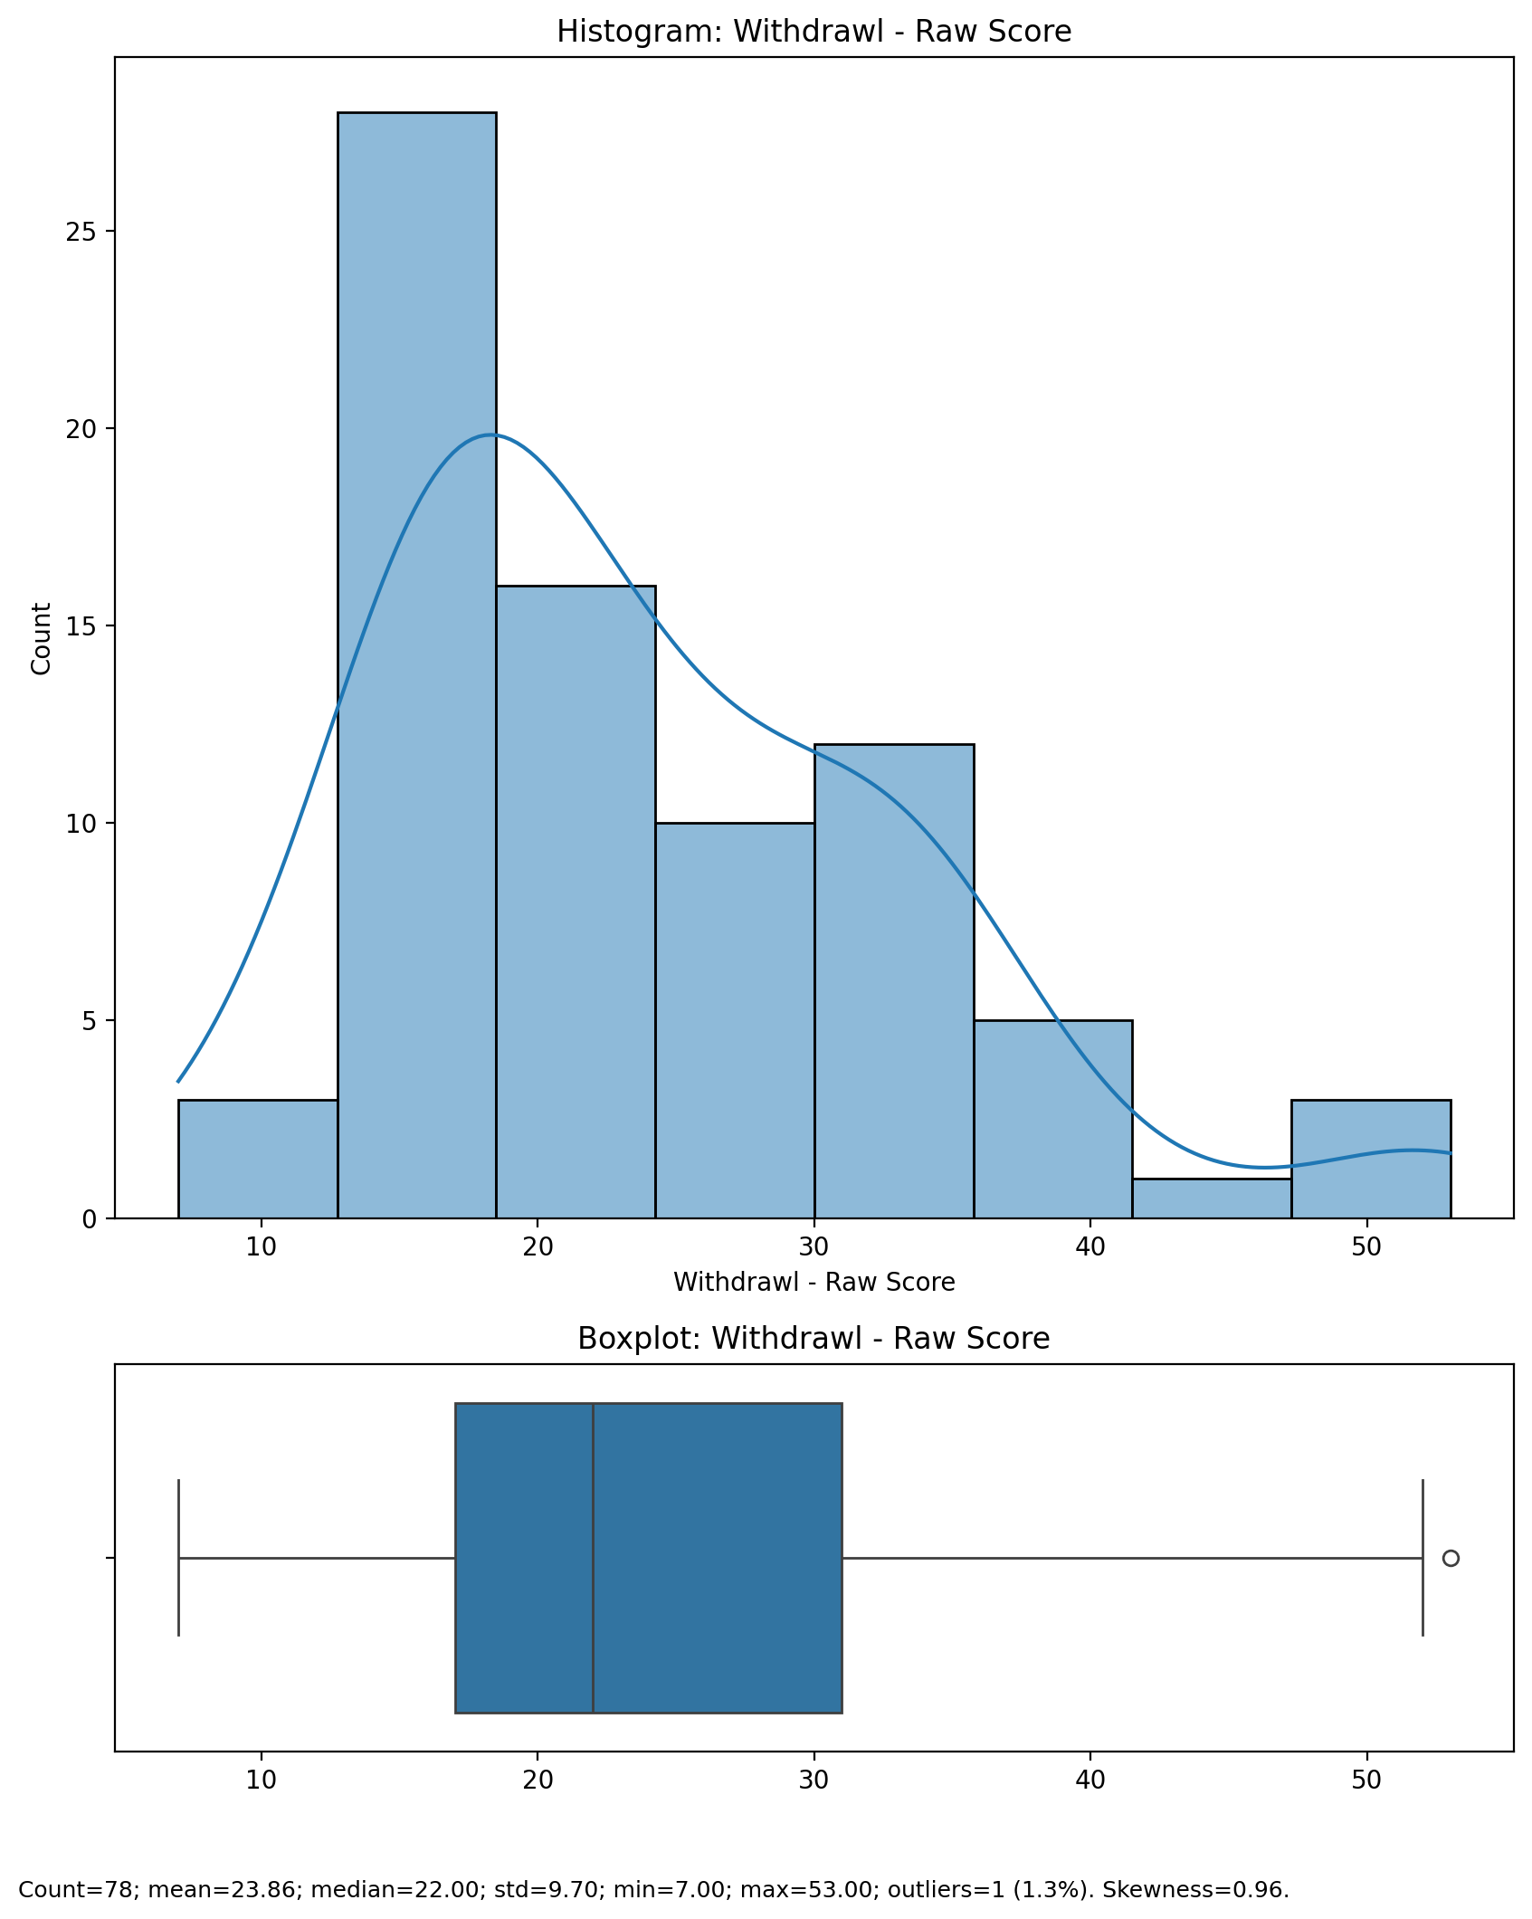

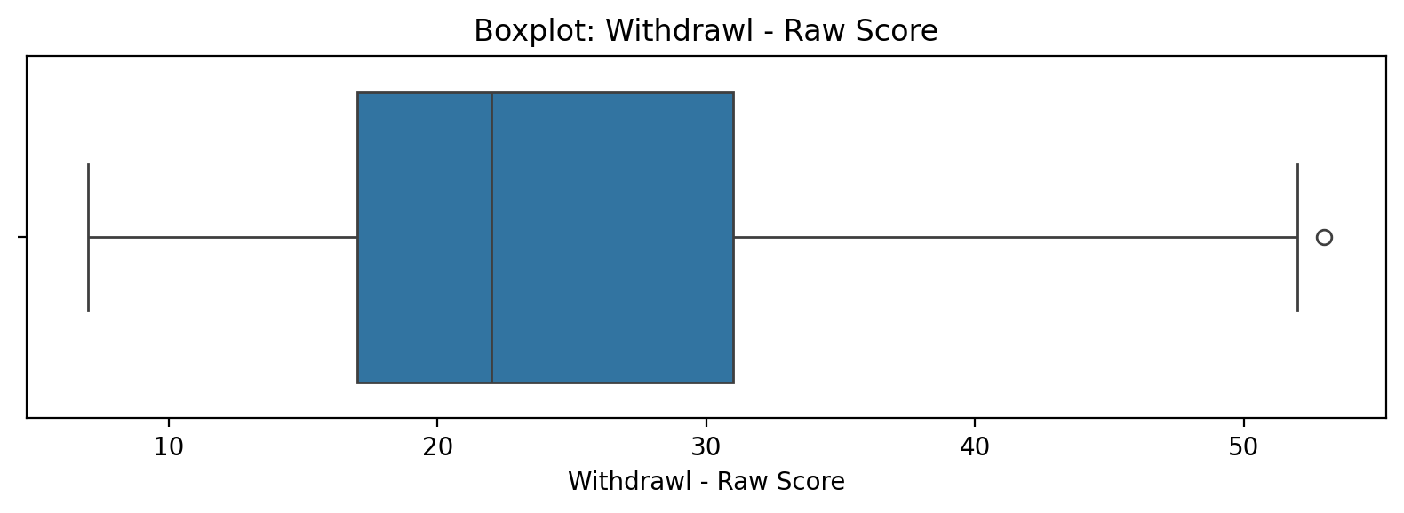

## Withdrawl - Raw Score

Top categories: Occasionally involved: 41 (51.9%) | Actively involved: 20 (25.3%) | Not involved: 16 (20.3%) | <<MISSING>>: 2 (2.5%). Note: Top category is sizeable — consider grouping smaller categories.



## Occupational & Relationship Consequences - Raw Score

Count=78; mean=6.32; median=5.00; std=3.18; min=1.00; max=16.00; outliers=2 (2.6%). Skewness=1.20.

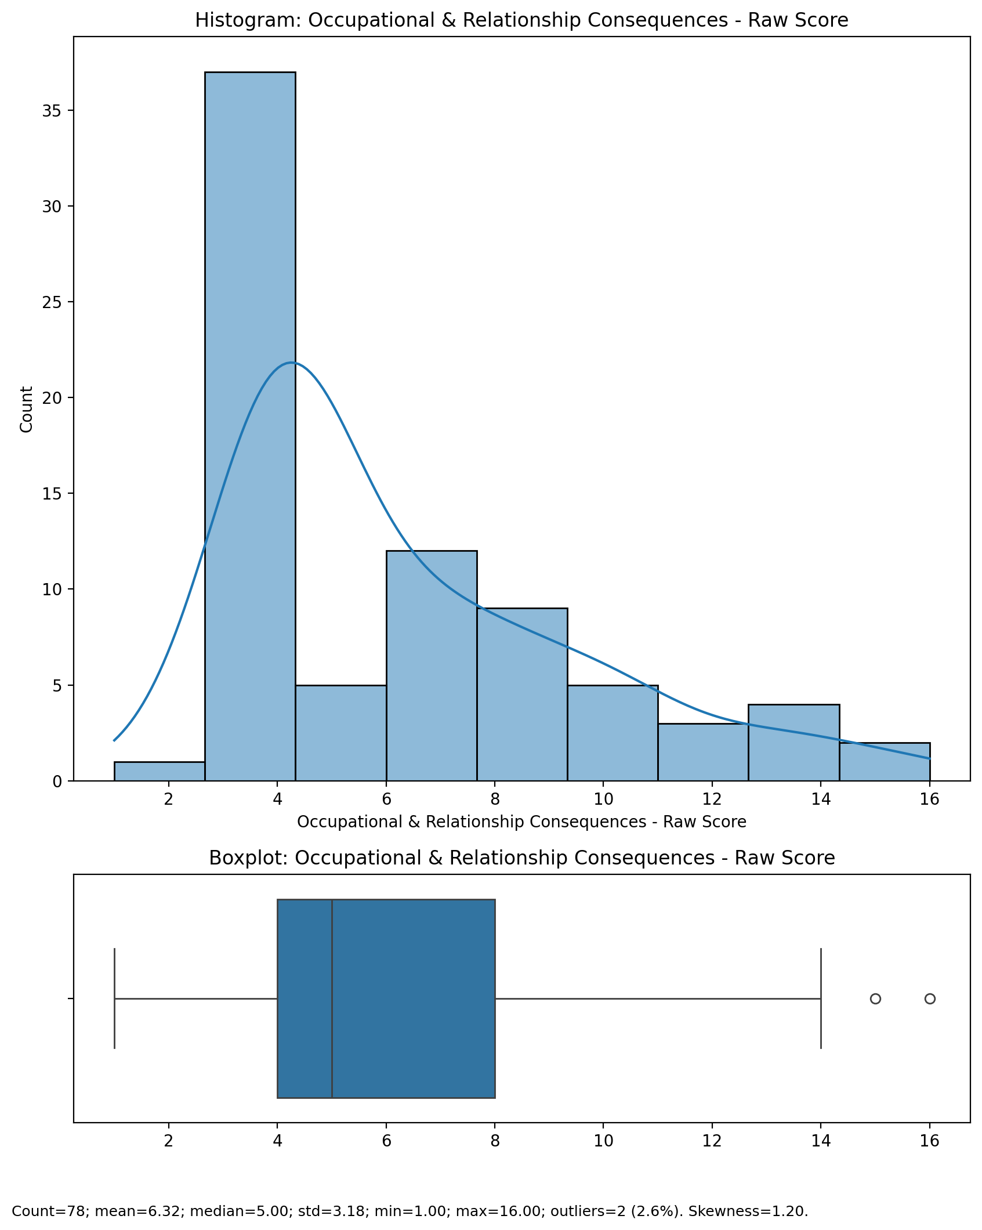

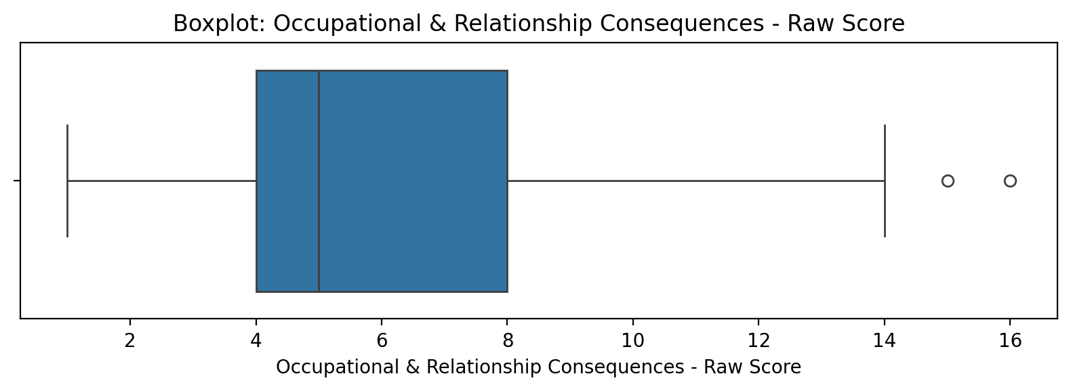

## Occupational & Relationship Consequences - Raw Score

Top categories: Occasionally involved: 41 (51.9%) | Actively involved: 20 (25.3%) | Not involved: 16 (20.3%) | <<MISSING>>: 2 (2.5%). Note: Top category is sizeable — consider grouping smaller categories.



## Compulsive Behaviour - Raw Score

Count=78; mean=6.31; median=6.00; std=2.98; min=2.00; max=14.00; outliers=0 (0.0%). Skewness=0.67.

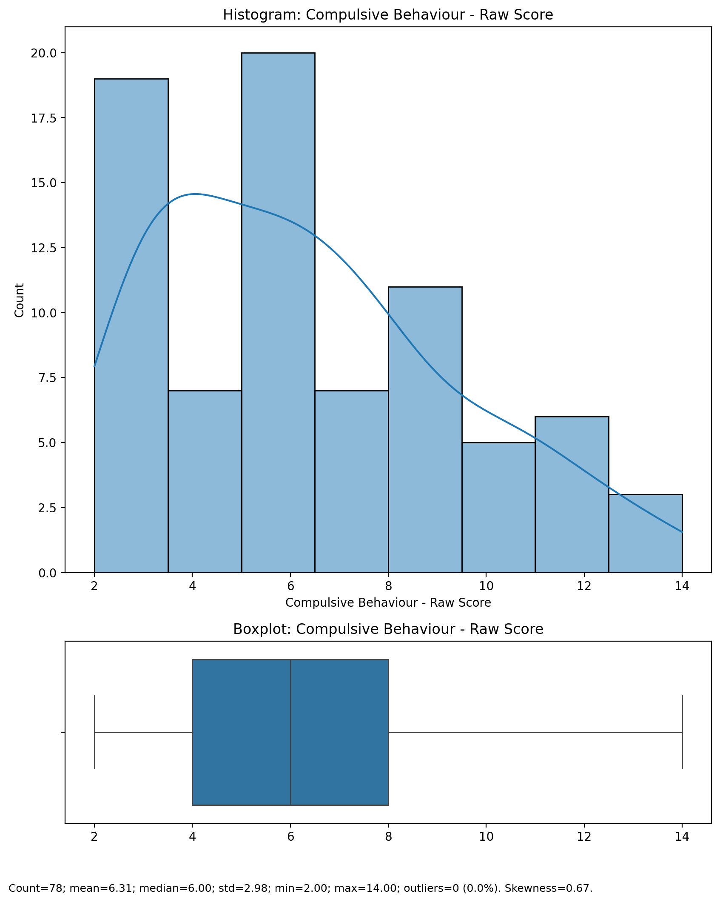

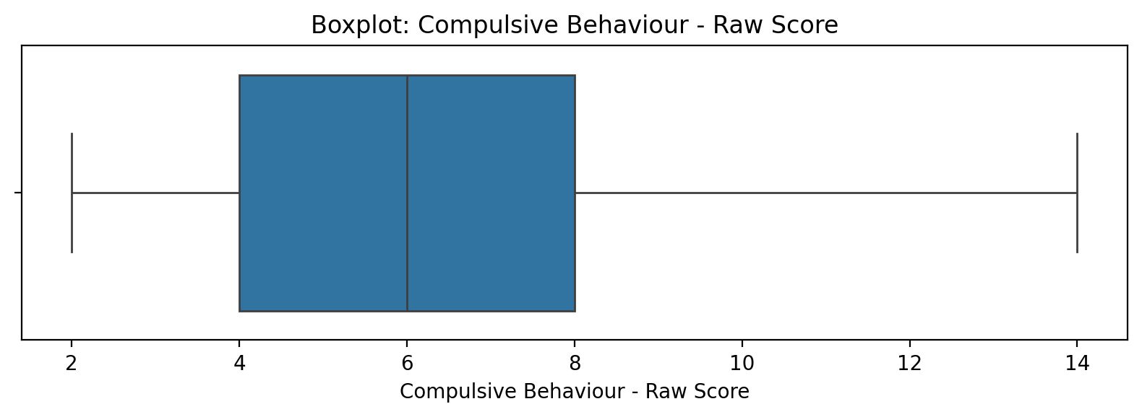

## Compulsive Behaviour - Raw Score

Top categories: Occasionally involved: 41 (51.9%) | Actively involved: 20 (25.3%) | Not involved: 16 (20.3%) | <<MISSING>>: 2 (2.5%). Note: Top category is sizeable — consider grouping smaller categories.



## Obsession with Internet - Raw Score

Count=78; mean=7.51; median=7.00; std=2.98; min=3.00; max=13.00; outliers=0 (0.0%). Skewness=0.24.

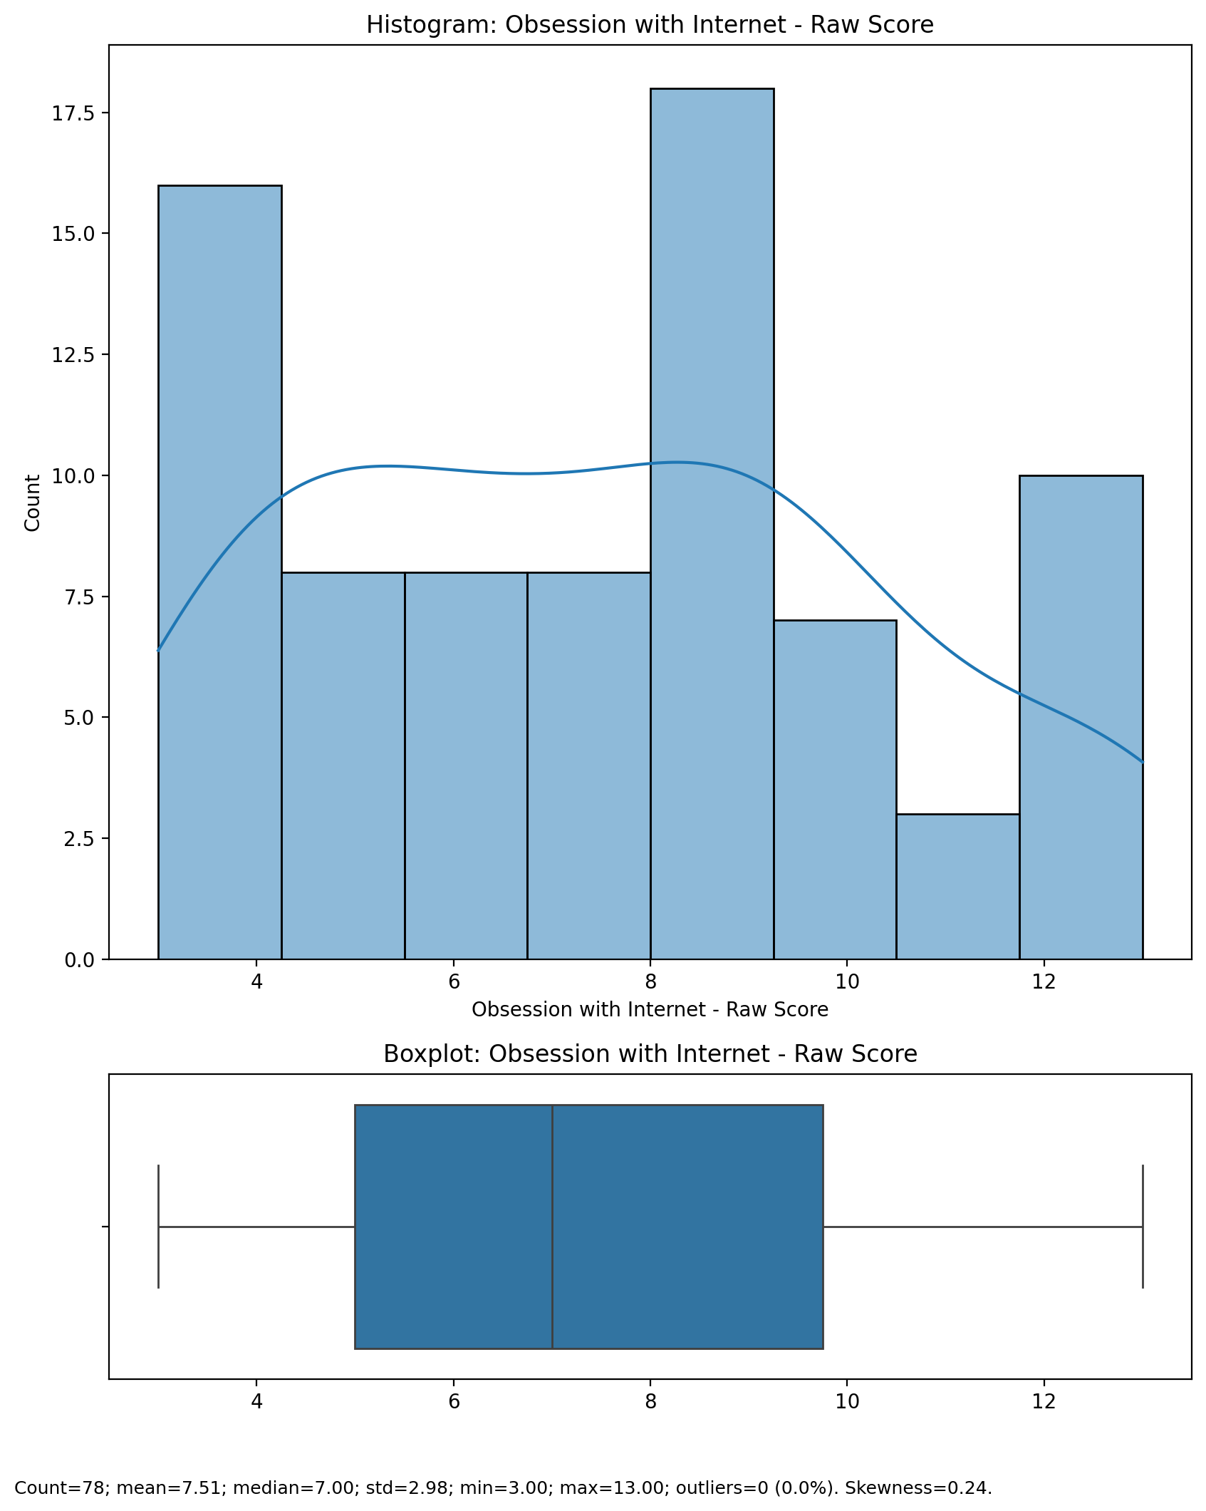

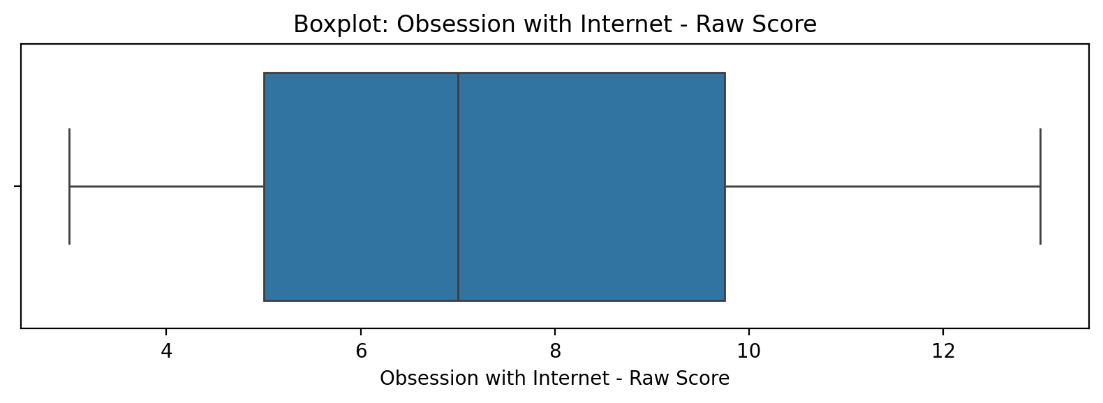

## Obsession with Internet - Raw Score

Top categories: Occasionally involved: 41 (51.9%) | Actively involved: 20 (25.3%) | Not involved: 16 (20.3%) | <<MISSING>>: 2 (2.5%). Note: Top category is sizeable — consider grouping smaller categories.



## Internet as a Source of Recreation - Raw Score

Count=78; mean=6.41; median=6.00; std=2.42; min=3.00; max=13.00; outliers=0 (0.0%). Skewness=0.52.

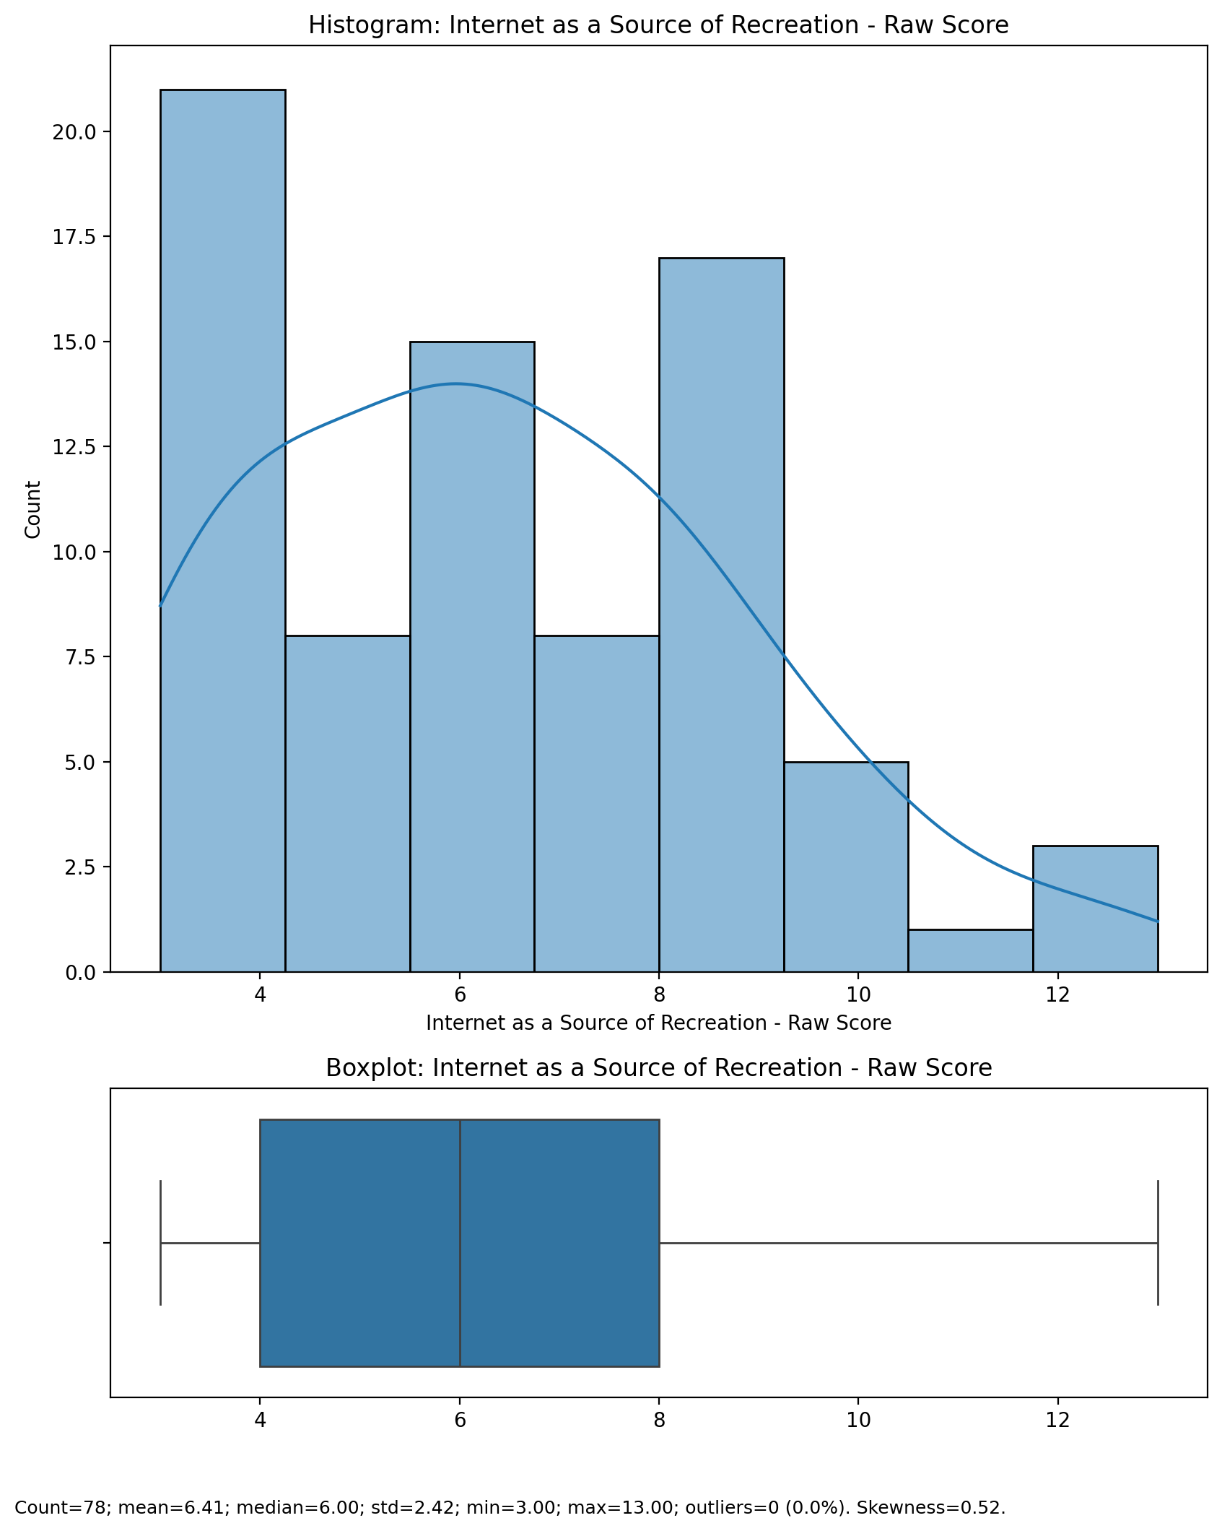

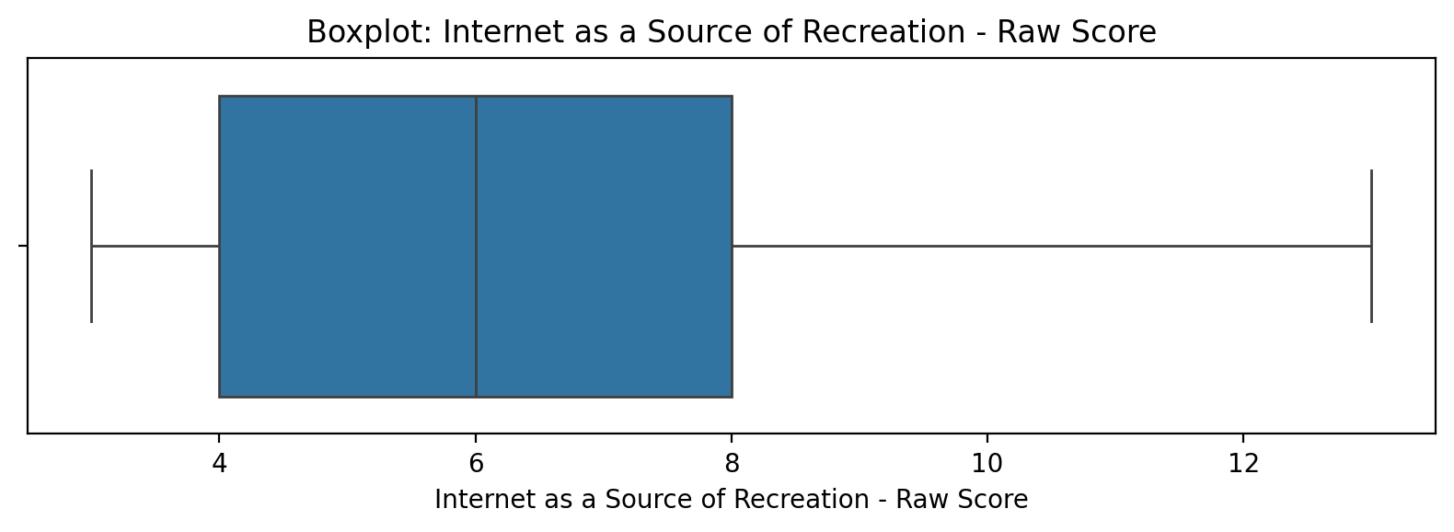

## Internet as a Source of Recreation - Raw Score

Top categories: Occasionally involved: 41 (51.9%) | Actively involved: 20 (25.3%) | Not involved: 16 (20.3%) | <<MISSING>>: 2 (2.5%). Note: Top category is sizeable — consider grouping smaller categories.



## Enhanced Socialization - Raw Score

Count=78; mean=6.50; median=6.00; std=2.89; min=3.00; max=13.00; outliers=0 (0.0%). Skewness=0.47.

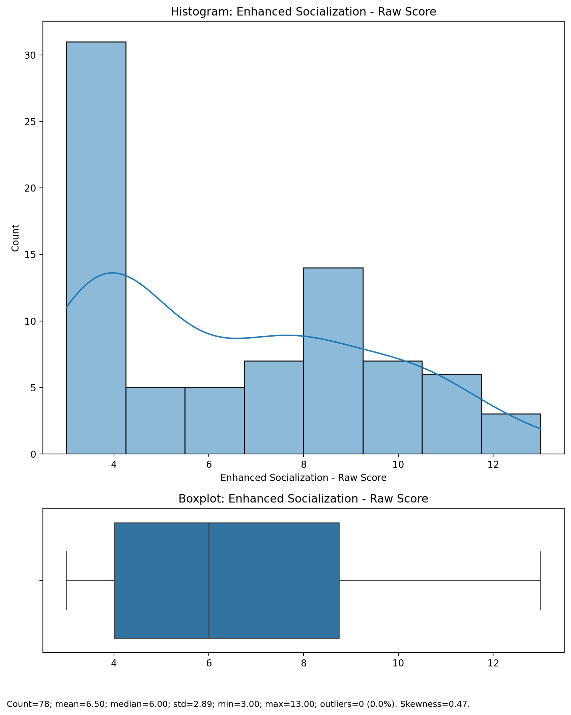

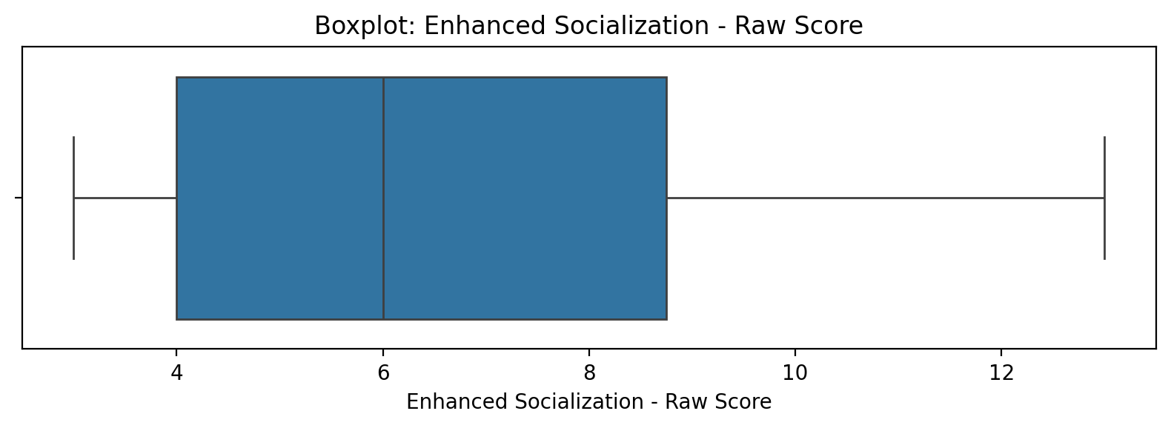

## Enhanced Socialization - Raw Score

Top categories: Occasionally involved: 41 (51.9%) | Actively involved: 20 (25.3%) | Not involved: 16 (20.3%) | <<MISSING>>: 2 (2.5%). Note: Top category is sizeable — consider grouping smaller categories.



## Perceived Control of Internet Use - Raw Score

Count=78; mean=4.28; median=4.00; std=2.61; min=2.00; max=10.00; outliers=0 (0.0%). Skewness=0.88.

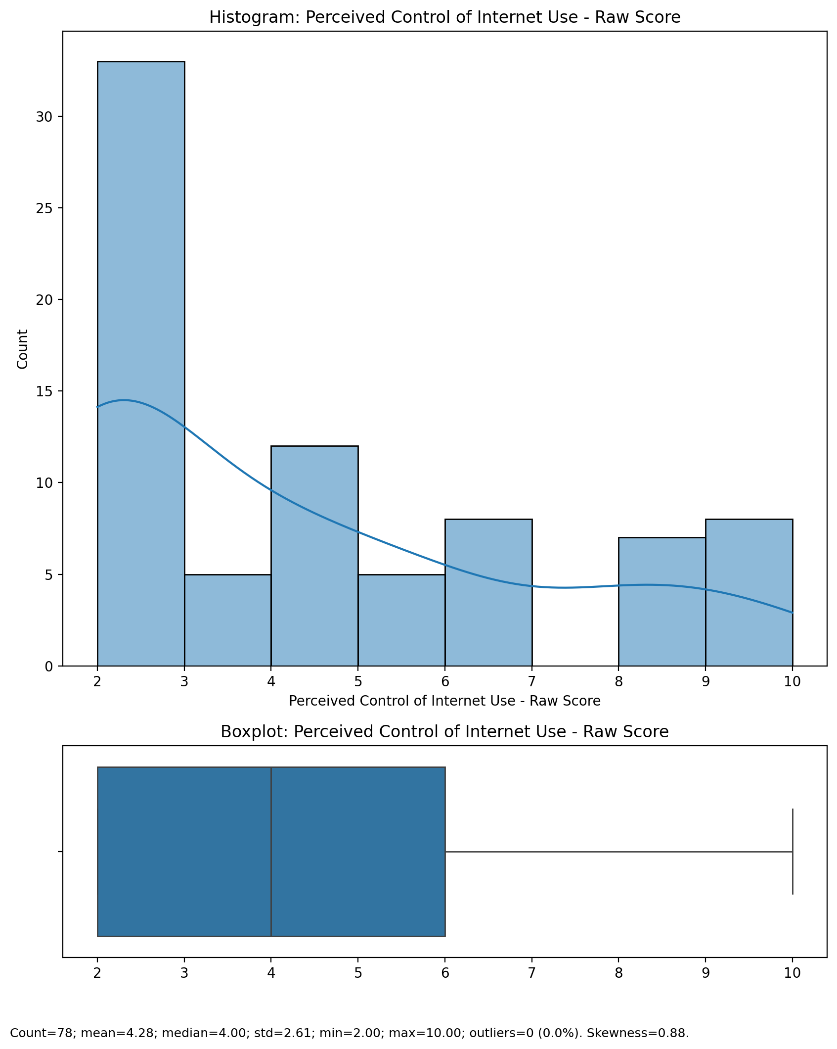

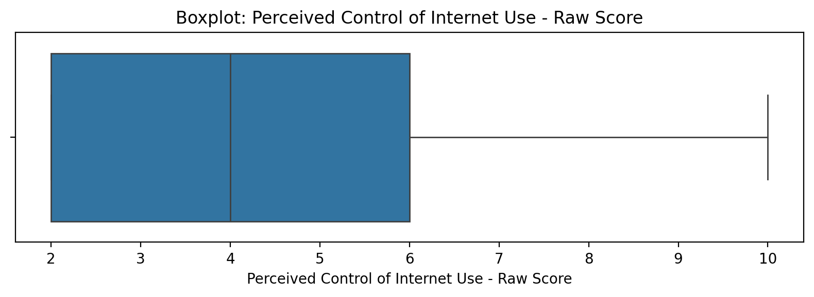

## Perceived Control of Internet Use - Raw Score

Top categories: Occasionally involved: 41 (51.9%) | Actively involved: 20 (25.3%) | Not involved: 16 (20.3%) | <<MISSING>>: 2 (2.5%). Note: Top category is sizeable — consider grouping smaller categories.



## Functional Impairment - Weighted Score

Count=78; mean=1.80; median=1.61; std=0.78; min=0.98; max=4.20; outliers=0 (0.0%). Skewness=0.83.

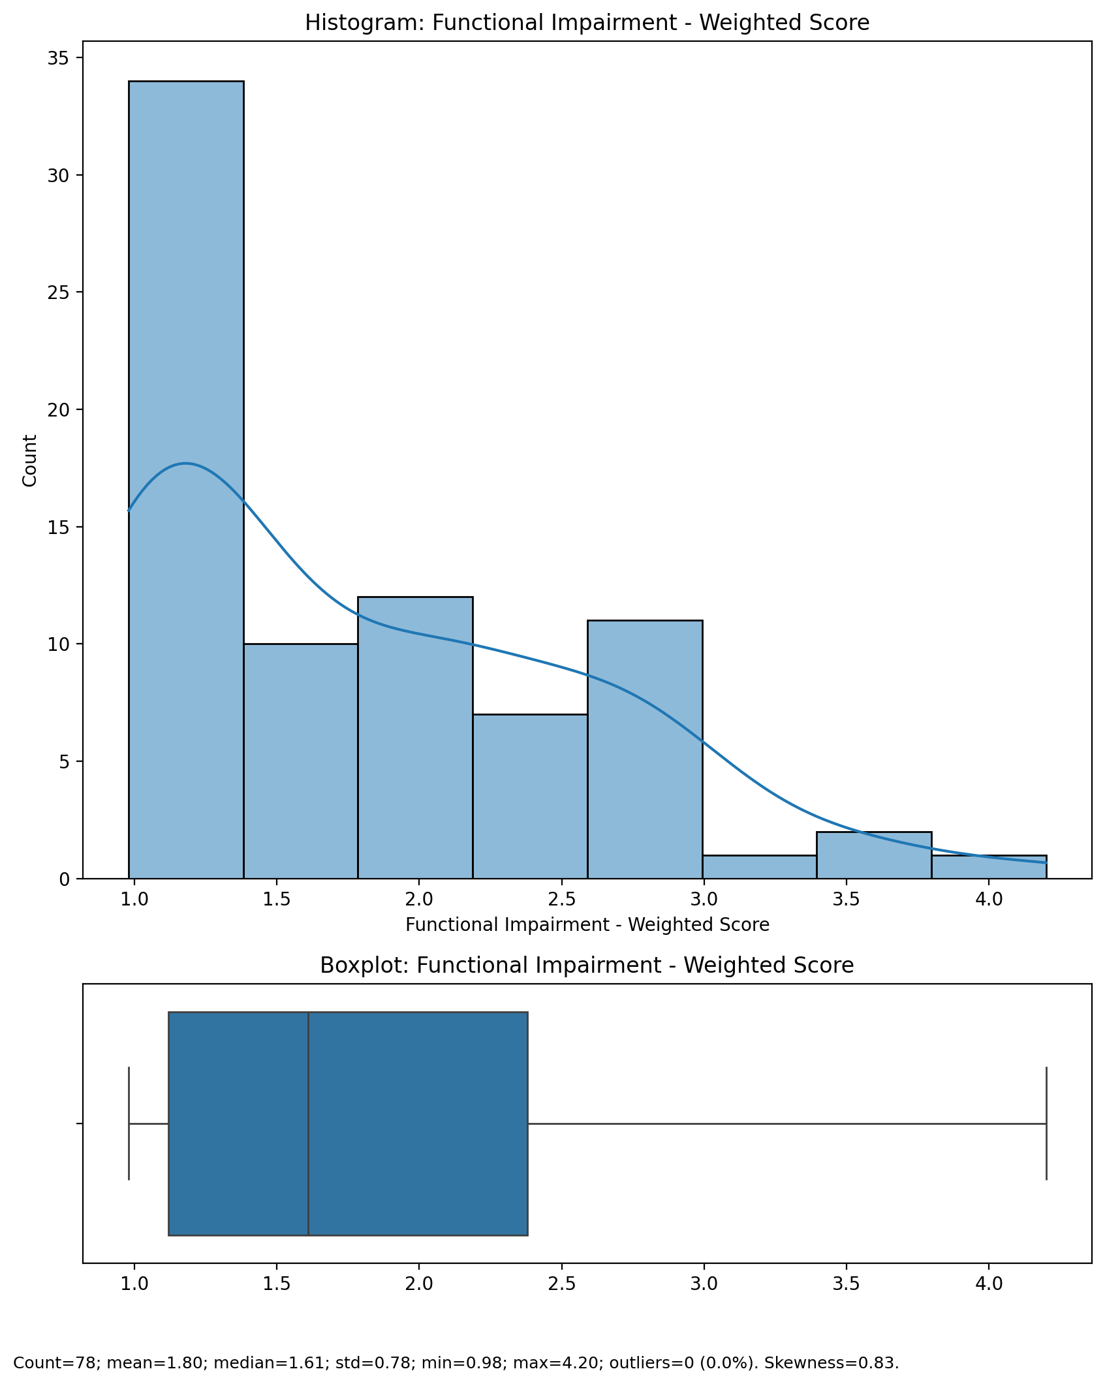

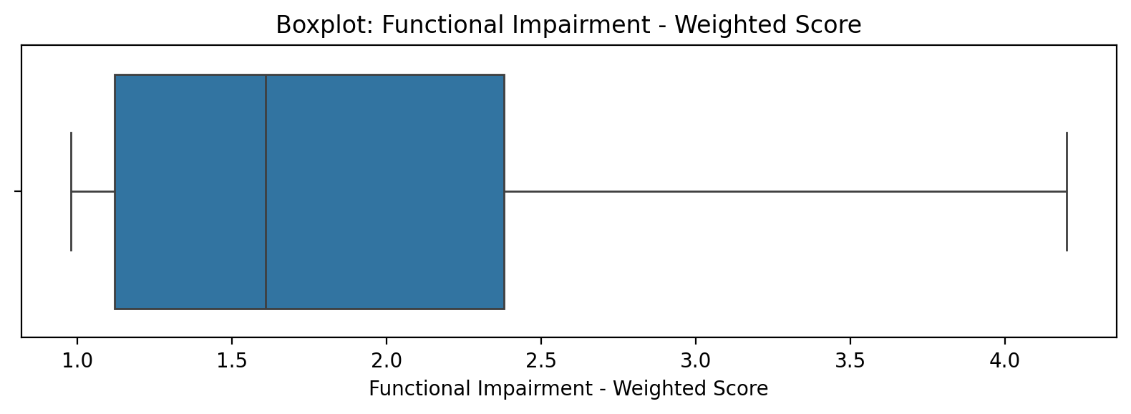

## Functional Impairment - Weighted Score

Top categories: Occasionally involved: 41 (51.9%) | Actively involved: 20 (25.3%) | Not involved: 16 (20.3%) | <<MISSING>>: 2 (2.5%). Note: Top category is sizeable — consider grouping smaller categories.



## Withdrawl - Weighted Score

Count=78; mean=7.87; median=7.26; std=3.20; min=2.31; max=17.49; outliers=1 (1.3%). Skewness=0.96.

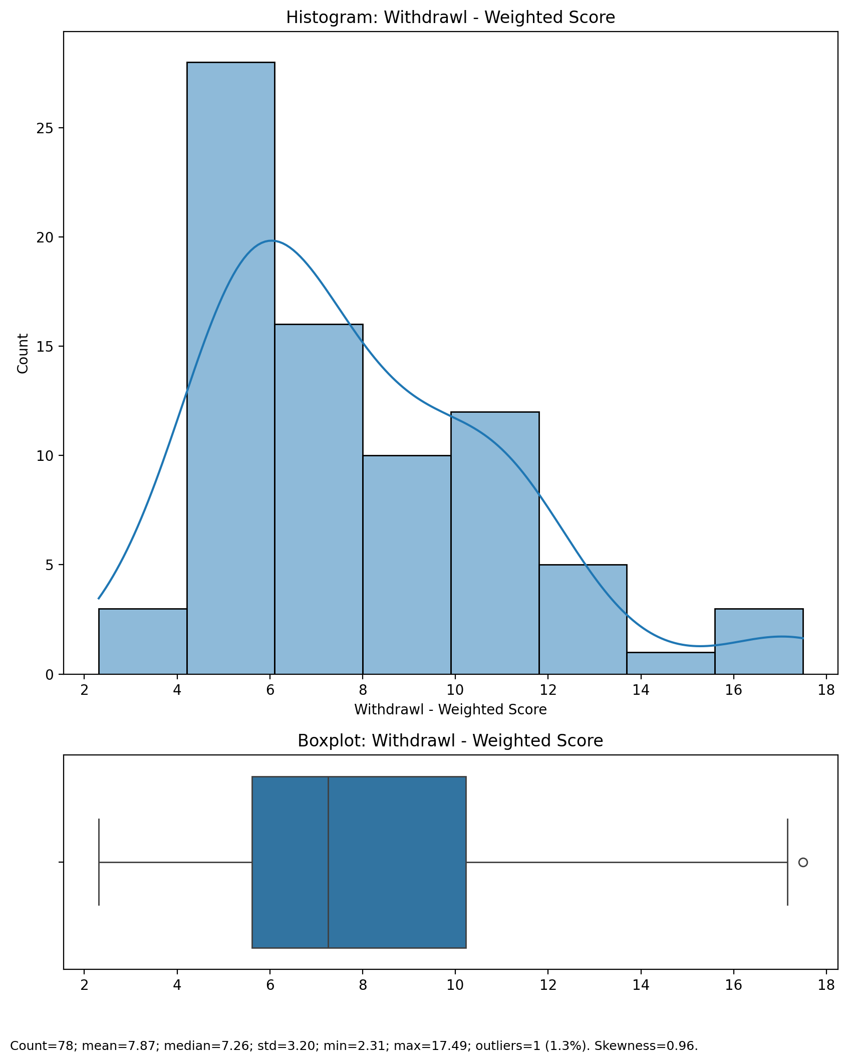

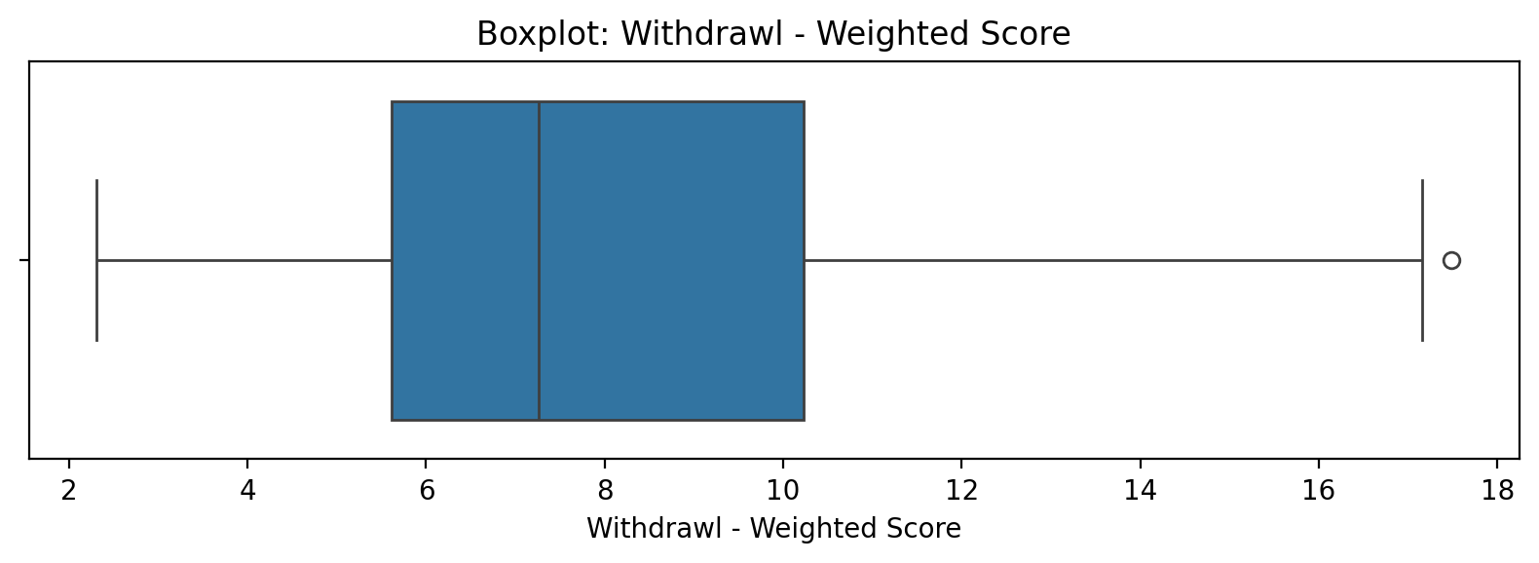

## Withdrawl - Weighted Score

Top categories: Occasionally involved: 41 (51.9%) | Actively involved: 20 (25.3%) | Not involved: 16 (20.3%) | <<MISSING>>: 2 (2.5%). Note: Top category is sizeable — consider grouping smaller categories.



## Occupational & Relationship Consequences - Weighted Score

Count=78; mean=0.63; median=0.50; std=0.32; min=0.10; max=1.60; outliers=2 (2.6%). Skewness=1.20.

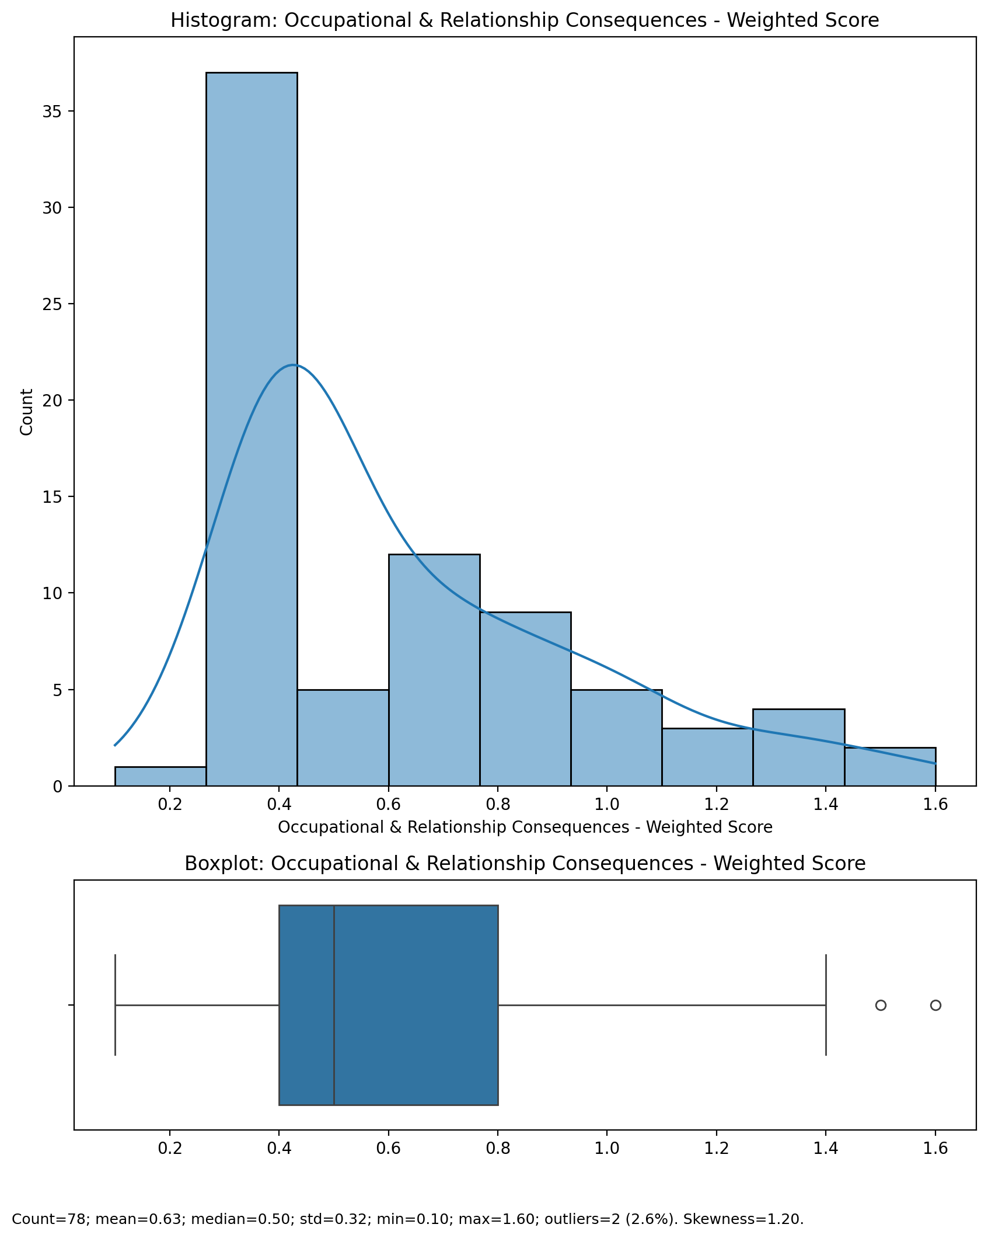

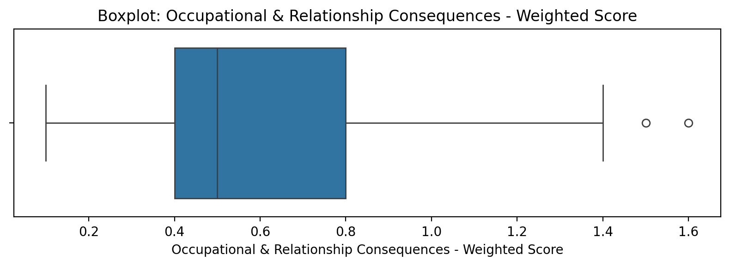

## Occupational & Relationship Consequences - Weighted Score

Top categories: Occasionally involved: 41 (51.9%) | Actively involved: 20 (25.3%) | Not involved: 16 (20.3%) | <<MISSING>>: 2 (2.5%). Note: Top category is sizeable — consider grouping smaller categories.



## Compulsive Behaviour - Weighted Score

Count=78; mean=0.50; median=0.48; std=0.24; min=0.16; max=1.12; outliers=0 (0.0%). Skewness=0.67.

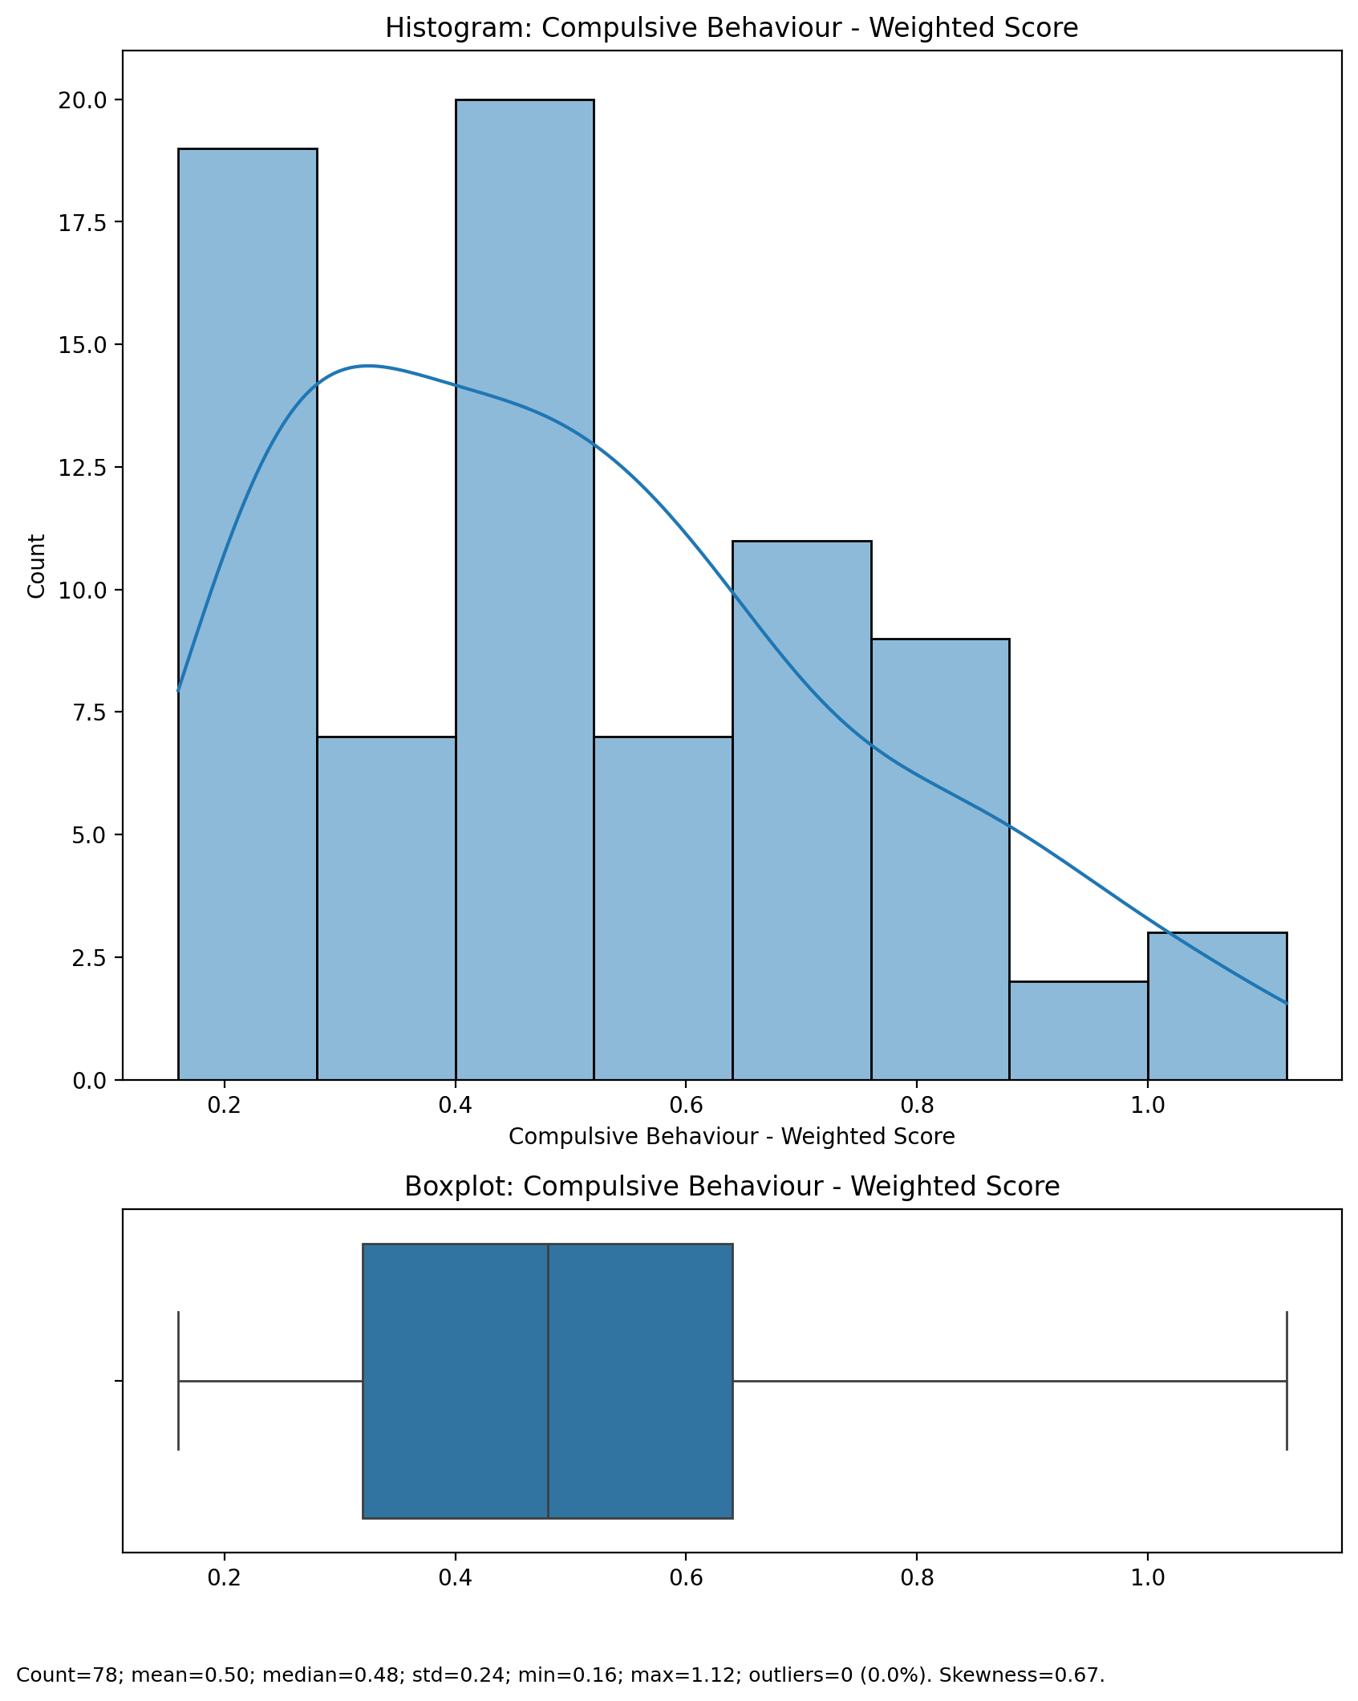

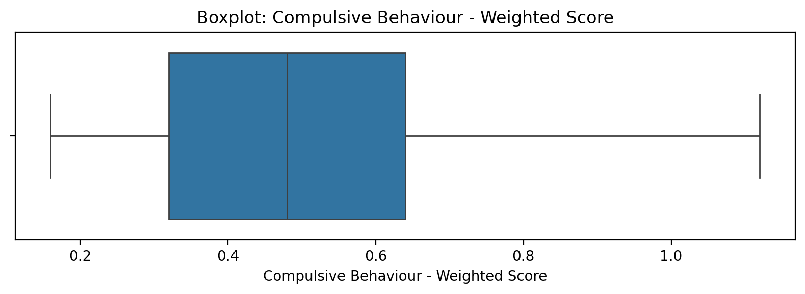

## Compulsive Behaviour - Weighted Score

Top categories: Occasionally involved: 41 (51.9%) | Actively involved: 20 (25.3%) | Not involved: 16 (20.3%) | <<MISSING>>: 2 (2.5%). Note: Top category is sizeable — consider grouping smaller categories.



## Obsession with Internet - Weighted Score

Count=78; mean=0.45; median=0.42; std=0.18; min=0.18; max=0.78; outliers=0 (0.0%). Skewness=0.24.

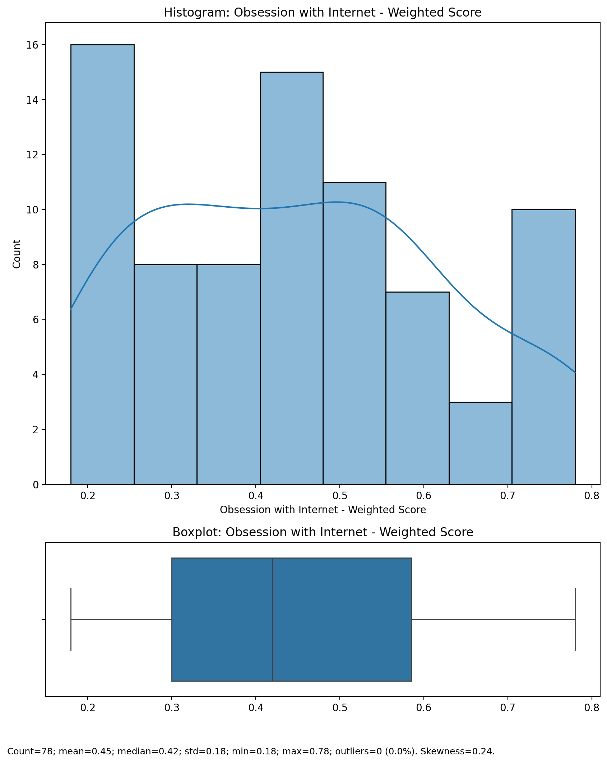

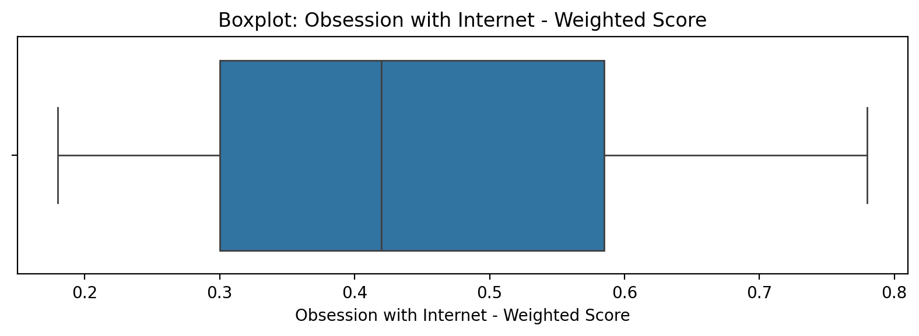

## Obsession with Internet - Weighted Score

Top categories: Occasionally involved: 41 (51.9%) | Actively involved: 20 (25.3%) | Not involved: 16 (20.3%) | <<MISSING>>: 2 (2.5%). Note: Top category is sizeable — consider grouping smaller categories.



## Internet as a Source of Recreation - Weighted Score

Count=78; mean=0.58; median=0.54; std=0.22; min=0.27; max=1.17; outliers=0 (0.0%). Skewness=0.52.

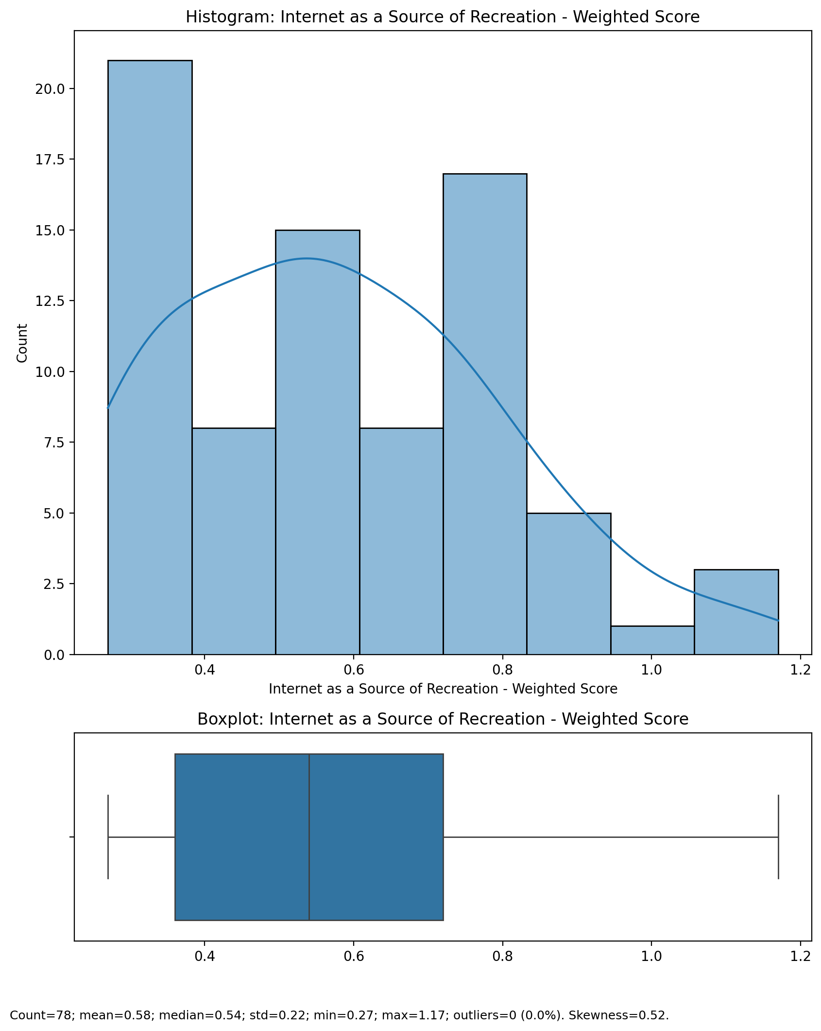

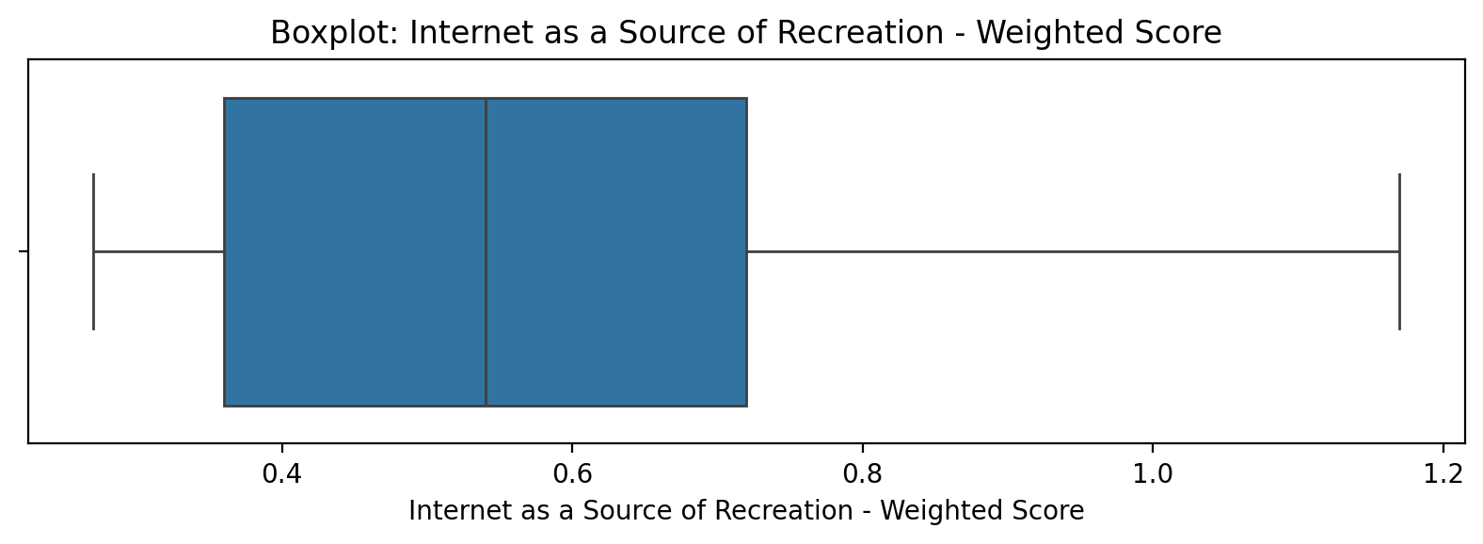

## Internet as a Source of Recreation - Weighted Score

Top categories: Occasionally involved: 41 (51.9%) | Actively involved: 20 (25.3%) | Not involved: 16 (20.3%) | <<MISSING>>: 2 (2.5%). Note: Top category is sizeable — consider grouping smaller categories.



## Enhanced Socialization - Weighted Score

Count=78; mean=0.39; median=0.36; std=0.17; min=0.18; max=0.78; outliers=0 (0.0%). Skewness=0.47.

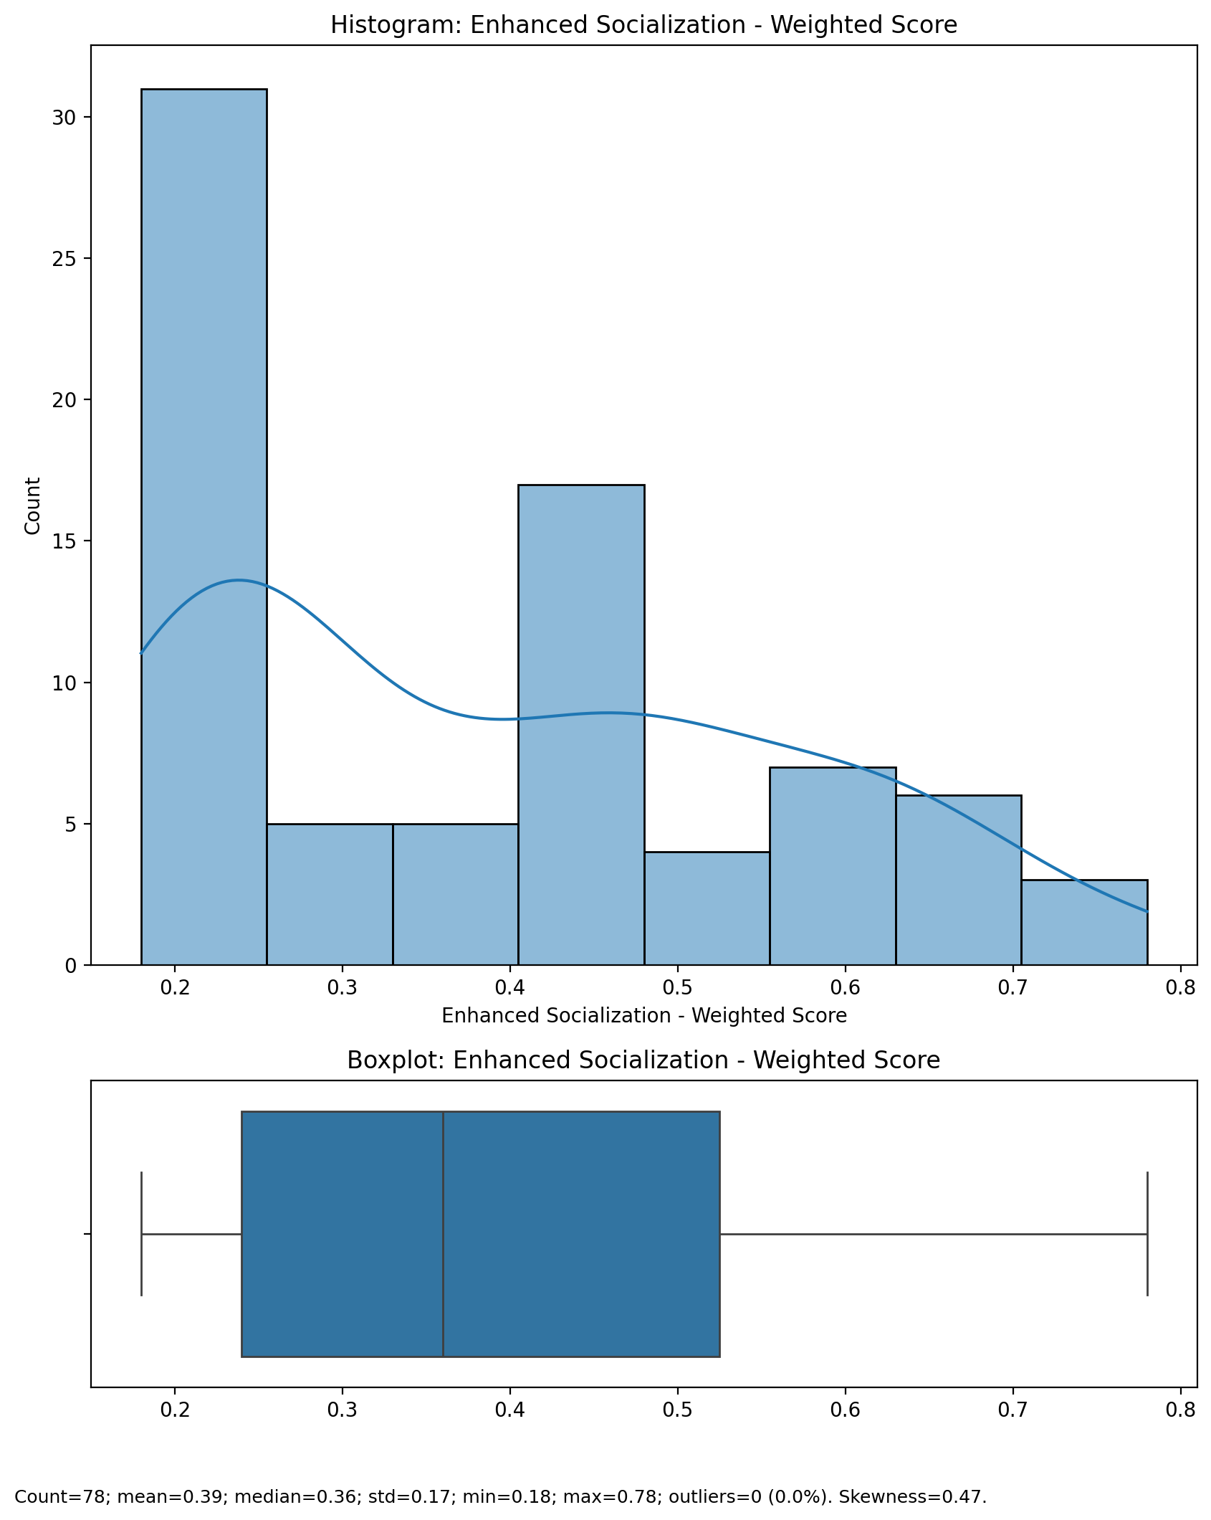

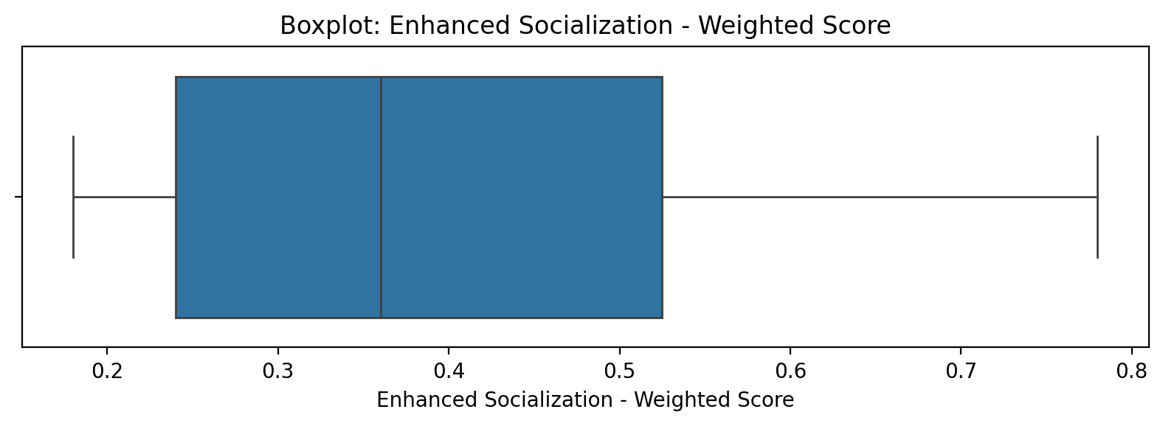

## Enhanced Socialization - Weighted Score

Top categories: Occasionally involved: 41 (51.9%) | Actively involved: 20 (25.3%) | Not involved: 16 (20.3%) | <<MISSING>>: 2 (2.5%). Note: Top category is sizeable — consider grouping smaller categories.



## Perceived Control of Internet Use - Weighted Score

Count=78; mean=0.26; median=0.24; std=0.16; min=0.12; max=0.60; outliers=0 (0.0%). Skewness=0.88.

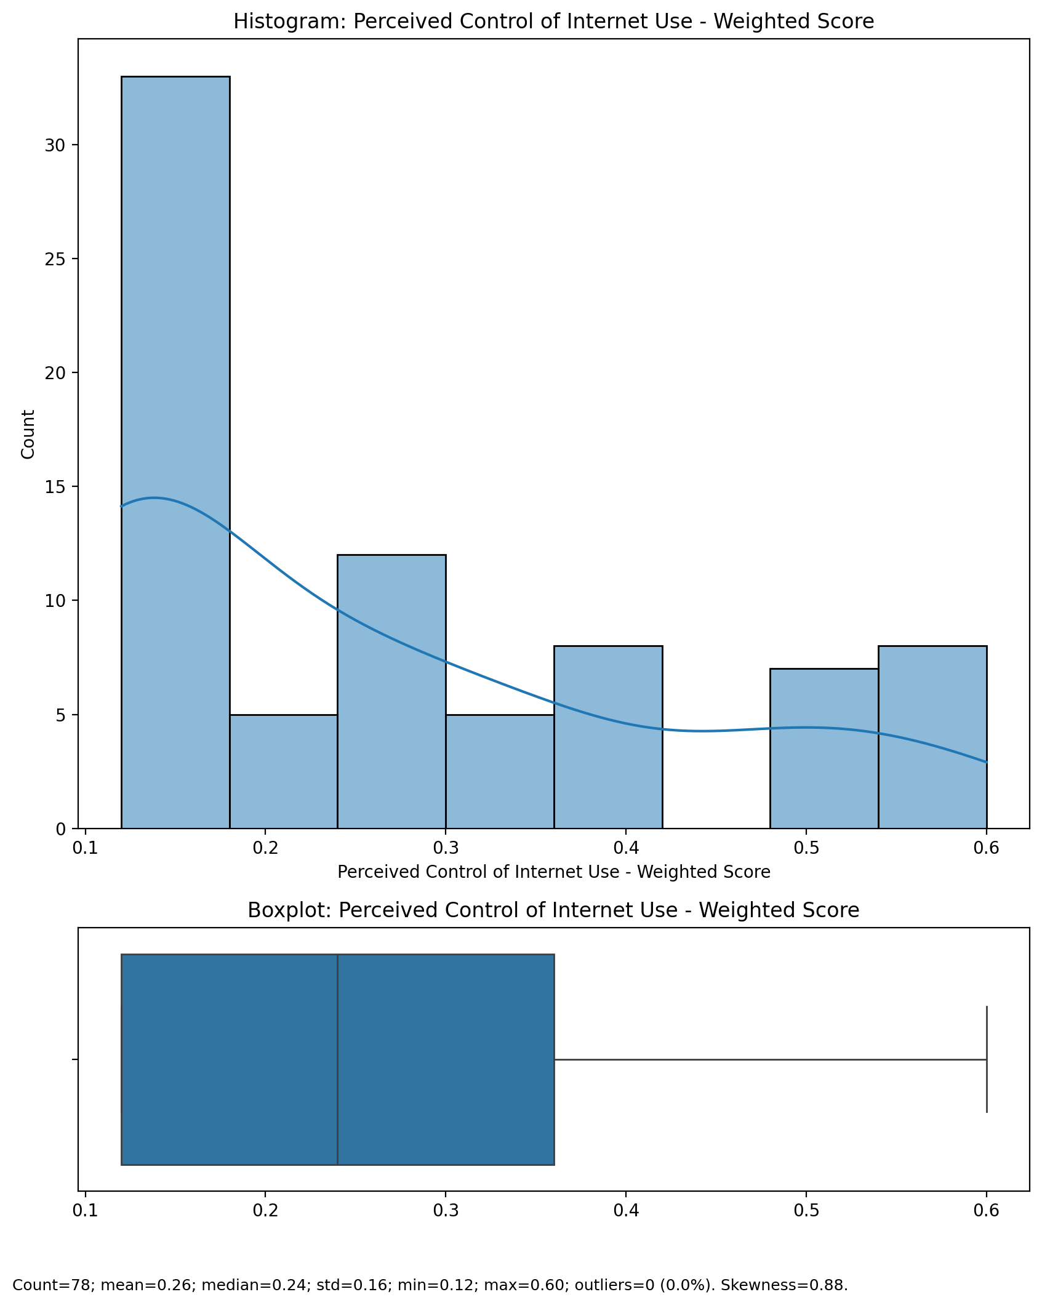

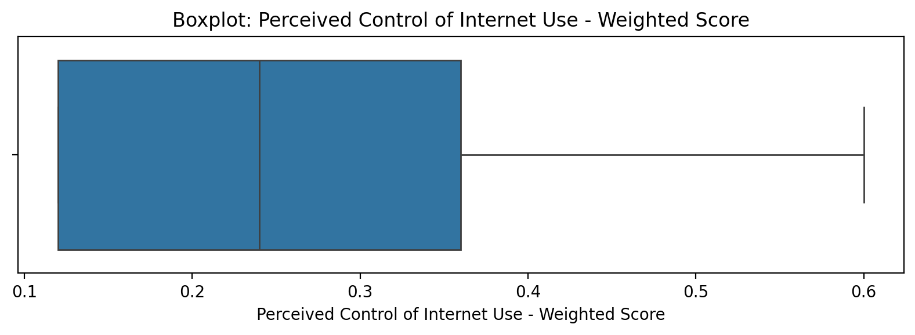

## Perceived Control of Internet Use - Weighted Score

Top categories: Occasionally involved: 41 (51.9%) | Actively involved: 20 (25.3%) | Not involved: 16 (20.3%) | <<MISSING>>: 2 (2.5%). Note: Top category is sizeable — consider grouping smaller categories.



## Internet Usage Total Score (Weighted)

Count=78; mean=12.48; median=11.52; std=4.38; min=6.93; max=25.56; outliers=1 (1.3%). Skewness=0.92.

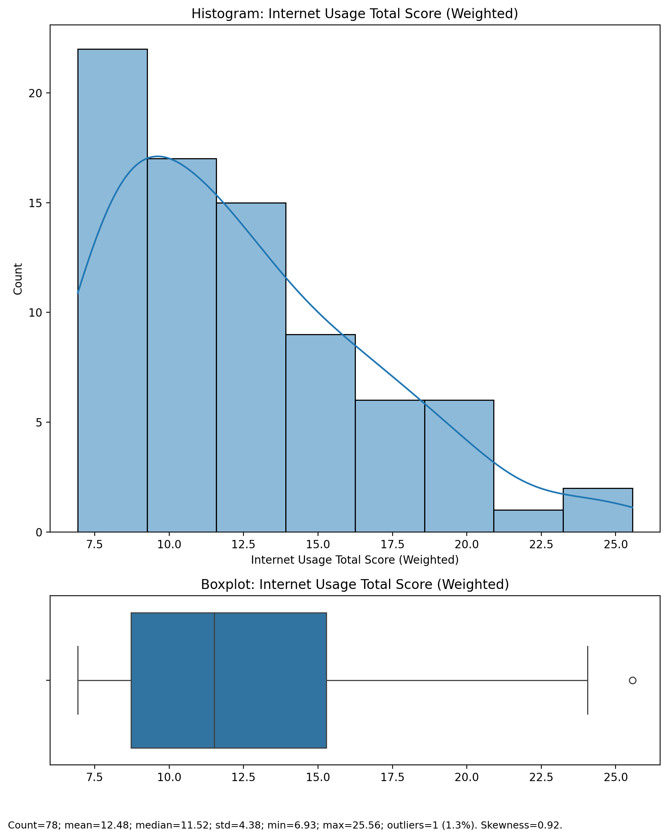

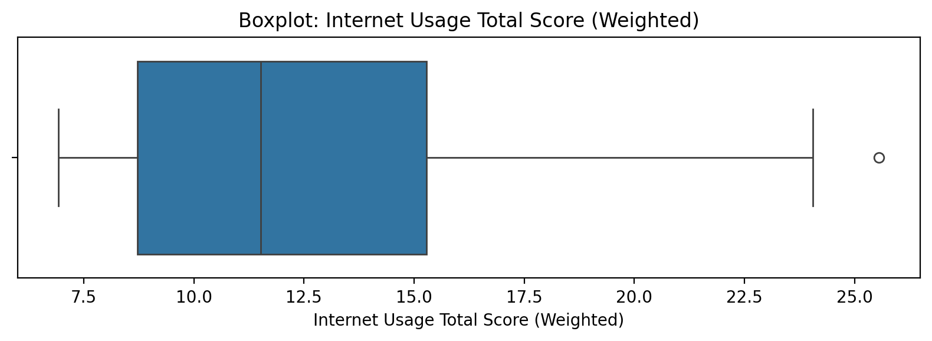

## Internet Usage Total Score (Weighted)

Top categories: Occasionally involved: 41 (51.9%) | Actively involved: 20 (25.3%) | Not involved: 16 (20.3%) | <<MISSING>>: 2 (2.5%). Note: Top category is sizeable — consider grouping smaller categories.



## Functional Impairment - Category

Top categories: Low: 53 (67.1%) | Mild: 17 (21.5%) | Moderate: 4 (5.1%) | Severe: 4 (5.1%) | <<MISSING>>: 1 (1.3%). Note: Top category is sizeable — consider grouping smaller categories.

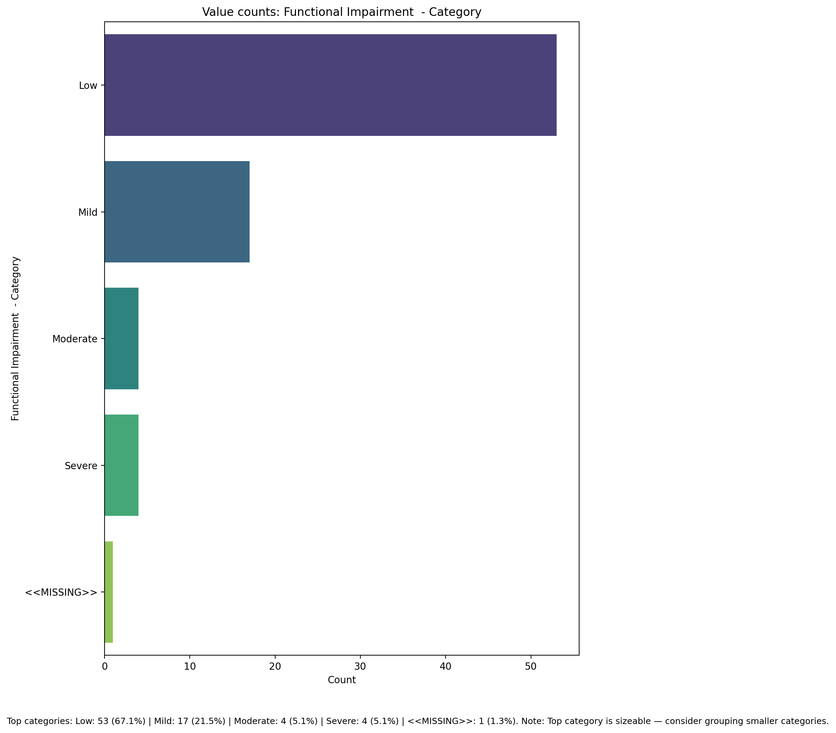

## Withdrawl – Category

Top categories: Low: 68 (86.1%) | Mild: 7 (8.9%) | Moderate: 3 (3.8%) | <<MISSING>>: 1 (1.3%). Note: Single category dominates — low variability.

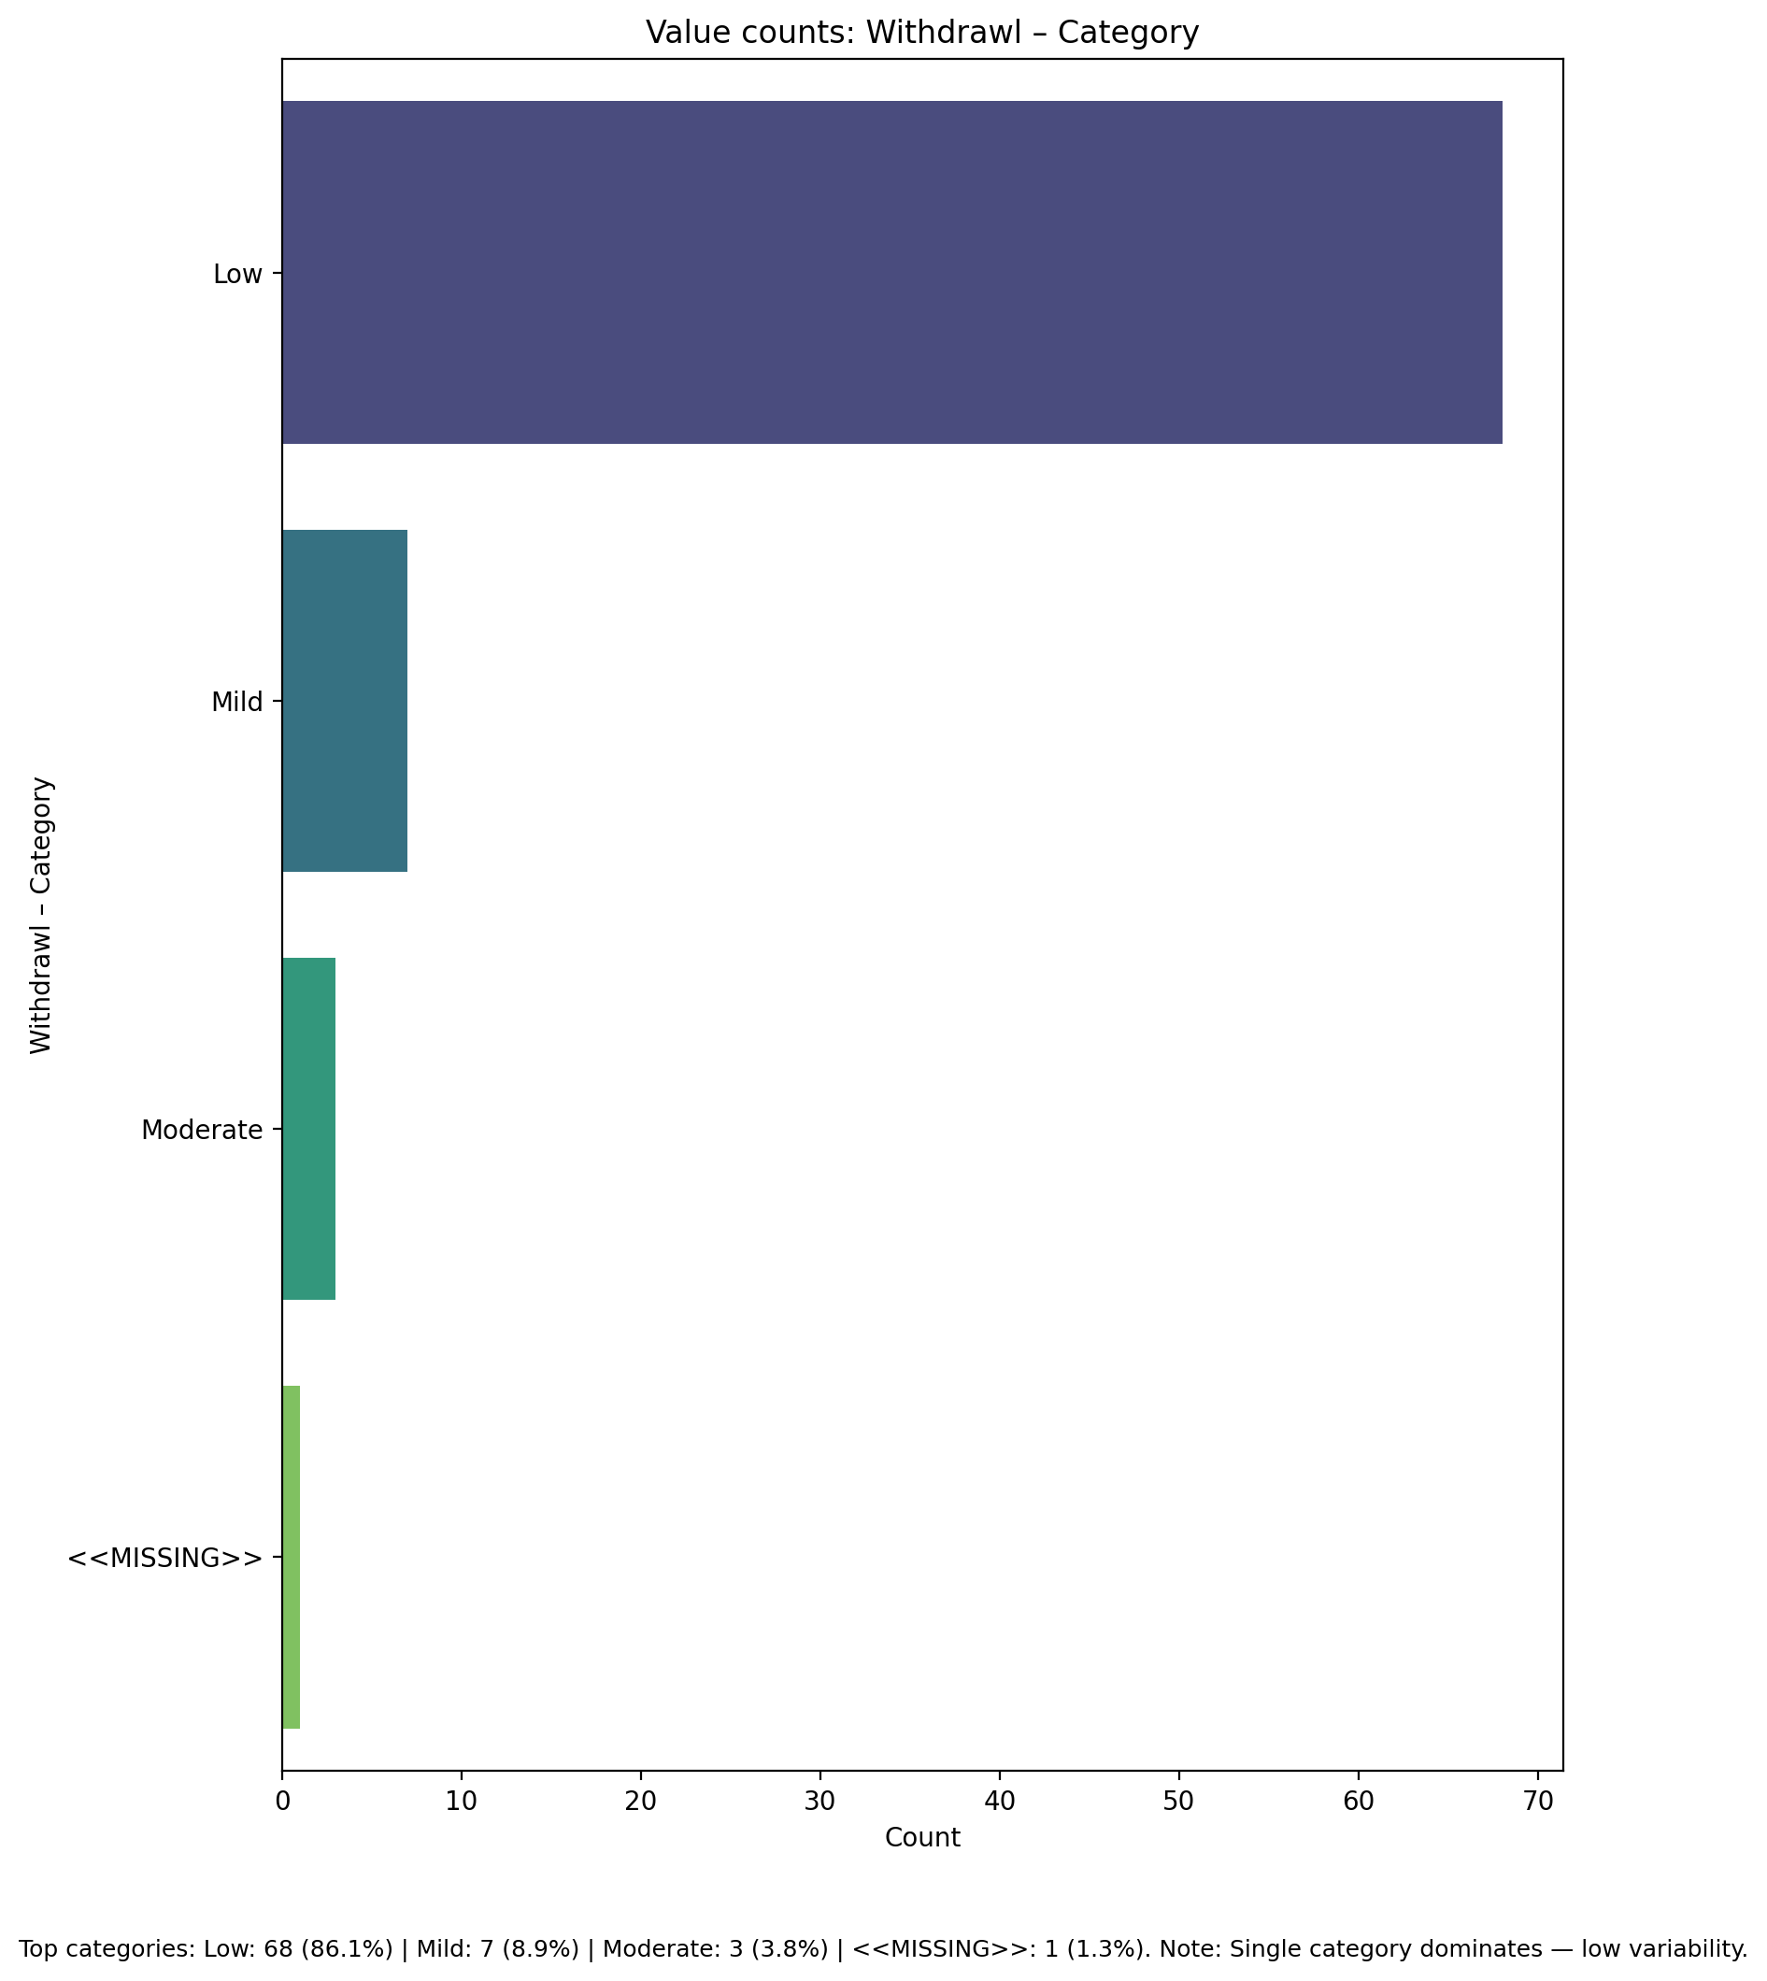

## Occupational & Relationship Consequences – Category

Top categories: Low: 59 (74.7%) | Mild: 16 (20.3%) | Moderate: 3 (3.8%) | <<MISSING>>: 1 (1.3%). Note: Top category is sizeable — consider grouping smaller categories.

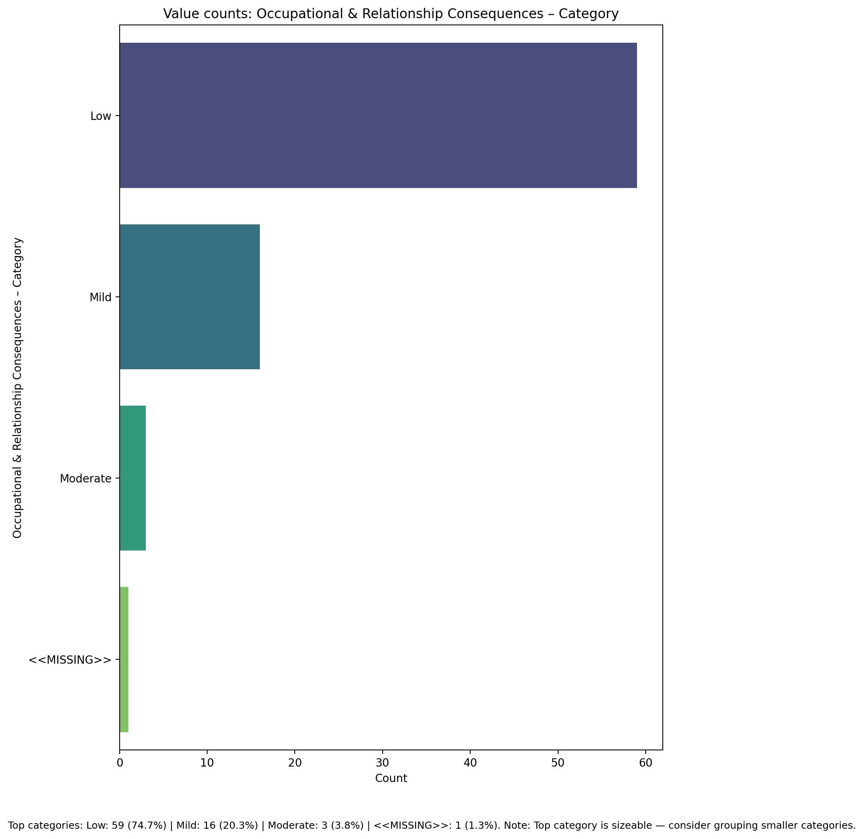

## Compulsive Behaviour – Category

Top categories: Low: 51 (64.6%) | Mild: 15 (19.0%) | Severe: 6 (7.6%) | Moderate: 6 (7.6%) | <<MISSING>>: 1 (1.3%). Note: Top category is sizeable — consider grouping smaller categories.

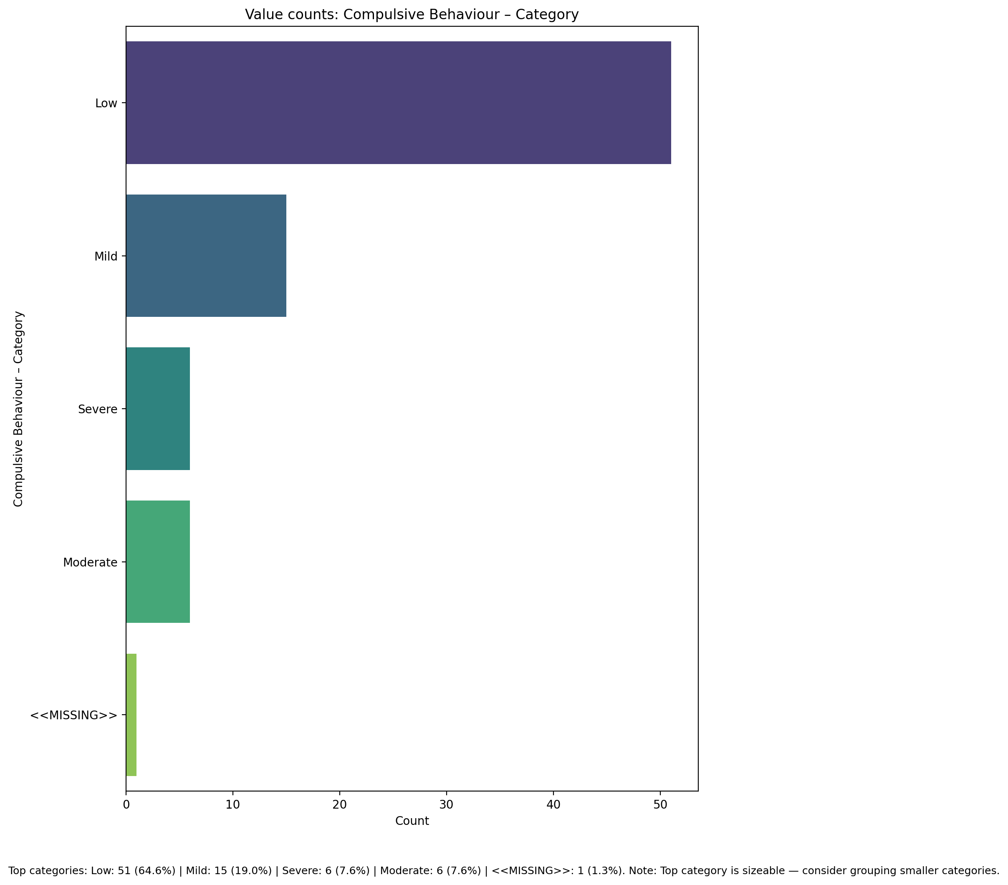

## Obsession with Internet – Category

Top categories: Low: 40 (50.6%) | Mild: 18 (22.8%) | Severe: 13 (16.5%) | Moderate: 7 (8.9%) | <<MISSING>>: 1 (1.3%). Note: Top category is sizeable — consider grouping smaller categories.

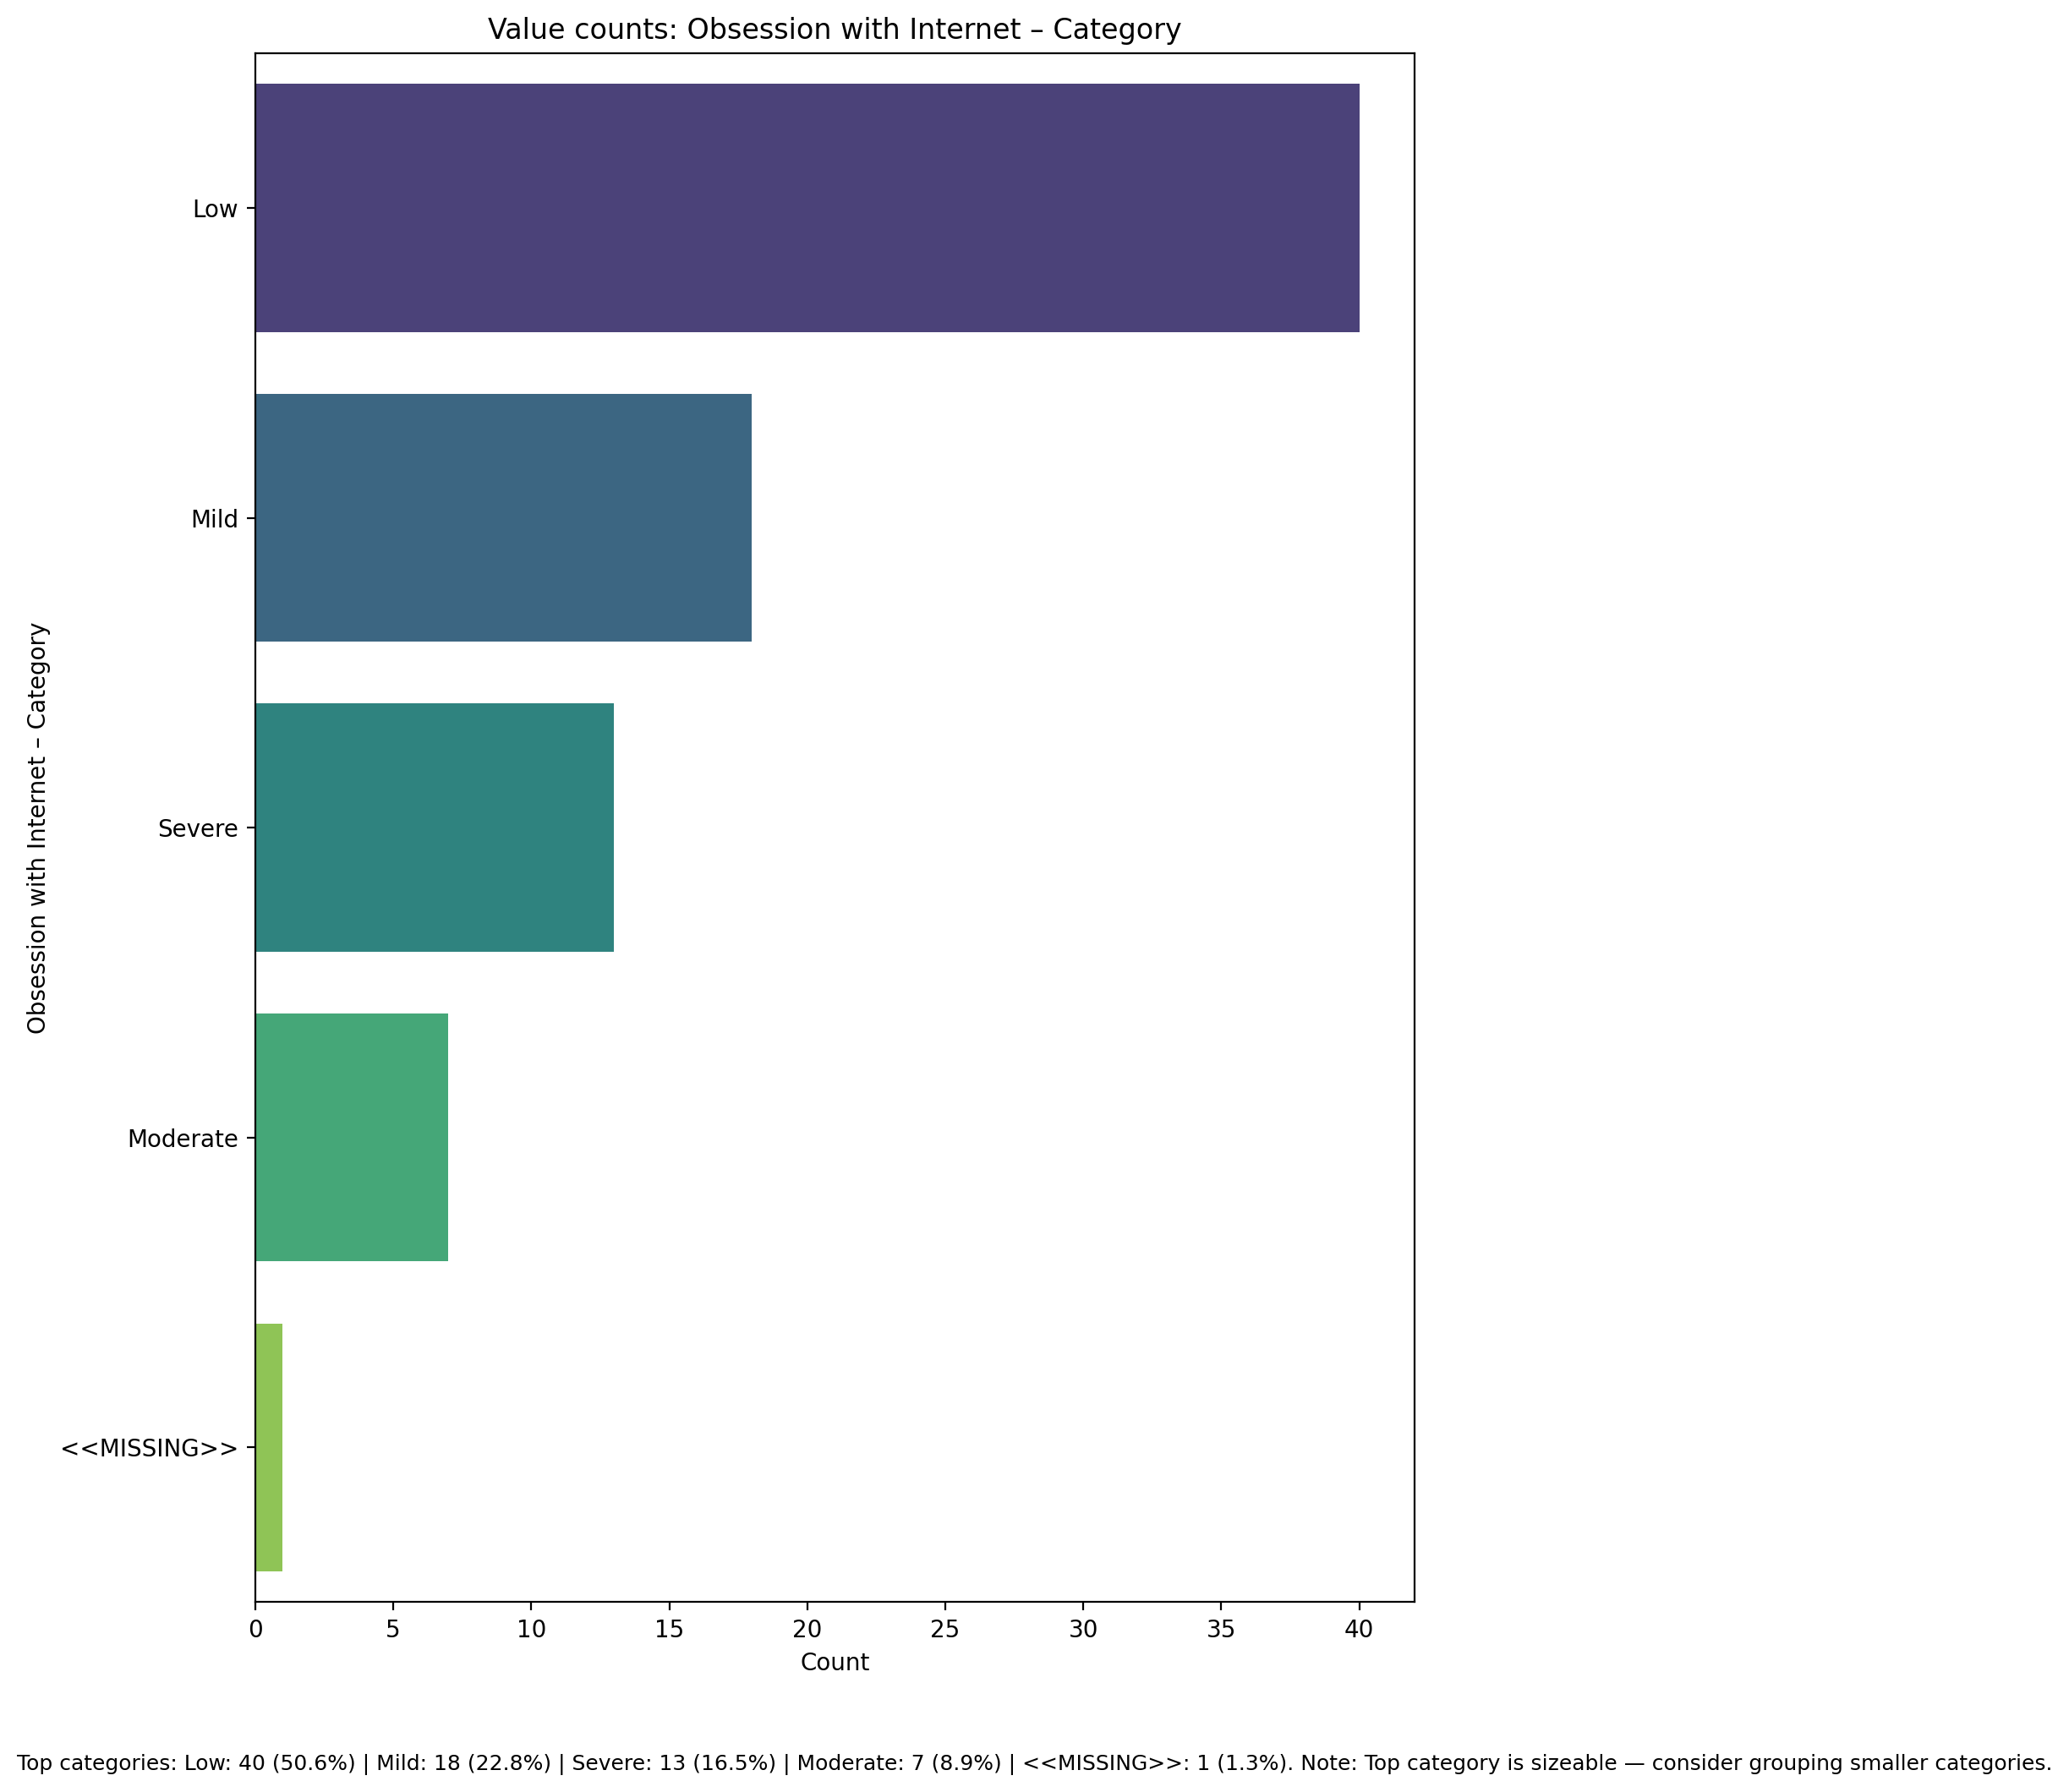

## Internet as a Source of Recreation – Category

Top categories: Low: 45 (57.0%) | Moderate: 17 (21.5%) | Severe: 9 (11.4%) | Mild: 7 (8.9%) | <<MISSING>>: 1 (1.3%). Note: Top category is sizeable — consider grouping smaller categories.

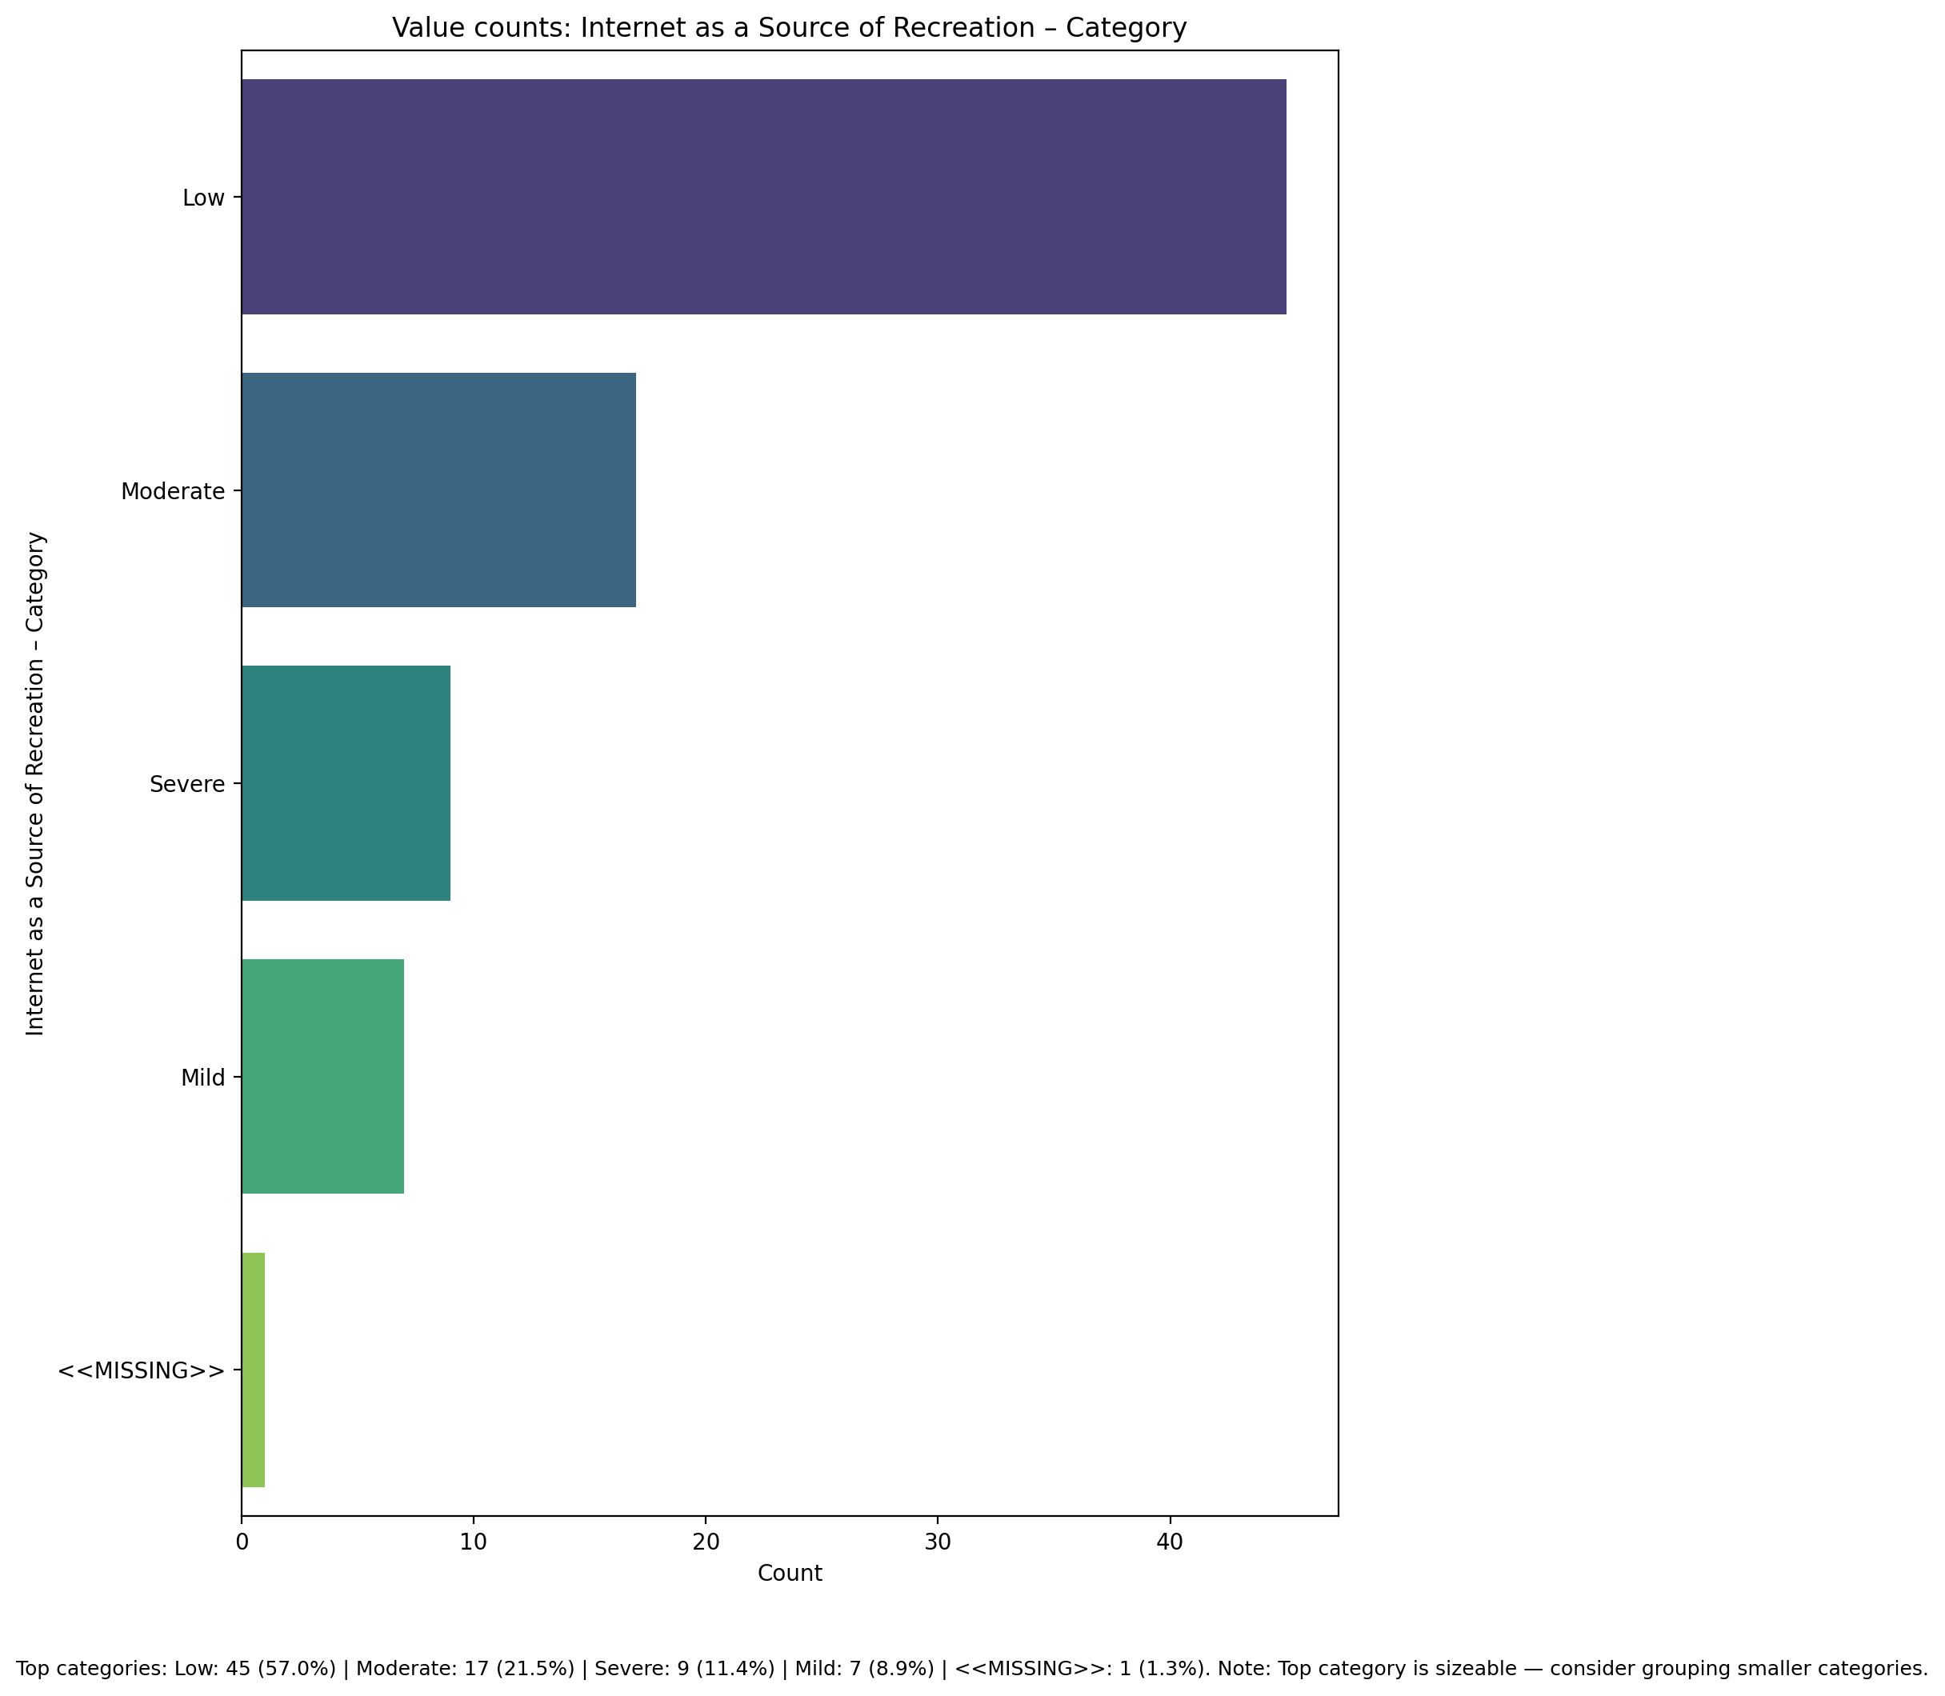

## Enhanced Socialization - Category

Top categories: Low: 37 (46.8%) | Severe: 20 (25.3%) | Mild: 11 (13.9%) | Moderate: 10 (12.7%) | <<MISSING>>: 1 (1.3%). Note: Top category is sizeable — consider grouping smaller categories.

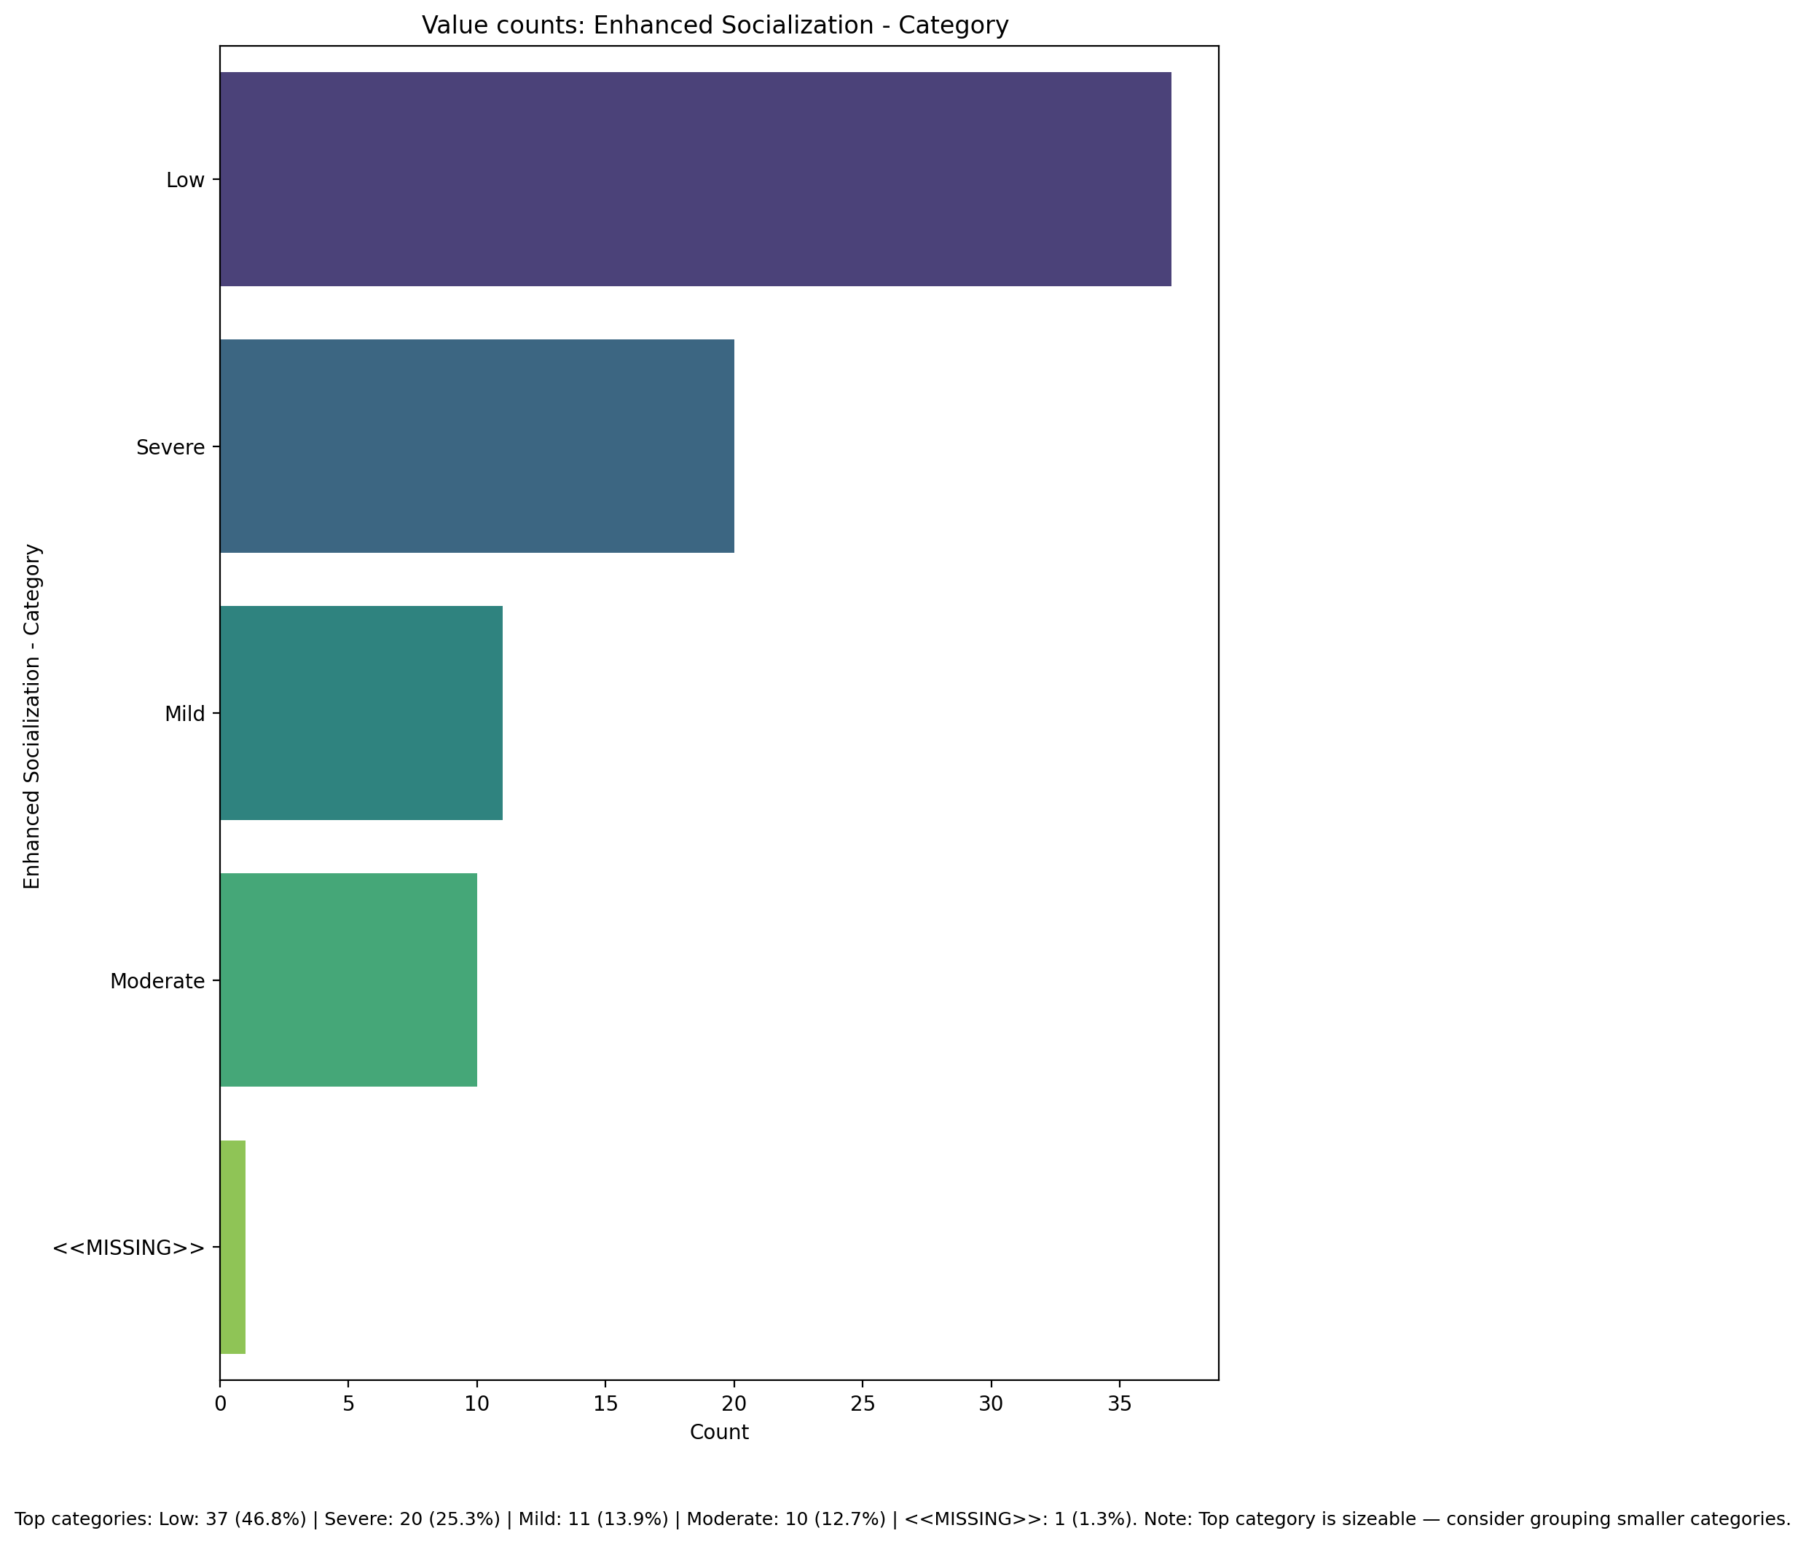

## Perceived Control of Internet Use - Category

Top categories: Low: 63 (79.7%) | Moderate: 9 (11.4%) | Severe: 6 (7.6%) | <<MISSING>>: 1 (1.3%). Note: Top category is sizeable — consider grouping smaller categories.

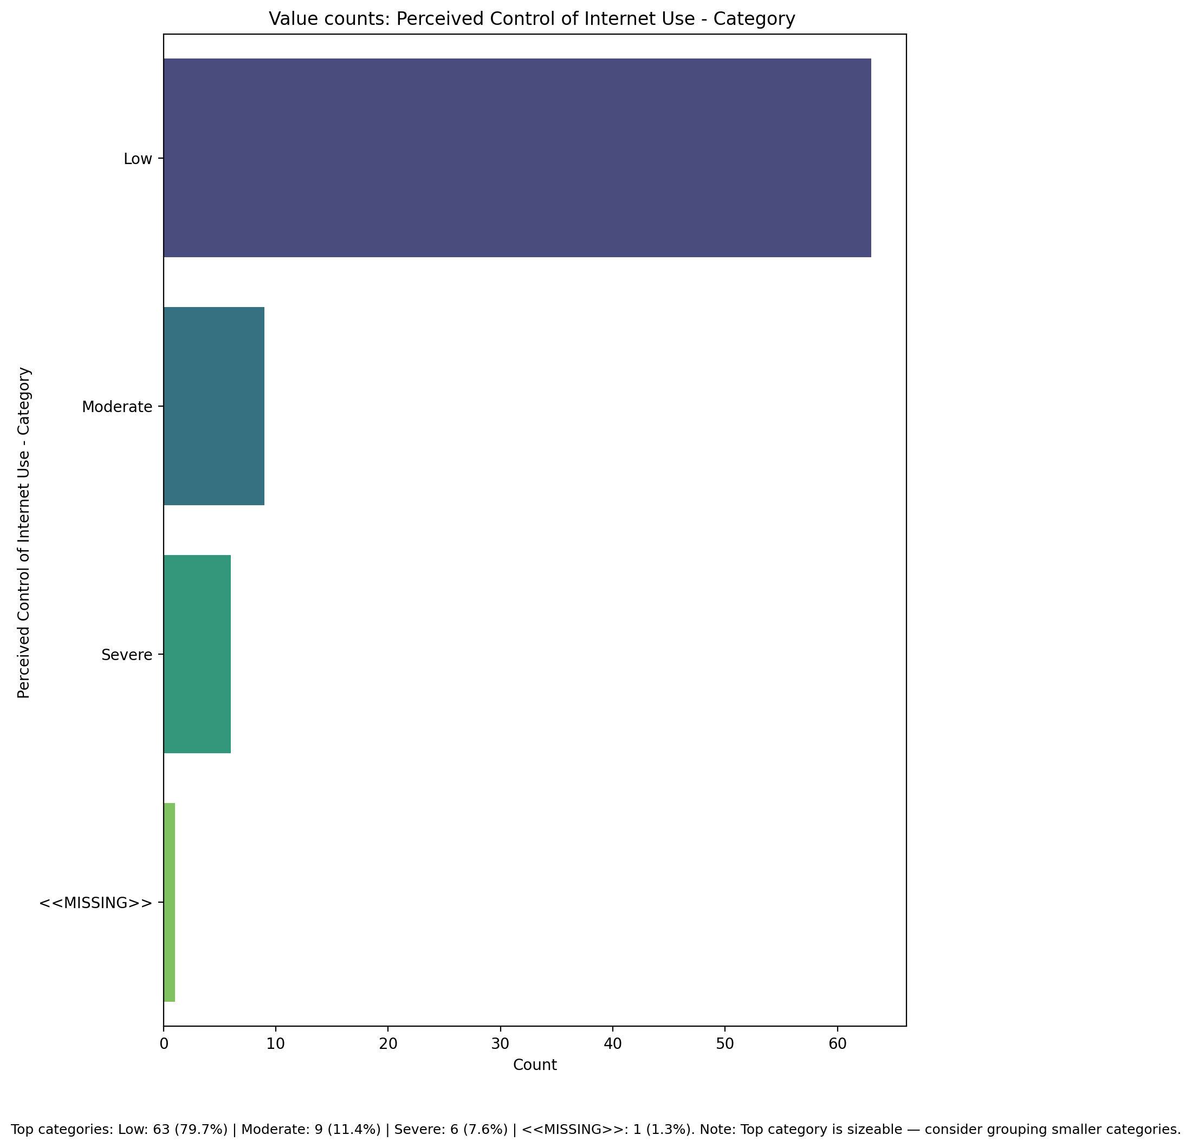

## Internet Usage Total Categoty

Top categories: Low: 57 (72.2%) | Mild: 13 (16.5%) | Moderate: 5 (6.3%) | Severe: 3 (3.8%) | <<MISSING>>: 1 (1.3%). Note: Top category is sizeable — consider grouping smaller categories.

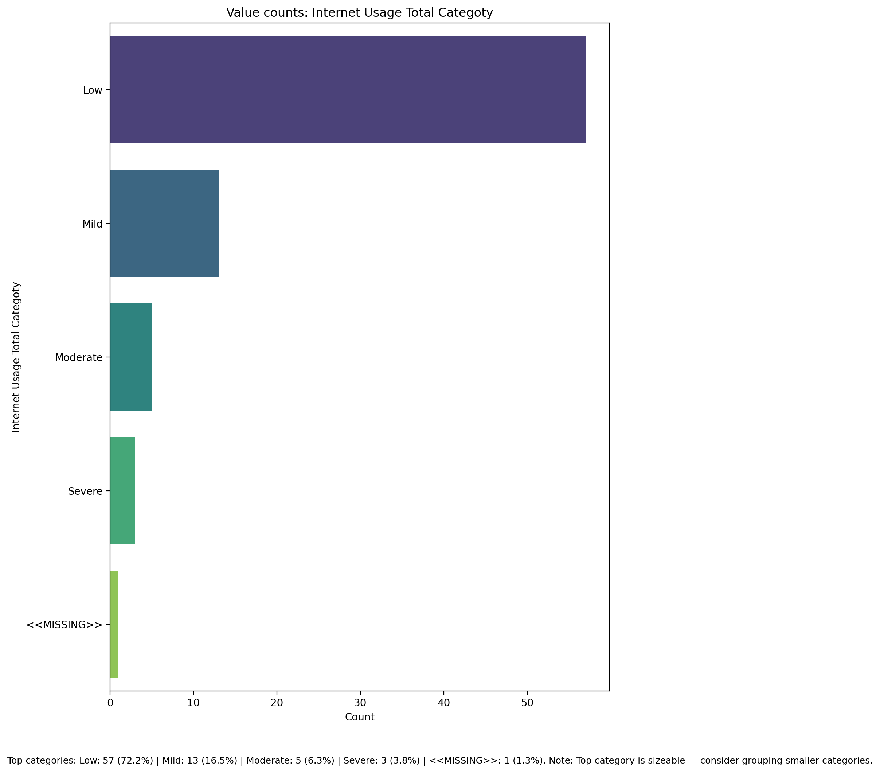

## Emotional Support - Raw Score

Count=78; mean=52.32; median=53.00; std=9.00; min=34.00; max=72.00; outliers=0 (0.0%). Skewness=-0.03.

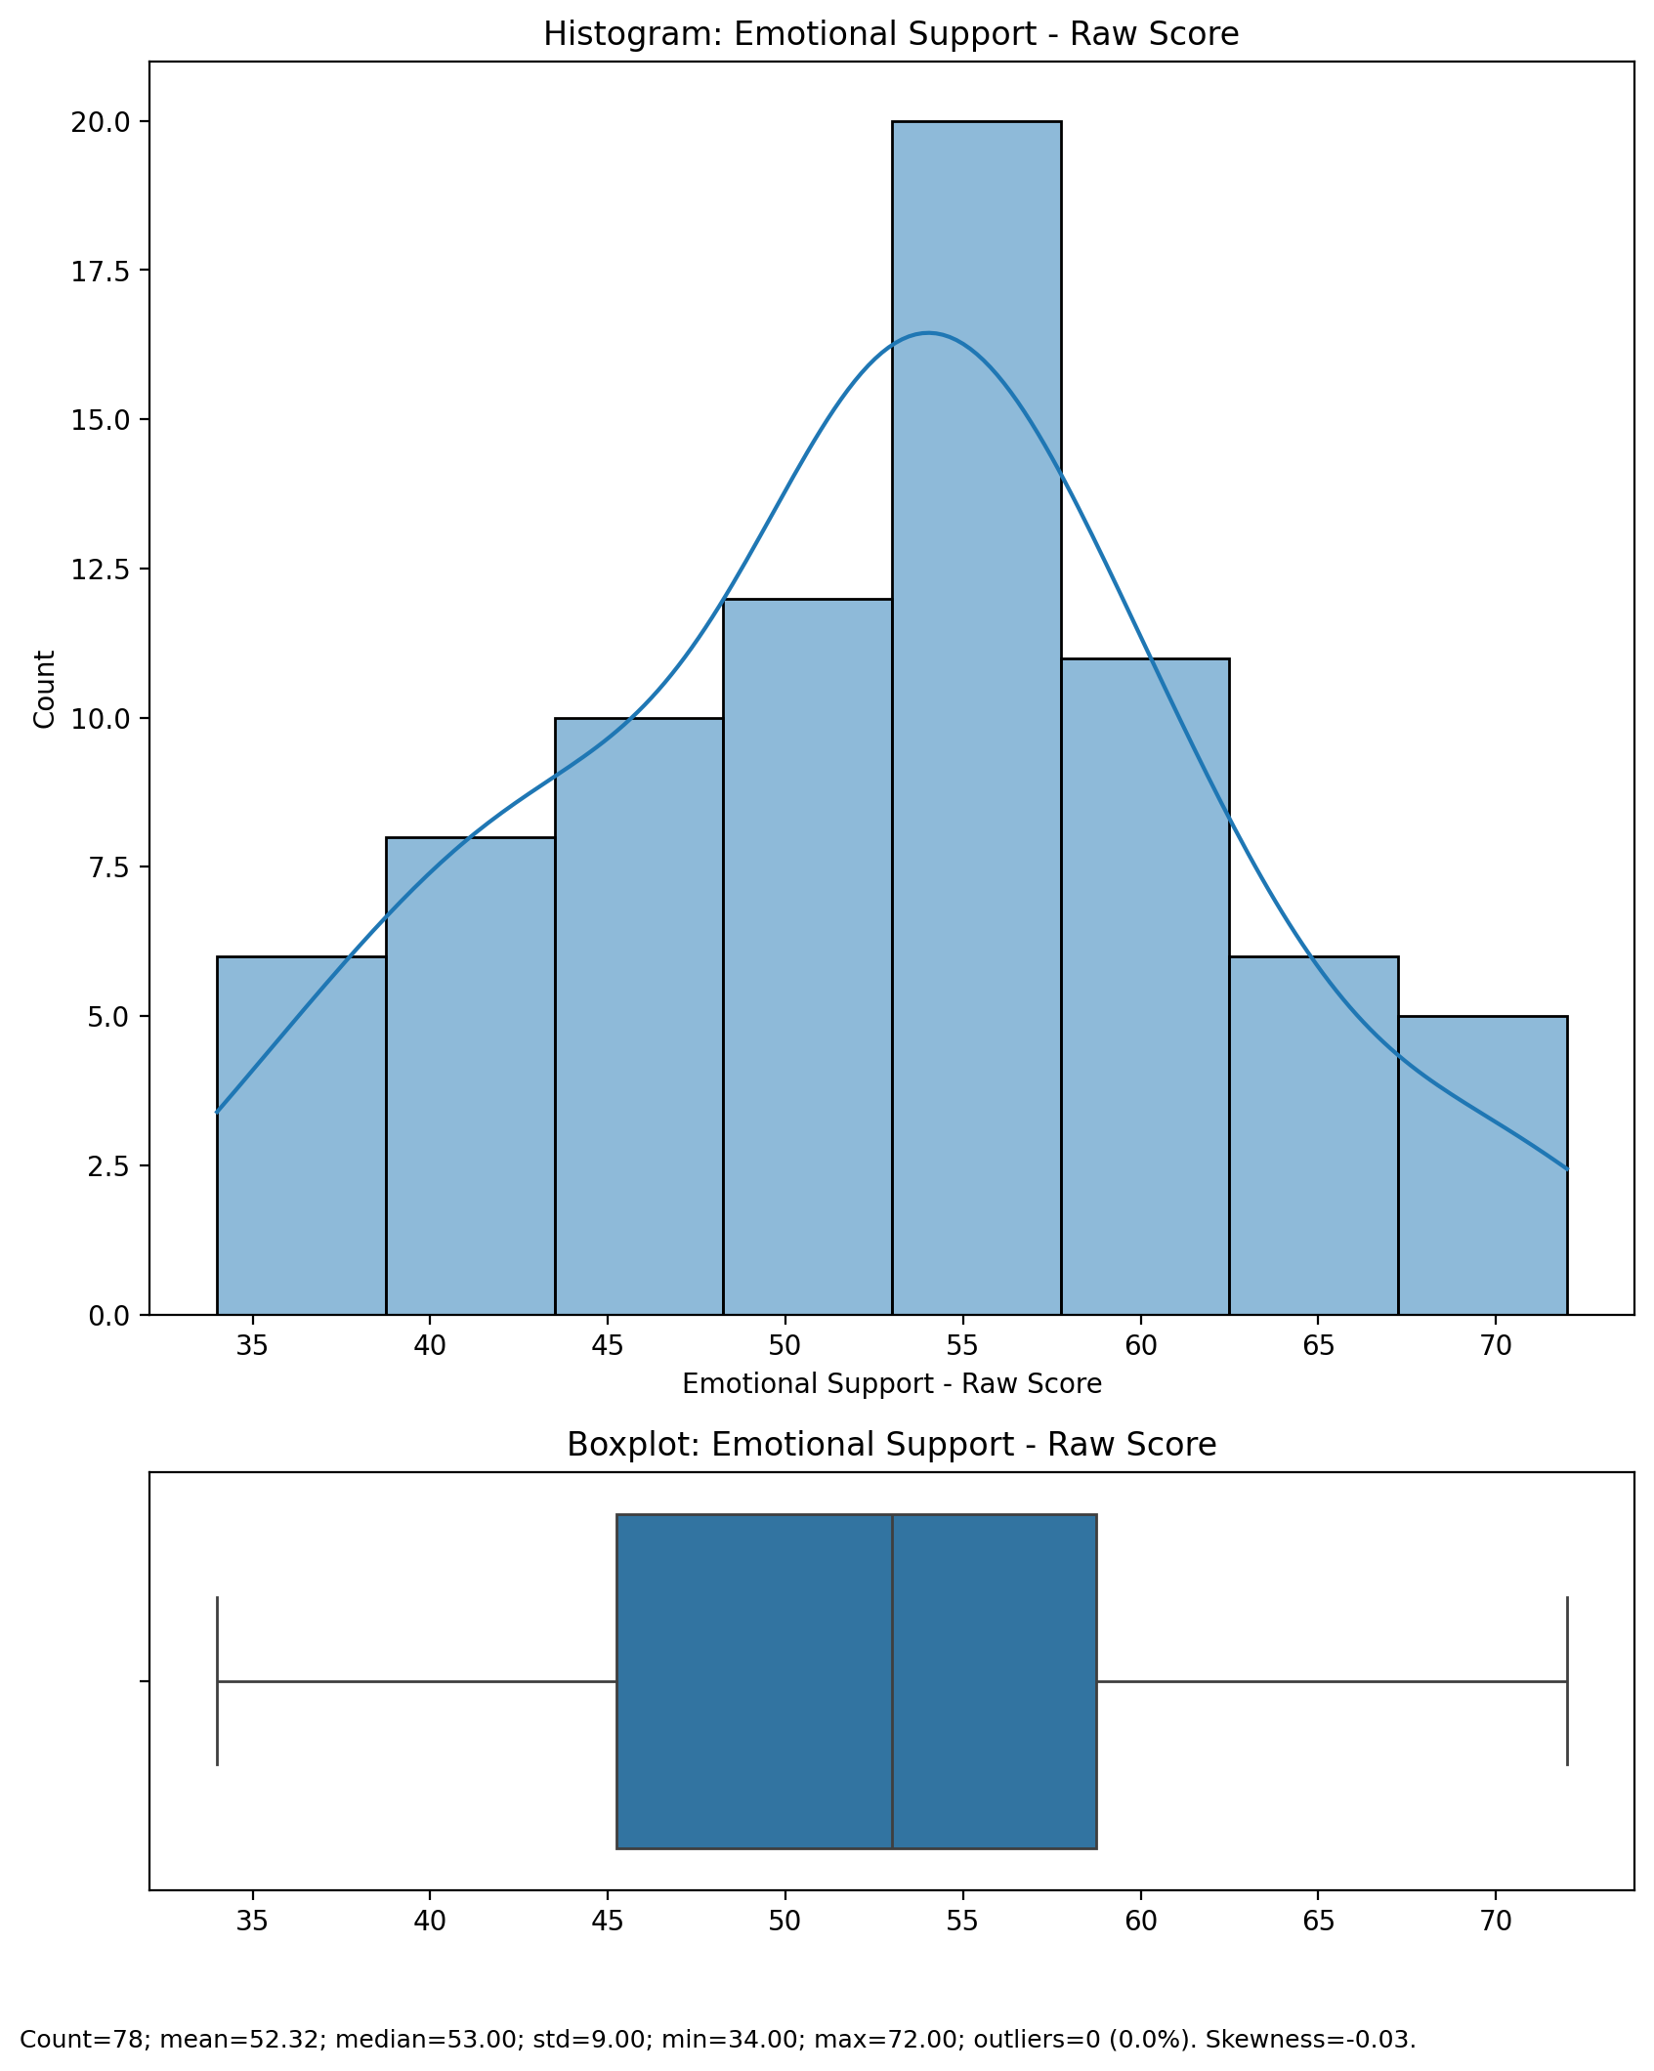

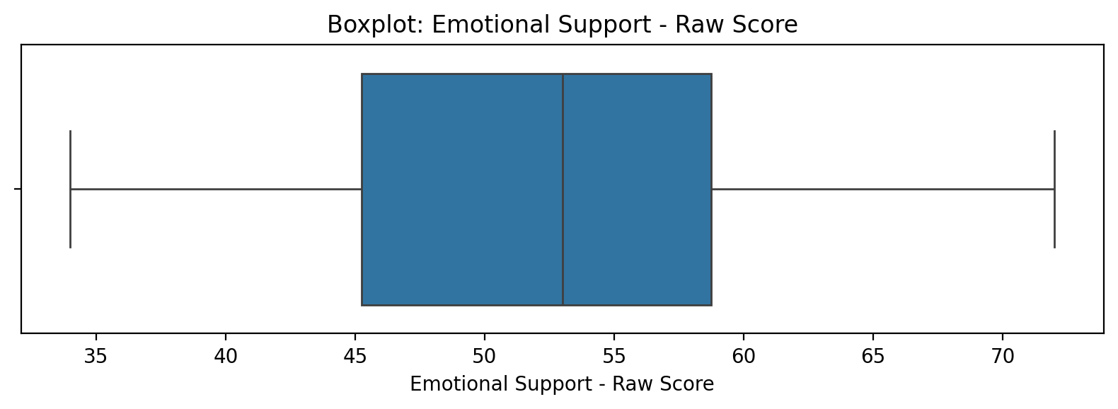

## Emotional Support - Raw Score

Top categories: Low: 57 (72.2%) | Mild: 13 (16.5%) | Moderate: 5 (6.3%) | Severe: 3 (3.8%) | <<MISSING>>: 1 (1.3%). Note: Top category is sizeable — consider grouping smaller categories.



## Informational Support - Raw Score

Count=78; mean=15.71; median=16.00; std=3.74; min=5.00; max=23.00; outliers=3 (3.8%). Skewness=-0.58.

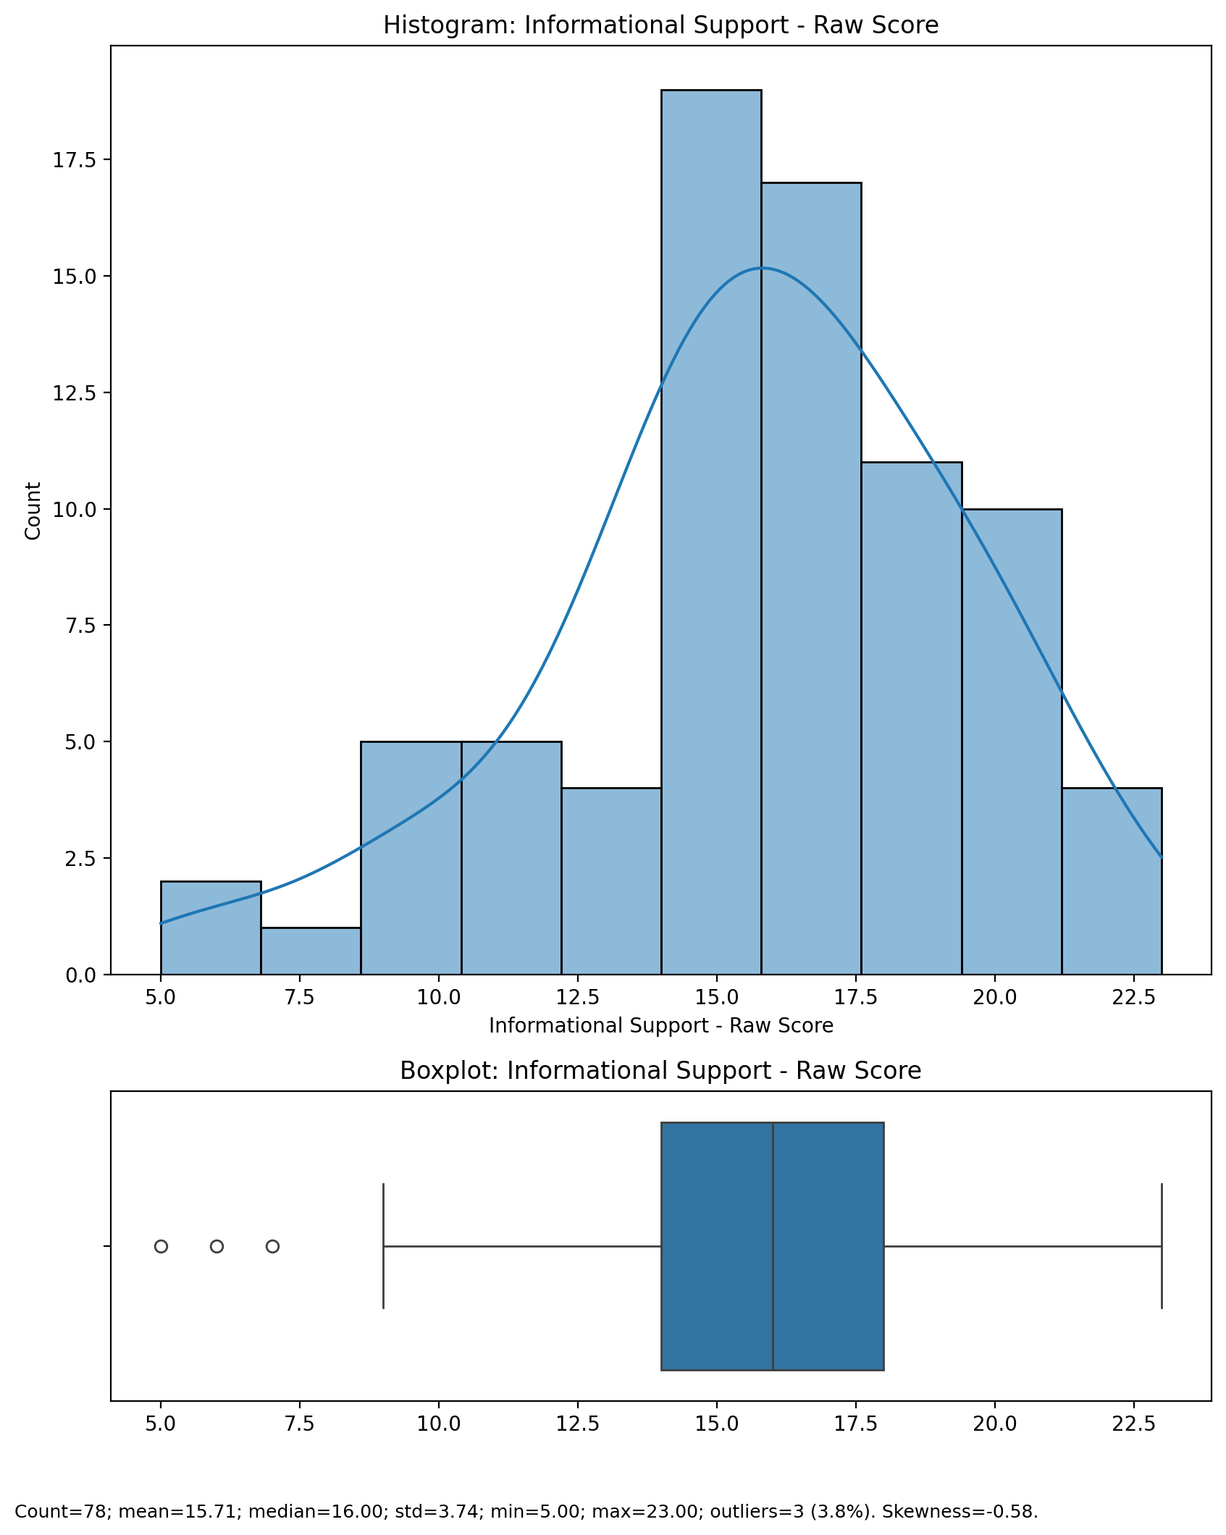

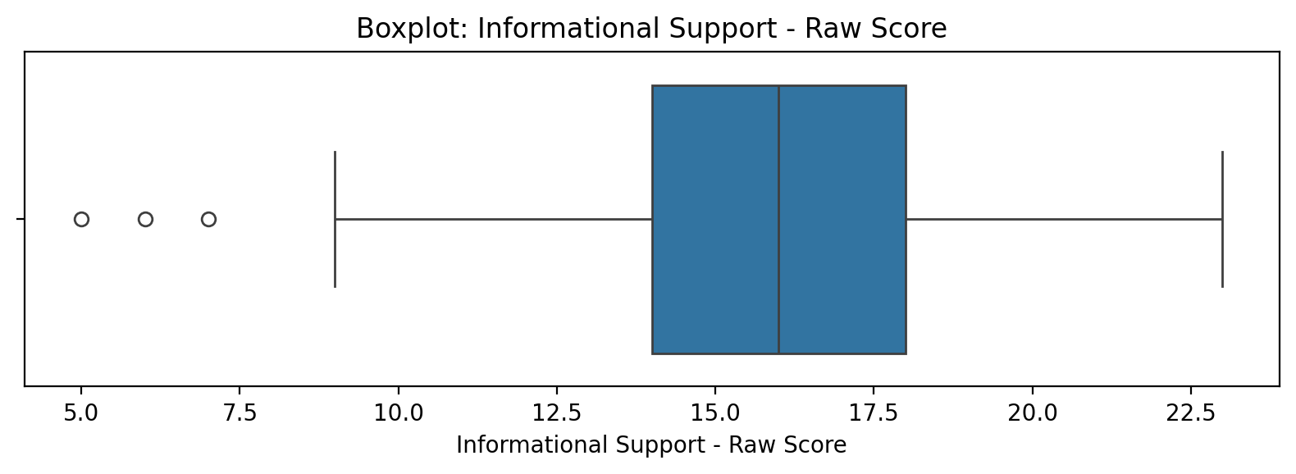

## Informational Support - Raw Score

Top categories: Low: 57 (72.2%) | Mild: 13 (16.5%) | Moderate: 5 (6.3%) | Severe: 3 (3.8%) | <<MISSING>>: 1 (1.3%). Note: Top category is sizeable — consider grouping smaller categories.



## Instrumental Support - Raw Score

Count=78; mean=23.97; median=24.00; std=4.33; min=12.00; max=34.00; outliers=1 (1.3%). Skewness=-0.27.

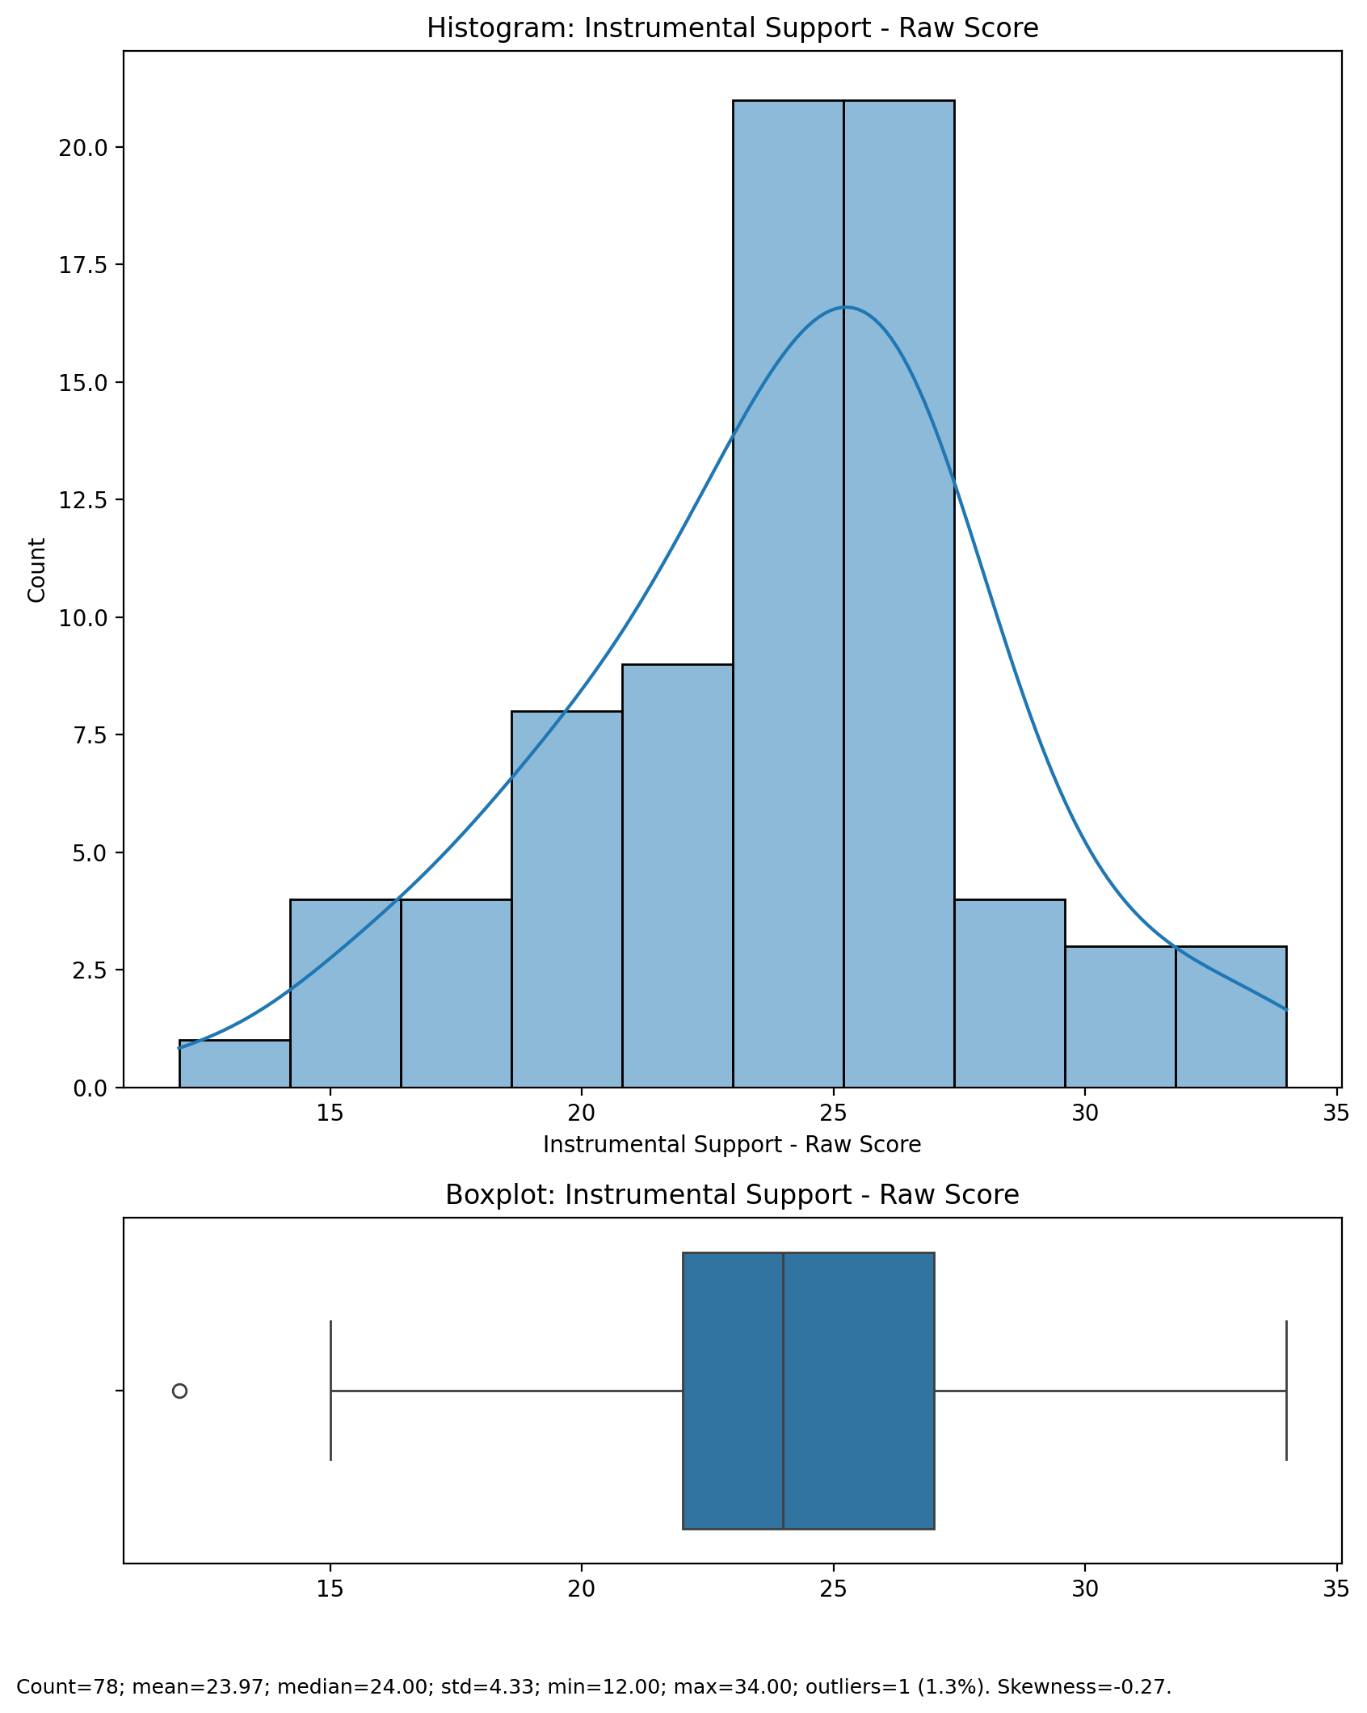

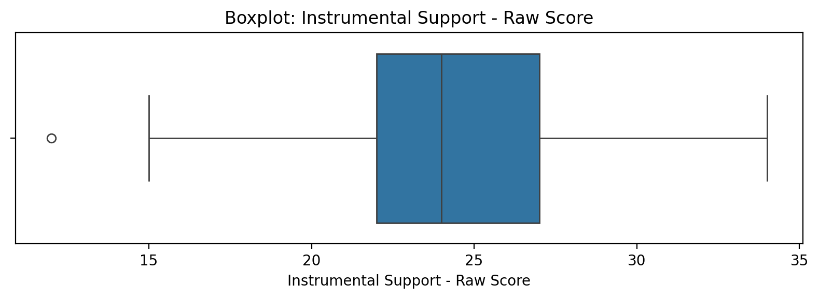

## Instrumental Support - Raw Score

Top categories: Low: 57 (72.2%) | Mild: 13 (16.5%) | Moderate: 5 (6.3%) | Severe: 3 (3.8%) | <<MISSING>>: 1 (1.3%). Note: Top category is sizeable — consider grouping smaller categories.



## Perceived Social Support Total Raw Score

Count=78; mean=92.00; median=94.50; std=14.51; min=59.00; max=125.00; outliers=0 (0.0%). Skewness=-0.11.

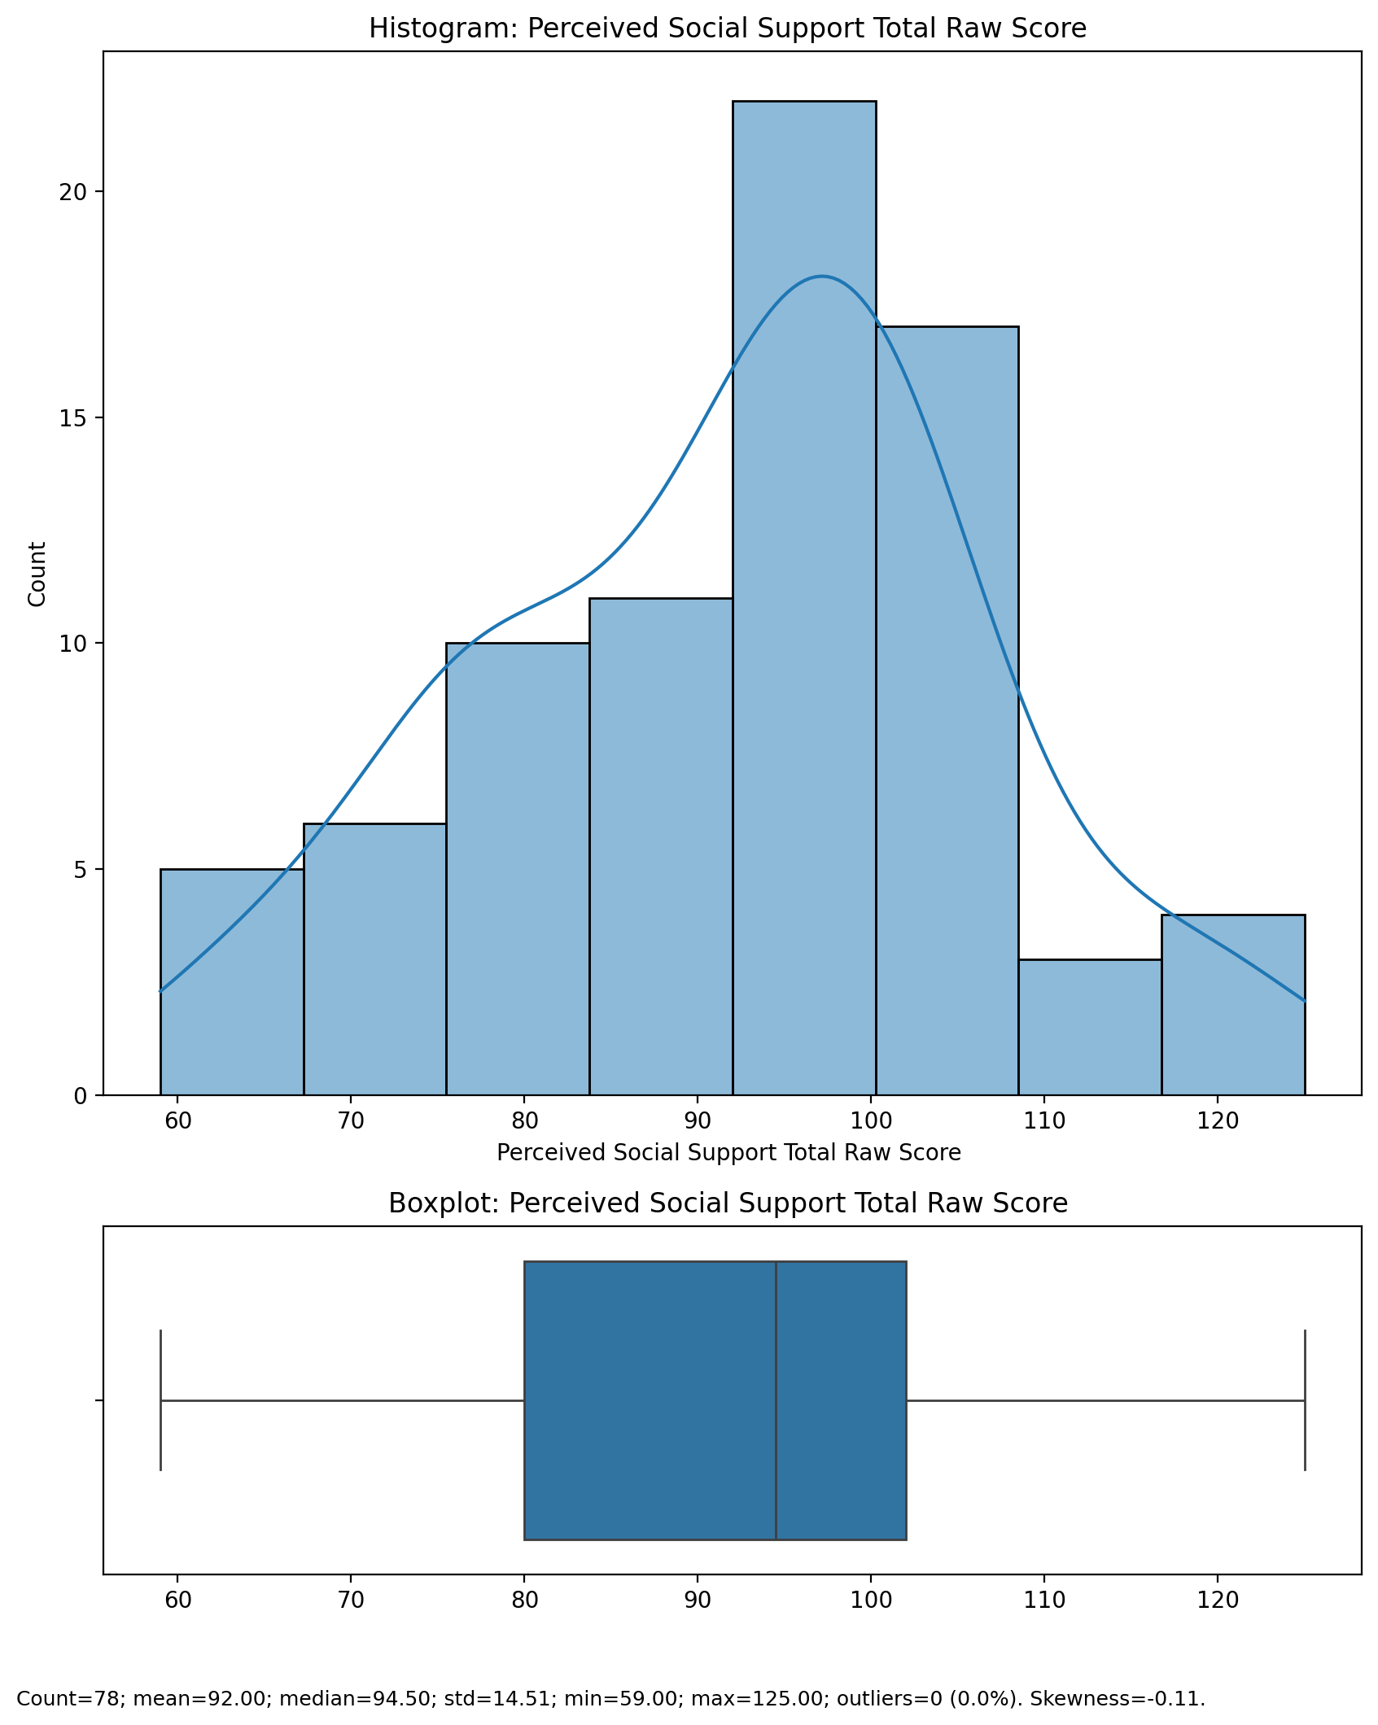

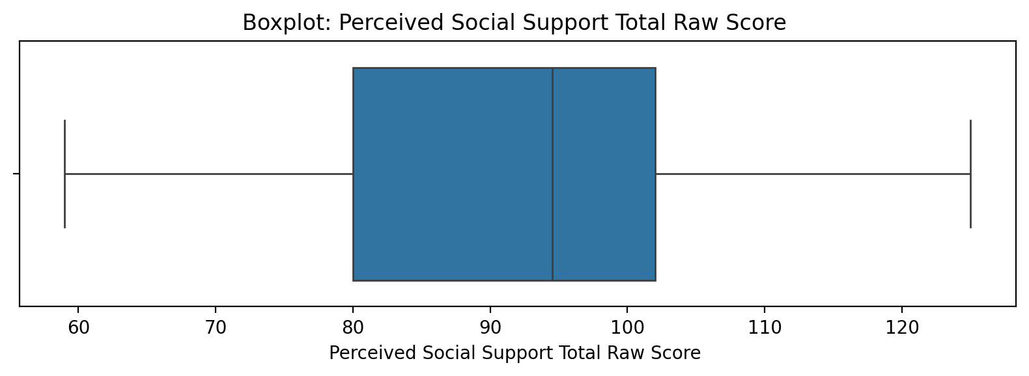

## Perceived Social Support Total Raw Score

Top categories: Low: 57 (72.2%) | Mild: 13 (16.5%) | Moderate: 5 (6.3%) | Severe: 3 (3.8%) | <<MISSING>>: 1 (1.3%). Note: Top category is sizeable — consider grouping smaller categories.



## Emotional Support - T Score

Count=78; mean=49.80; median=50.56; std=10.27; min=28.97; max=72.16; outliers=0 (0.0%). Skewness=-0.01.

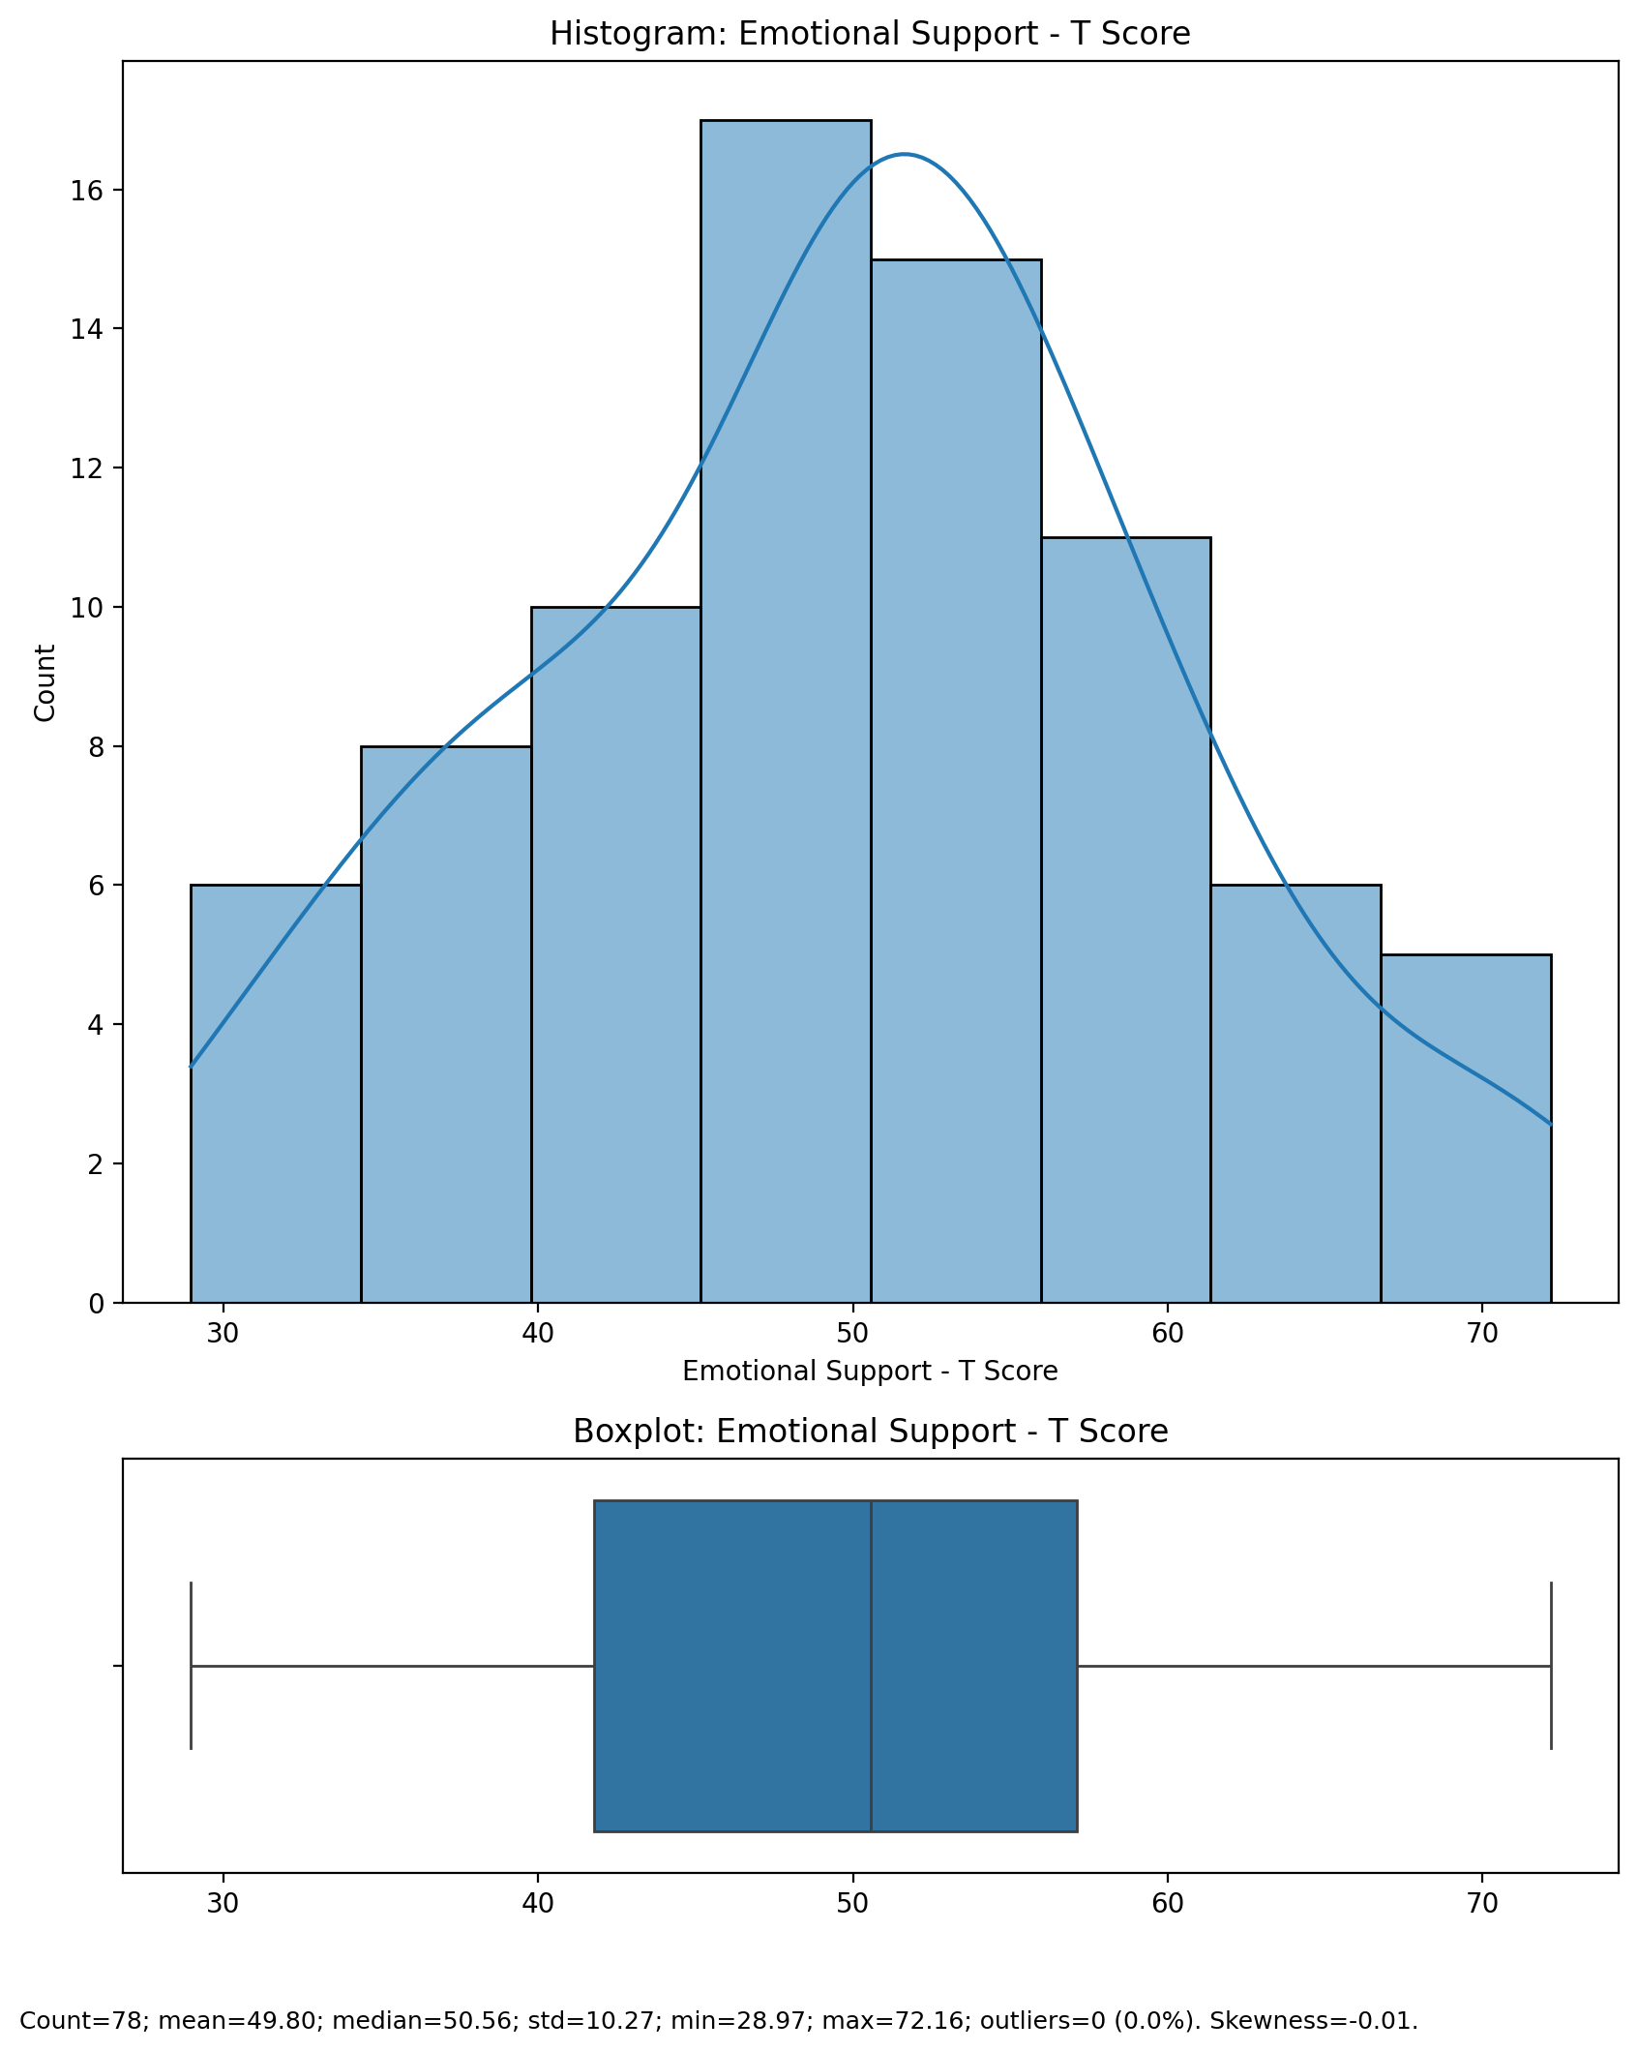

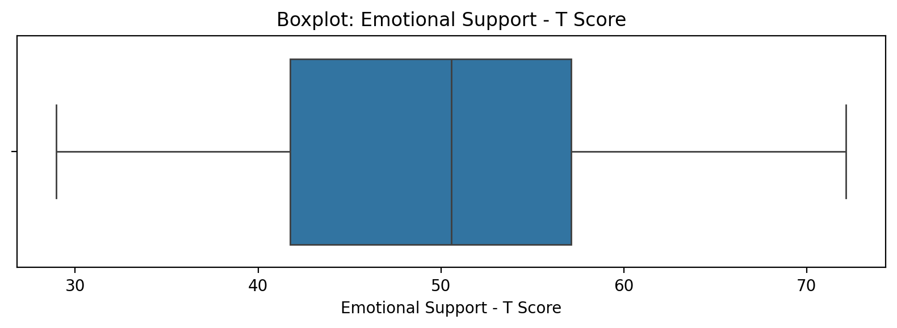

## Emotional Support - T Score

Top categories: Low: 57 (72.2%) | Mild: 13 (16.5%) | Moderate: 5 (6.3%) | Severe: 3 (3.8%) | <<MISSING>>: 1 (1.3%). Note: Top category is sizeable — consider grouping smaller categories.



## Informational Support - T Score

Count=78; mean=45.62; median=47.14; std=13.93; min=0.00; max=70.16; outliers=3 (3.8%). Skewness=-1.24.

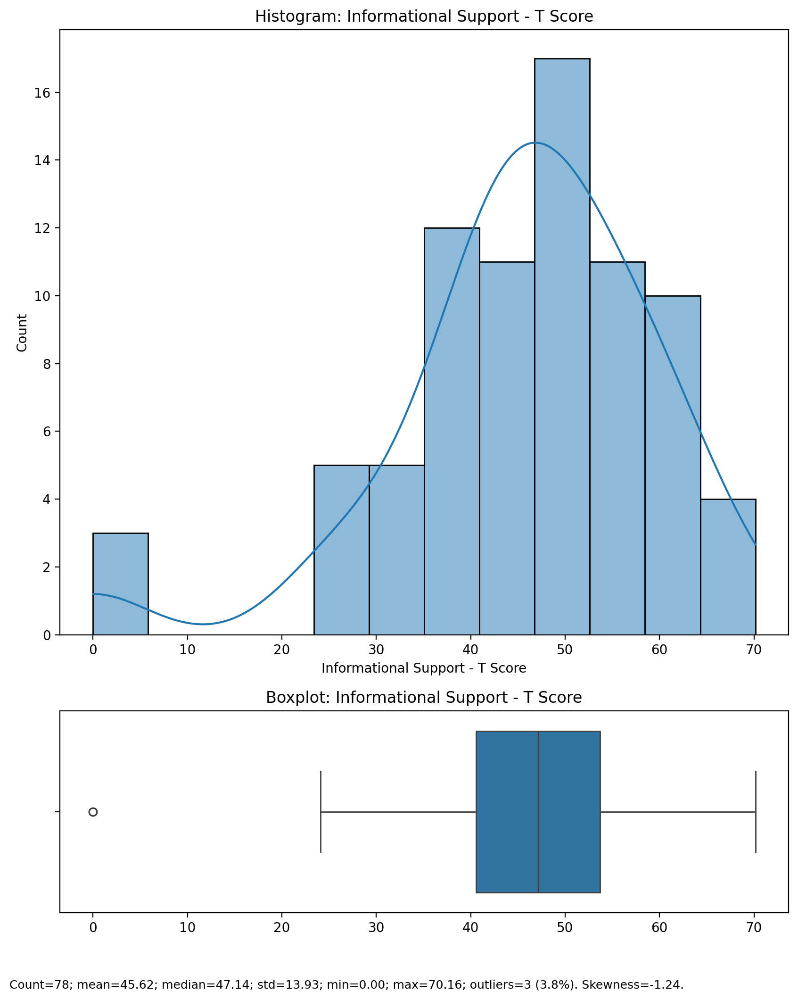

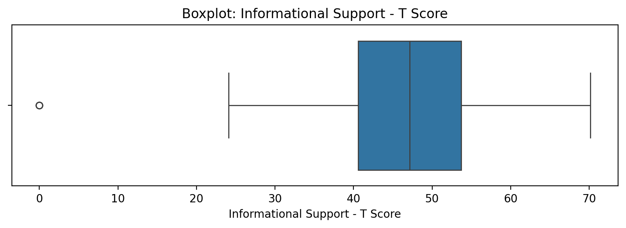

## Informational Support - T Score

Top categories: Low: 57 (72.2%) | Mild: 13 (16.5%) | Moderate: 5 (6.3%) | Severe: 3 (3.8%) | <<MISSING>>: 1 (1.3%). Note: Top category is sizeable — consider grouping smaller categories.



## Instrumental Support - T Score

Count=78; mean=49.51; median=49.90; std=11.34; min=0.00; max=73.94; outliers=1 (1.3%). Skewness=-1.05.

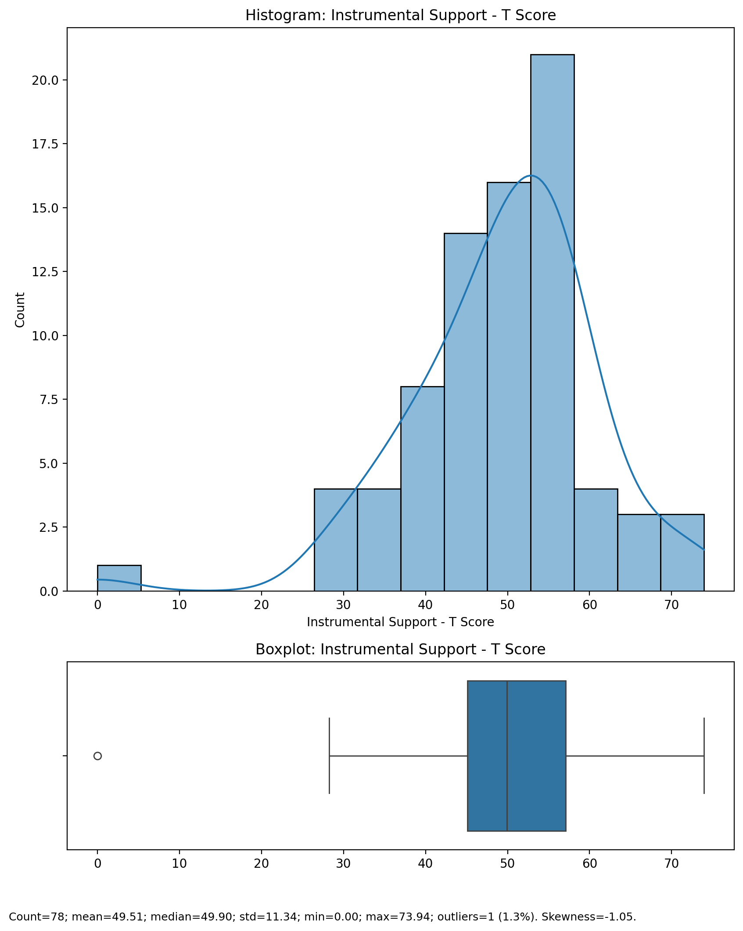

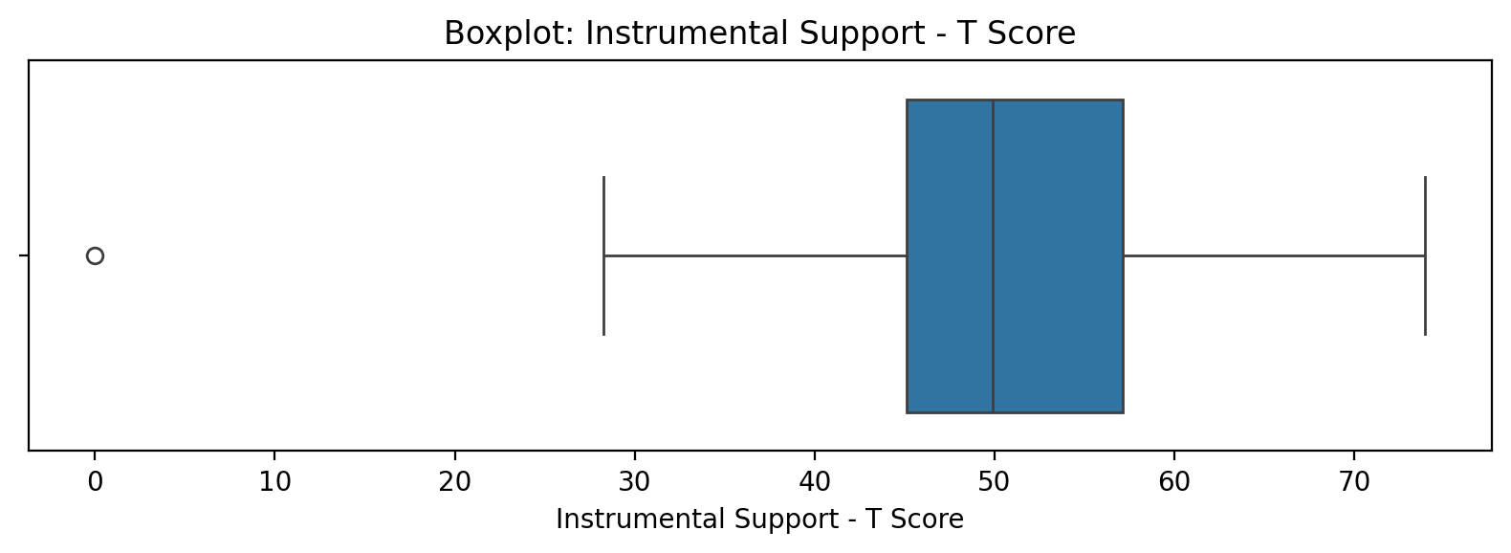

## Instrumental Support - T Score

Top categories: Low: 57 (72.2%) | Mild: 13 (16.5%) | Moderate: 5 (6.3%) | Severe: 3 (3.8%) | <<MISSING>>: 1 (1.3%). Note: Top category is sizeable — consider grouping smaller categories.



## Perceived Social Support Total T Score

Count=78; mean=48.63; median=50.94; std=12.04; min=0.00; max=74.03; outliers=1 (1.3%). Skewness=-0.78.

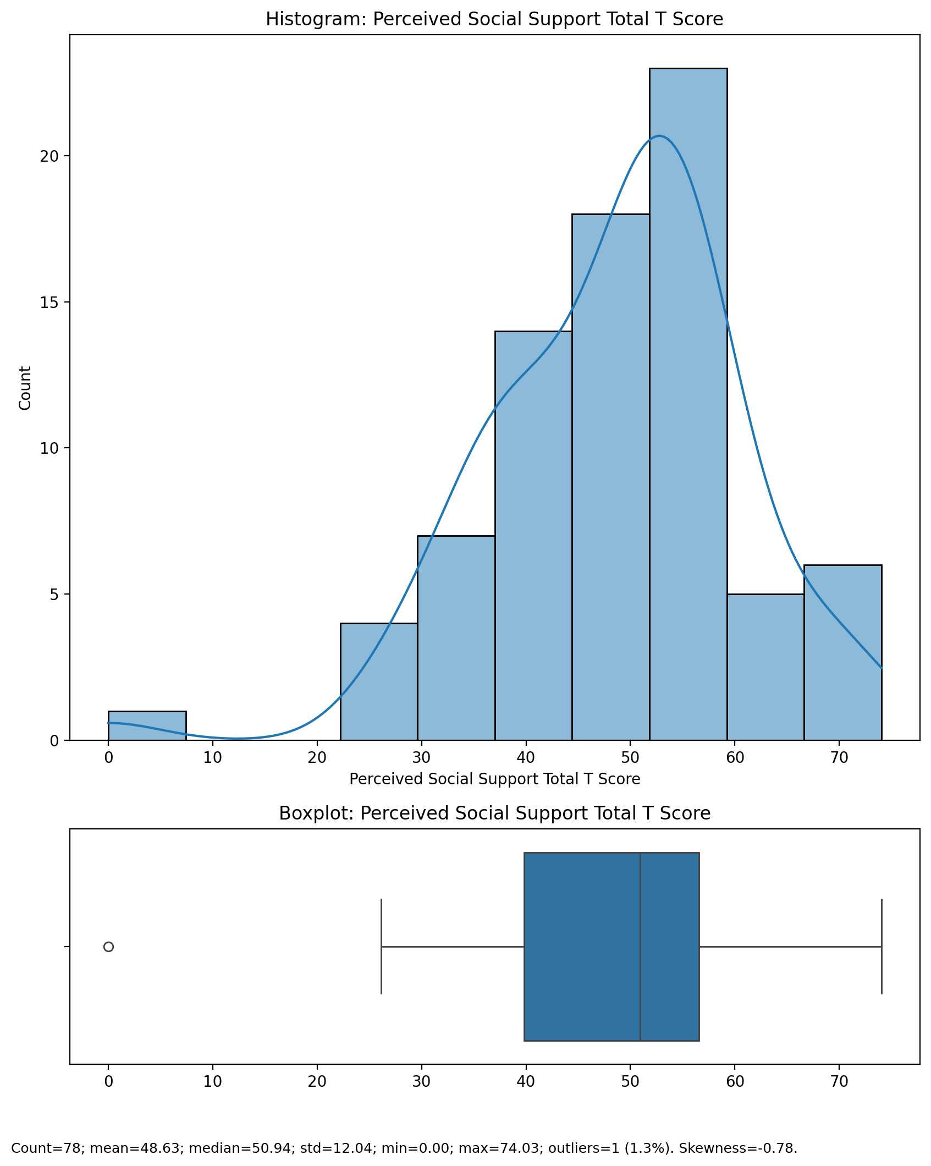

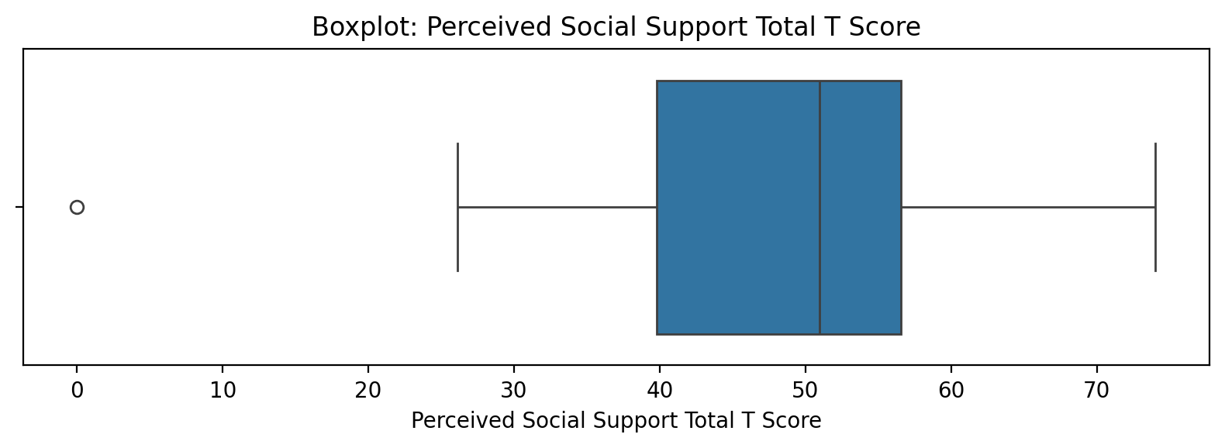

## Perceived Social Support Total T Score

Top categories: Low: 57 (72.2%) | Mild: 13 (16.5%) | Moderate: 5 (6.3%) | Severe: 3 (3.8%) | <<MISSING>>: 1 (1.3%). Note: Top category is sizeable — consider grouping smaller categories.



## Emotional Support - Rank

Top categories: Average: 36 (45.6%) | Low: 19 (24.1%) | High: 15 (19.0%) | Very High: 5 (6.3%) | Very Low: 3 (3.8%) | <<MISSING>>: 1 (1.3%). Note: Top category is sizeable — consider grouping smaller categories.

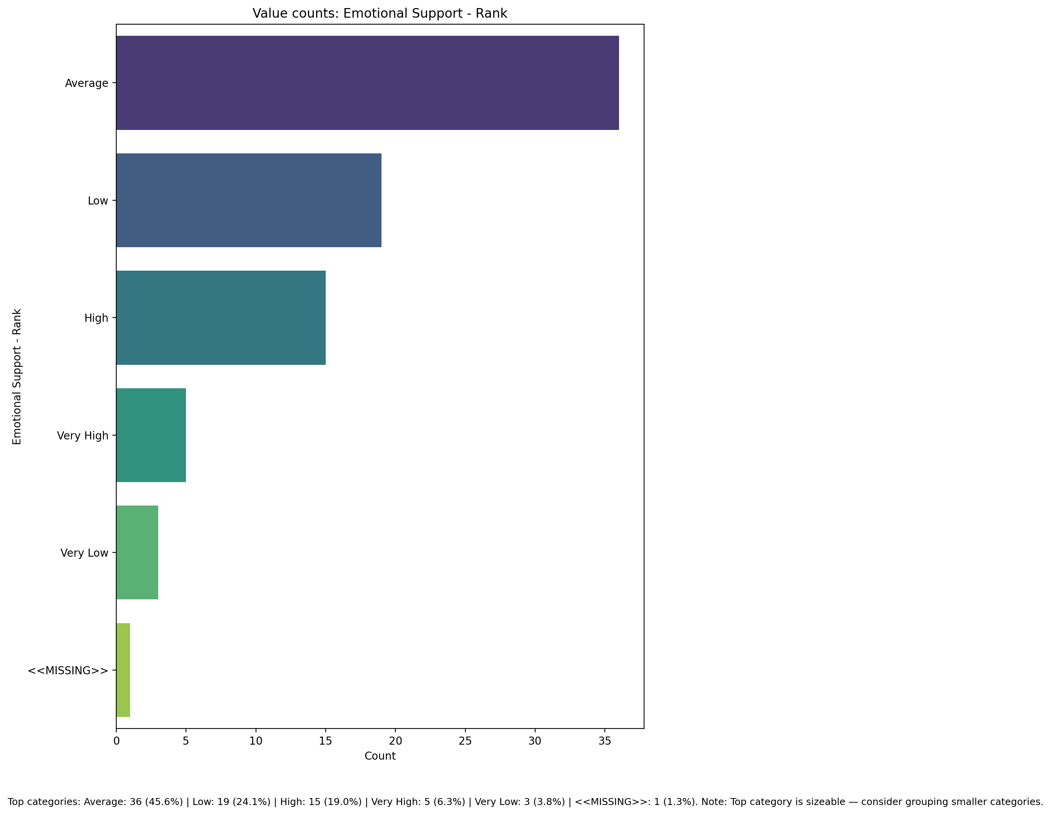

## Informational Support - Rank

Top categories: Low: 27 (34.2%) | Average: 25 (31.6%) | High: 16 (20.3%) | Very Low: 9 (11.4%) | <<MISSING>>: 1 (1.3%) | Very High: 1 (1.3%). Note: Healthy spread across categories.

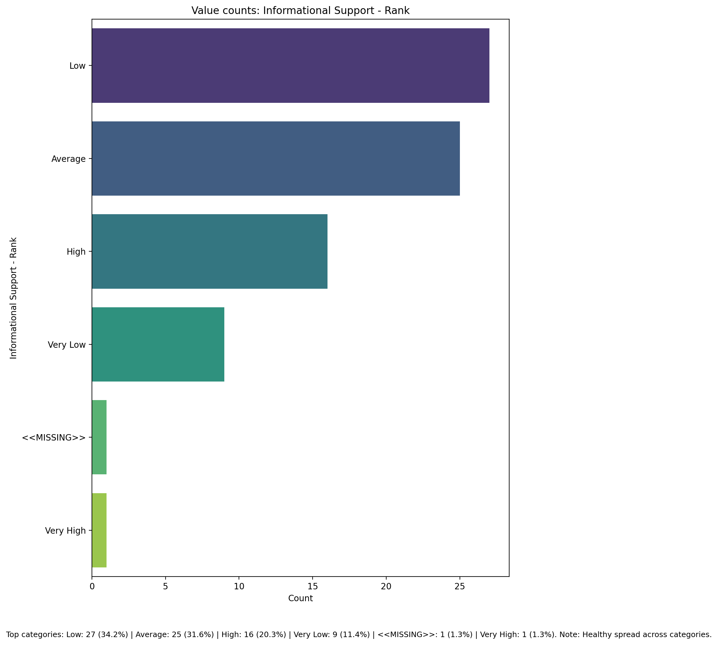

## Instrumental Support - Rank

Top categories: Average: 37 (46.8%) | High: 19 (24.1%) | Low: 14 (17.7%) | Very Low: 5 (6.3%) | Very High: 3 (3.8%) | <<MISSING>>: 1 (1.3%). Note: Top category is sizeable — consider grouping smaller categories.

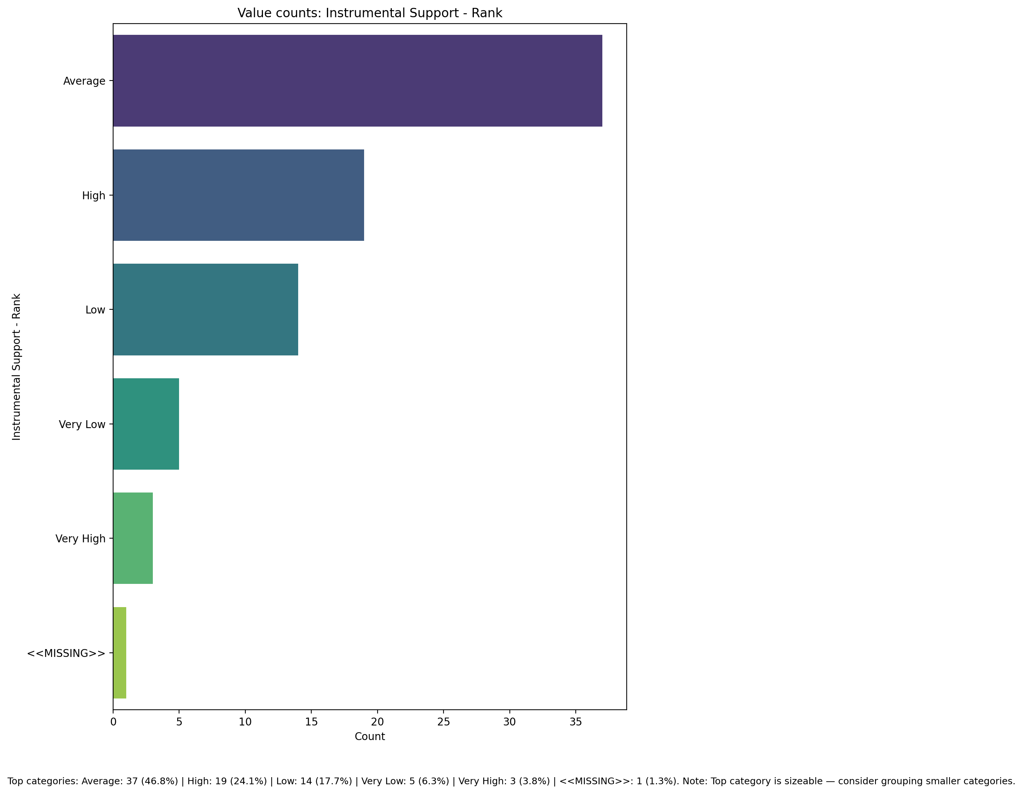

## Perceived Social Support TOTAL - Rank

Top categories: Average: 39 (49.4%) | Low: 20 (25.3%) | High: 12 (15.2%) | Very Low: 5 (6.3%) | Very High: 2 (2.5%) | <<MISSING>>: 1 (1.3%). Note: Top category is sizeable — consider grouping smaller categories.

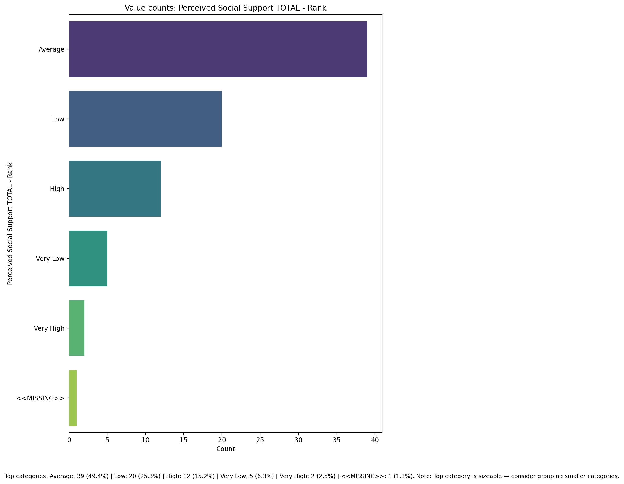

## Power Self Concept - Real Self Concept Score

Count=78; mean=22.62; median=22.00; std=4.62; min=13.00; max=30.00; outliers=0 (0.0%). Skewness=-0.18.

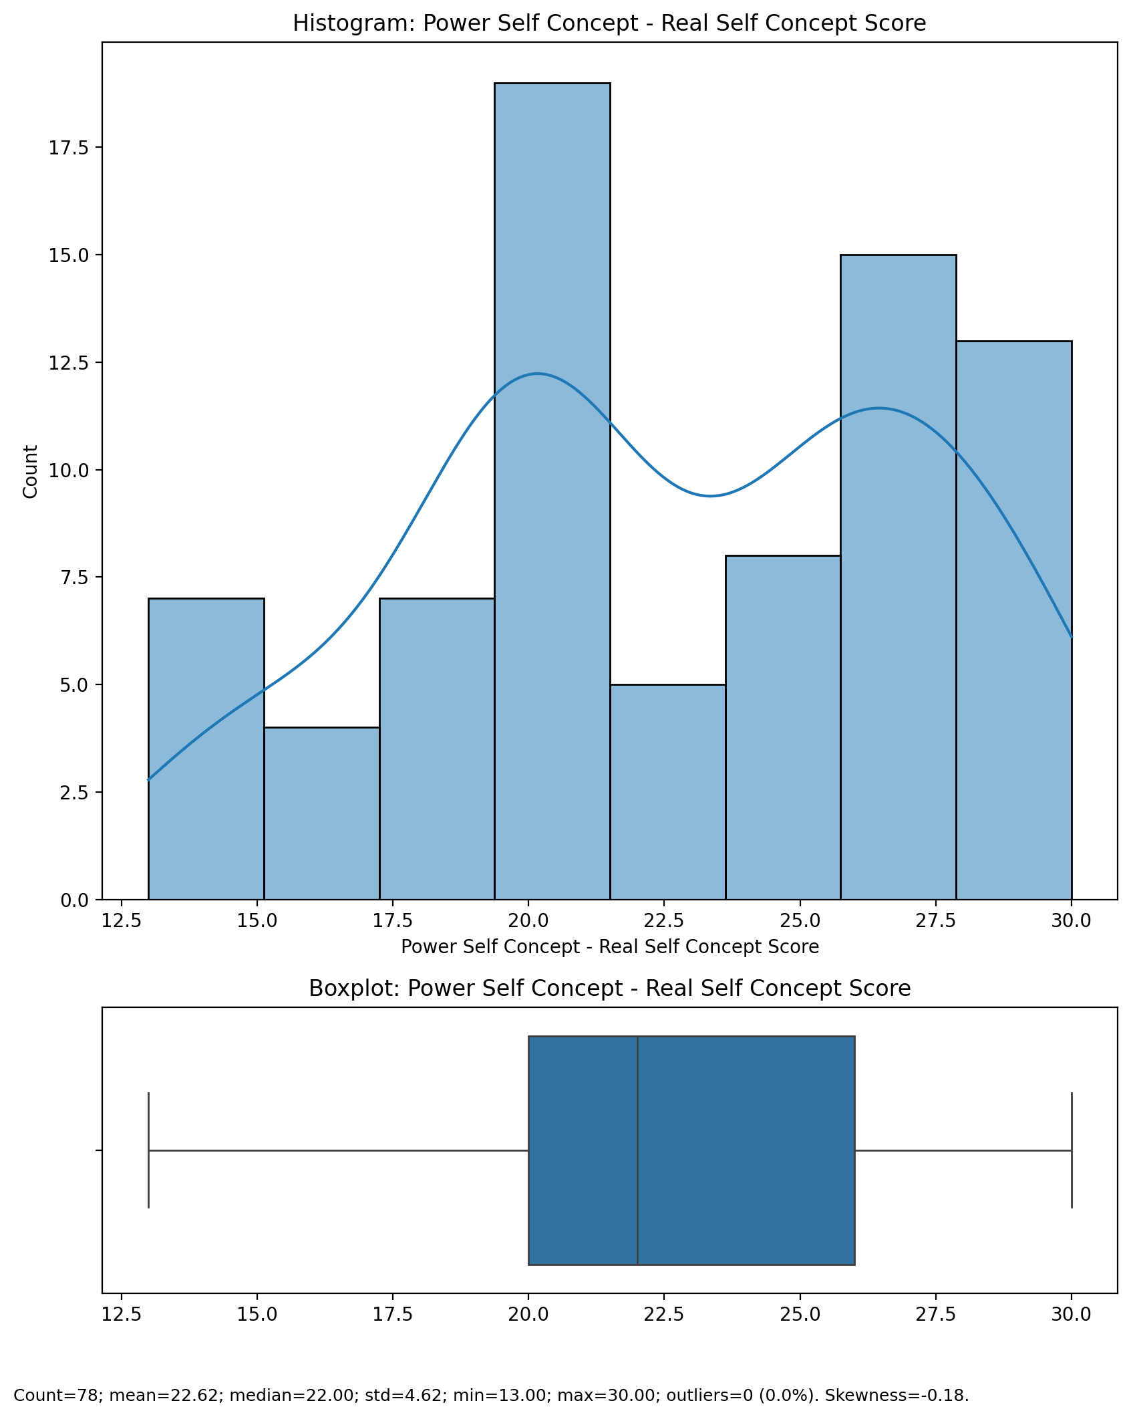

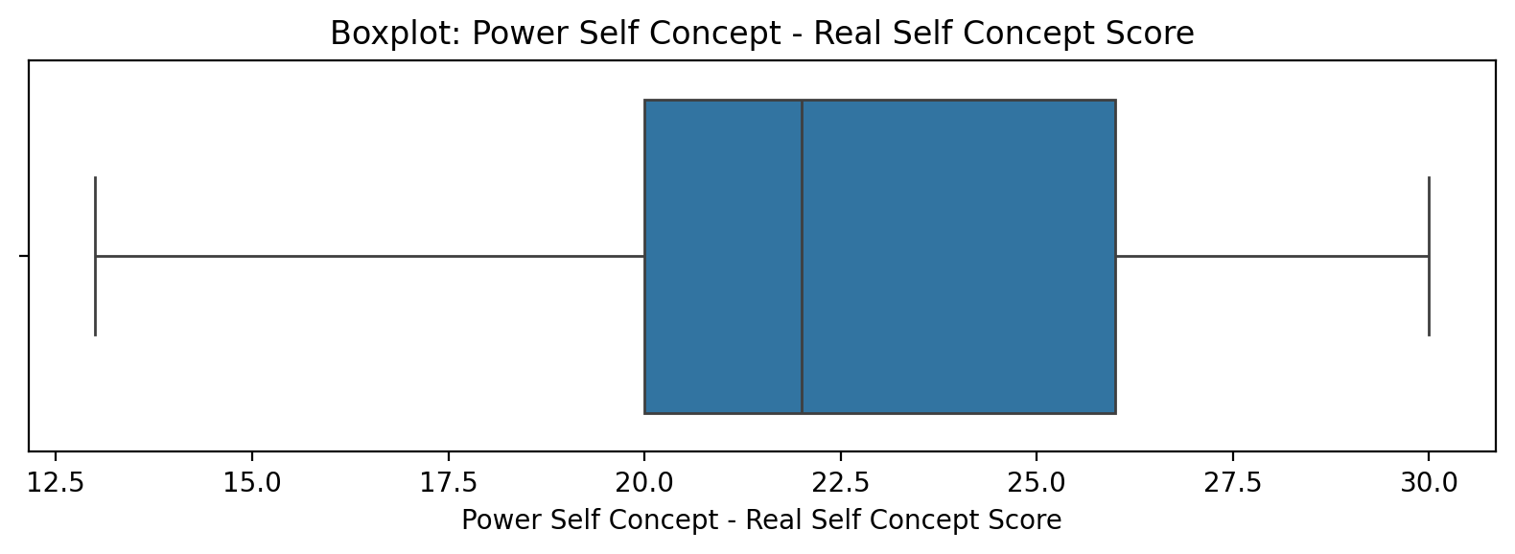

## Power Self Concept - Real Self Concept Score

Top categories: Average: 39 (49.4%) | Low: 20 (25.3%) | High: 12 (15.2%) | Very Low: 5 (6.3%) | Very High: 2 (2.5%) | <<MISSING>>: 1 (1.3%). Note: Top category is sizeable — consider grouping smaller categories.



## Power Self Concept - Ideal Self Concept score

Count=78; mean=25.85; median=27.00; std=3.79; min=15.00; max=30.00; outliers=0 (0.0%). Skewness=-0.79.

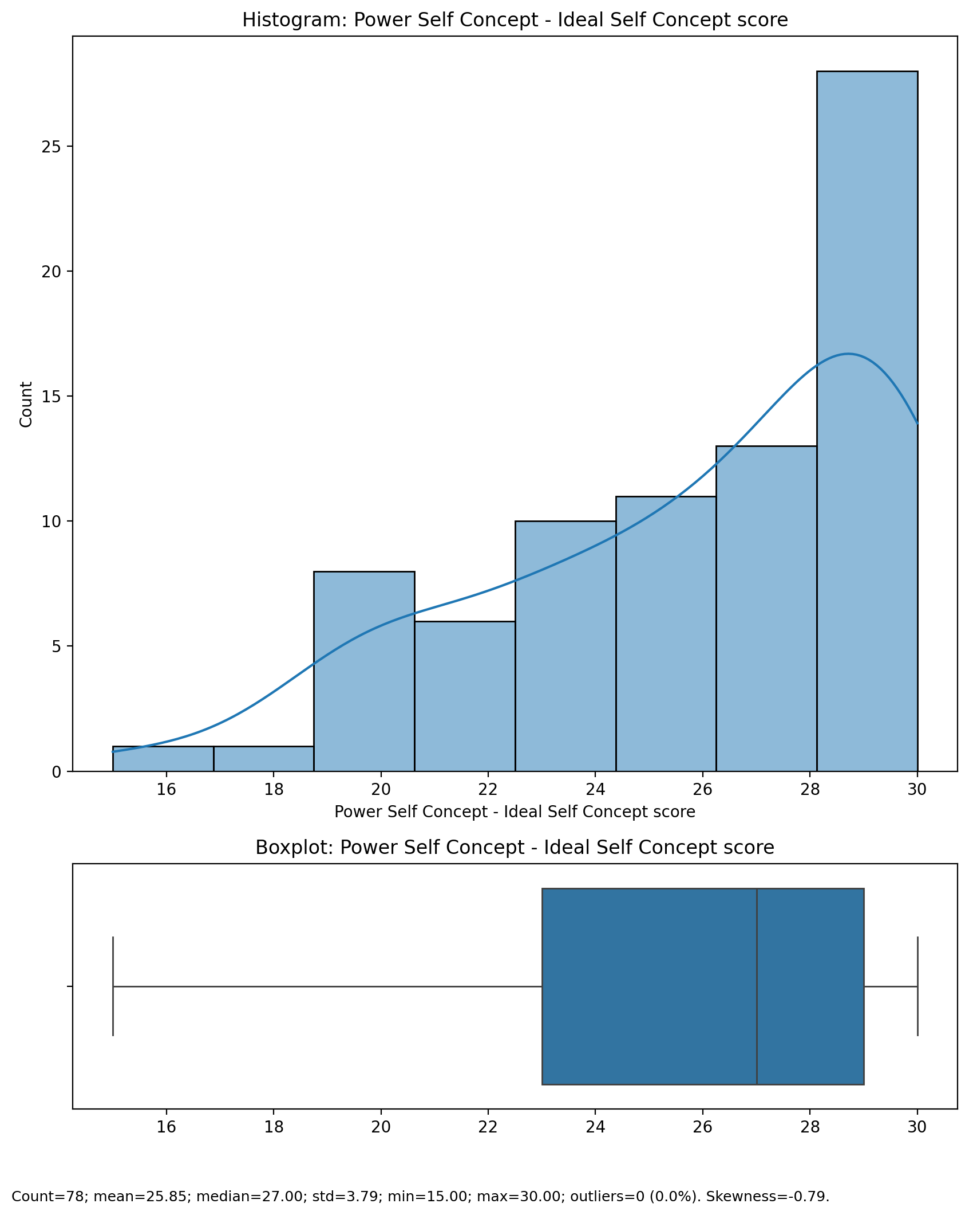

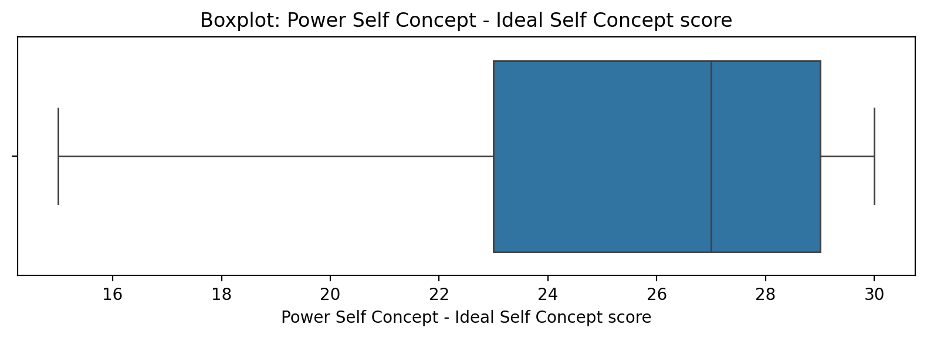

## Power Self Concept - Ideal Self Concept score

Top categories: Average: 39 (49.4%) | Low: 20 (25.3%) | High: 12 (15.2%) | Very Low: 5 (6.3%) | Very High: 2 (2.5%) | <<MISSING>>: 1 (1.3%). Note: Top category is sizeable — consider grouping smaller categories.



## Power Self Concept – Social Self Concept Score

Count=78; mean=22.31; median=23.00; std=4.74; min=10.00; max=30.00; outliers=0 (0.0%). Skewness=-0.44.

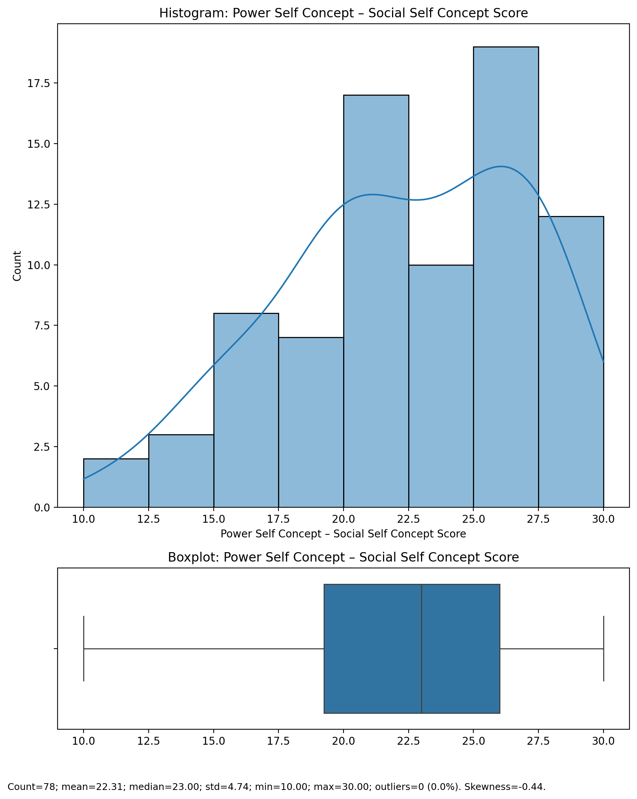

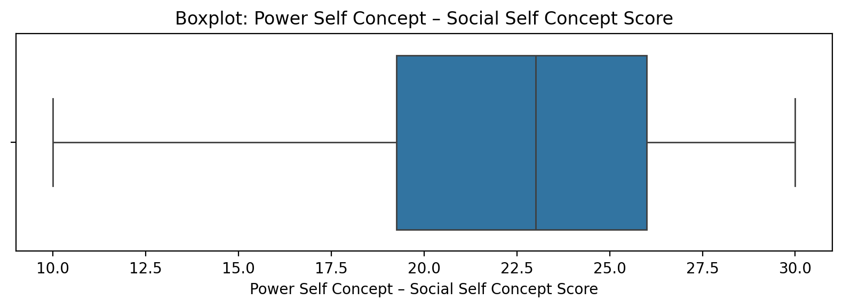

## Power Self Concept – Social Self Concept Score

Top categories: Average: 39 (49.4%) | Low: 20 (25.3%) | High: 12 (15.2%) | Very Low: 5 (6.3%) | Very High: 2 (2.5%) | <<MISSING>>: 1 (1.3%). Note: Top category is sizeable — consider grouping smaller categories.



## Social Self Concept - Real Self Concept Score

Count=78; mean=23.97; median=24.00; std=4.54; min=11.00; max=30.00; outliers=0 (0.0%). Skewness=-0.50.

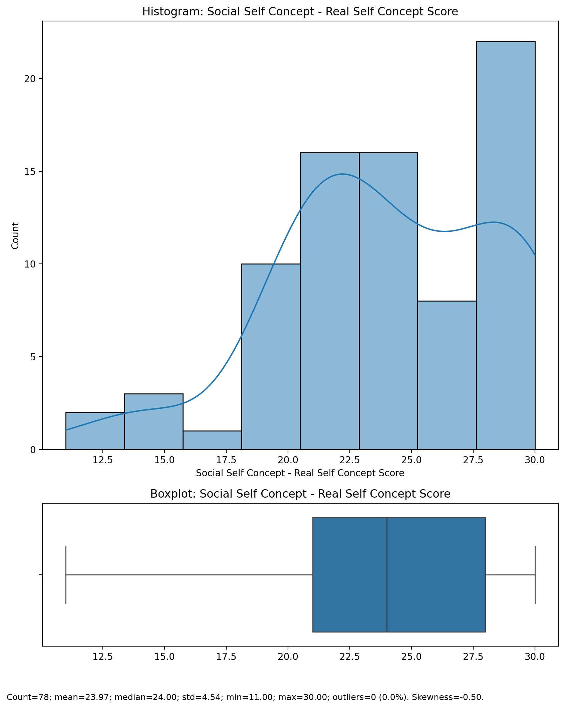

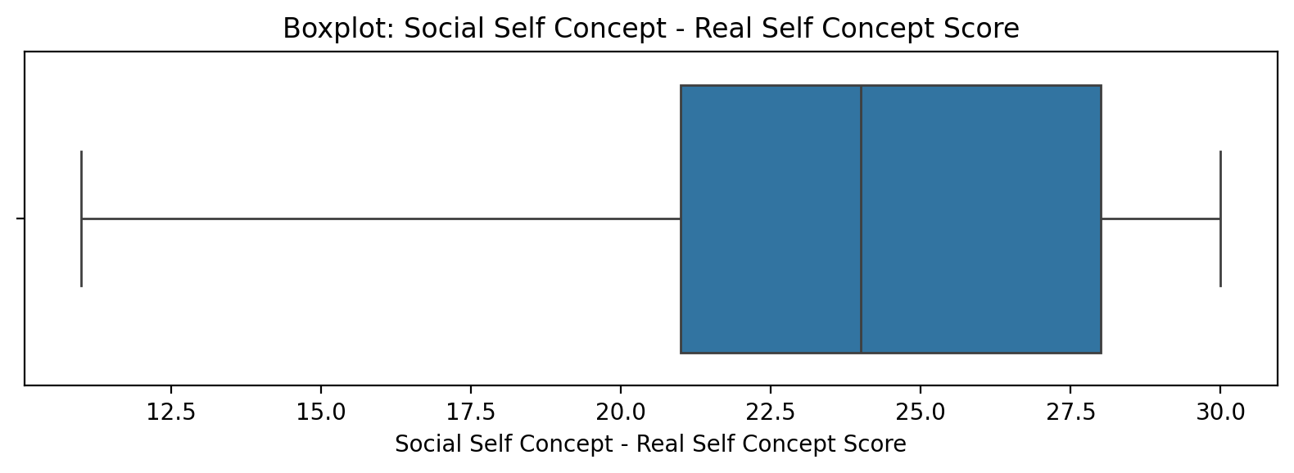

## Social Self Concept - Real Self Concept Score

Top categories: Average: 39 (49.4%) | Low: 20 (25.3%) | High: 12 (15.2%) | Very Low: 5 (6.3%) | Very High: 2 (2.5%) | <<MISSING>>: 1 (1.3%). Note: Top category is sizeable — consider grouping smaller categories.



## Social Self Concept – Ideal Self Concept Score

Count=78; mean=25.55; median=27.00; std=4.41; min=13.00; max=30.00; outliers=2 (2.6%). Skewness=-1.11.

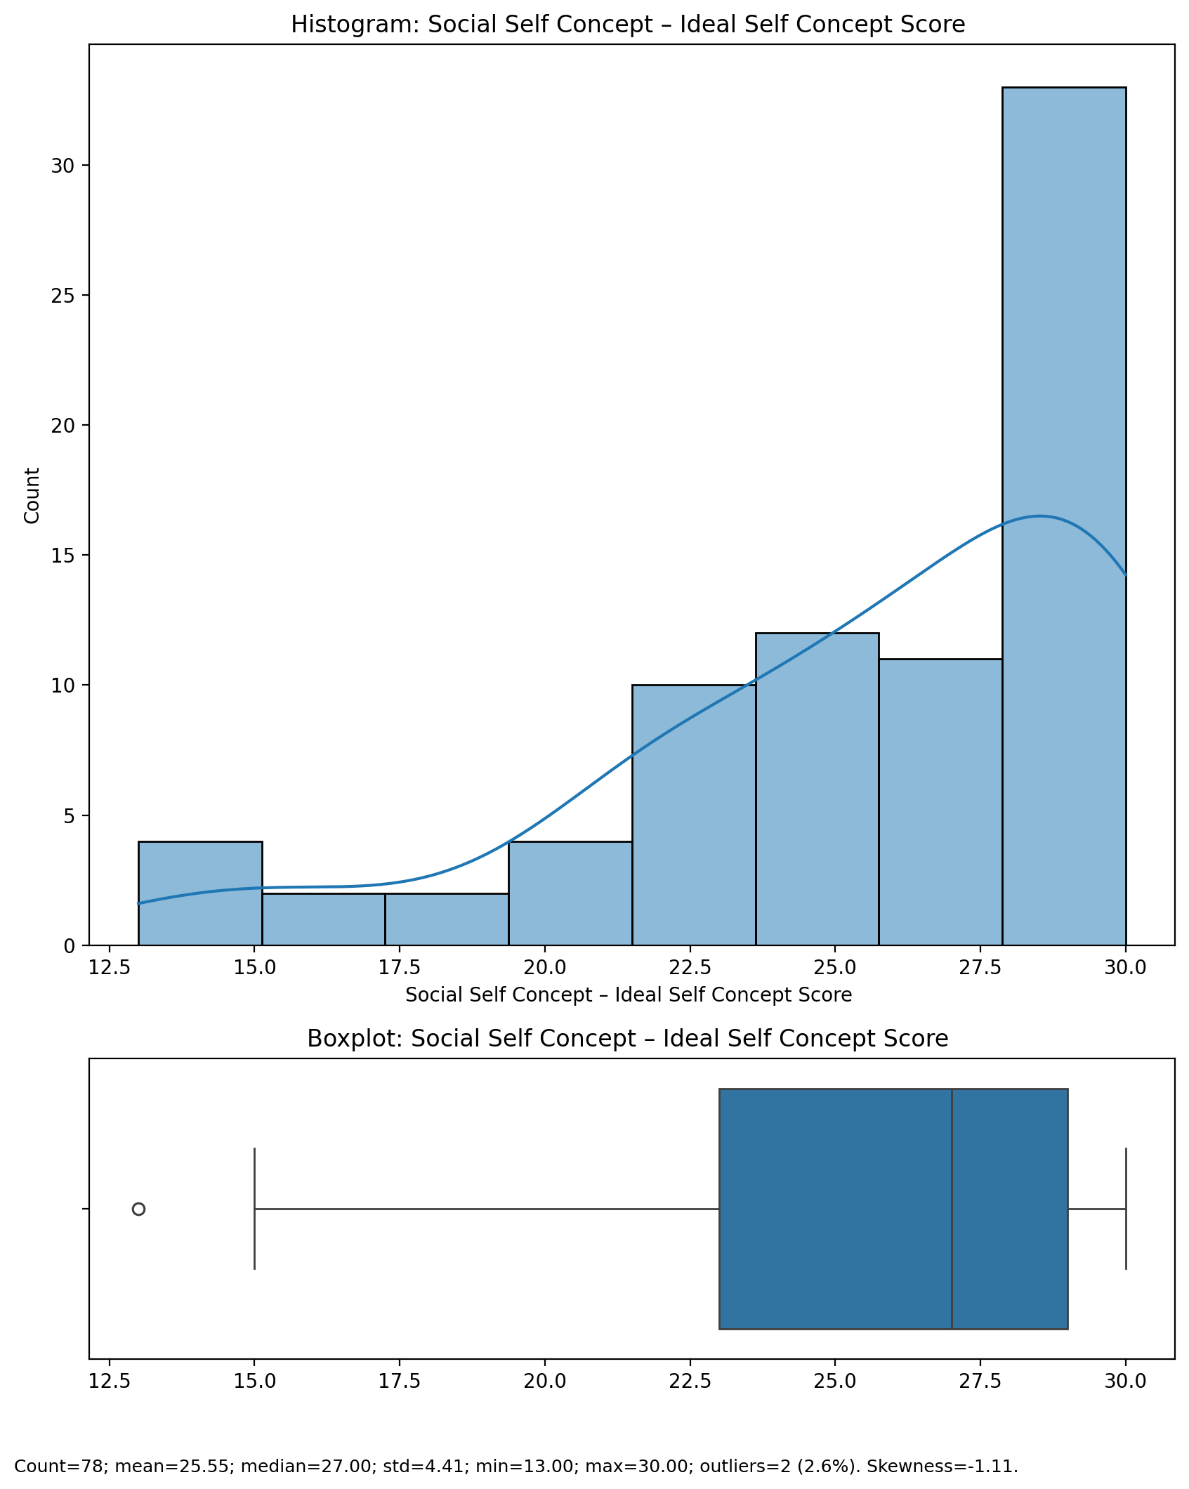

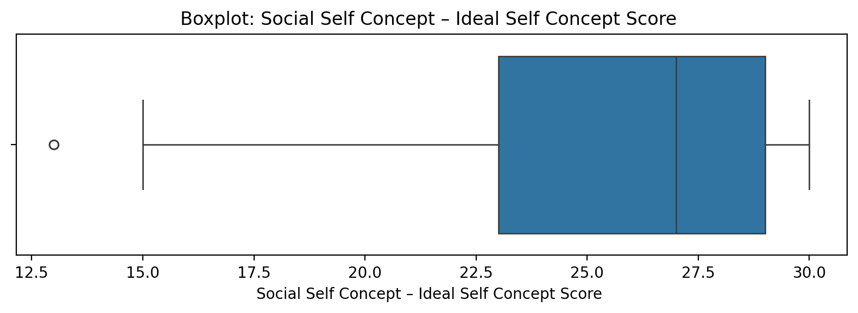

## Social Self Concept – Ideal Self Concept Score

Top categories: Average: 39 (49.4%) | Low: 20 (25.3%) | High: 12 (15.2%) | Very Low: 5 (6.3%) | Very High: 2 (2.5%) | <<MISSING>>: 1 (1.3%). Note: Top category is sizeable — consider grouping smaller categories.



## Social Self Concept – Social Self Concept Score

Count=78; mean=23.42; median=24.00; std=4.57; min=10.00; max=30.00; outliers=0 (0.0%). Skewness=-0.52.

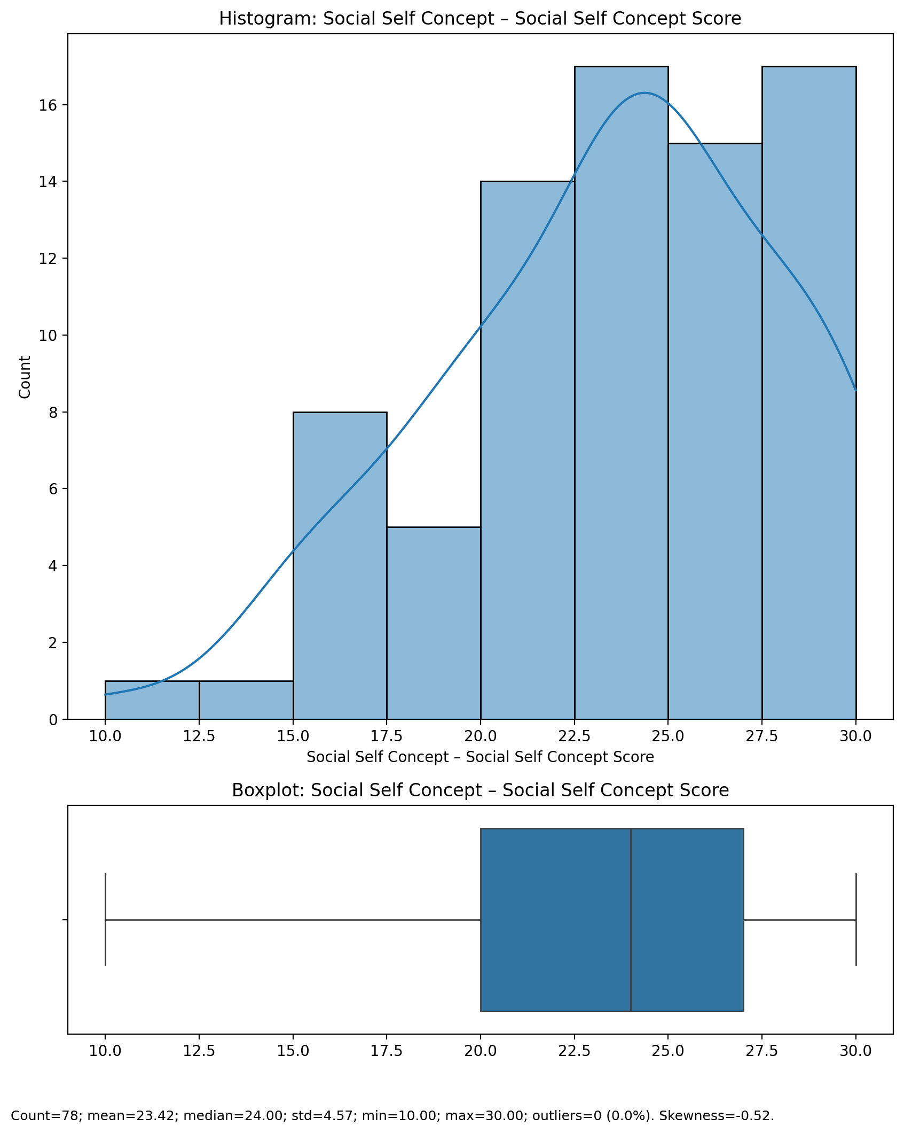

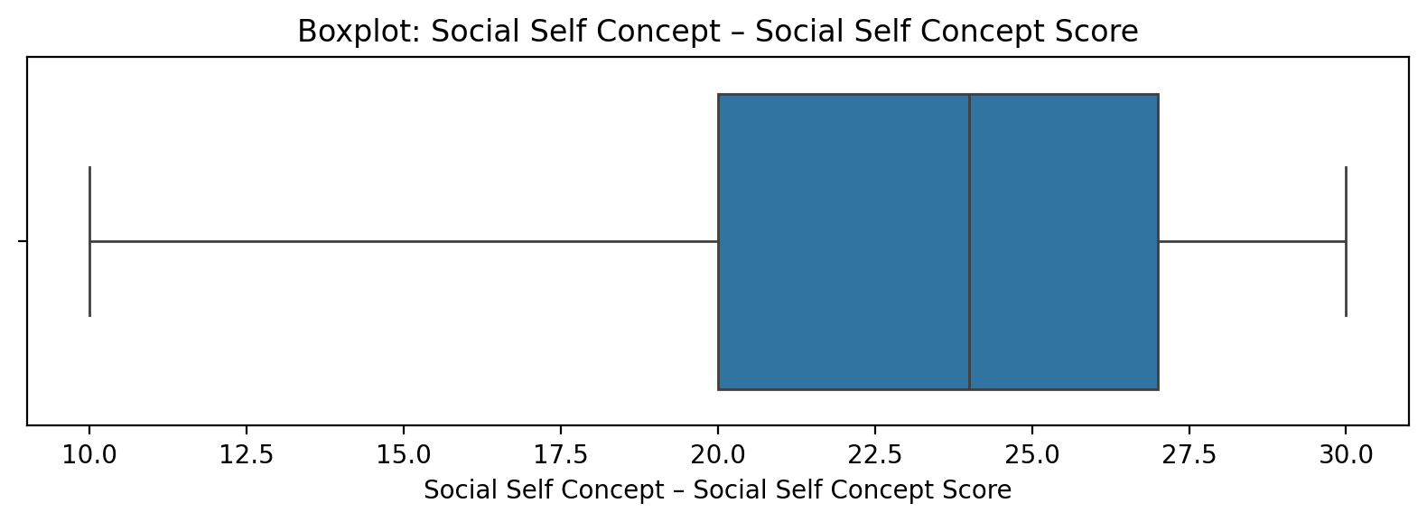

## Social Self Concept – Social Self Concept Score

Top categories: Average: 39 (49.4%) | Low: 20 (25.3%) | High: 12 (15.2%) | Very Low: 5 (6.3%) | Very High: 2 (2.5%) | <<MISSING>>: 1 (1.3%). Note: Top category is sizeable — consider grouping smaller categories.



## Ability Self Concept - Real Self Concept Score

Count=78; mean=23.77; median=23.50; std=4.48; min=16.00; max=30.00; outliers=0 (0.0%). Skewness=-0.08.

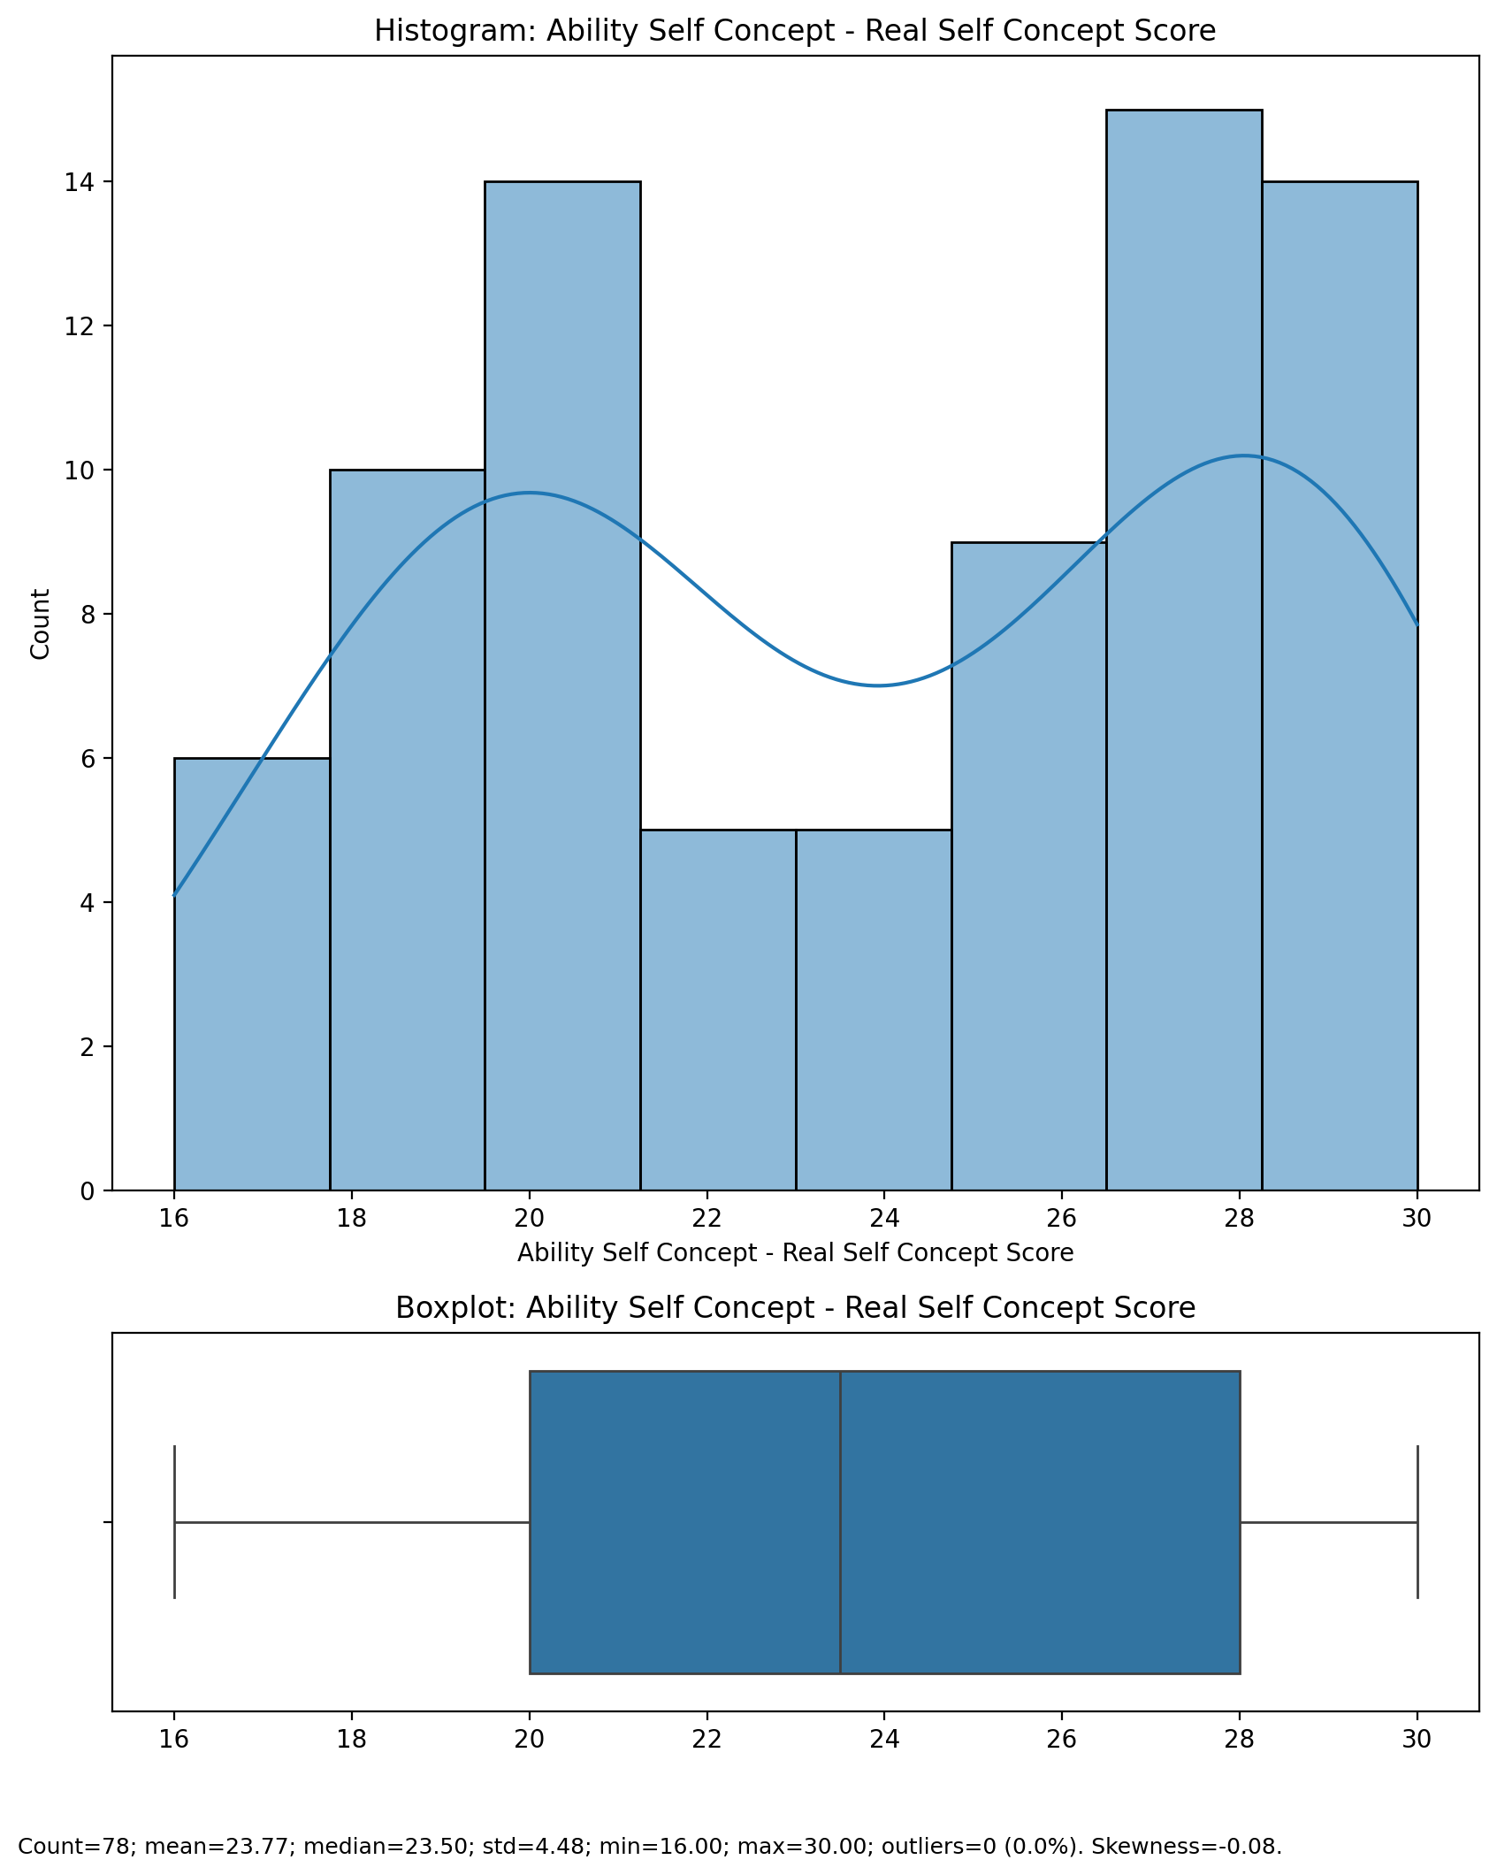

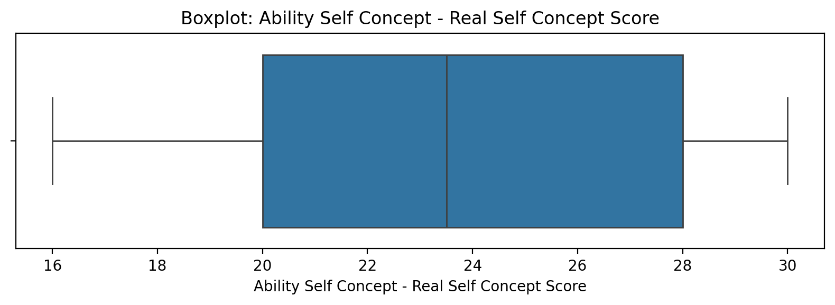

## Ability Self Concept - Real Self Concept Score

Top categories: Average: 39 (49.4%) | Low: 20 (25.3%) | High: 12 (15.2%) | Very Low: 5 (6.3%) | Very High: 2 (2.5%) | <<MISSING>>: 1 (1.3%). Note: Top category is sizeable — consider grouping smaller categories.



## Ability Self Concept - Ideal Self Concept Score

Count=78; mean=25.69; median=28.00; std=4.74; min=13.00; max=30.00; outliers=0 (0.0%). Skewness=-1.03.

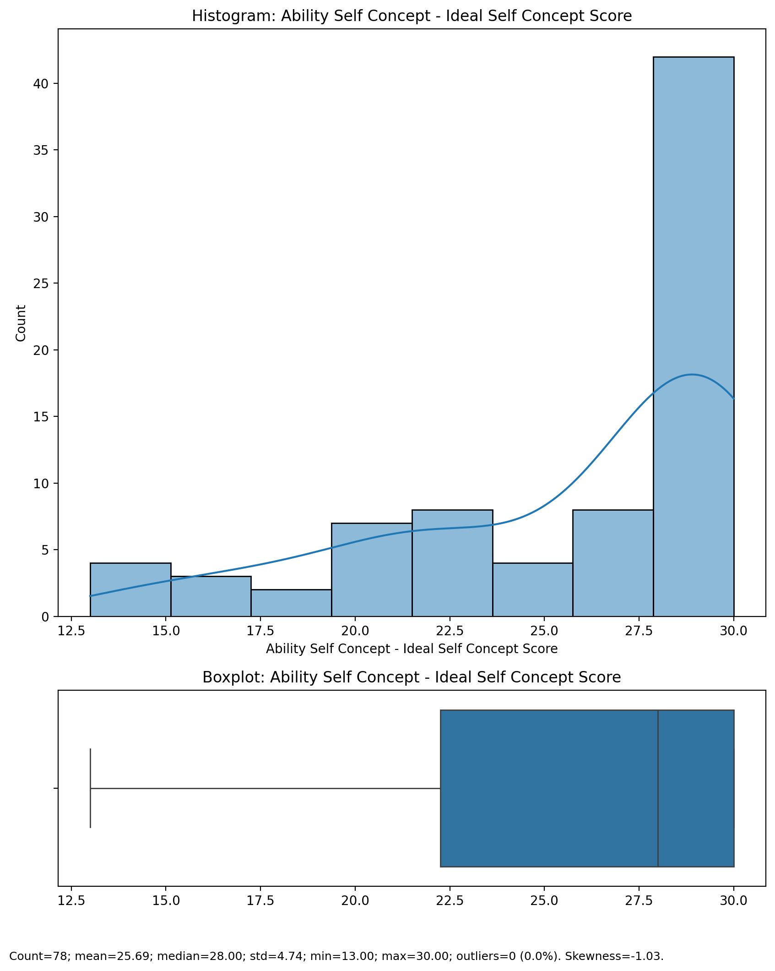

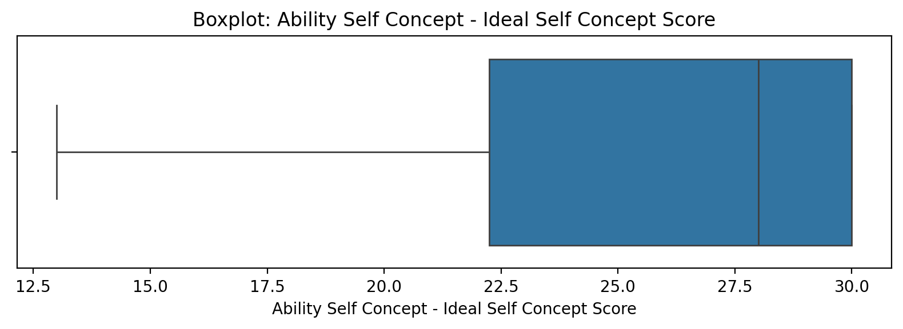

## Ability Self Concept - Ideal Self Concept Score

Top categories: Average: 39 (49.4%) | Low: 20 (25.3%) | High: 12 (15.2%) | Very Low: 5 (6.3%) | Very High: 2 (2.5%) | <<MISSING>>: 1 (1.3%). Note: Top category is sizeable — consider grouping smaller categories.



## Ability Self Concept – Social Self Concept Score

Count=78; mean=23.06; median=23.00; std=4.46; min=10.00; max=30.00; outliers=0 (0.0%). Skewness=-0.41.

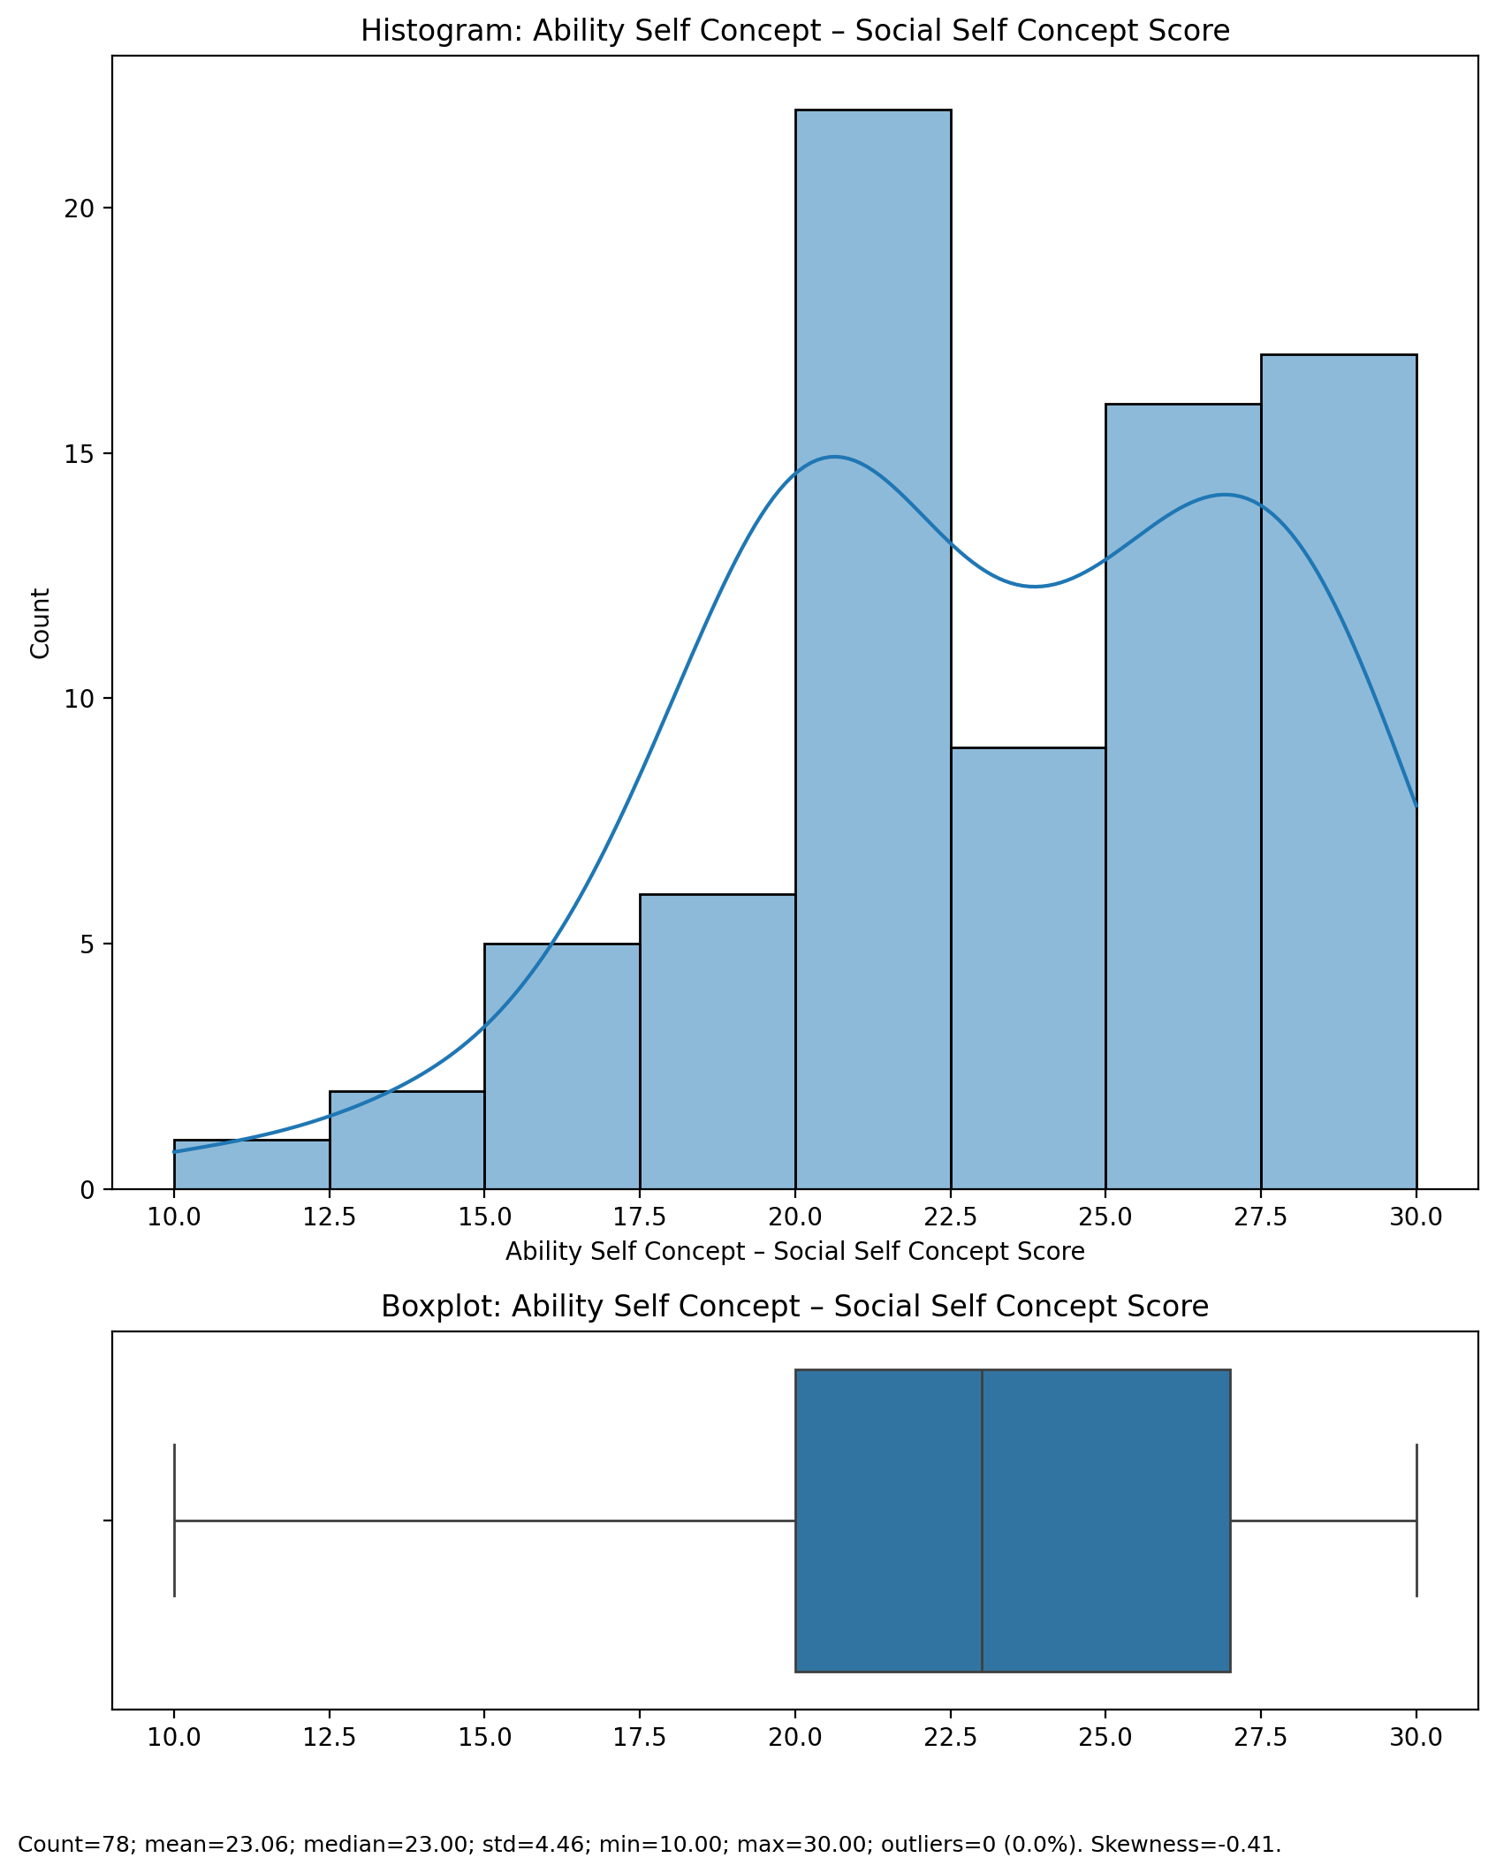

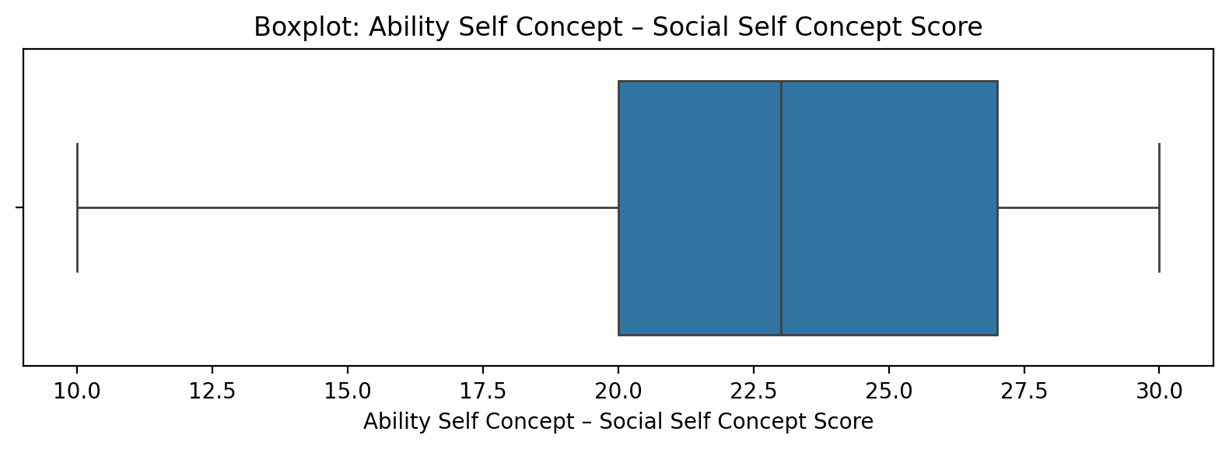

## Ability Self Concept – Social Self Concept Score

Top categories: Average: 39 (49.4%) | Low: 20 (25.3%) | High: 12 (15.2%) | Very Low: 5 (6.3%) | Very High: 2 (2.5%) | <<MISSING>>: 1 (1.3%). Note: Top category is sizeable — consider grouping smaller categories.



## Physical Self Concept - Real Self Concept Score

Count=78; mean=23.32; median=23.00; std=4.61; min=13.00; max=30.00; outliers=0 (0.0%). Skewness=-0.18.

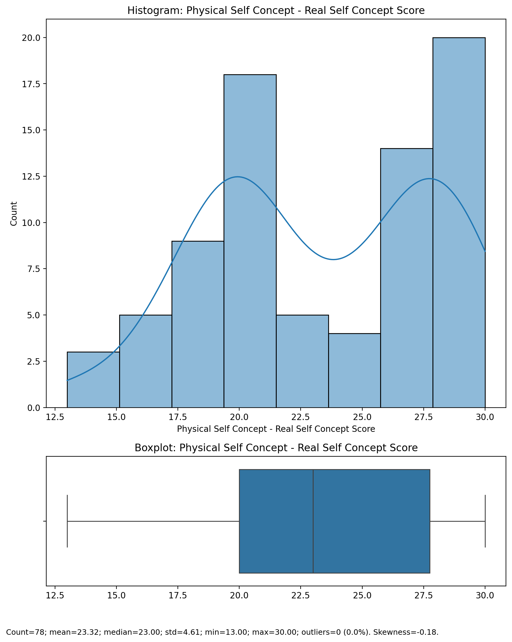

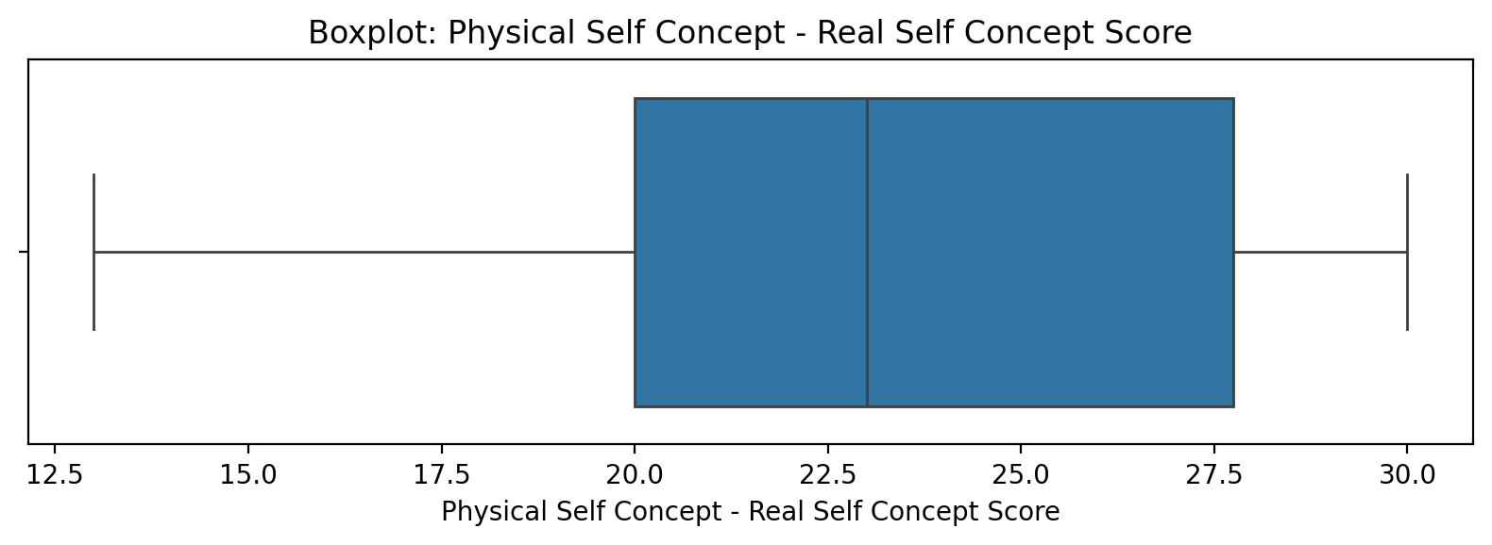

## Physical Self Concept - Real Self Concept Score

Top categories: Average: 39 (49.4%) | Low: 20 (25.3%) | High: 12 (15.2%) | Very Low: 5 (6.3%) | Very High: 2 (2.5%) | <<MISSING>>: 1 (1.3%). Note: Top category is sizeable — consider grouping smaller categories.



## Physical Self Concept – Ideal Self Concept Score

Count=78; mean=25.88; median=27.50; std=4.45; min=15.00; max=30.00; outliers=0 (0.0%). Skewness=-0.84.

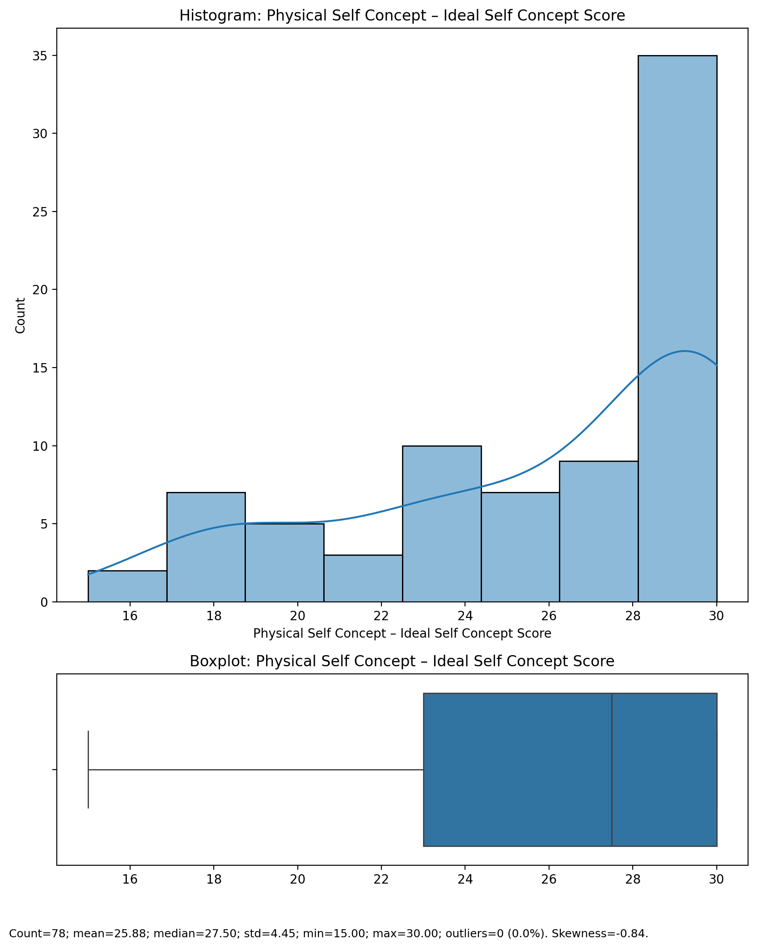

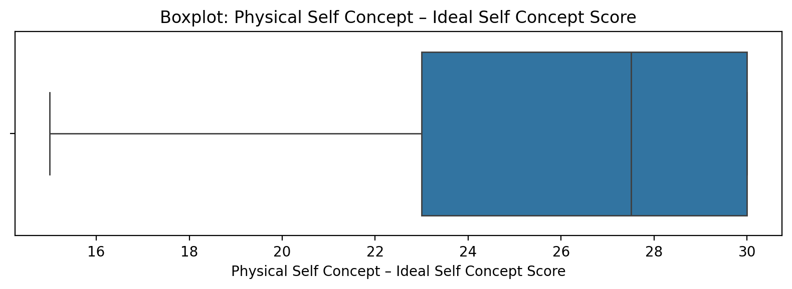

## Physical Self Concept – Ideal Self Concept Score

Top categories: Average: 39 (49.4%) | Low: 20 (25.3%) | High: 12 (15.2%) | Very Low: 5 (6.3%) | Very High: 2 (2.5%) | <<MISSING>>: 1 (1.3%). Note: Top category is sizeable — consider grouping smaller categories.



## Physical Self Concept – Social Self Concept Score

Count=78; mean=22.76; median=23.00; std=4.62; min=10.00; max=30.00; outliers=0 (0.0%). Skewness=-0.33.

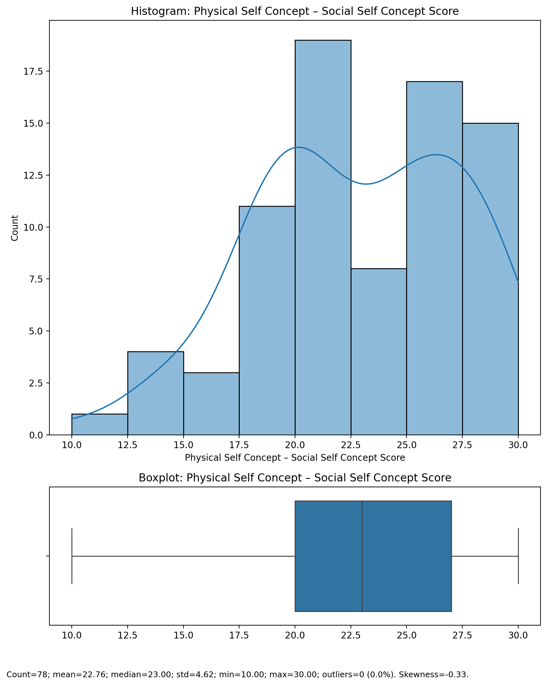

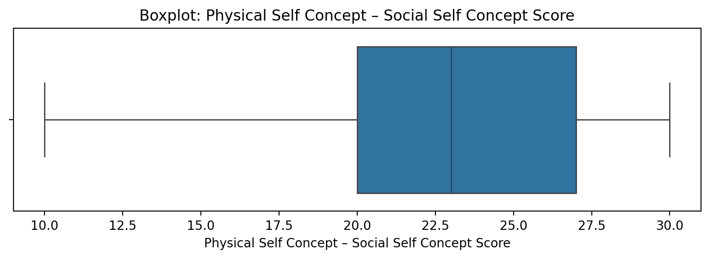

## Physical Self Concept – Social Self Concept Score

Top categories: Average: 39 (49.4%) | Low: 20 (25.3%) | High: 12 (15.2%) | Very Low: 5 (6.3%) | Very High: 2 (2.5%) | <<MISSING>>: 1 (1.3%). Note: Top category is sizeable — consider grouping smaller categories.



## Psychological Self Concept - Real Self Concept Score

Count=78; mean=56.74; median=58.00; std=10.96; min=30.00; max=72.00; outliers=0 (0.0%). Skewness=-0.59.

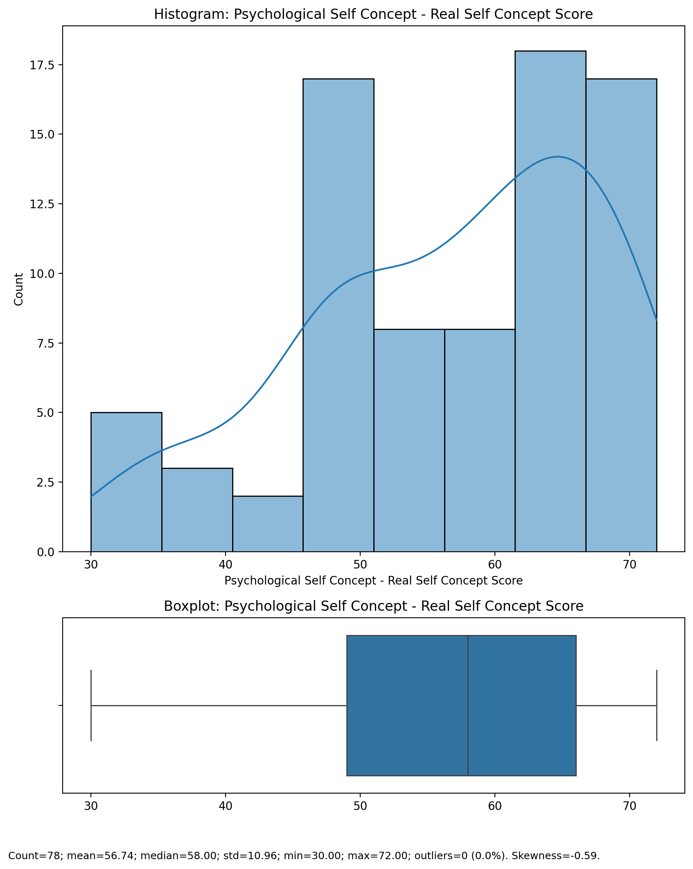

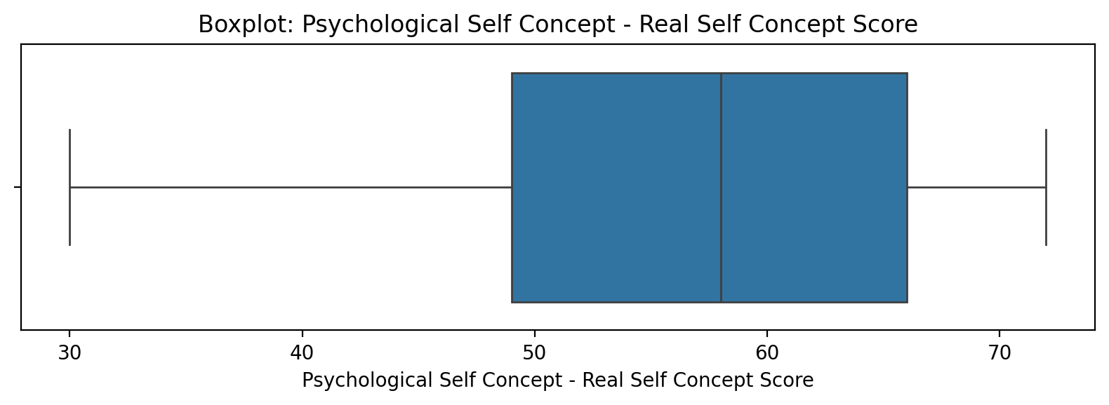

## Psychological Self Concept - Real Self Concept Score

Top categories: Average: 39 (49.4%) | Low: 20 (25.3%) | High: 12 (15.2%) | Very Low: 5 (6.3%) | Very High: 2 (2.5%) | <<MISSING>>: 1 (1.3%). Note: Top category is sizeable — consider grouping smaller categories.



## Psychological Self Concept – Ideal Self Concept Score

Count=78; mean=62.01; median=65.50; std=10.68; min=32.00; max=72.00; outliers=3 (3.8%). Skewness=-1.22.

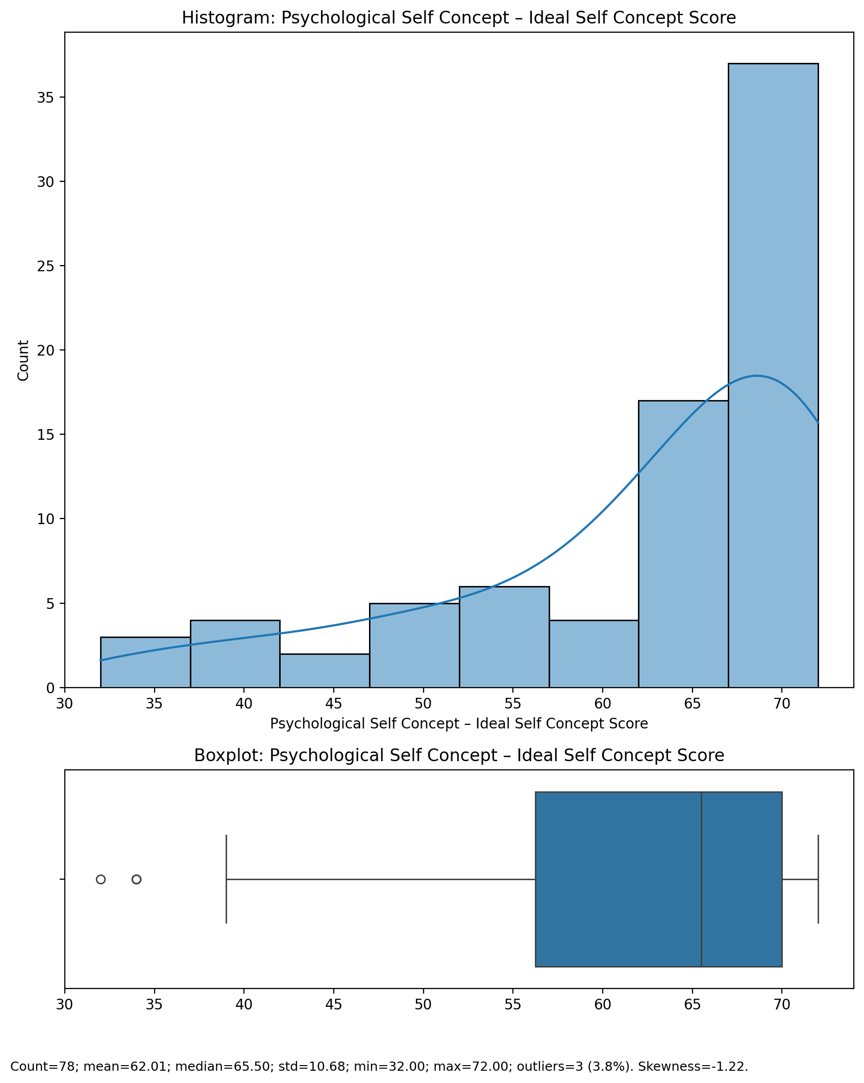

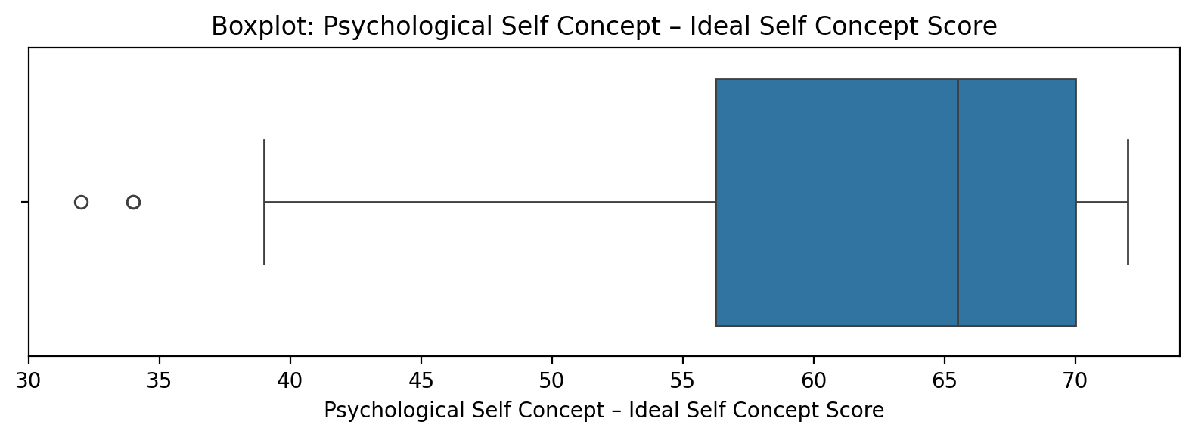

## Psychological Self Concept – Ideal Self Concept Score

Top categories: Average: 39 (49.4%) | Low: 20 (25.3%) | High: 12 (15.2%) | Very Low: 5 (6.3%) | Very High: 2 (2.5%) | <<MISSING>>: 1 (1.3%). Note: Top category is sizeable — consider grouping smaller categories.



## Psychological Self Concept – Social Self Concept Score

Count=78; mean=55.36; median=56.00; std=11.05; min=24.00; max=72.00; outliers=0 (0.0%). Skewness=-0.56.

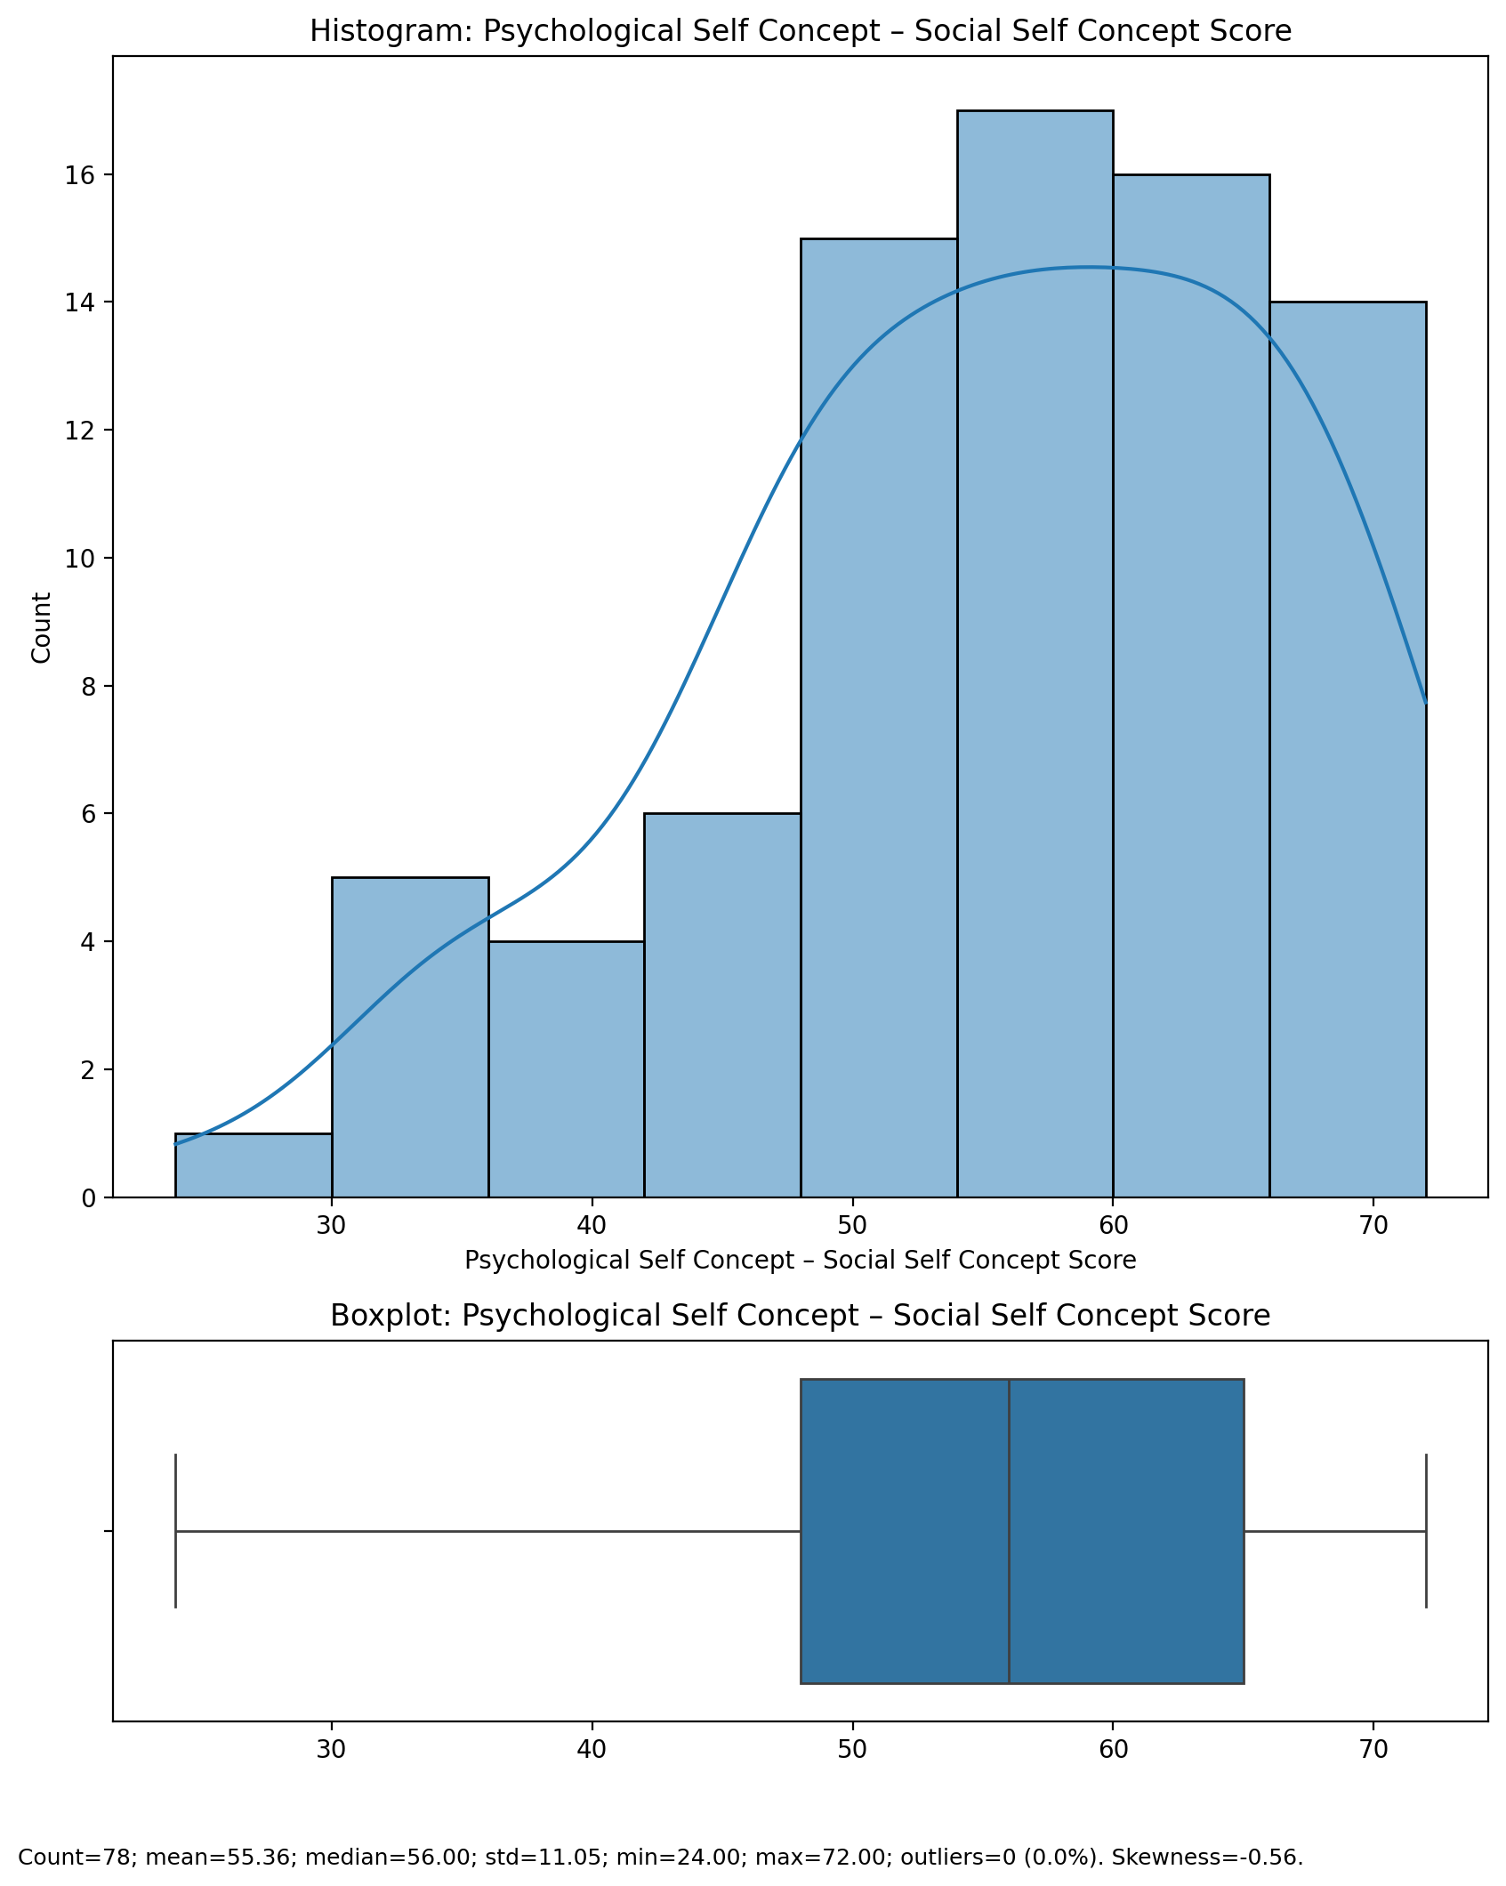

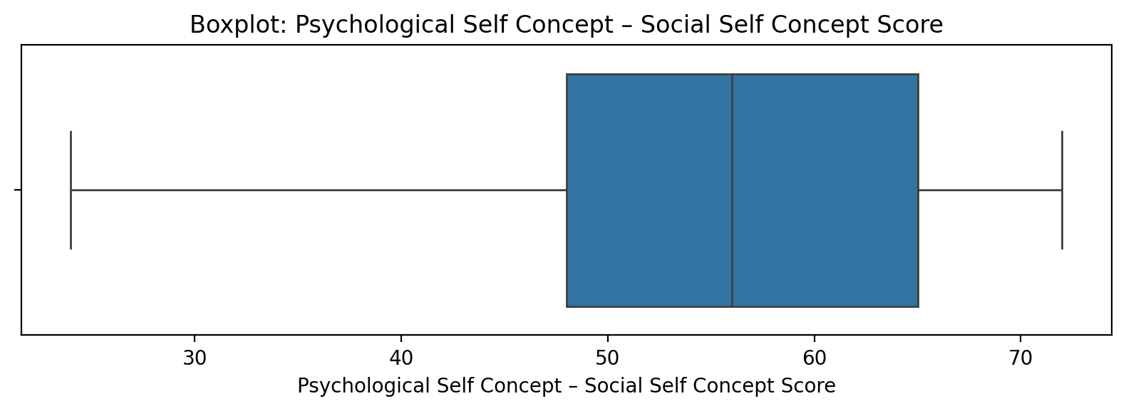

## Psychological Self Concept – Social Self Concept Score

Top categories: Average: 39 (49.4%) | Low: 20 (25.3%) | High: 12 (15.2%) | Very Low: 5 (6.3%) | Very High: 2 (2.5%) | <<MISSING>>: 1 (1.3%). Note: Top category is sizeable — consider grouping smaller categories.



## Real Self Concept Total Score

Count=78; mean=150.42; median=151.50; std=27.18; min=84.00; max=192.00; outliers=0 (0.0%). Skewness=-0.29.

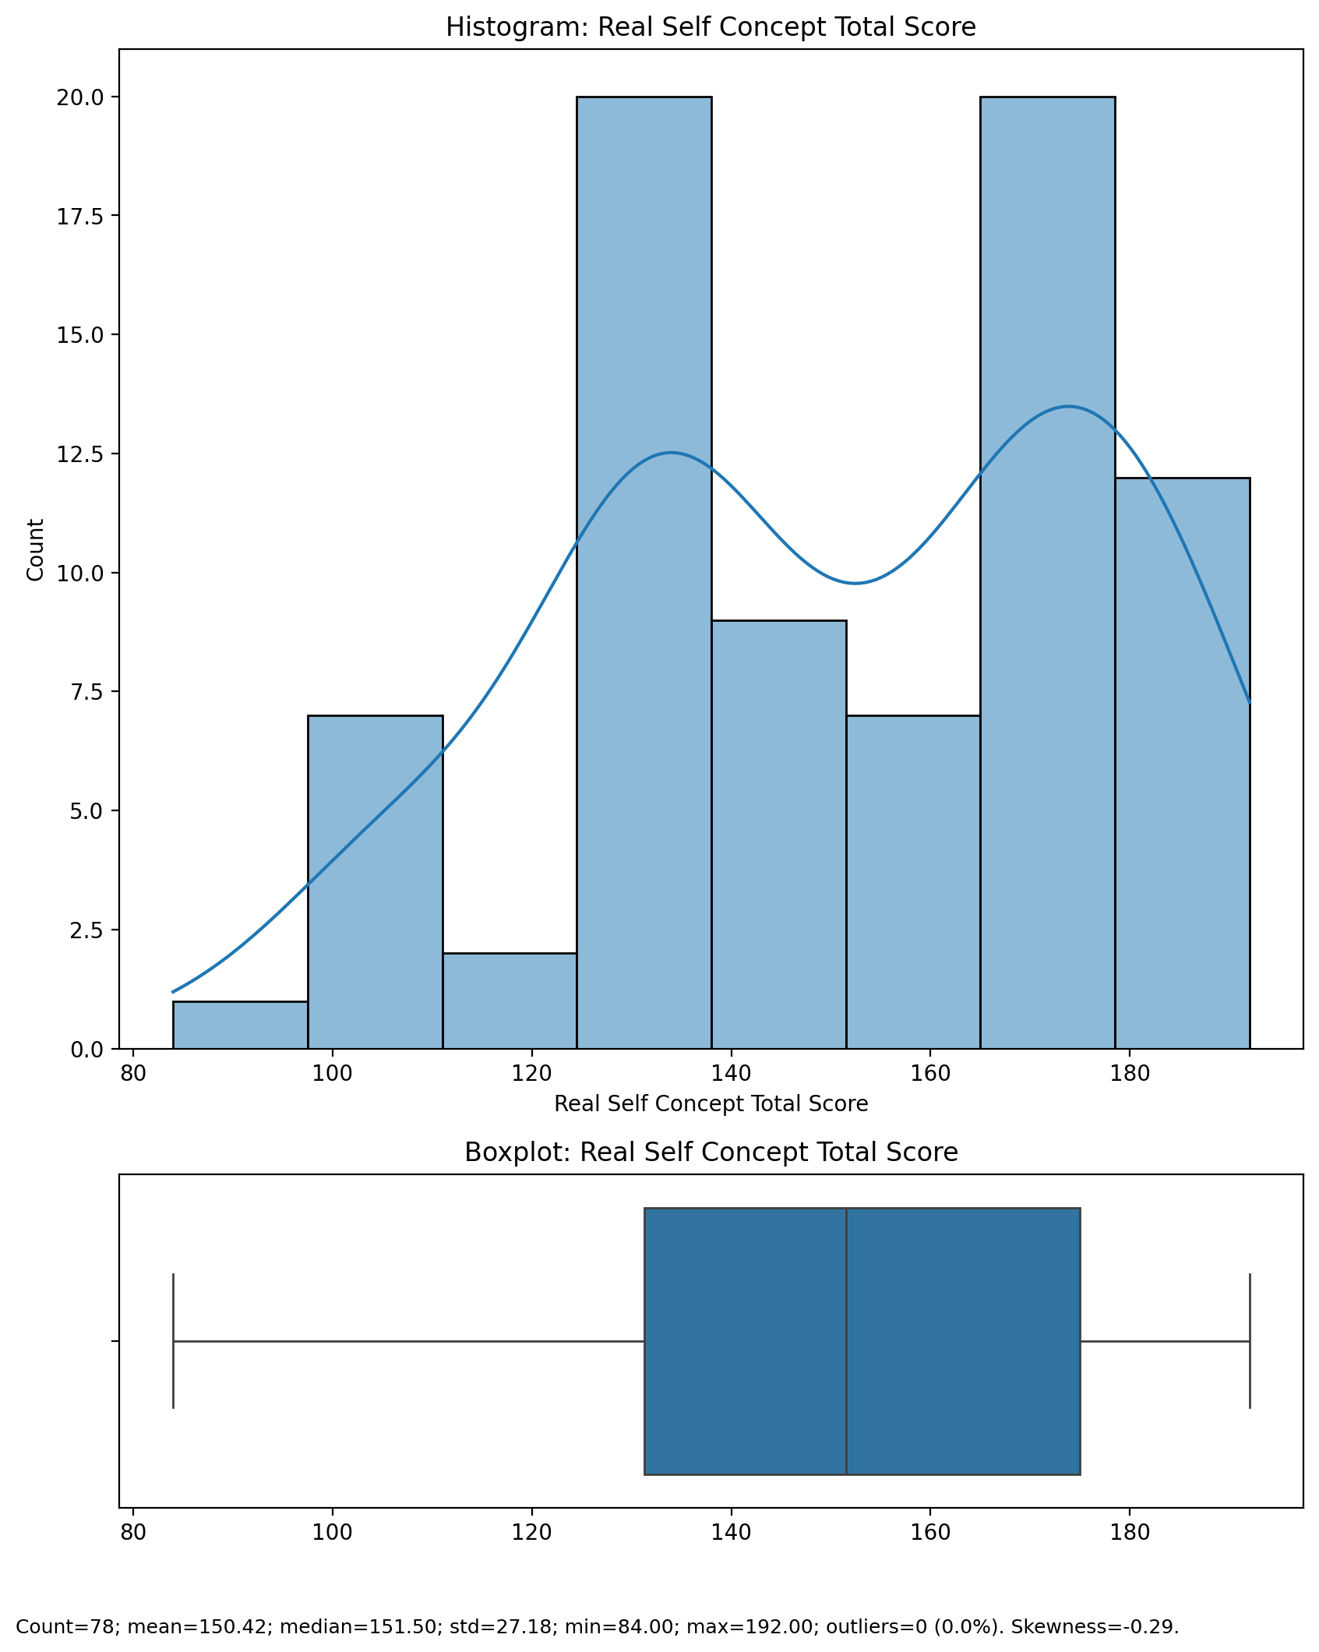

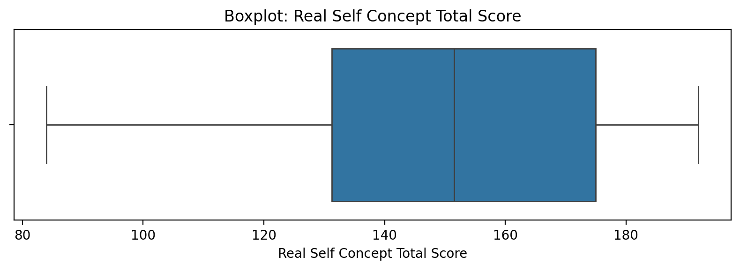

## Real Self Concept Total Score

Top categories: Average: 39 (49.4%) | Low: 20 (25.3%) | High: 12 (15.2%) | Very Low: 5 (6.3%) | Very High: 2 (2.5%) | <<MISSING>>: 1 (1.3%). Note: Top category is sizeable — consider grouping smaller categories.



## Ideal Self Concept Total Score

Count=78; mean=164.99; median=174.50; std=26.69; min=94.00; max=192.00; outliers=2 (2.6%). Skewness=-1.05.

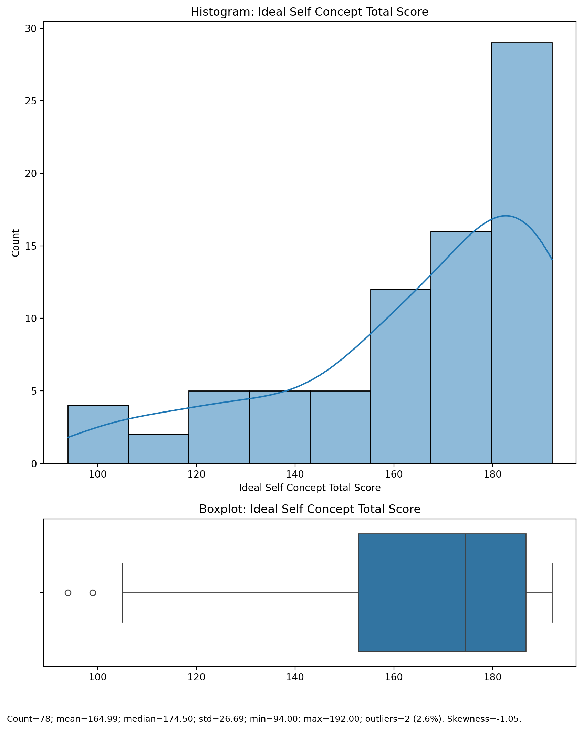

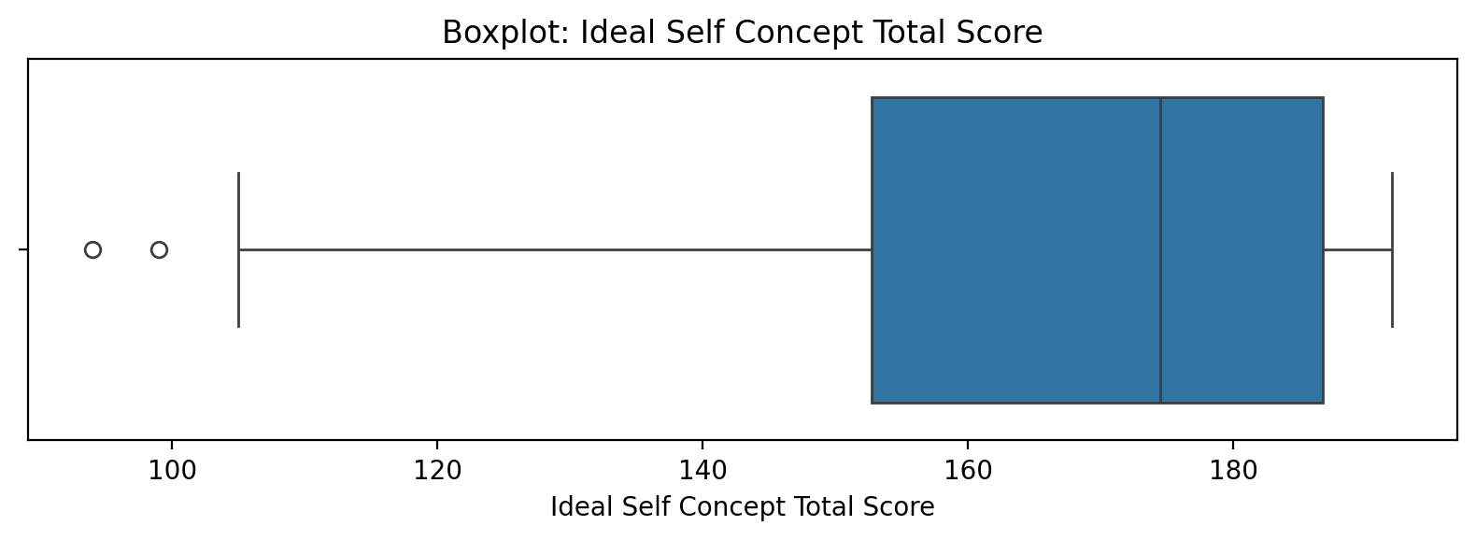

## Ideal Self Concept Total Score

Top categories: Average: 39 (49.4%) | Low: 20 (25.3%) | High: 12 (15.2%) | Very Low: 5 (6.3%) | Very High: 2 (2.5%) | <<MISSING>>: 1 (1.3%). Note: Top category is sizeable — consider grouping smaller categories.



## Social Self Concept Total Score

Count=78; mean=146.91; median=152.00; std=27.52; min=64.00; max=192.00; outliers=1 (1.3%). Skewness=-0.48.

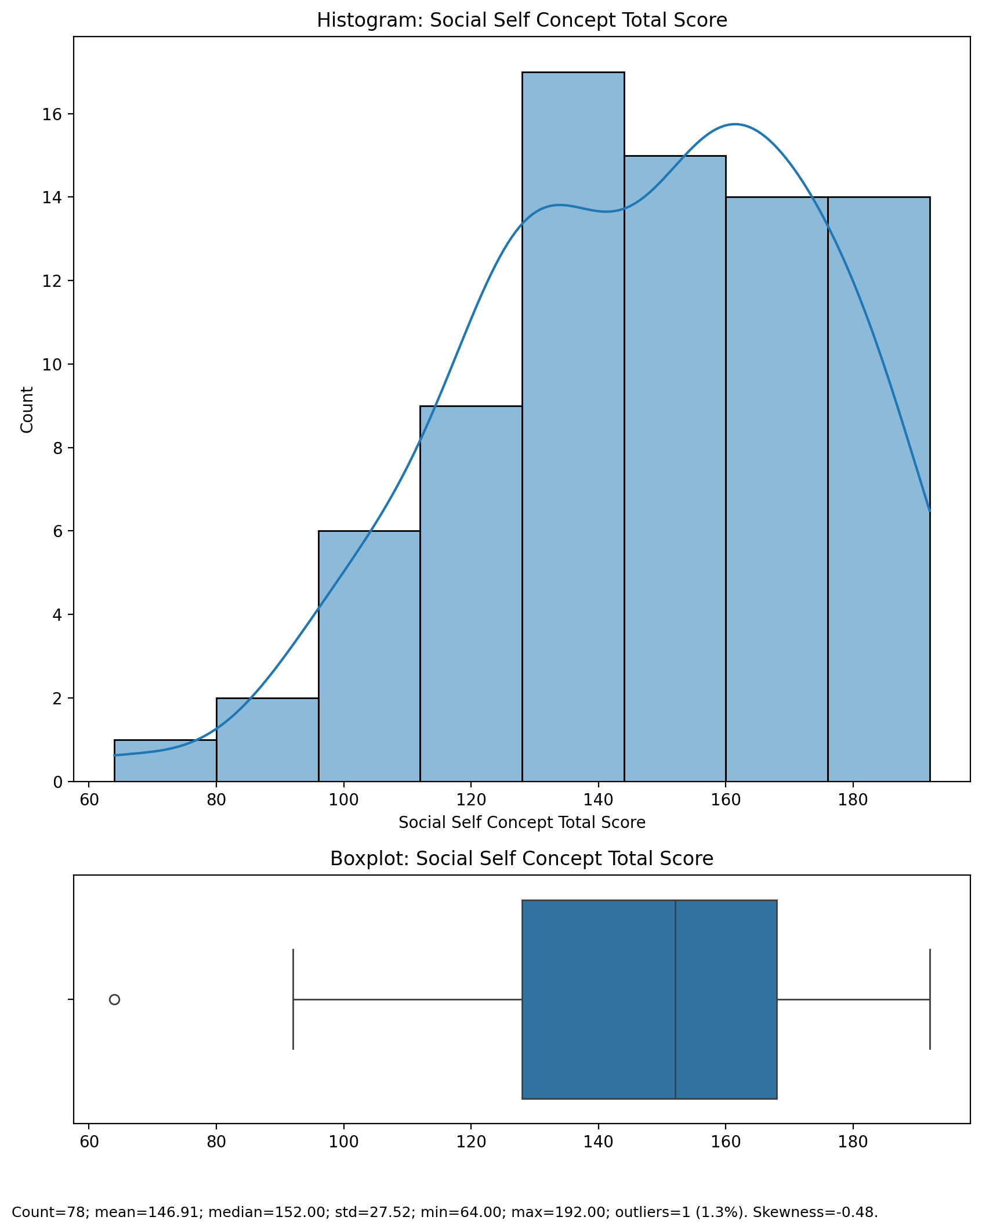

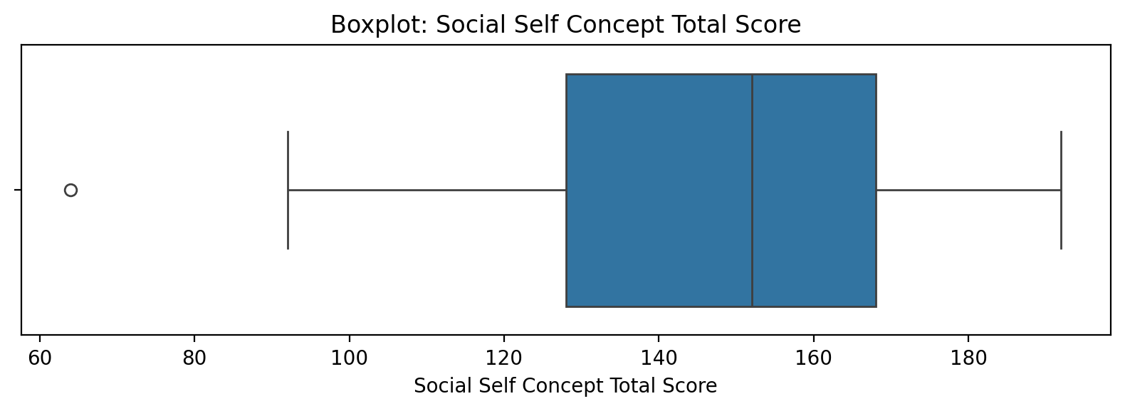

## Social Self Concept Total Score

Top categories: Average: 39 (49.4%) | Low: 20 (25.3%) | High: 12 (15.2%) | Very Low: 5 (6.3%) | Very High: 2 (2.5%) | <<MISSING>>: 1 (1.3%). Note: Top category is sizeable — consider grouping smaller categories.



## Real Self Concept Total Category

Top categories: HIGH: 42 (53.2%) | AVERAGE: 35 (44.3%) | <<MISSING>>: 1 (1.3%) | LOW: 1 (1.3%). Note: Top category is sizeable — consider grouping smaller categories.

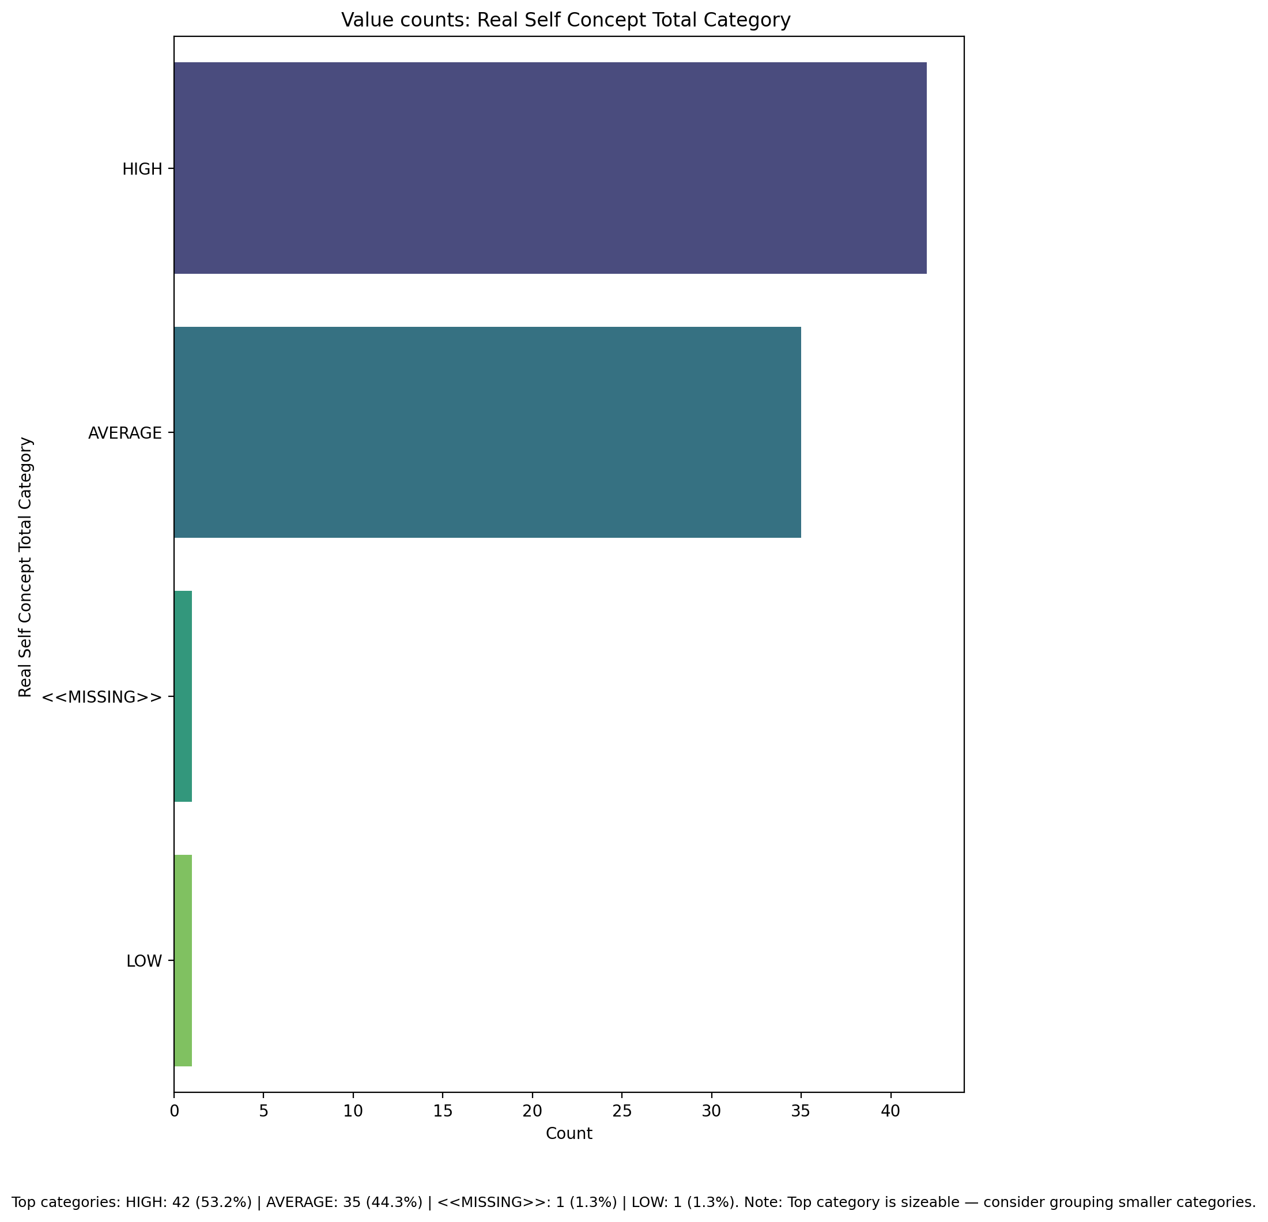

## Ideal Self Concept Total Category

Top categories: HIGH: 61 (77.2%) | AVERAGE: 17 (21.5%) | <<MISSING>>: 1 (1.3%). Note: Top category is sizeable — consider grouping smaller categories.

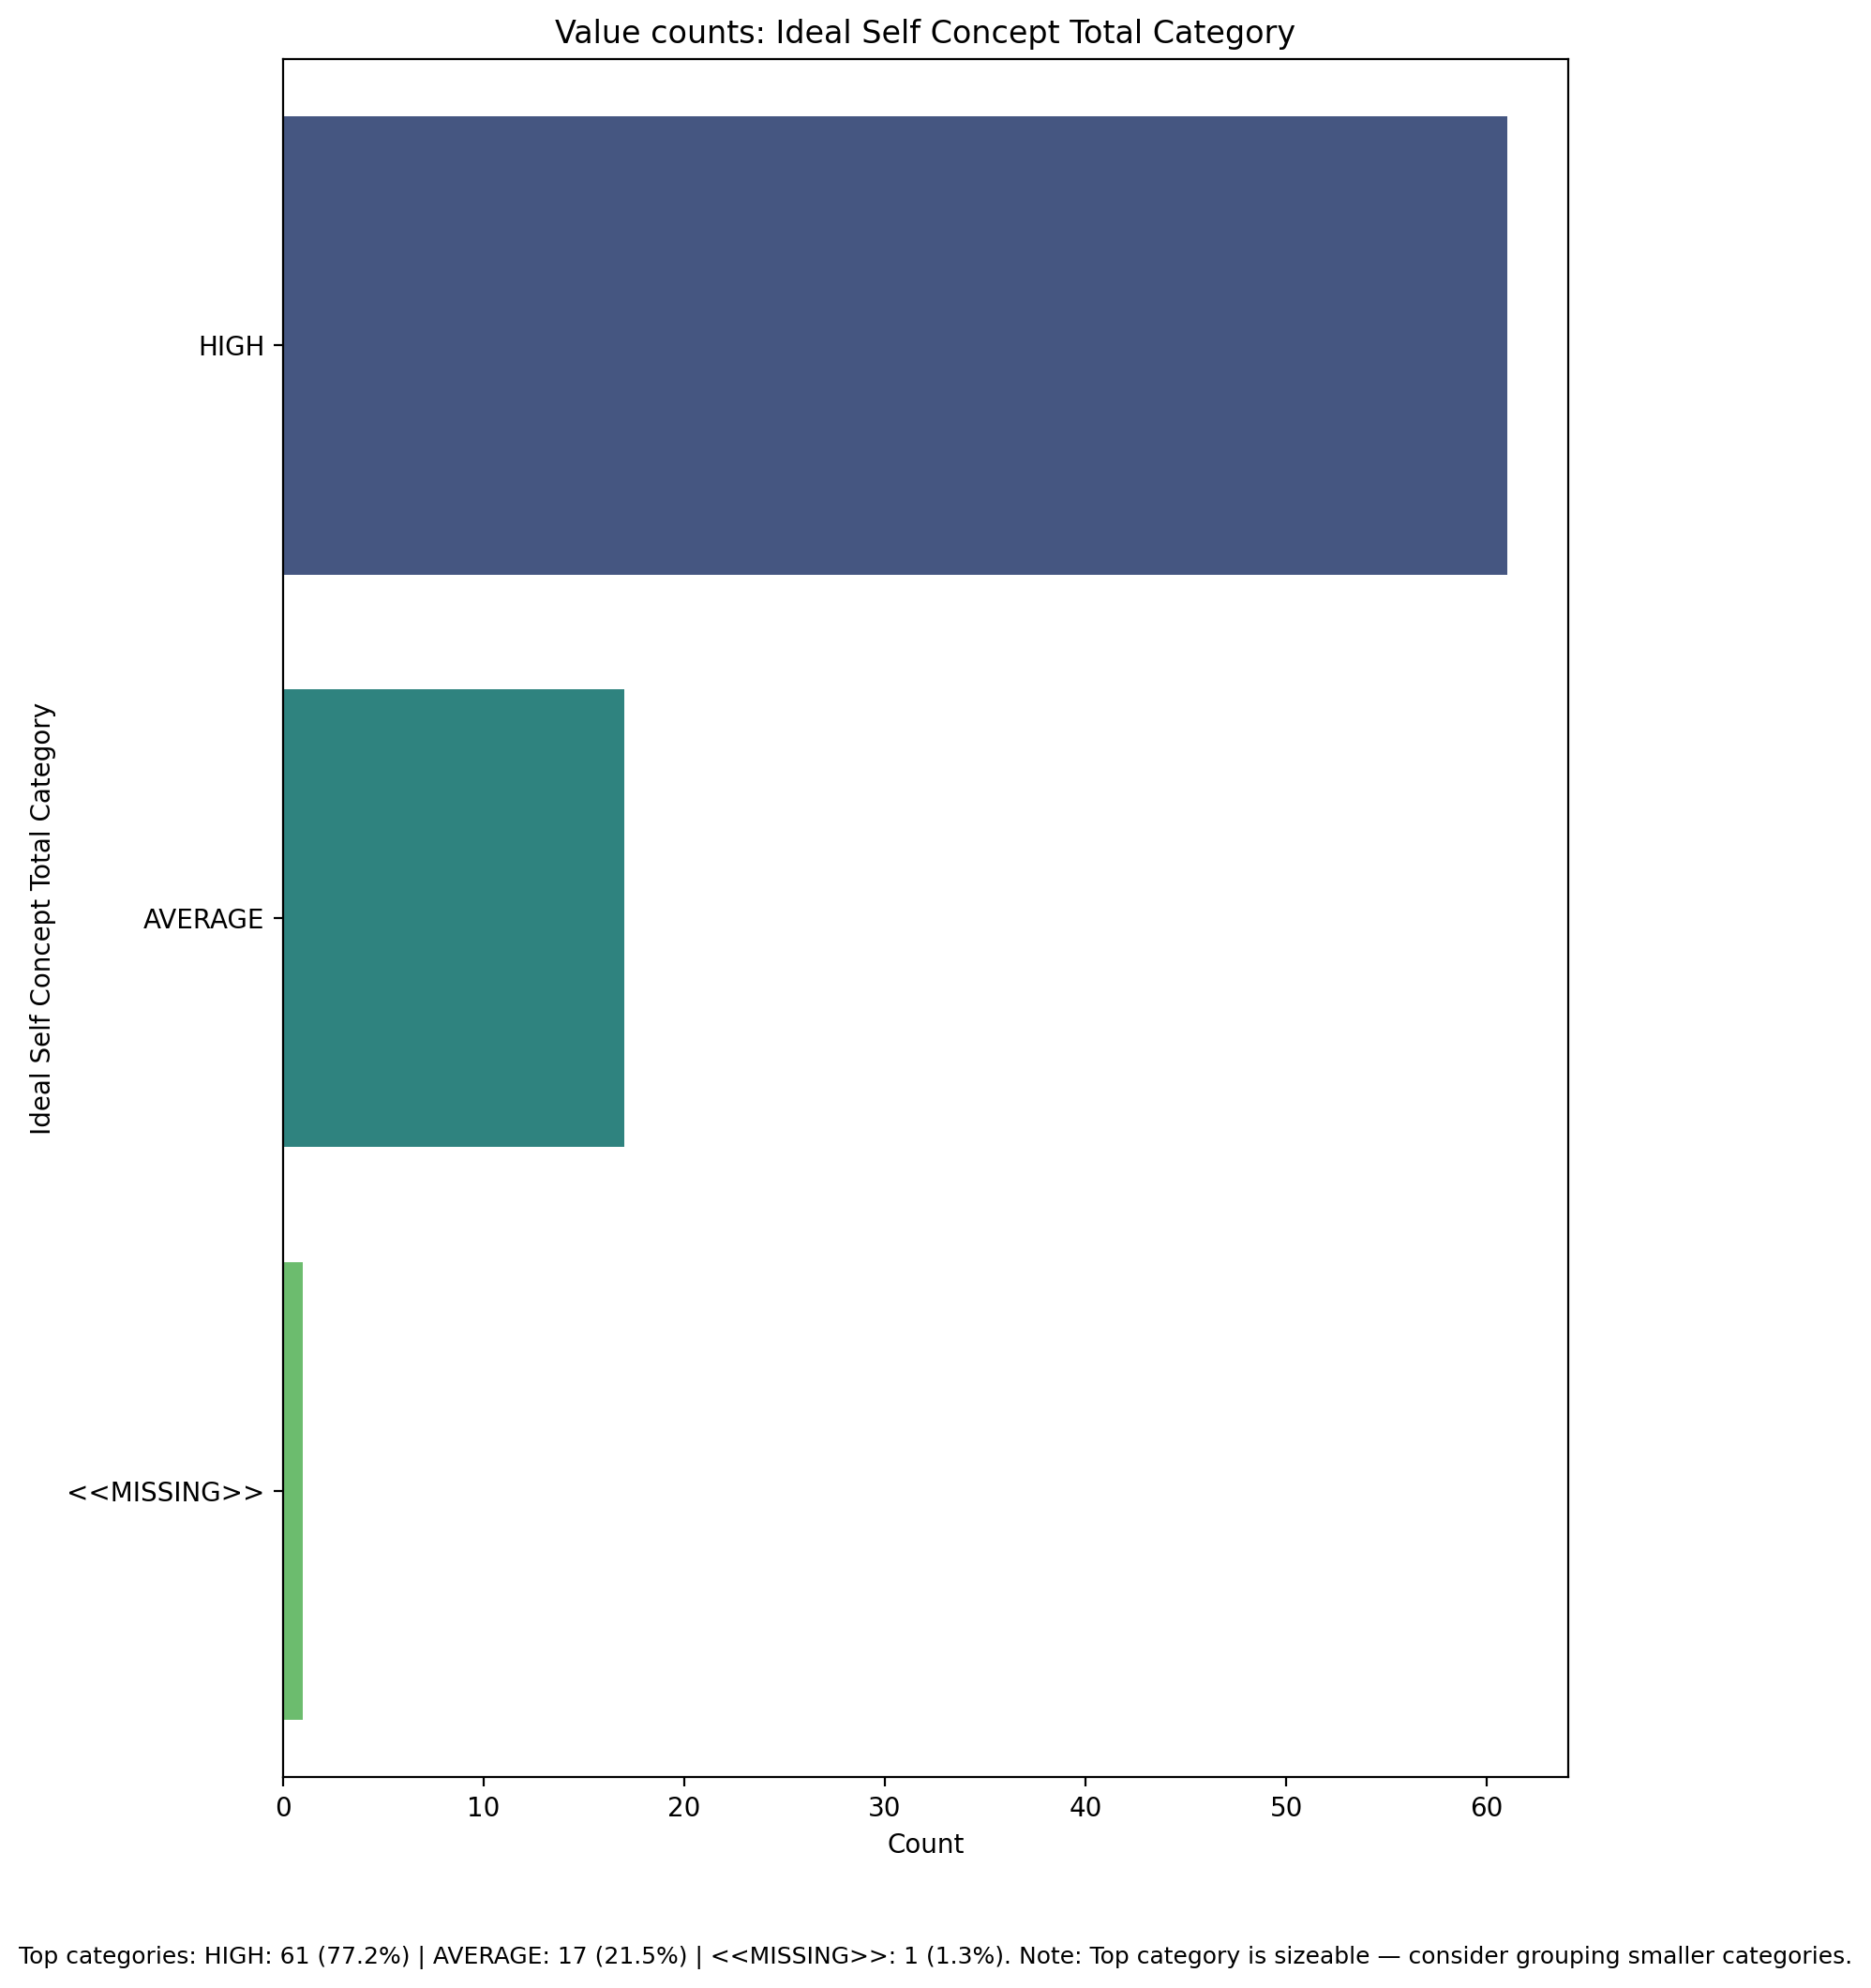

## Social Self Concept Total Category

Top categories: HIGH: 42 (53.2%) | AVERAGE: 34 (43.0%) | LOW: 2 (2.5%) | <<MISSING>>: 1 (1.3%). Note: Top category is sizeable — consider grouping smaller categories.

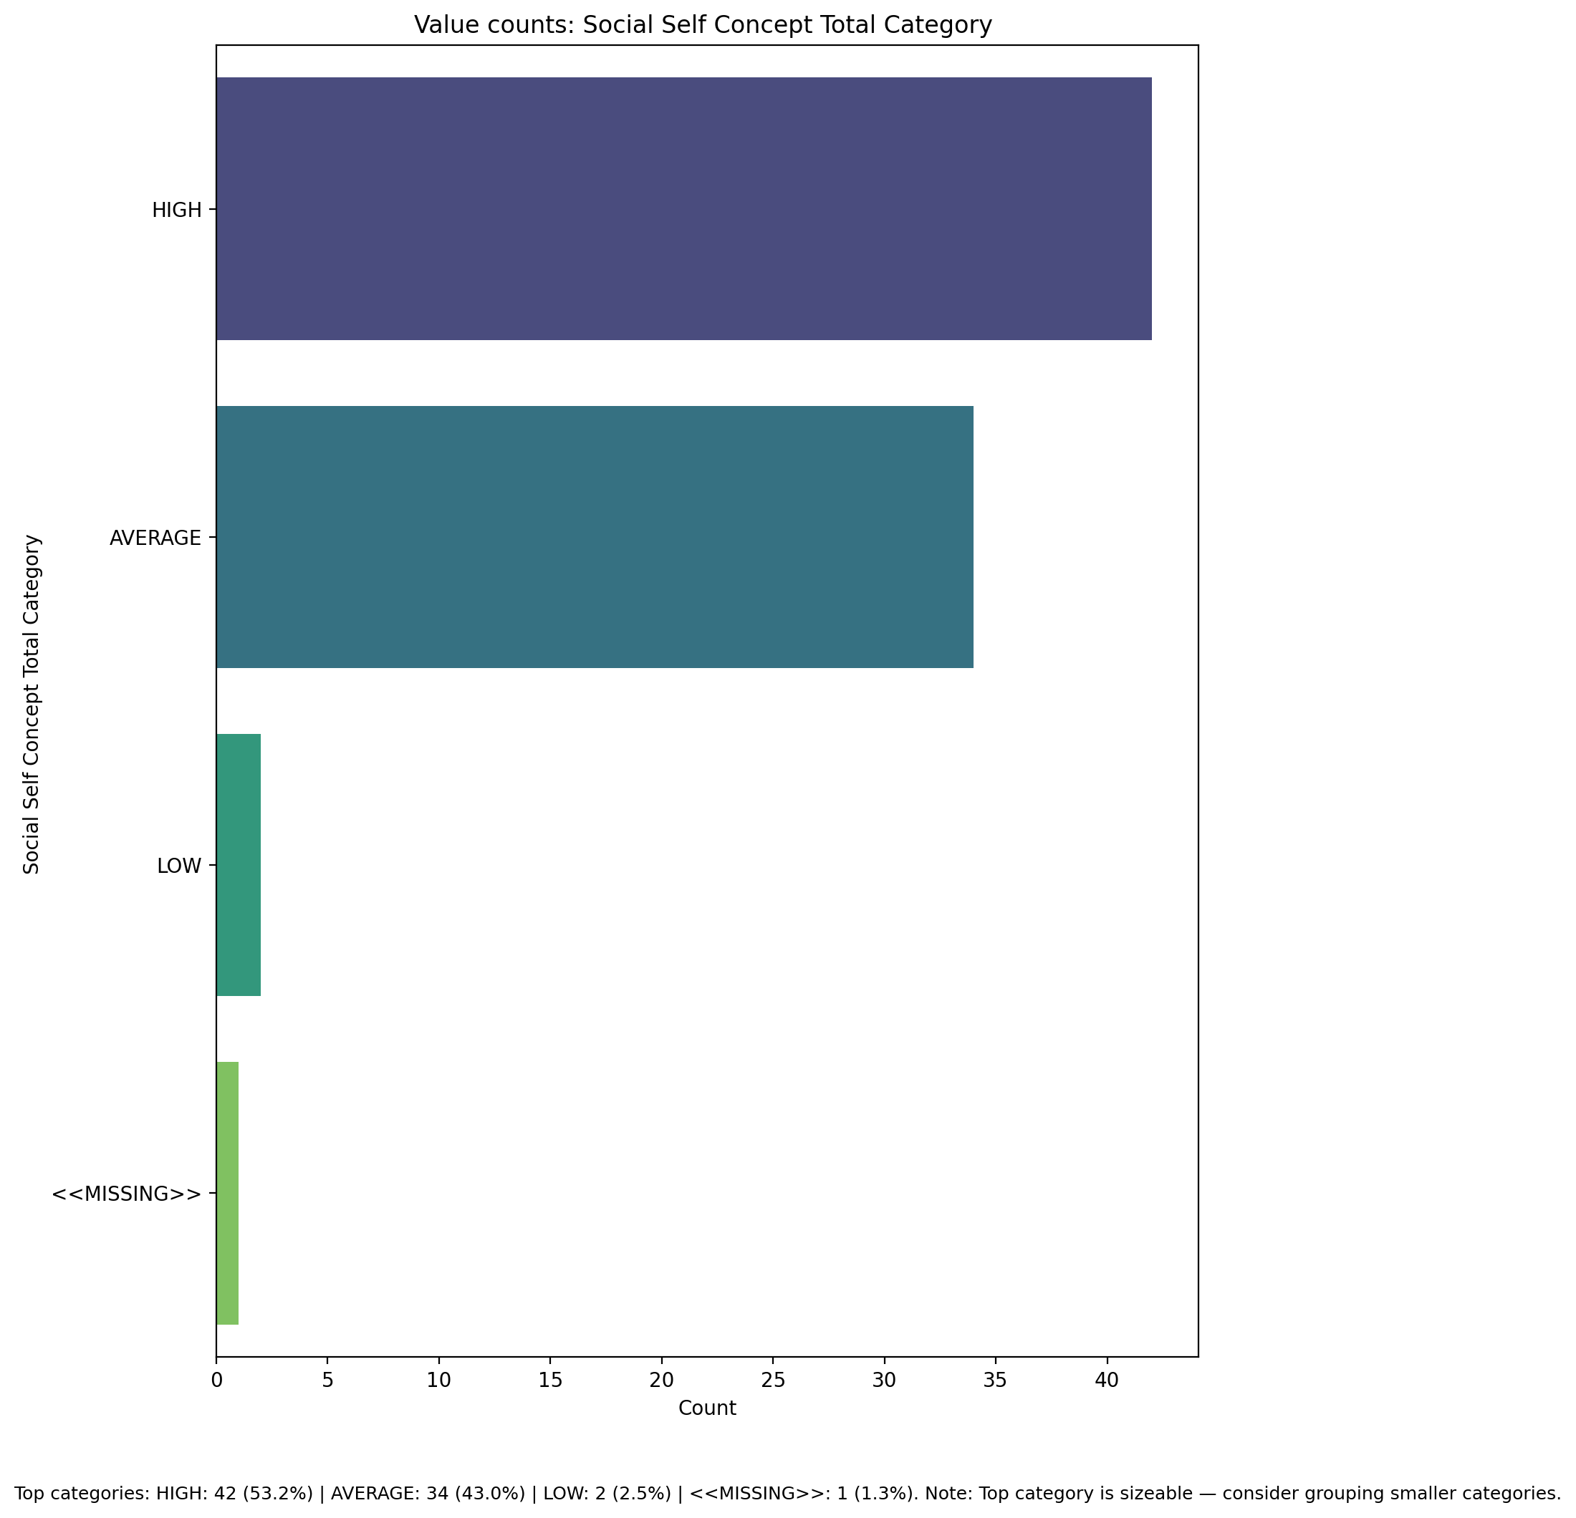

## Perceived Social Stress Score

Count=78; mean=56.14; median=58.00; std=14.49; min=10.00; max=86.00; outliers=6 (7.7%). Skewness=-0.62.

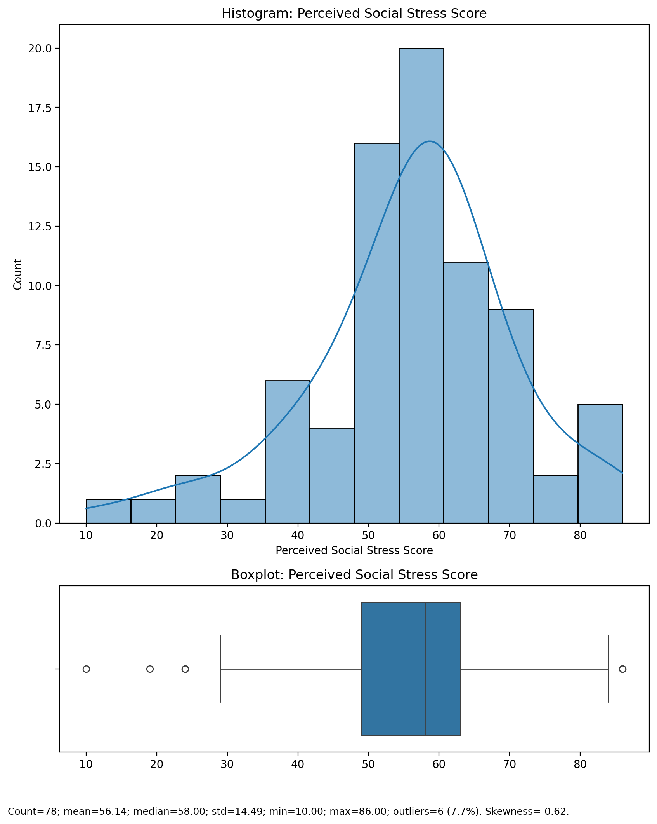

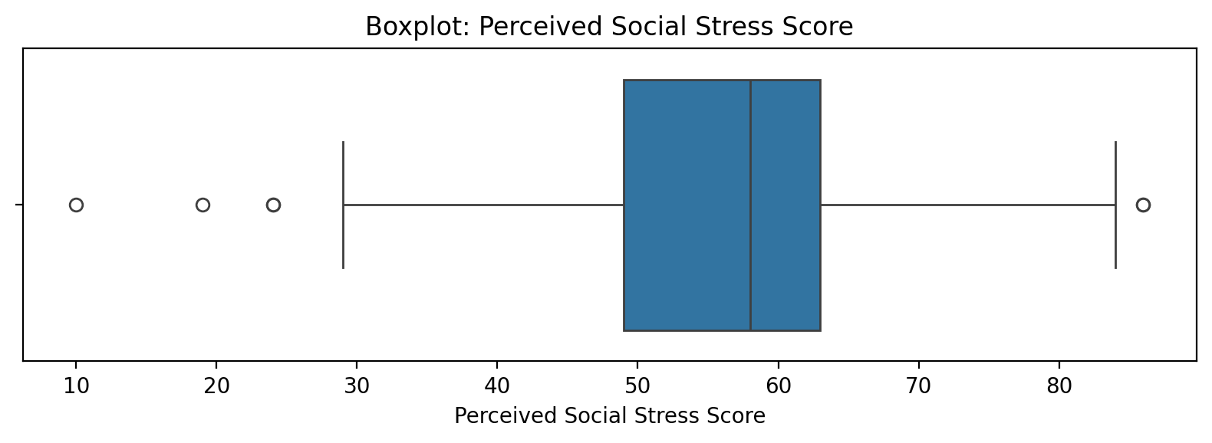

## Perceived Social Stress Score

Top categories: HIGH: 42 (53.2%) | AVERAGE: 34 (43.0%) | LOW: 2 (2.5%) | <<MISSING>>: 1 (1.3%). Note: Top category is sizeable — consider grouping smaller categories.



## Perceived Social Stress Category

Top categories: AVERAGE: 68 (86.1%) | LOW: 5 (6.3%) | HIGH: 5 (6.3%) | <<MISSING>>: 1 (1.3%). Note: Single category dominates — low variability.

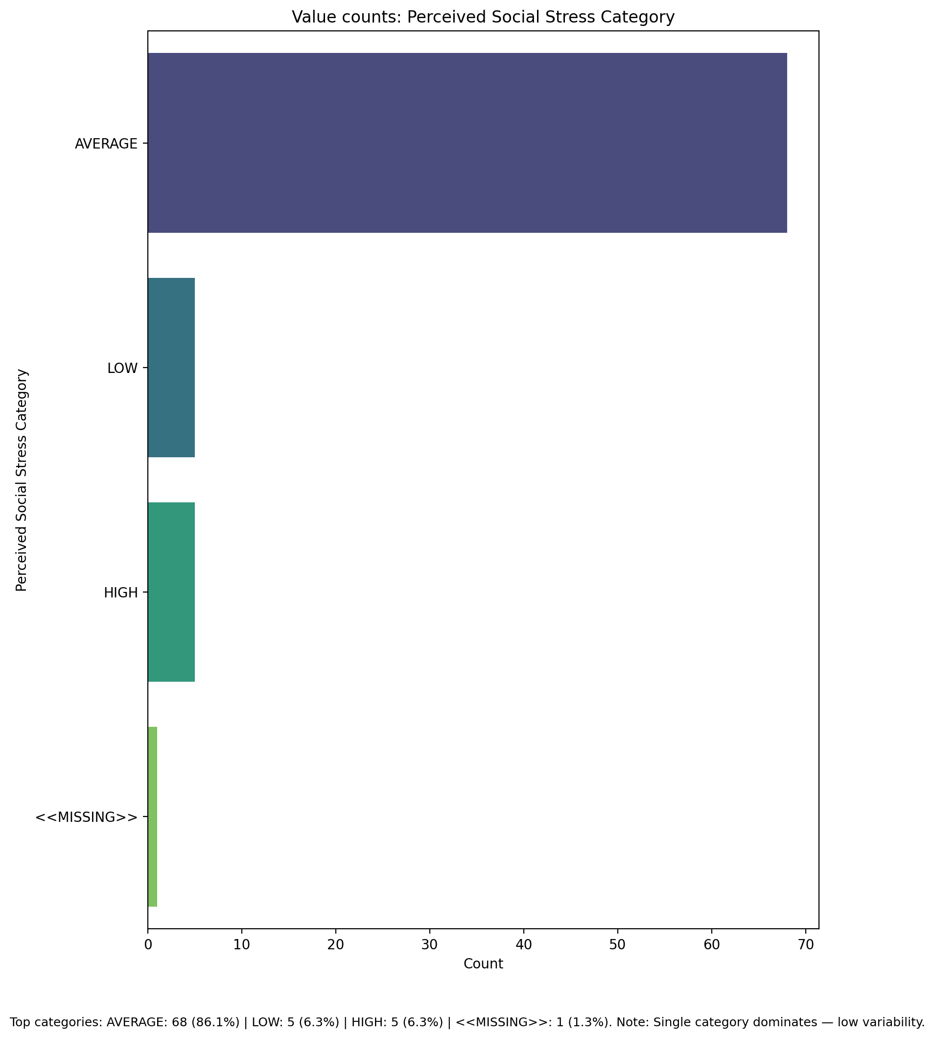

## Monthly household income_midpoint_INR

Count=74; mean=50878.38; median=40000.00; std=42542.15; min=5000.00; max=125000.00; outliers=0 (0.0%). Skewness=0.54.

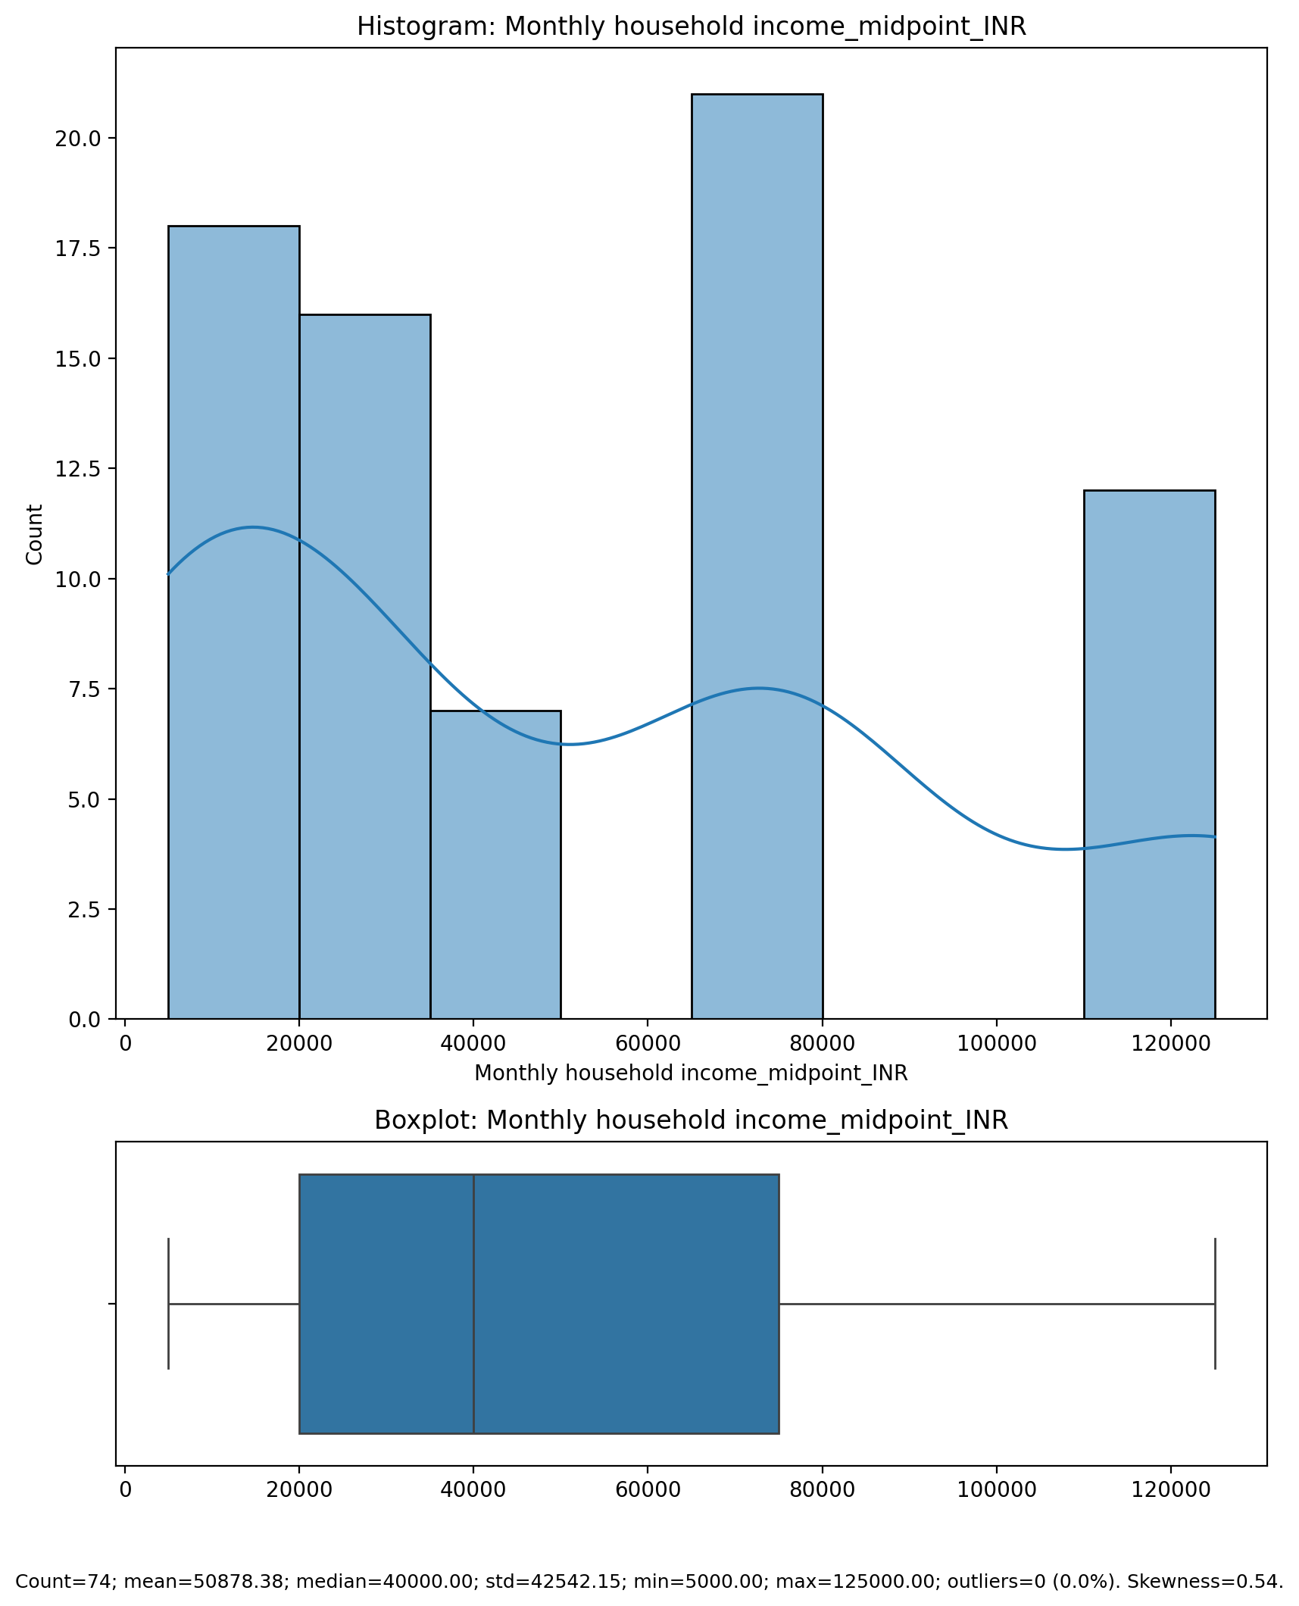

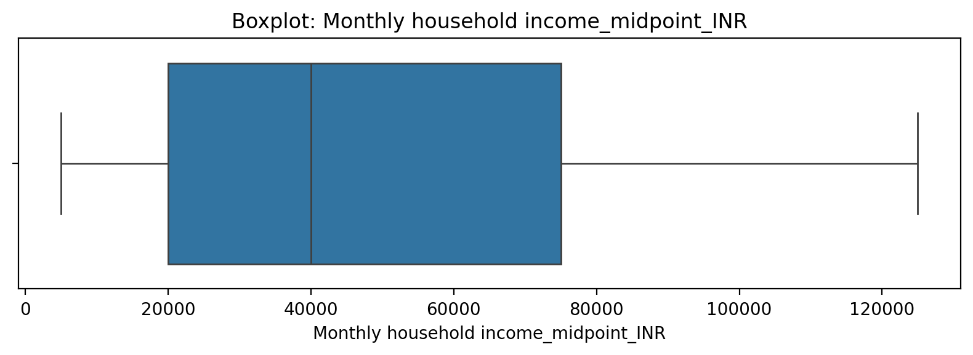

## Monthly household income_midpoint_INR

Top categories: AVERAGE: 68 (86.1%) | LOW: 5 (6.3%) | HIGH: 5 (6.3%) | <<MISSING>>: 1 (1.3%). Note: Single category dominates — low variability.



## Monthly household income_cat

Top categories: 50k-100k: 21 (26.6%) | Below 10k: 18 (22.8%) | 10k-30k: 16 (20.3%) | Above 100k: 12 (15.2%) | 30k-50k: 7 (8.9%) | Unknown: 5 (6.3%). Note: Healthy spread across categories.

